Android OS Setup

Eduroam
- Navigate to the Apps Drawer or pull down the Notifications bar.
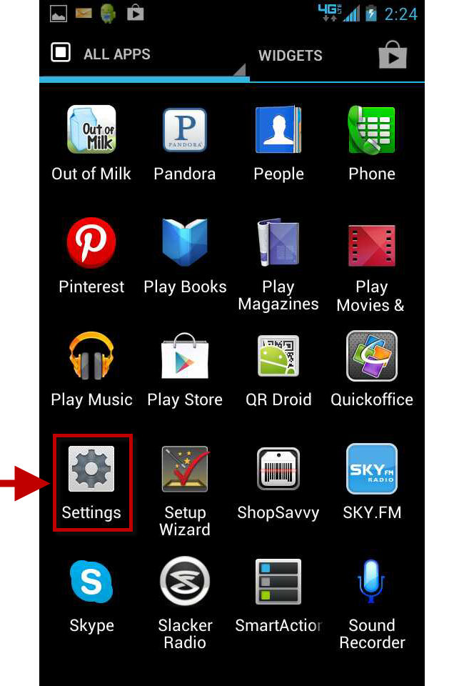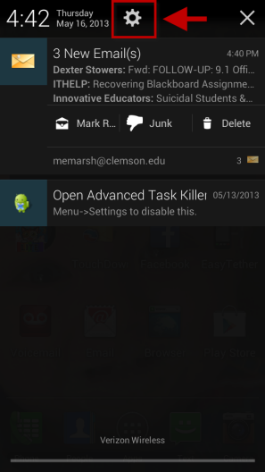
- Tap Settings.
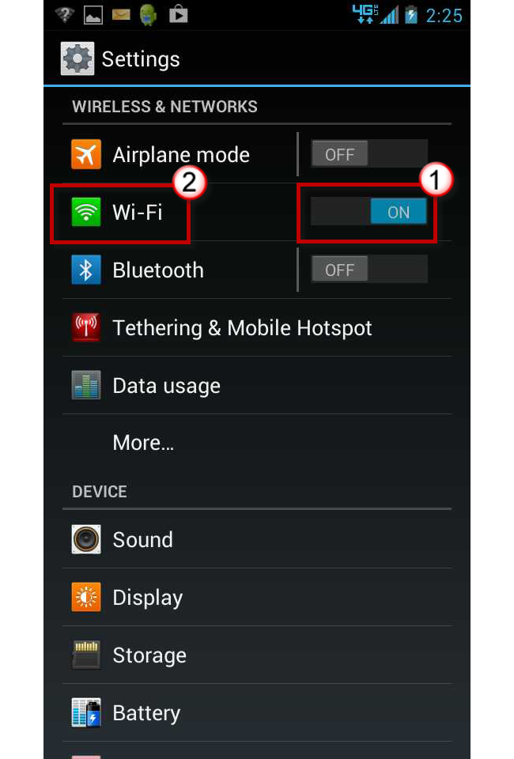
- Slide the button to turn ON the Wi-Fi.
- Then tap the green Wi-Fi icon.
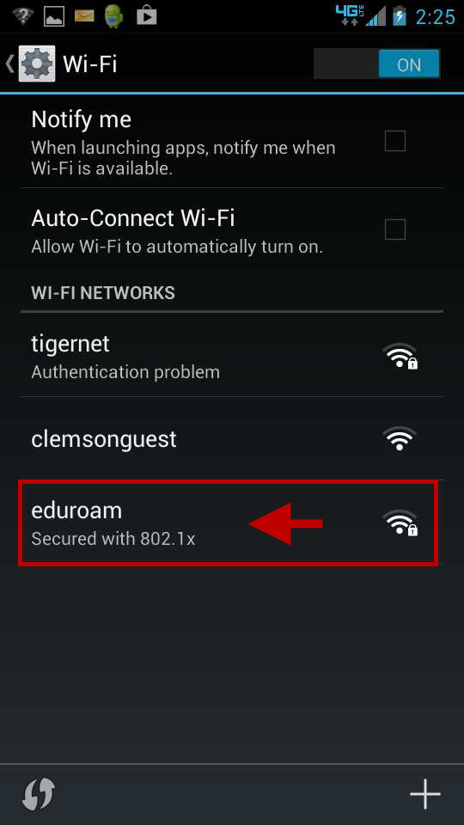
- The Wi-Fi screen is displayed.
- Tap eduroam.
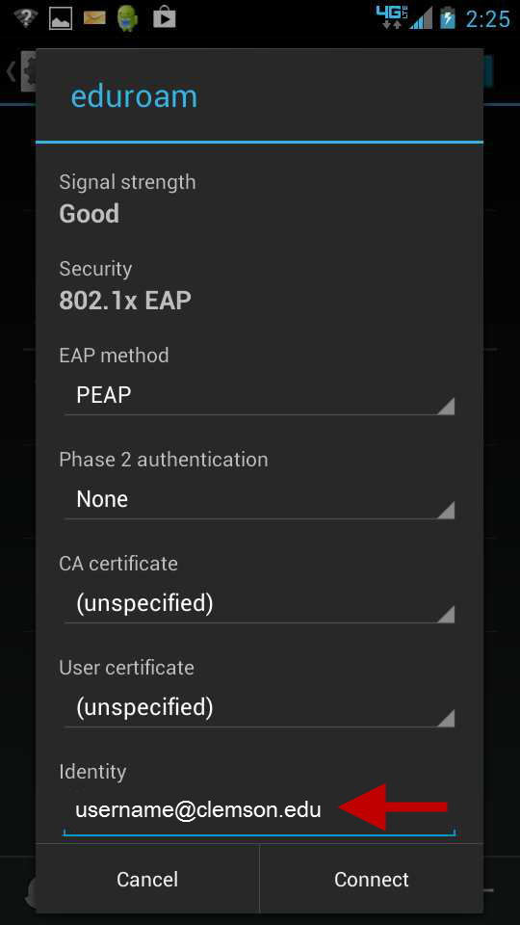
- In the Identity field, enter username@clemson.edu.
- Tap and scroll down.
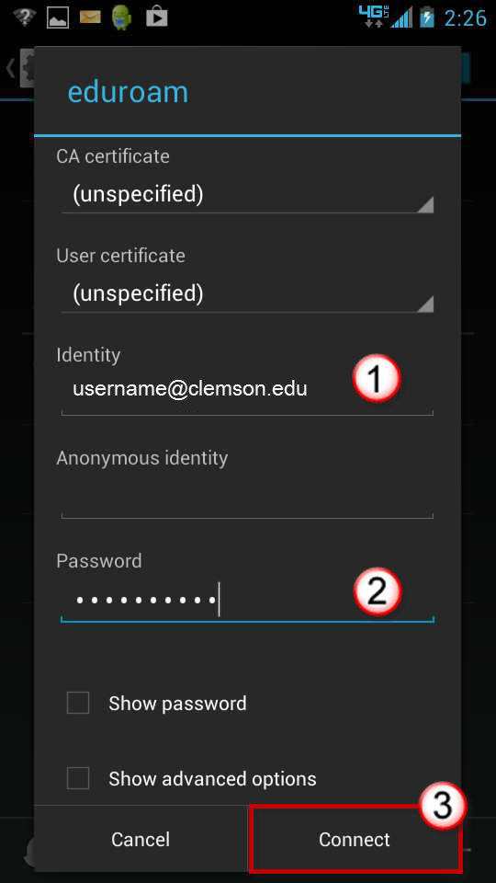

- Enter your Password.
- Then click Connect.
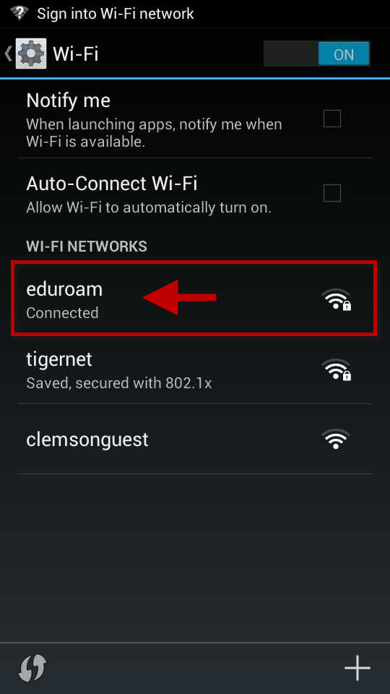
- You are now connected to eduroam.

