Blackberry Setup

eduroam
- Navigate to the Settings Menu
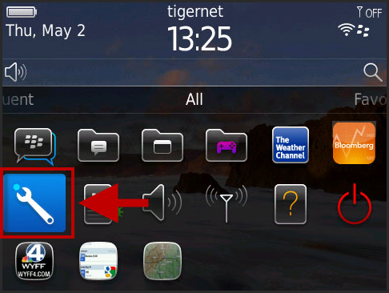
- Select Networks and Connections
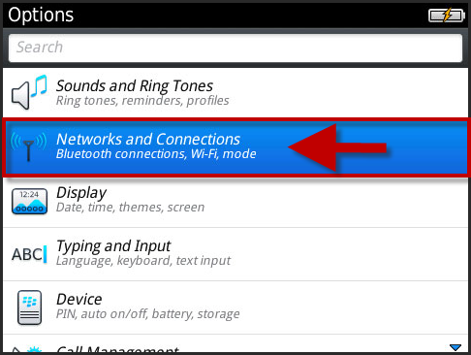
- Select Wi-Fi Network.
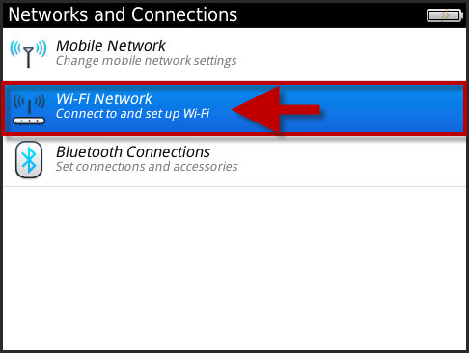

- Select eduroam.
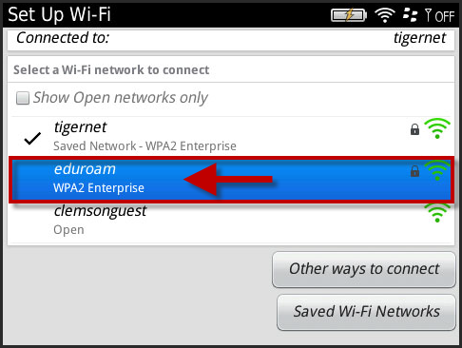
- The Wi-Fi Security screen will be displayed.
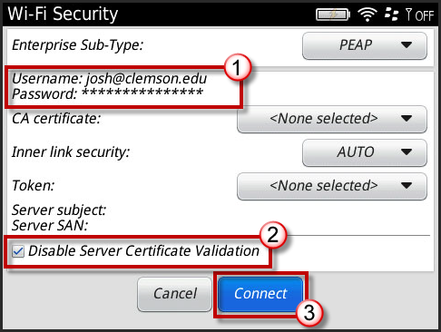
- When prompted, login to the eduroam network with your username@clemson.edu and password.
- Enable the checkbox to Disable Server Verification Box.
- Then click Connect.
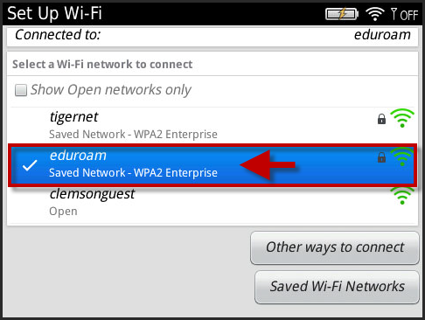
- You are now connected to eduroam.

