IOS Setup

eduroam
- Under Settings | Wi-Fi | Select eduroam.
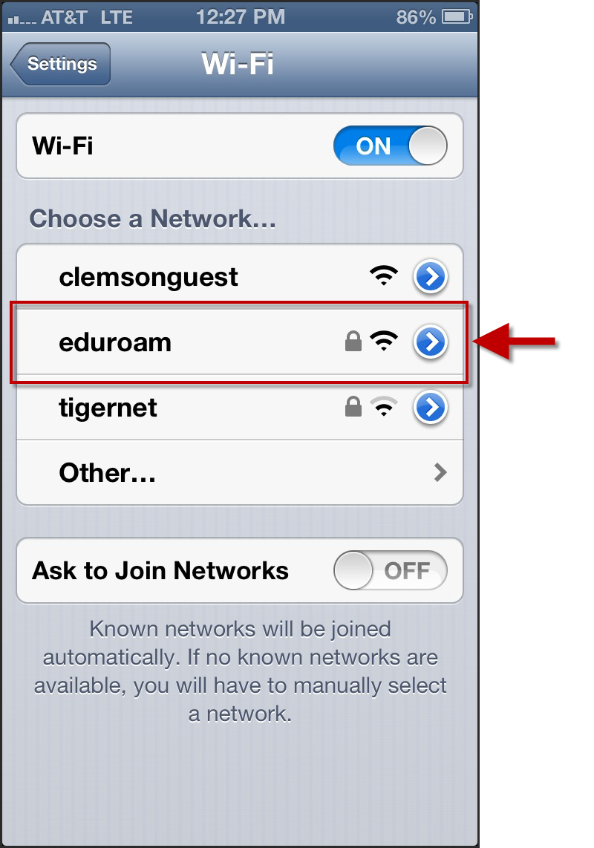
- Enter your username@clemson.edu and password.
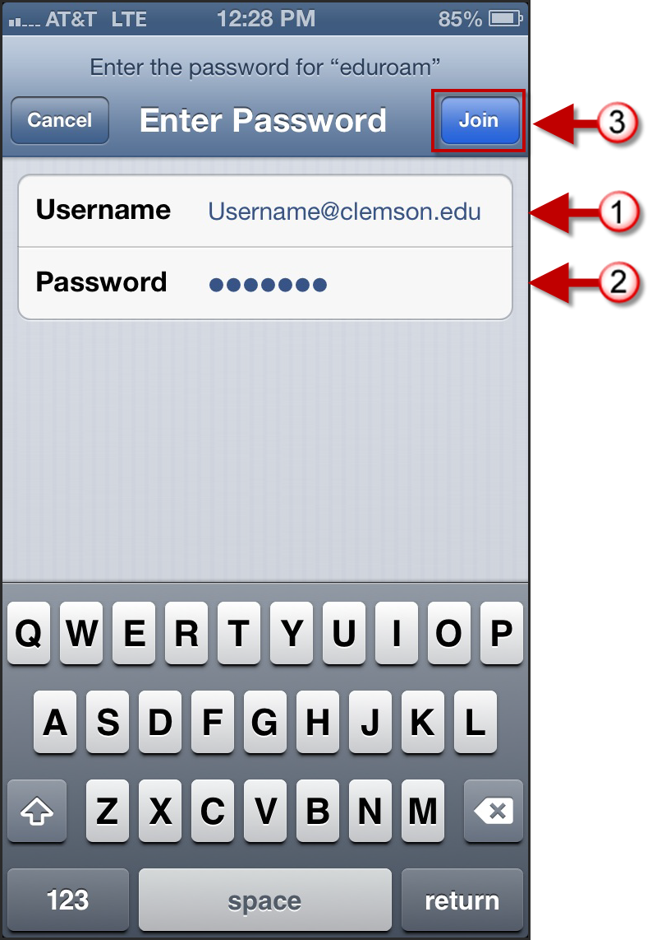
- Then click Join.

- Click Accept.
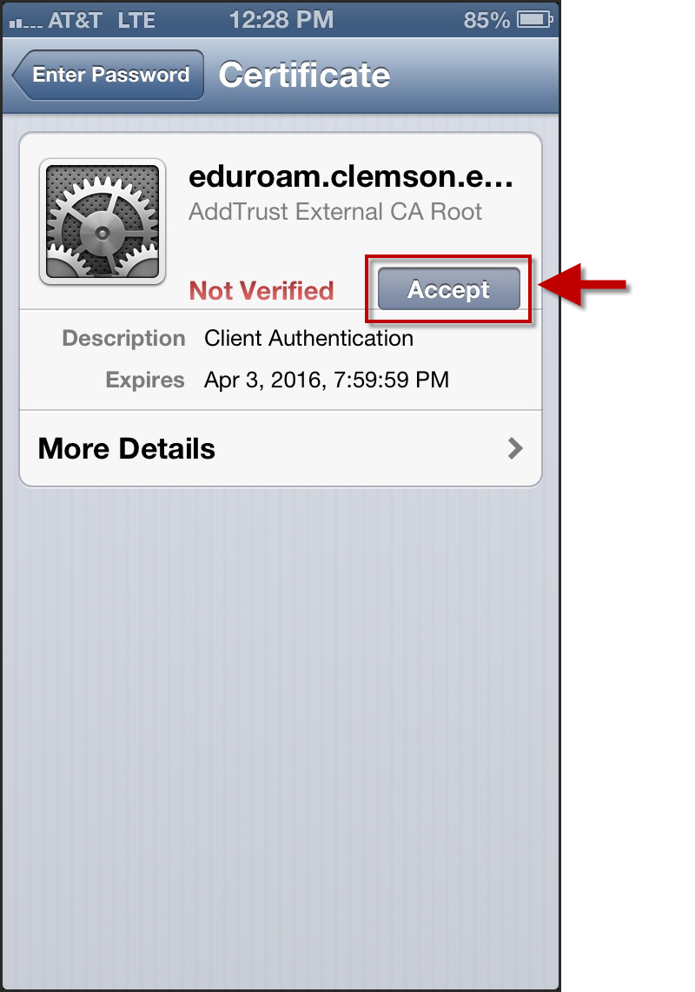
- You are now connected to eduroam.
