Mac OSX Installer

esduroam
- Launch the eduroam.pkg.
- The Clemson University Wireless Installer will open.
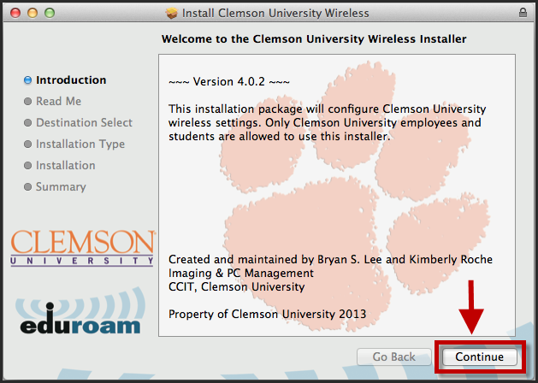
- Click Continue.
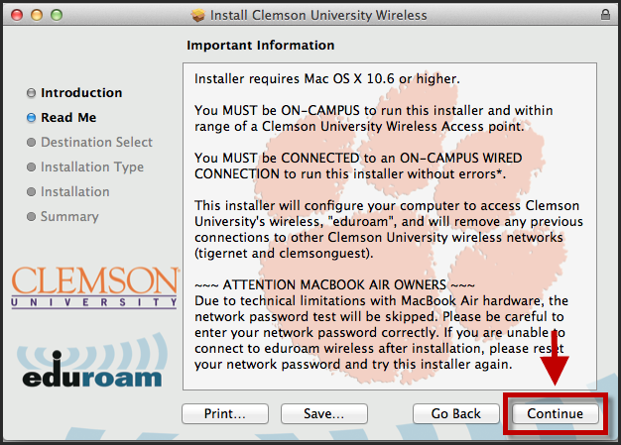
- Click Continue.
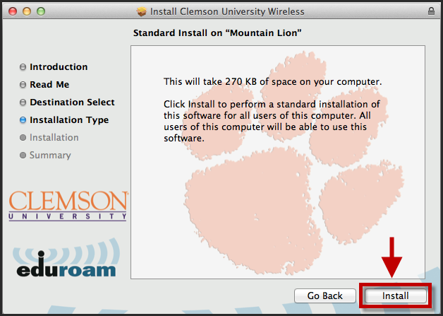
- Click Install.
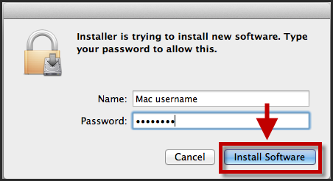
- Enter your Mac username and Password.
- Then click Install Software.
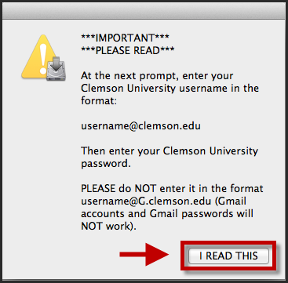
- A pop-up window will display. Please read the information in the window.
- Then click I READ THIS.
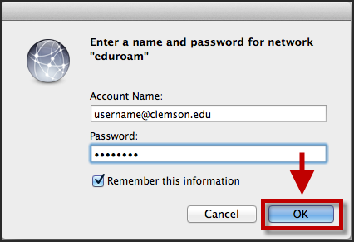
- When prompted, login to the eduroam network with your username@clemson.edu and password.
NOTE: Do NOT enter it in the format of a Gmail address. (i.e. username@g.clemson.edu) This will NOT work.
- Click OK.
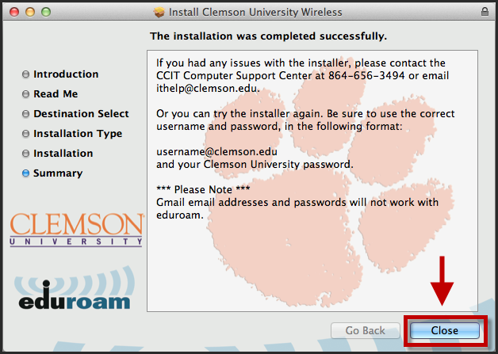
- You should now be connected to eduroam.
- Click Close to exit the installer’s.

