Mac OSX Setup

eduroam
- Click on the Wi-Fi icon in the top menu.
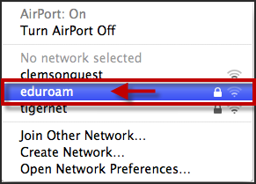
- Select eduroam.
- When prompted, login to the eduroam network with your username@clemson.edu and password.
NOTE: Do NOT enter it in the format of a Gmail address. (i.e. username@g.clemson.edu) This will NOT work.
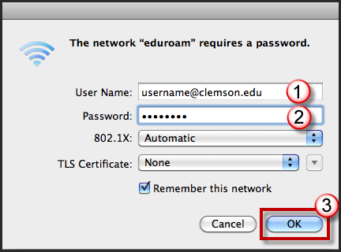
- Then click OK.
NOTE: If you use Keychain, you will be prompted to save the Wi-Fi password in Keychain.
- Next, click on the Apple icon in the top menu.
- Select System Preferences.
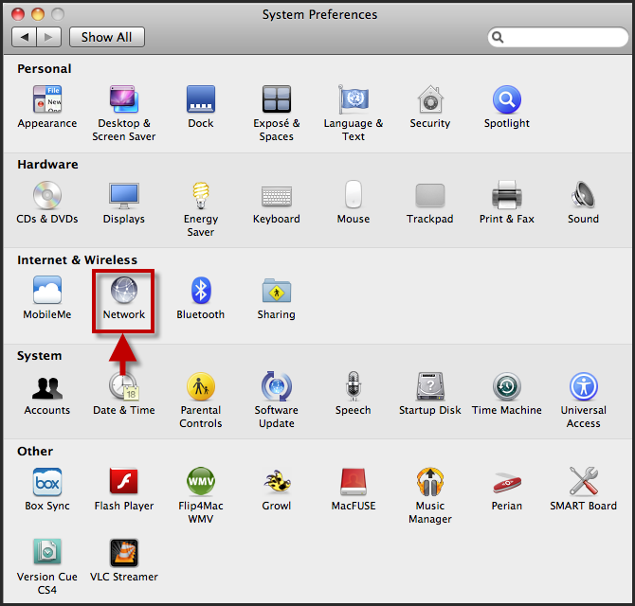
- Click Network.
- Select Airport or Wi-Fi in the left column.
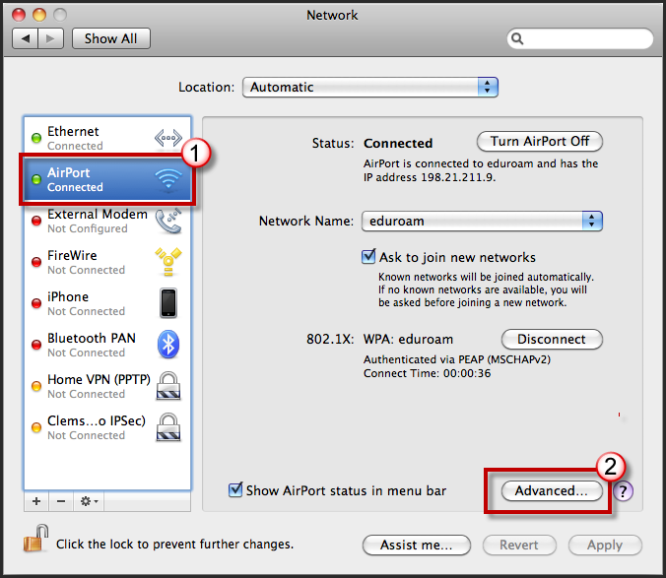
- Then click Advanced.

- Click the Airport or Wi-Fi tab.
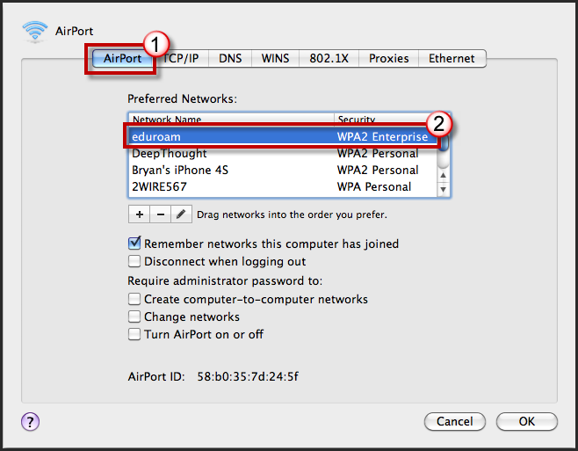
- Click the eduroam network and drag it to the top of the list.
NOTE: If you see “tigernet” or “clemsonguest”, remove these from the list by selecting them and clicking the Remove Airport Network button.
- Next click the 802.1X tab.
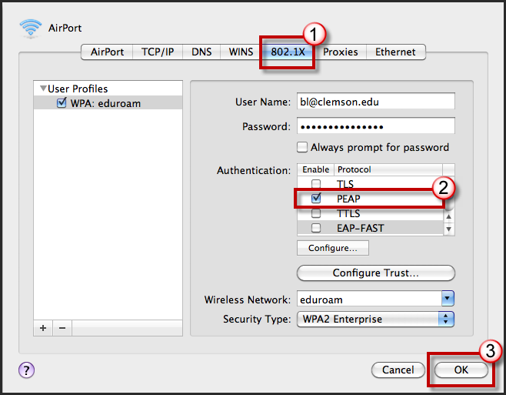
- Uncheck any authentication methods other than PEAP.
- Click OK.
- Then click Apply to save the new Network preferences.

