Windows 7/8 Installer

eduroam

- Launch the eduroam.exe.
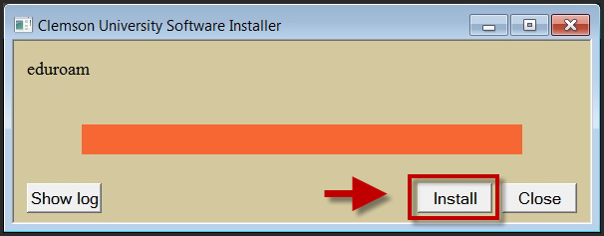
- Click Install.
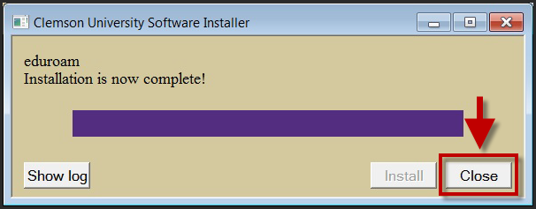
- Click Close.
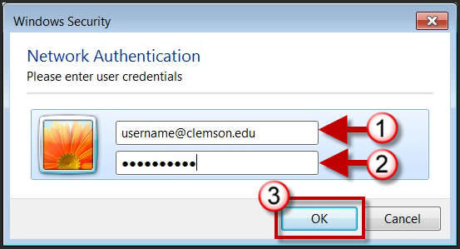
- Login with your username@clemson.edu and password, then click OK.

