Windows RT

eduroam
- Navigate to the Settings menu.
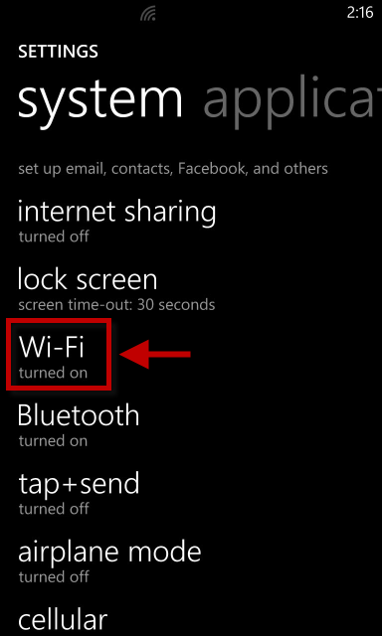
- Tap Wi-Fi.
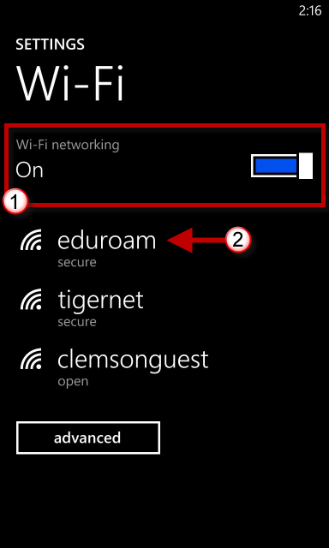
- Slide the button to turn On the Wi-Fi.
- Select eduroam.
- When prompted login to the eduroam network with your username@clemson.edu and password.
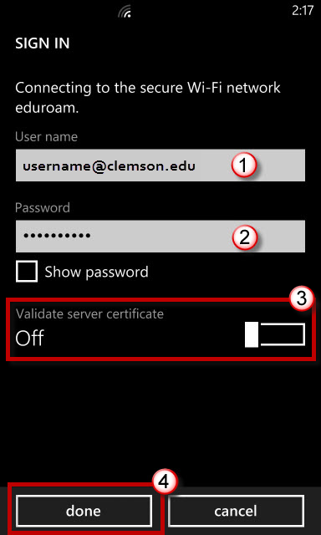
- Slide the button to turn off Validating server certificate.
- Then click done.
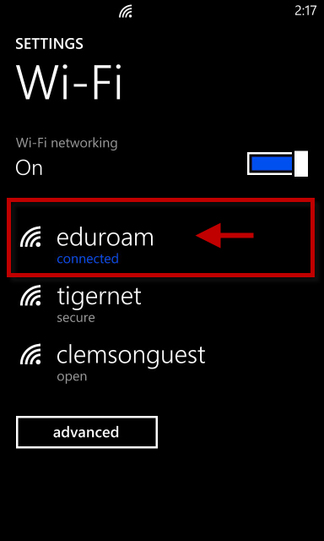
- You are now connected to eduroam.

