Automatic Regrading of a Test Option

Intermediate

Contents
Using Automatic Regrading Option Overview 1
How to use the Automatic Regrading Option 1
Accessing the Test Canvas 1
Editing the Test 2
Deleting a Test Question 2
Updating the Point Value 4
Changing the Point Value on Multiple Questions: 4
Changing the Point Value for Individual Questions: 4
Edit Questions and Change the Correct Answer 6

Using Automatic Regrading Option Overview
Prior to students taking the test, you can add, edit and delete questions in the Test Canvas of the test. After students have started taking the test, you have limited options for altering a test. You will not be able to add questions but you can edit, delete or change the point values of test questions. Once modified, all of the previously taken tests will be regraded.

How to use the Automatic Regrading Option

Accessing the Test Canvas
Access the Test Canvas in one of two ways:
- Control Panel | Course Tools | Tests, Surveys, and Pools | Tests | Click on the Action link (Double Chevron) to the right of the test title | Choose Edit | You are now in the Test Canvas screen
- OR Click on the Menu button where your Content (Tests) can be found | Click on the Action link to the right of the test title | Choose Edit the Test | You are now in the Test Canvas screen

- If students have taken the test, the screen will have additional notes as shown below:
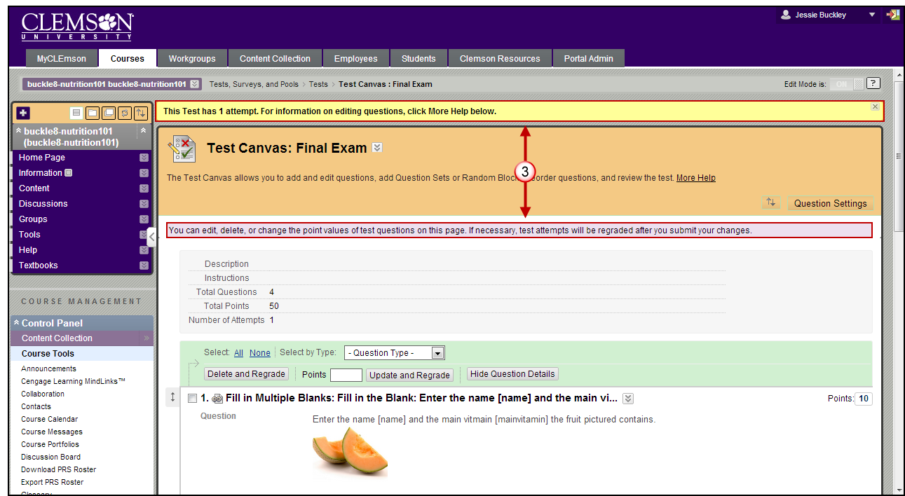

Editing the Test

Deleting a Test Question
Note: If any students are in the process of taking a test, you will not be able to delete questions until they have submitted their work and the test is no longer in progress.
- You have the option to delete a test question as seen in the images that follow. There are two options:
  - Option 1: Click the box to the left of the test question and then click the Delete and Regrade button:
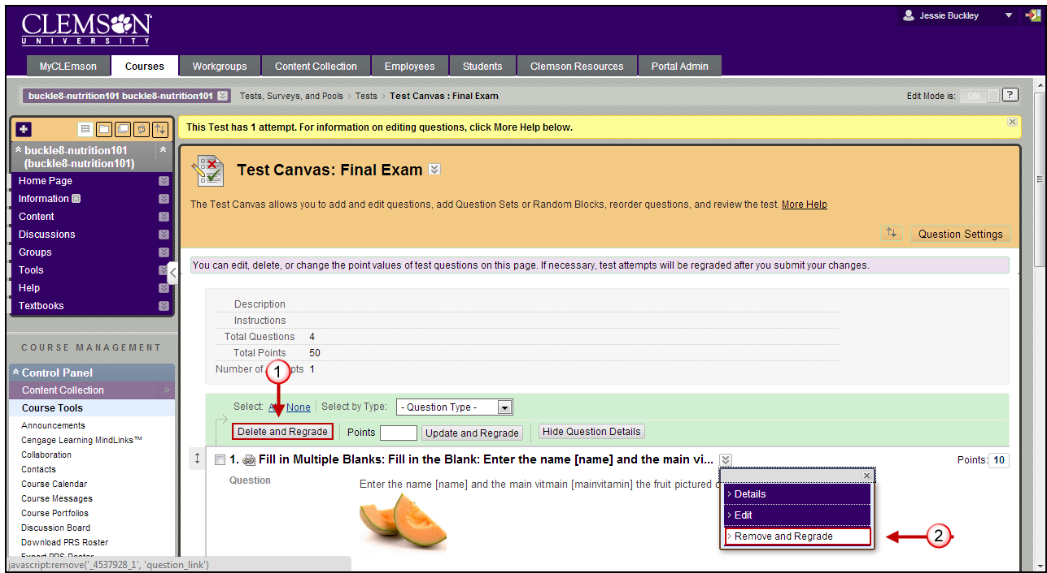
  - Option 2: Click the action link to the right of the question and choose Remove and Regrade

Updating the Point Value
You can change the point value either one question at a time or several questions at a time. Once you make the changes, all existing test attempts will be regraded.

Changing the Point Value on Multiple Questions:
- While in the Test Canvas, select the check box to the left of the questions for all questions you would like to change.
- Locate the Action Bar (as seen below) and type a number in the Points text box.
- Click Update and Regrade and the new point value will be applied.
- You will receive a warning. Press OK to proceed with the changes.

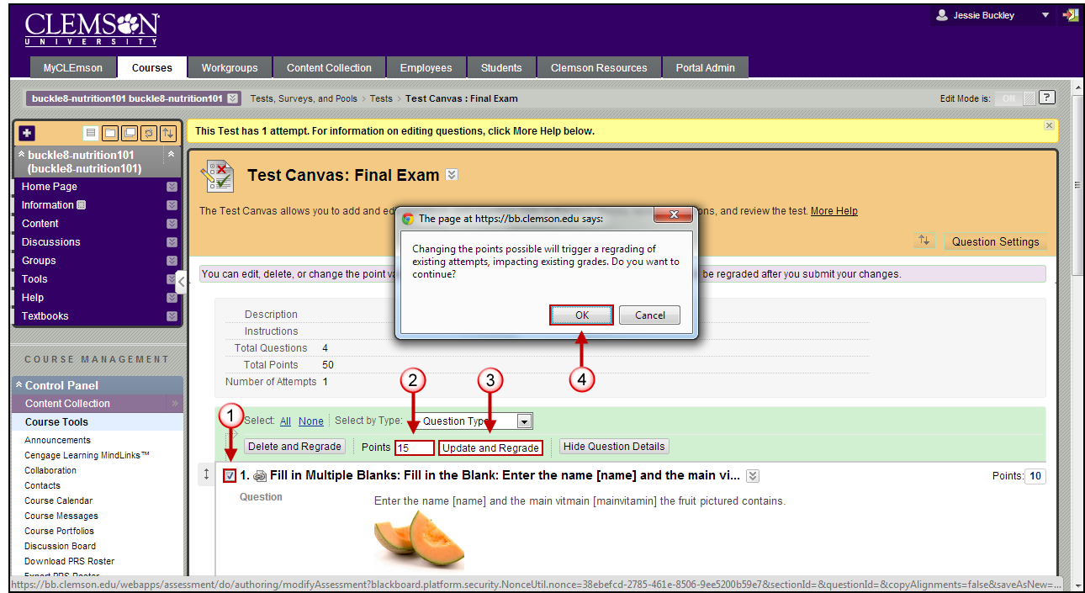

Changing the Point Value for Individual Questions:
- Access the Test Canvas and click on the point value to the right of the question you would like to change.
- The Update Points pop-up will appear. Edit the points and choose to make the question Extra Credit or Full Credit.
- Click Submit and Regrade.
- You will receive a warning. Click OK to proceed with the changes.
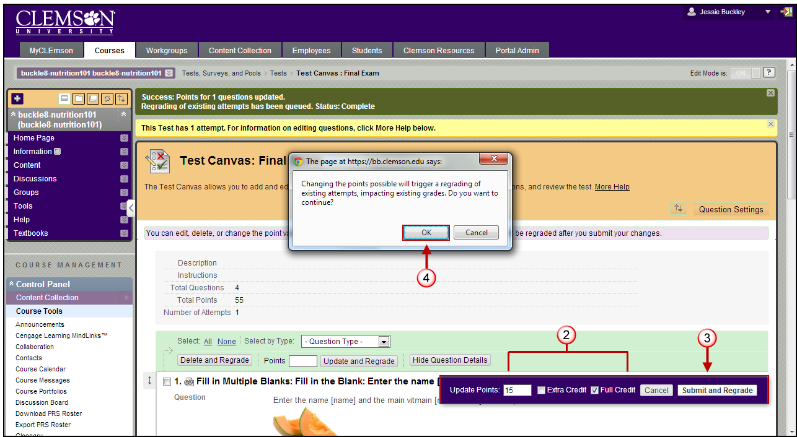
- If the Point Values are updated correctly, you will see a Status Complete message similar to that shown below.
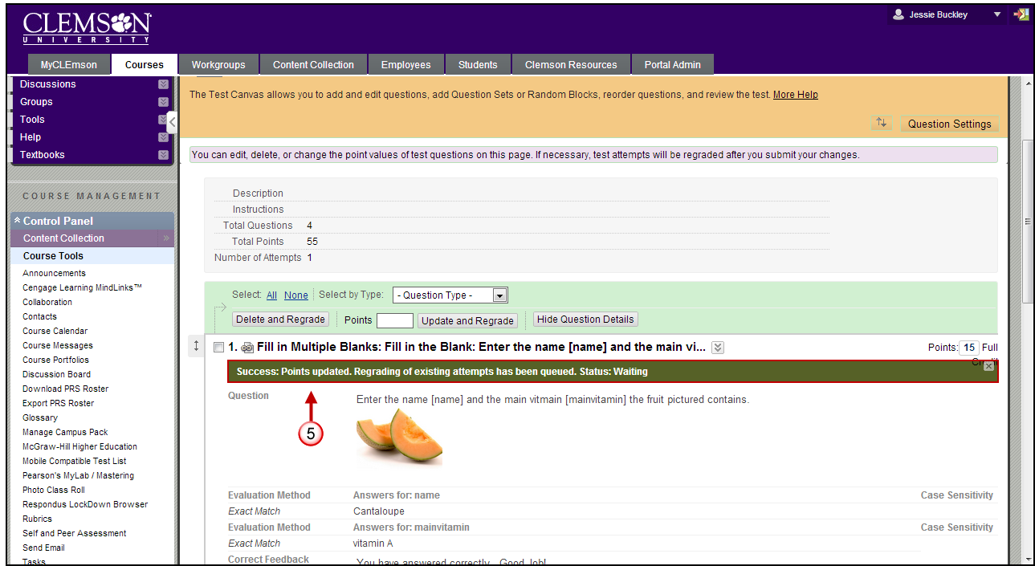

Edit Questions and Change the Correct Answer
You may edit the text within a question at any time without it affecting the submitted attempts. If you change the correct answer for a question, the automatic regrading will be triggered.
- To edit, start in the Test Canvas and click on the Action link to the right of a question. Choose Edit.
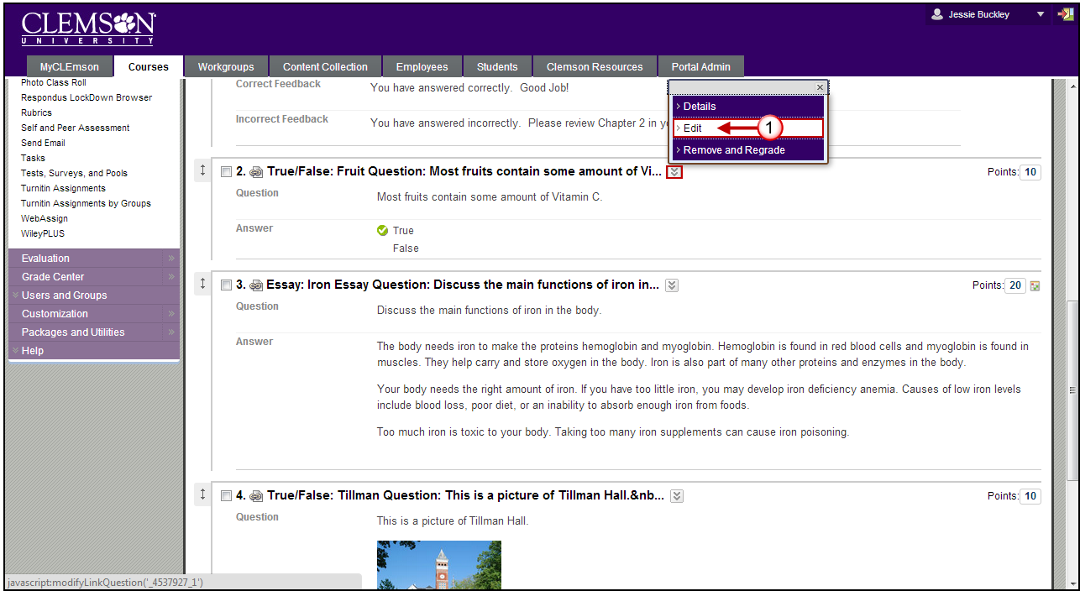
- Make your changes then click Submit and Update Attempts.
