Course Central

Supported Web Browsers & Windows Operating Systems 1
Supported Web Browsers & Mac Operating Systems 1
I. Navigating to Course Central 2
II. Creating a new Blackboard Learn Course from Course Central 3
III. Filtering your Blackboard Learn Course List 4
IV. Linking your Sections to an existing Blackboard Learn Course 5
V. Adding additional Owners to your Blackboard Learn Course 6
Adding Additional Instructors 6
Adding a TA to your Blackboard Learn Course 8
VI. Unlinking your Sections from your Blackboard Learn Course 11
VII. Unlinking multiple Sections from your Blackboard Learn Course 12
VIII. Creating a Mailing List for your Section 12
IX. Deleting Blackboard Learn Courses 13

Course Central is the new tool that you can use to link your courses to Blackboard at the beginning of each semester. This is also the tool you can use to create a Mailing List for your class.

Supported Web Browsers & Windows Operating Systems
Windows OS | Internet Explorer 8 | Internet Explorer 7 | Firefox 3.6x | Firefox 3.5x
Windows XP | Supported | Supported | Supported | Supported
Windows Vista | Supported | Supported | Supported | Supported
Windows 7 | Supported | Supported | Supported | Supported

Supported Web Browsers & Mac Operating Systems
Mac OS | Safari 5.x | Firefox 3.6x | Firefox 3.5x
Mac OSX 10.5 “Leopard” | Supported | Supported | Supported
Mac OSX 10.6 “Snow Leopard” | Supported | Supported | Supported

Please note that there is no longer an Express Setup. All you need to do is create a new Blackboard course for each section and link that section to the new course. In the instructions below, start with section II titled “Creating a new Blackboard Learn Course.” After you create the course, refer to section IV titled “Linking your Sections to your Blackboard Learn Course.” While this process is not as quick as the earlier Express Setup option, it is part of a framework that will give instructors more control over their Blackboard Learn courses.

Navigating to Course Central
Course Central can be accessed by navigating to the following URL: http://central.clemson.edu . Alternatively, it can be accessed through Blackboard Learn.
To navigate to Course Central from within Blackboard Learn:
- Open your web browser and navigate to Blackboard Learn (http://bb.clemson.edu).
- Click the Courses tab.
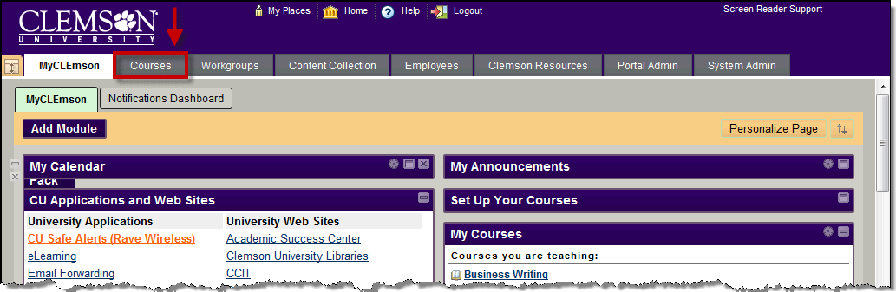
- On the right side of the Courses tab, click the Course Central (Course Setup Tool) link.
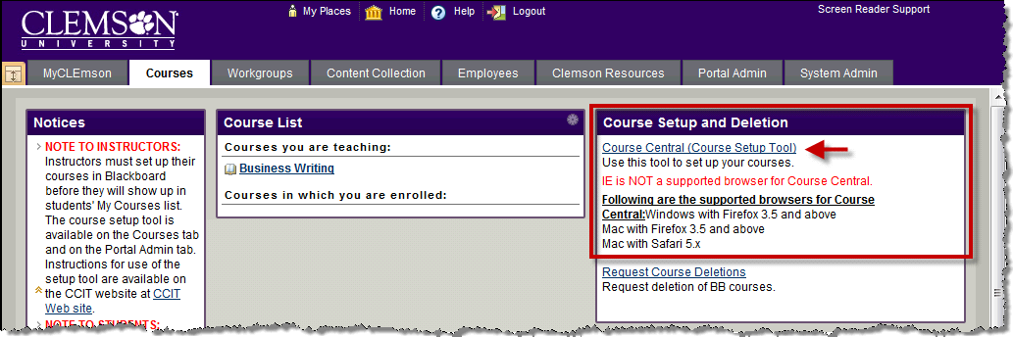
- This will open the Course Central login page in a separate tab or window.
- Enter your network Userid and Password.
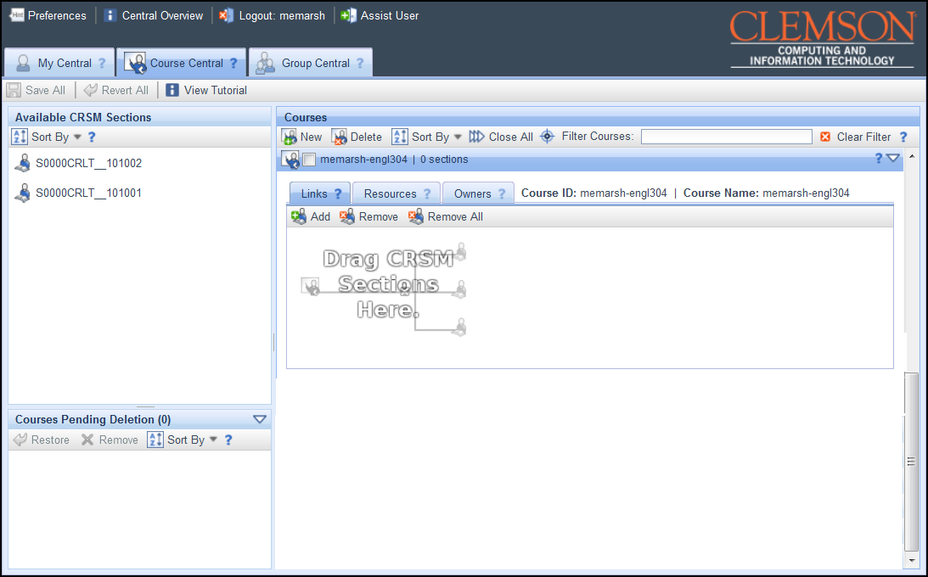
- Course Central will load with the Course Central page displayed.

Creating a new Blackboard Learn Course from Course Central
To create a new Blackboard Learn course from Course Central:
- Click the New button in the Courses area toolbar.
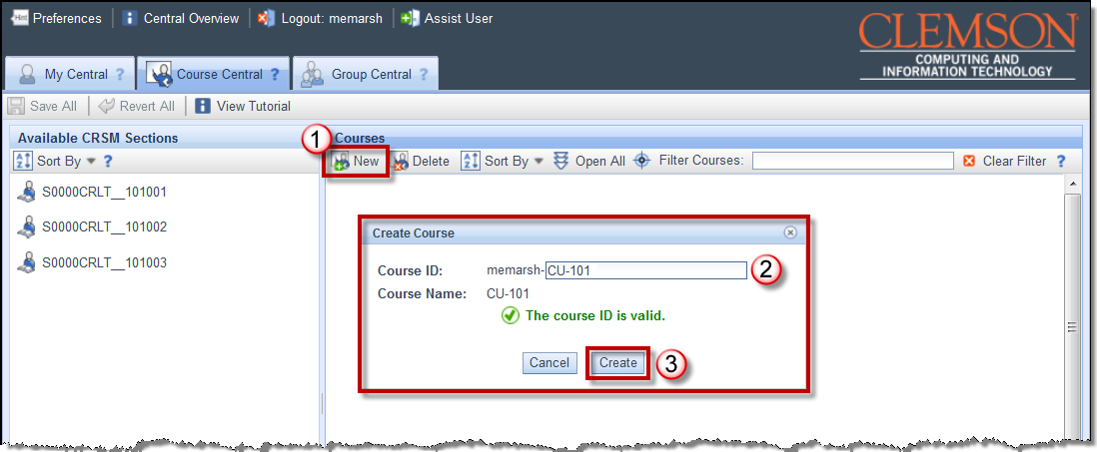
- The Create Course pop-up window will be displayed.
- The beginning prefix of your course will be displayed. For example, if your Userid is MEMARSH, your Course ID will begin with MEMARSH. There is a limit of 24 characters.
- Enter additional course identifiers in the field provided. For example, if your class code is CU101, you could enter CU-101.
- Then click Create.
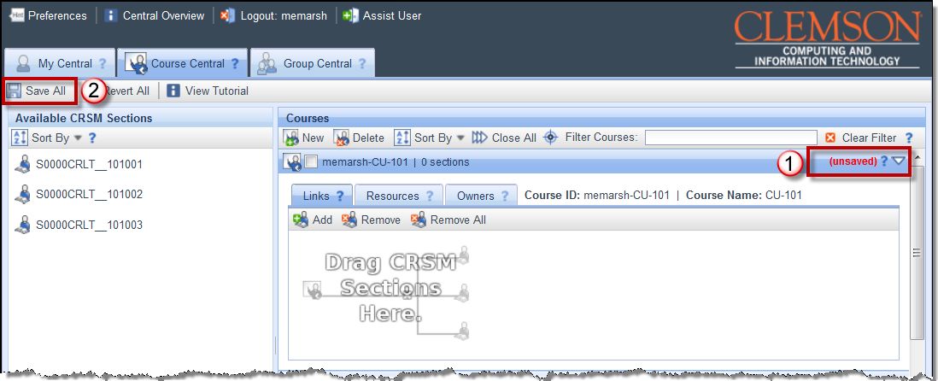
- The new course will be displayed in the Courses area. Notice that on the right side of the course the word (unsaved) is highlighted in red. At this point this course has not been saved.
- To save this new course, click Save All.

Filtering your Blackboard Learn Course List
To filter your Blackboard Learn course list:
- In the Courses area, enter criteria to filter your list of Blackboard Learn courses. The criteria are case sensitive. For example, I will get different results for the filter criteria “DE” than I will for “de”.
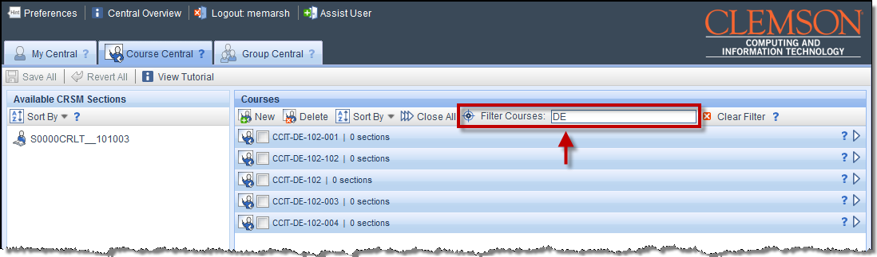
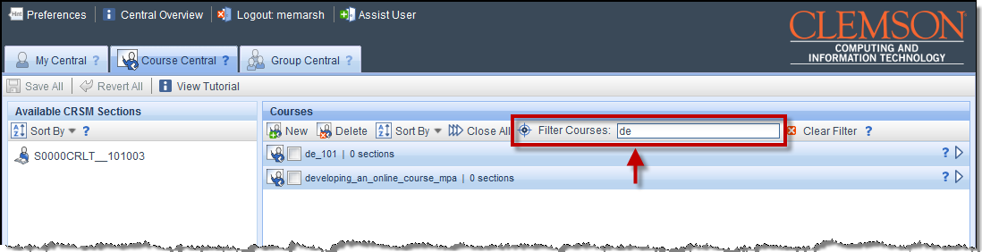
- As you type, the system will automatically begin filtering your Blackboard Learn course list.
- To remove the filter criteria and return to the full list of your Blackboard Learn courses, click the Clear Filter button.

Linking your Sections to an existing Blackboard Learn Course
To link your Sections to your Blackboard Learn course from Course Central:
- In the Courses area, locate the Blackboard Learn Course to link your Course Roster.
- Click the triangle at the right to expand the course.
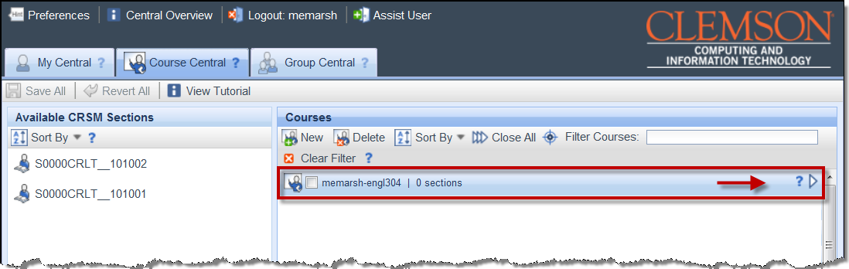
- Next, locate the Sections to link to the selected Blackboard Learn course in the Available Sections area
- Drag and drop the Sections to link to the Links tab of the selected Blackboard Learn course. Alternatively, you can click the Add button () to select multiple sections to link.
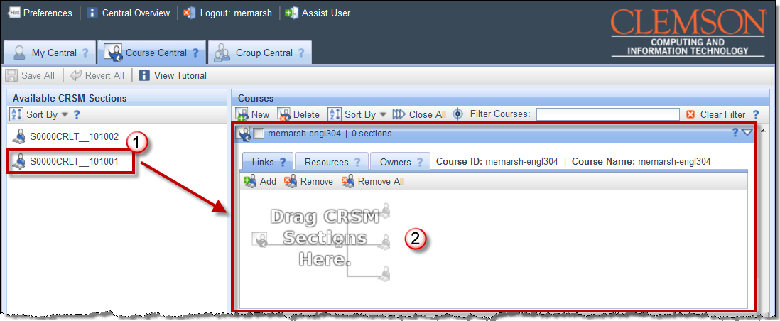
- The section is displayed on the Links tab of the Blackboard Learn course. Notice that on the right side of the Blackboard Learn course the words (unsaved) are highlighted in red. At this point this course has not been saved.
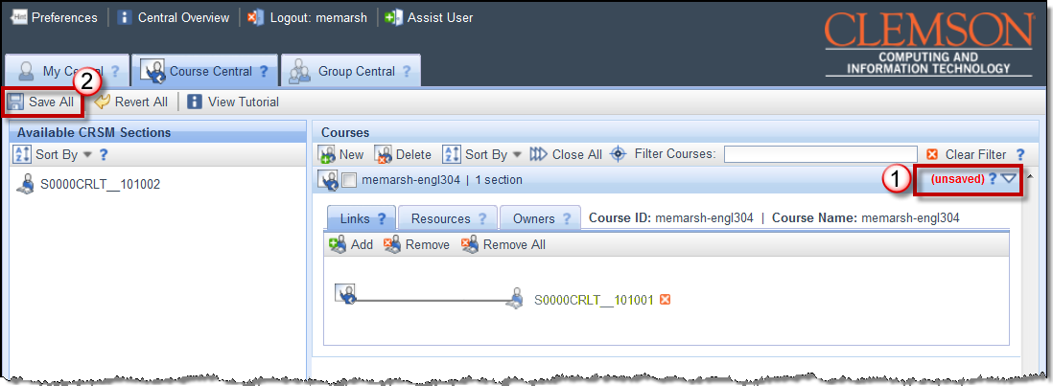
- To save this link, click Save All.
- Open your web browser and navigate to Blackboard Learn. Check the Photo Class roll under Course Tools, the Grade Center, or Users under the Users and Groups section of the Control Panel to ensure that your students have been populated.
Note: If the students don’t show up in one of the sections mentioned above, wait a few minutes and then check again. If they don’t show up within a couple of hours contact ITHELP@clemson.edu.

Adding additional Owners to your Blackboard Learn Course
Note: Adding additional owners (Instructors & TA’s) to your Blackboard Learn Course only gives them access to Blackboard. If they need to have access to enter grades into Web, or to modify or deploy the Student Assessment of Instructors then they need to be added from the mainframe.

Adding Additional Instructors
To add an additional instructor to your Blackboard Learn course:
- In the Courses area, locate the Blackboard Learn Course to add an additional instructor.
- Click the triangle at the right to expand the course.
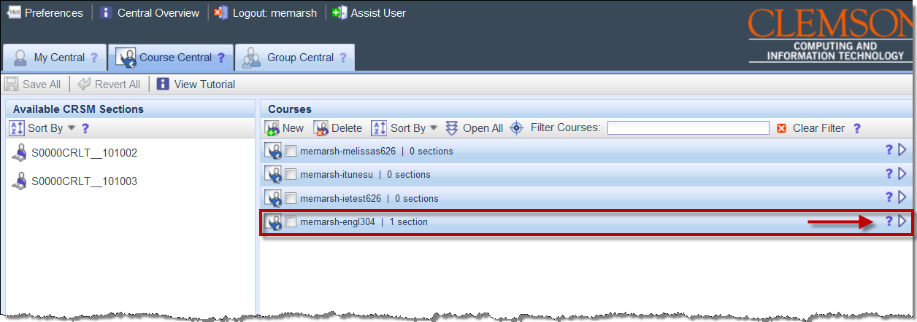
- Next, click the Owners tab.
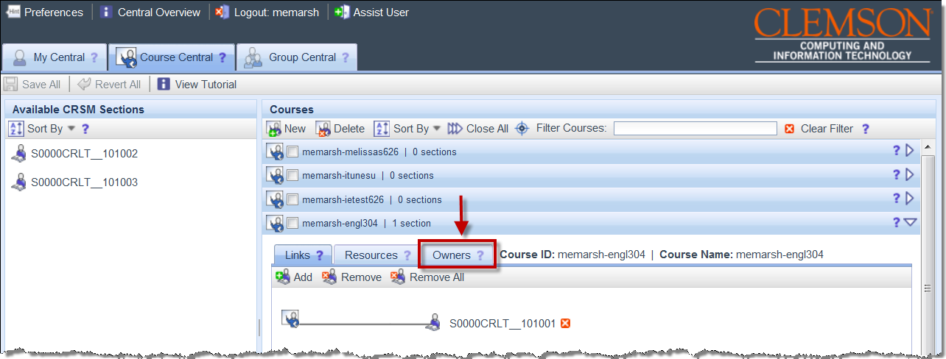
- In the field provided, enter the user ID for the additional instructor.
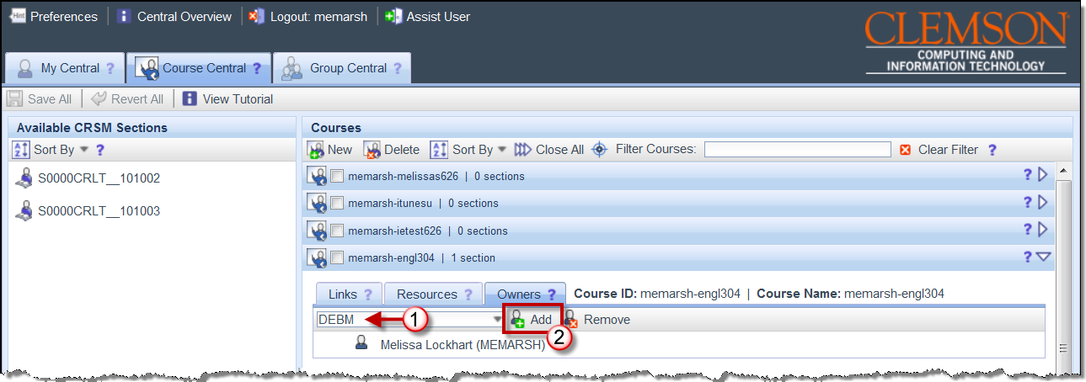
- Then click Add.
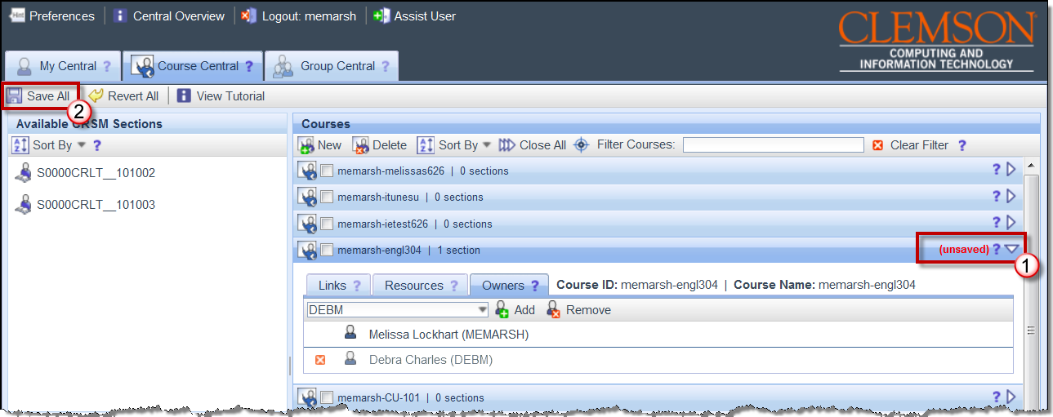
- The new instructor will be displayed in the Owners area. Notice that on the right side of the course the word (unsaved) is highlighted in red. At this point the addition of the new instructor has not been saved.
- To save this new instructor, click Save All.

Adding a TA to your Blackboard Learn Course
- In the Courses area, locate the Blackboard Learn Course to add an additional instructor.
- Click the triangle at the right to expand the course.
- Next, click the Owners tab.
- In the field provided, enter the user ID for the TA.
Note: The TA’s employee ID should be used, not their student ID.
- Then click Add.
- The new instructor will be displayed in the Owners area. Notice that on the right side of the course the word (unsaved) is highlighted in red. At this point the addition of the new instructor has not been saved.
- To save this new instructor, click Save All.
- Next, open your web browser and login to Blackboard.
- Navigate to your Blackboard Learn course.
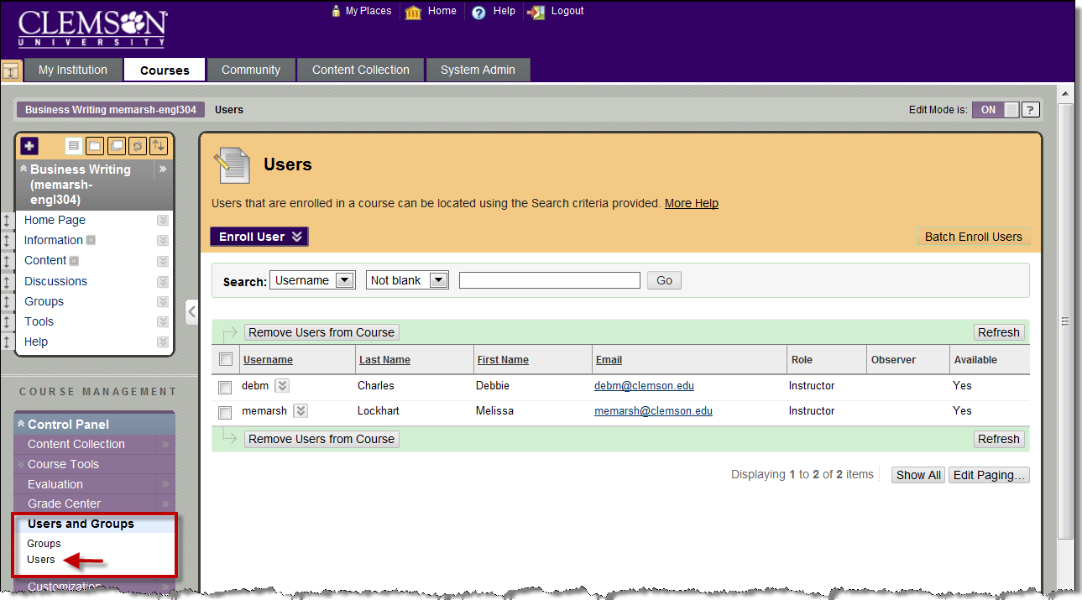
- From the Control Panel, click the chevron to expand Users and Groups.
- Then click the Users link.
- The Users page is displayed.
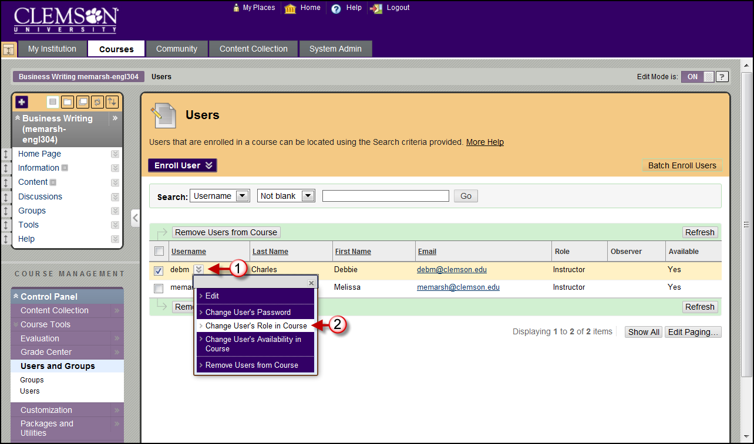
- Click the chevron to the right of the Username.
- Then select Change User’s Role in Course.
- The Change User’s Role in Course page is displayed.
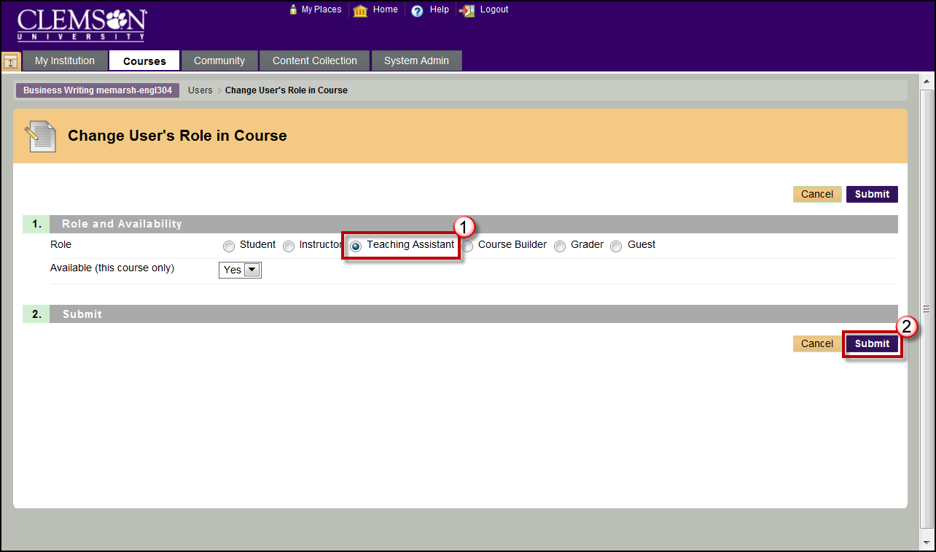
- Select the Teaching Assistant radio button.
- Then click Submit.
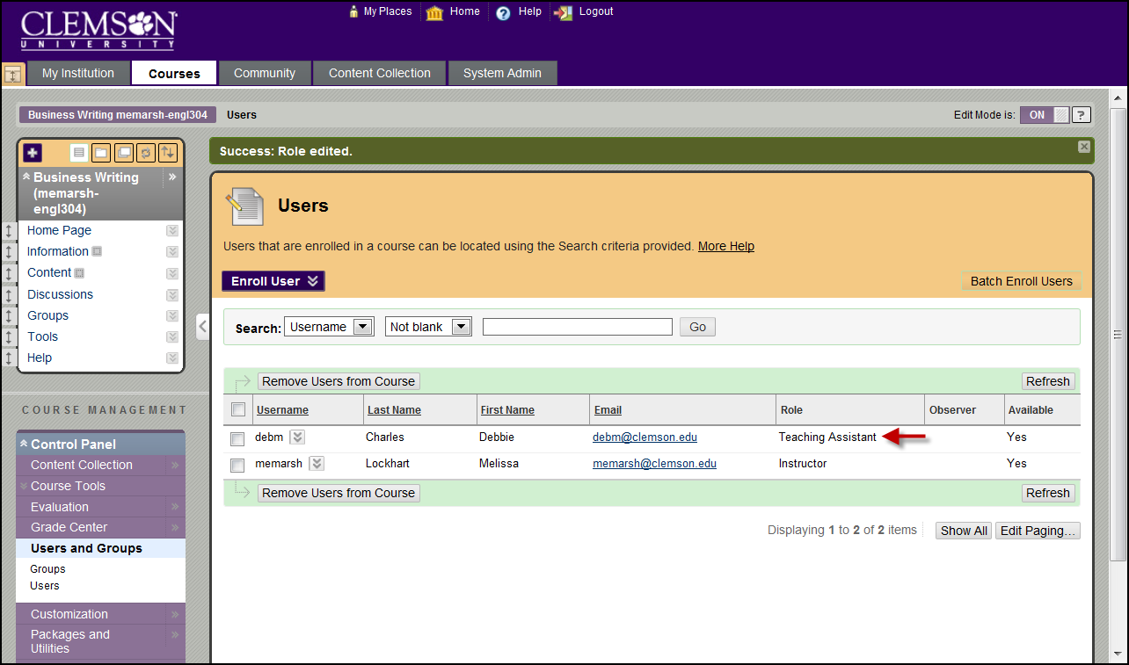
- The User’s page is displayed with the updated role.

Unlinking your Sections from your Blackboard Learn Course
To unlink a Section from your Blackboard Learn Course from Course Central:
- Click the Remove button () at the end of the Sections identifier.
- Alternatively, you can select the Sections identifier that is on the Links tab of the Blackboard Learn Course.
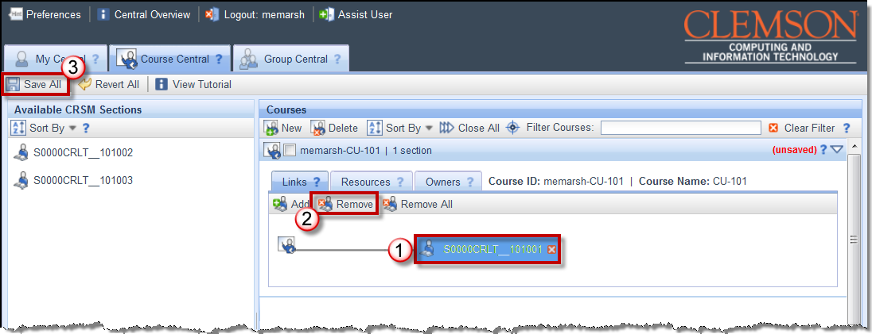
- Then click the Remove button.
- Then click Save All.

Unlinking multiple Sections from your Blackboard Learn Course
To unlink multiple Sections from your Blackboard Learn Course from Course Central:
- Click the Remove All button () at the beginning of the group of the Section identifiers.
- Alternatively you can press Shift and click to select the Section identifiers that are on the Links tab of the Blackboard Learn Course.
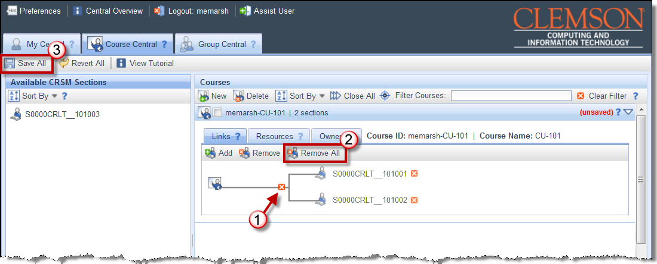
- Then click the Remove All button.
- Then click Save All.

Creating a Mailing List for your Section
To create an email distribution list for your section:
- In the Courses area, locate the Blackboard Learn Course that your Sections are linked to.
- Click the triangle at the right to expand the course.
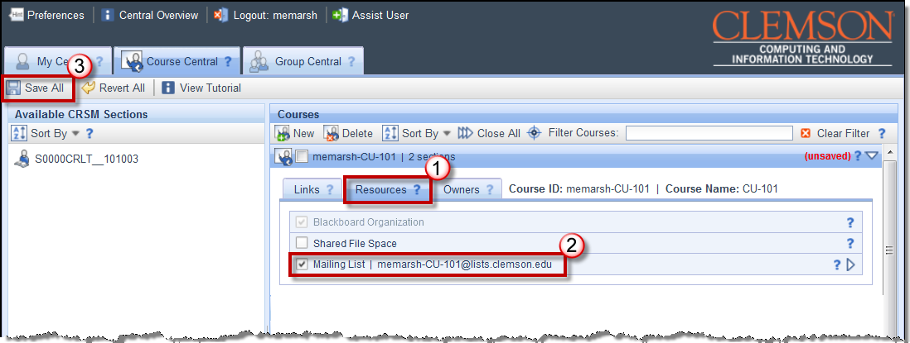
- Click the Resources tab for the selected Blackboard Learn course.
- Select the Mailing List checkbox.
- Then click Save All.
- Next click the My Central tab.
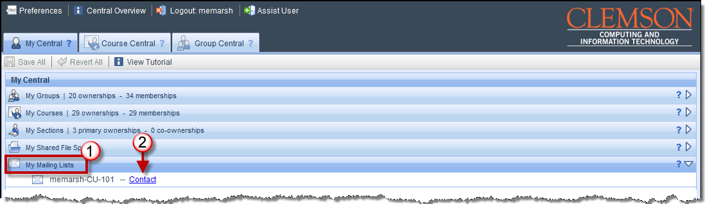
- Click My Mailing Lists to expand and view mailing lists that have been setup for your courses.
- Find the course that you want to email.
- If you have an email client setup on your computer, click the Contact link to email the members of the course distribution list.
- If you are using a web email client, right-click the Contact link at the end of the Blackboard Learn course identifier and select Copy Email Address. Open your web email client and use CTRL + V to paste the course distribution email address in the To: field.
- Then enter your email message and press Send.

Deleting Blackboard Learn Courses
To delete a Blackboard Learn course:
- In the Courses area, select the Blackboard Learn courses to delete.
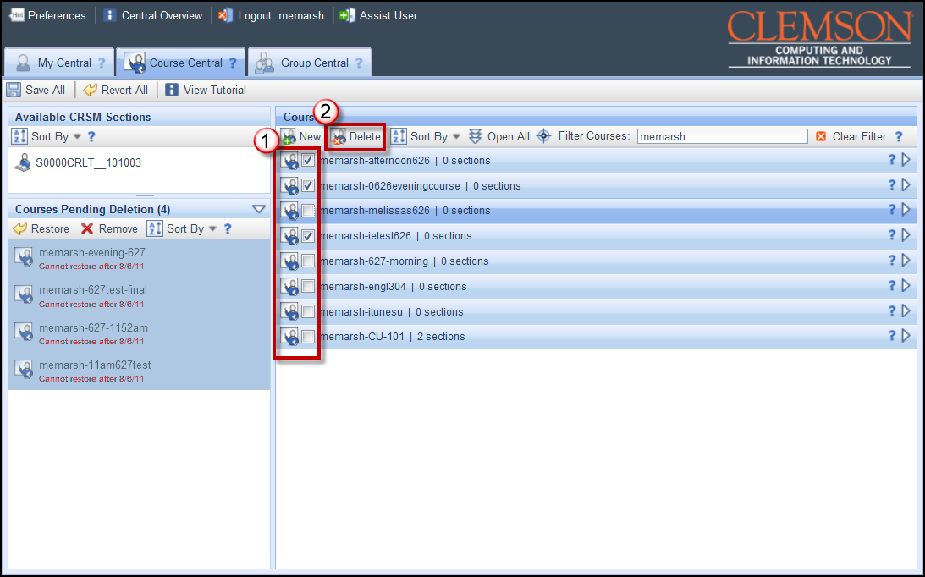
- Then click the Delete button in the Courses area toolbar.
- If you are the only instructor for the selected Blackboard Learn course, you will see the What do you want to do? pop-up window. This window allows you to either reassign the Blackboard Learn course to an alternate instructor, or to trash the course.
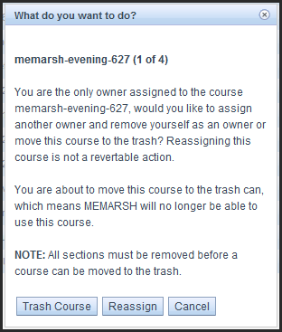
- Click Trash Course to delete this Blackboard Learn course.
- Click Reassign to assign another owner to the Blackboard Learn course and remove yourself as an owner. When you select this option a field will be displayed to enter a User ID for the new course owner.

- If you are not the only instructor for the selected Blackboard Learn course, you will see a different What do you want to do? pop-up window. This window allow you to remove yourself as the owner of the course, or to trash the course.
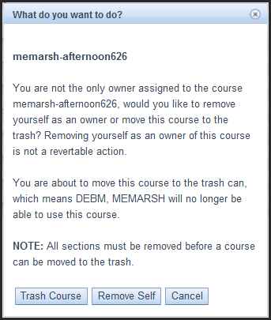
- Click Trash Course to delete this Blackboard Learn course.
- Click Remove Self to remove yourself as an owner of this course.
- If you click Trash Course, the system will move the course to the Course Pending Deletion area.
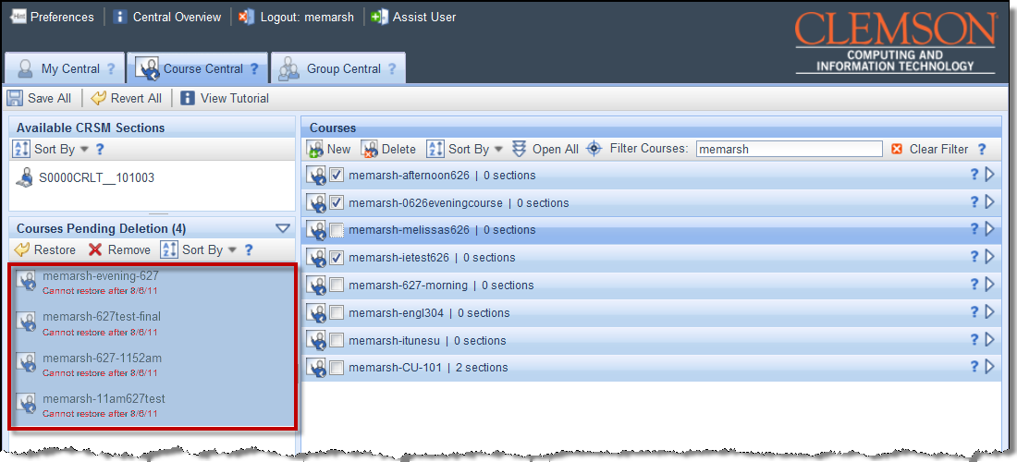
- If you have accidentally deleted a Blackboard Learn course, it can still be restored if it is in the Courses Pending Deletion area. There is a date below each course that indicates the last day the course can be restored.
- To permanently remove a Blackboard Learn course from the system, you can select the course in the Courses Pending Deletion area. Then click Remove.

- The system will display the What do you want to do? pop-up window again. This time the options will be to delete or reassign the course.
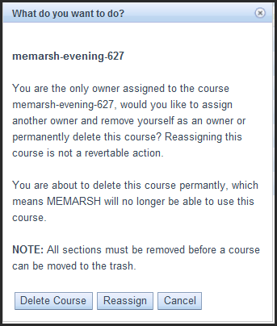
- Once you click Delete Course the Blackboard Learn course is deleted permanently.
- To save the changes you have made, click Save All.

