Creating Assessments

Blackboard Beginners

Build a Test 1
Modifying Test Creation Settings 5
Adding Essay Questions to a Test 7
Add Multiple Choice Questions to a Test 12
Add True/False Questions to a Test 18
Add Matching Questions 21
Add Fill-in Multiple Blank Questions 26
Select Questions from a Question Pool or Assessment 32

Build a Test
- Login to Blackboard Learn.
- Click the Courses tab.
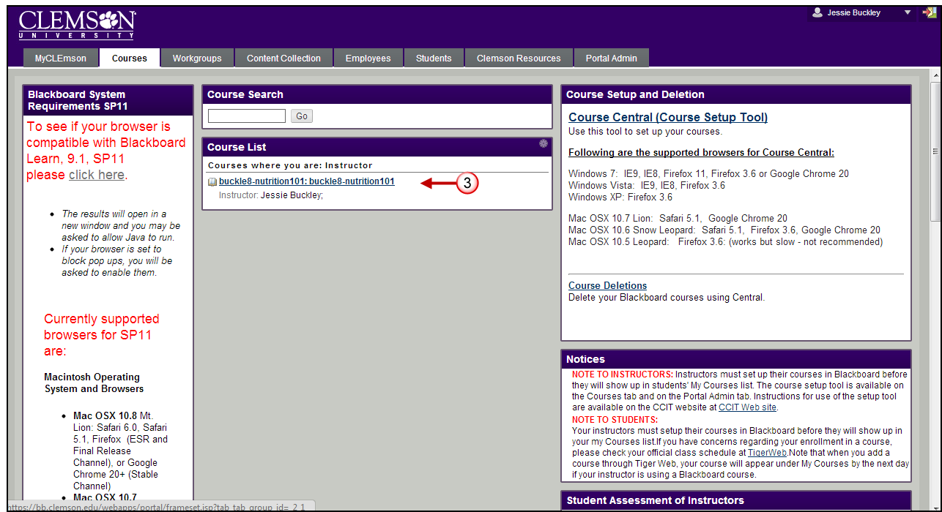
- Click the course to open from the Course List module.
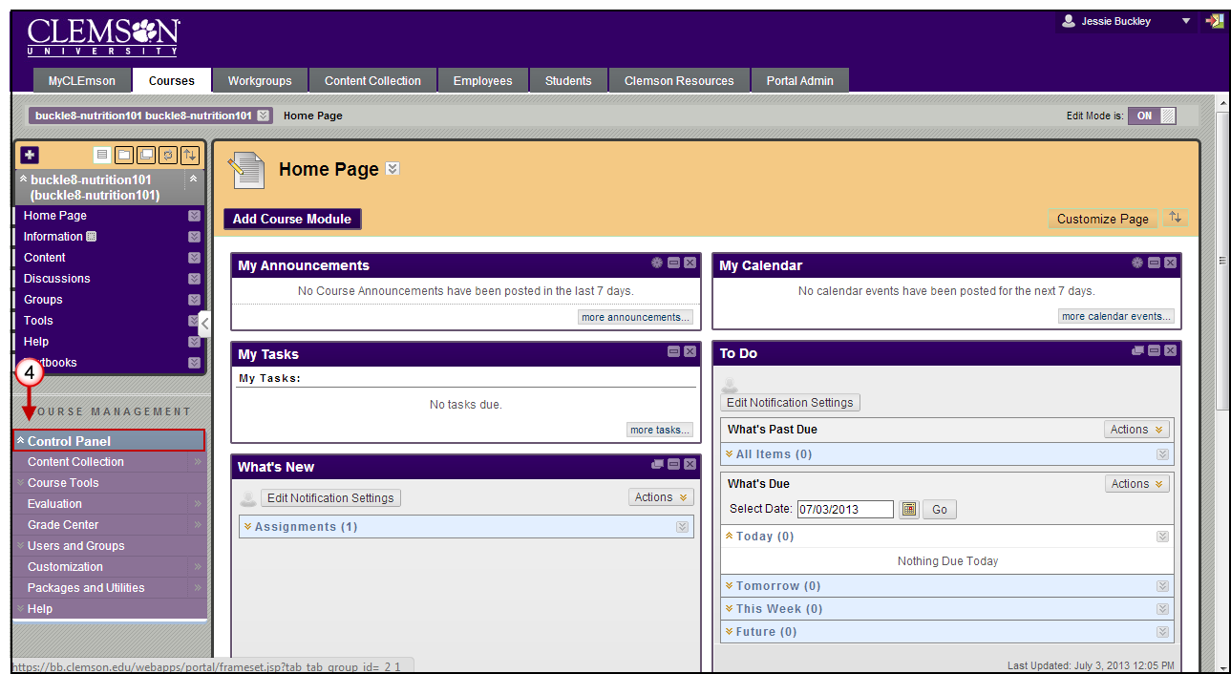
- The course Home Page is displayed. Click the chevron to expand the Control Panel.
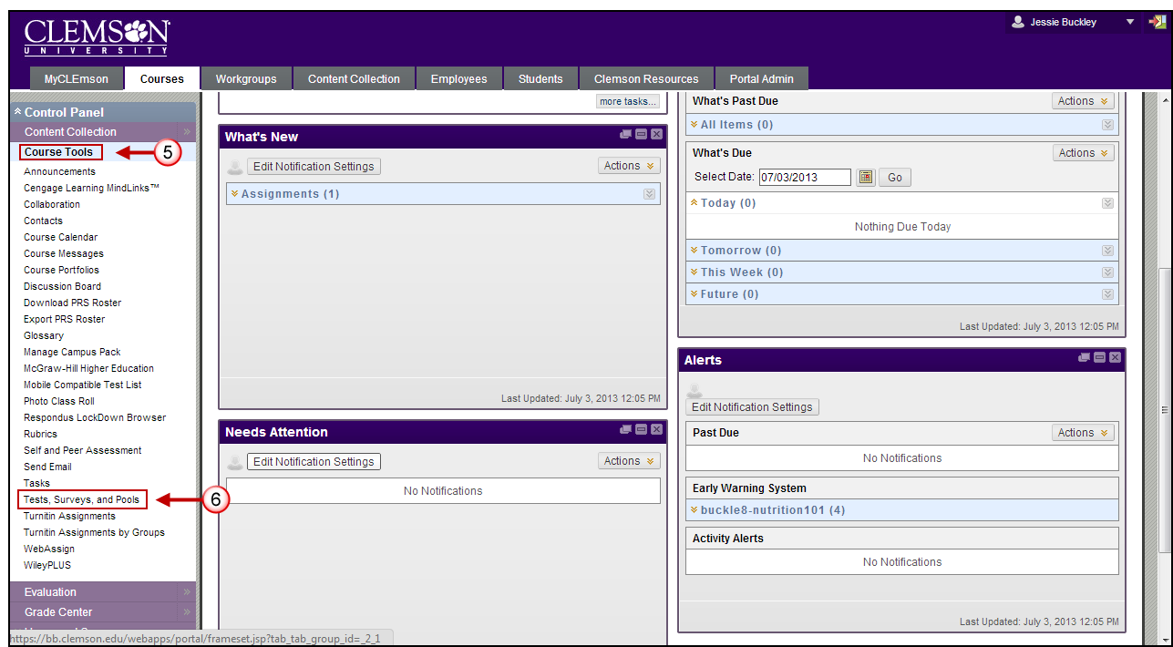
- From the Control Panel, click the chevron to expand Course Tools.
- Then click Tests, Surveys and Pools.
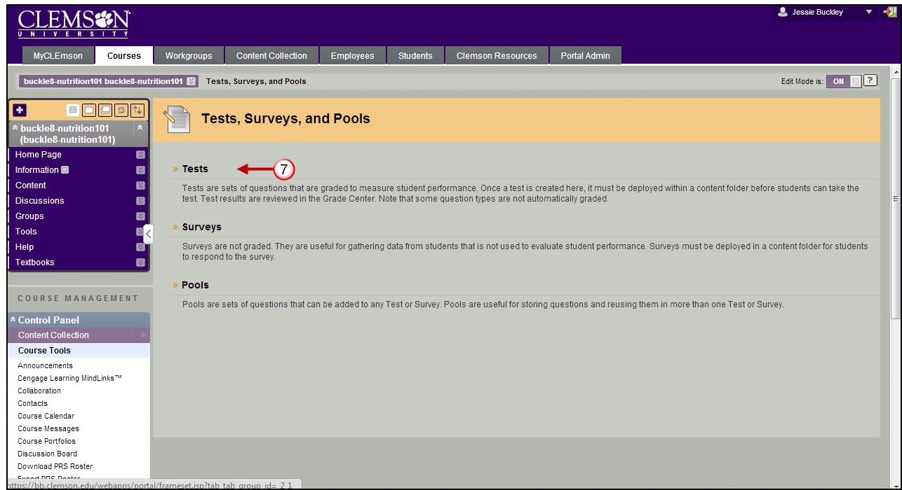
- The Tests, Surveys, and Pools page is displayed. Click Tests.
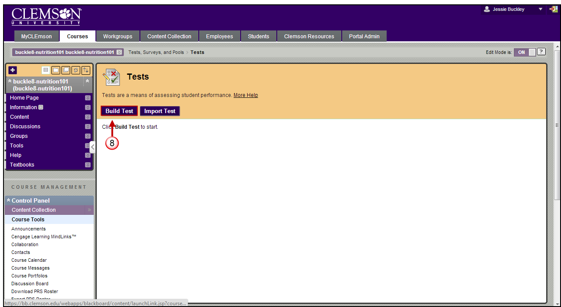
- The Tests page is displayed. Click Build Test.
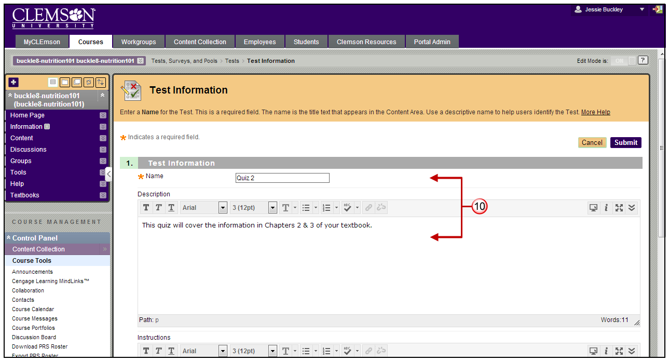
- The Test Information page is displayed.
- Enter a Name and Description for the test or quiz.
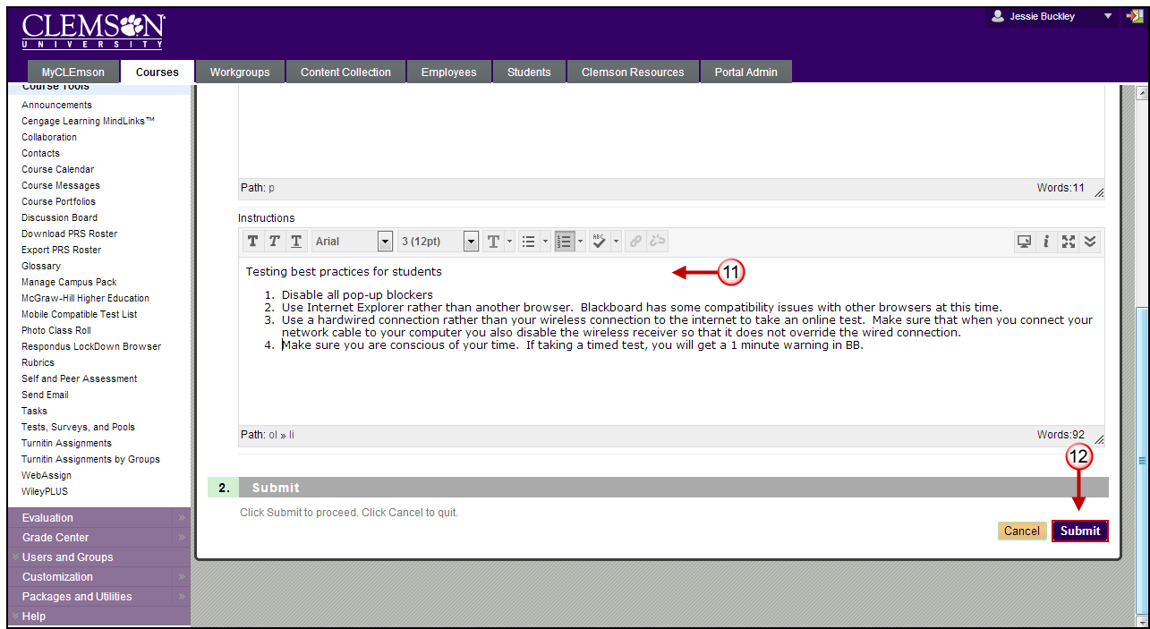
- Enter Instructions for the students. These instructions should include some of the Testing Best Practices for Students that are included in the Testing Best Practices document on the Blackboard Learn page. Recommended browsers can be found in the Testing Best Practices document as well as the Blackboard Learn login page. In the case that you require students to use the Respondus Lock Down Browser, you should provide students with the URL to the Respondus Lock Down Browser page.
- Then click Submit.

Modifying Test Creation Settings
To modify the test creation settings for the selected test from the Test Canvas page:
- Click the Question Settings button.
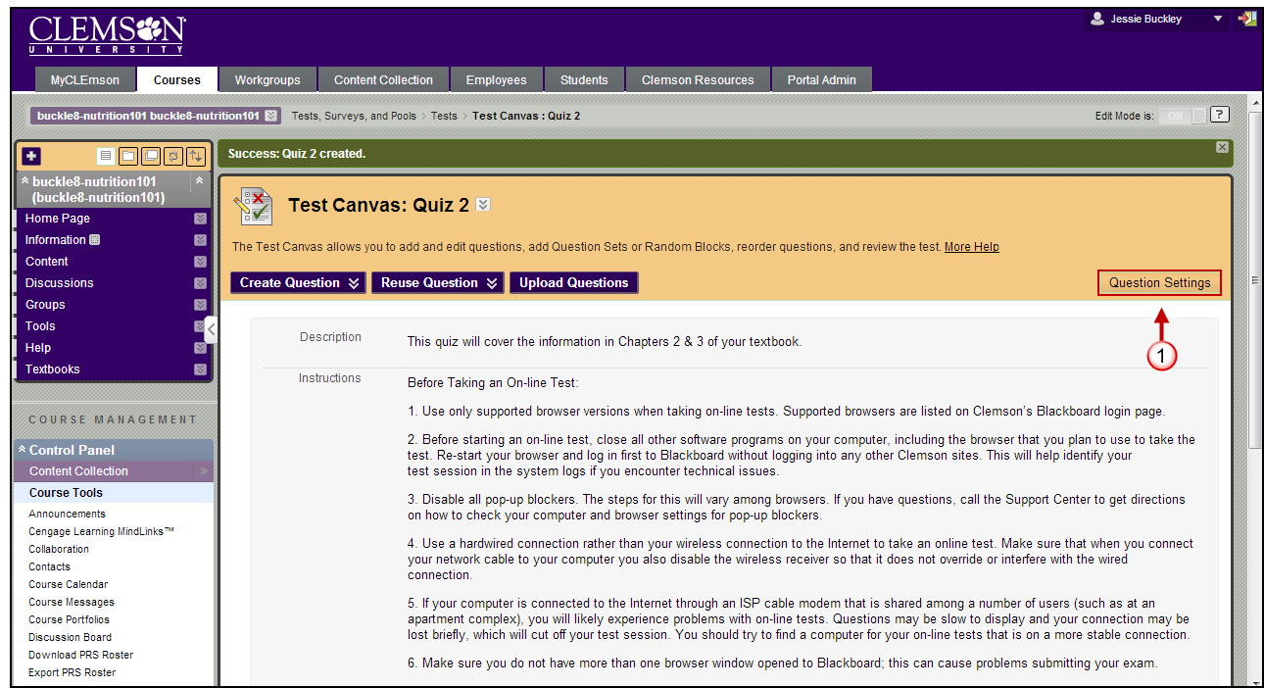
- The system displays the Test Creation Settings page.
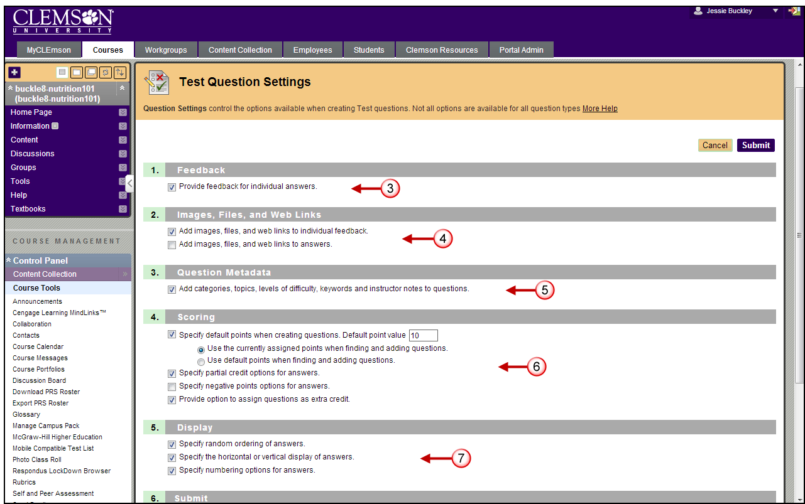
- Enable the checkbox in the Feedback section to include the option to enter feedback for individual answers in the test rather than just one set of feedback for correct or incorrect answers.
Note: Please note that individual feedback cannot be provided for answers in True/False, Multiple Answer, Ordering or Matching questions.
- Blackboard allows you to attach images, files and external links to questions and answers. Enable the first checkbox in the Images, Files and External Links section to allow this feature for questions. Enable the second checkbox to allow this feature for answers.
- Enable the checkbox in the Question Metadata section if you want to include the option to create categories and keywords for questions. This feature is used when searching for questions for a Question Pool.
- If you want to create a default point value for each question in the test, enable the first checkbox in the Scoring section. Then specify the default point value.
Note: You must set the Default Point Value before creating questions for it to be effective. If the default point value is changed, only questions created after it is modified will have the new point value. Questions created before the modification will have the old point value. For example, set the Default Point Value to 10 then create questions in the Assessment. These questions will have a point value of 10. Next, change the Default Point Value to 15, and create additional questions in the Assessment. These new questions will have a point value of 15, but the questions created initially will still have a point value of ten.
- If you want to accept partial credit for answers, enable the second checkbox in the Scoring section.
Note: Partial Credit is only available for the following question types: Calculated Formula, Fill in Multiple Blanks, Jumbled Sentence, Matching, Multiple Answer, Multiple Choice, Opinion Scale/Likert, Ordering, and Quiz Bowl.
- If you want to be able to select a question on the test for extra credit, then enable the checkbox to Provide the option to assign questions as extra credit.
- If you want the answers for the questions to be randomly ordered, enable the first checkbox in the Display section.
- Enable the second checkbox in the Display section if you want to be able to select the orientation of the answer. Please note that answer orientation is only available for the following question types: Either/Or, Multiple Answer, Multiple Choice, Opinion Scale/Likert, and True/False.
- Enable the third checkbox in the Display section if you want to be able to specify your numbering options for answers. Please note that this option is only available for the following question types: Matching, Multiple Answer, Multiple Choice, Opinion Scale/Likert, and Ordering.
- Click Submit to accept modified Test Question Settings.

Adding Essay Questions to a Test
To add Essay questions to a test from the Test Canvas page:
- Hover your mouse over the Create Question action link and select Essay.
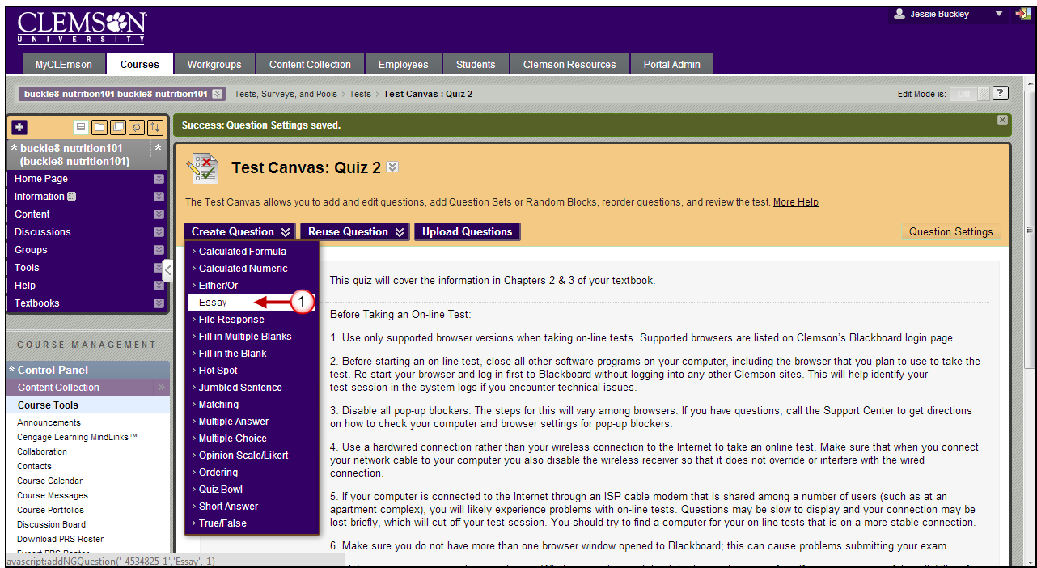
- The system displays the Create/Edit Essay Question page.
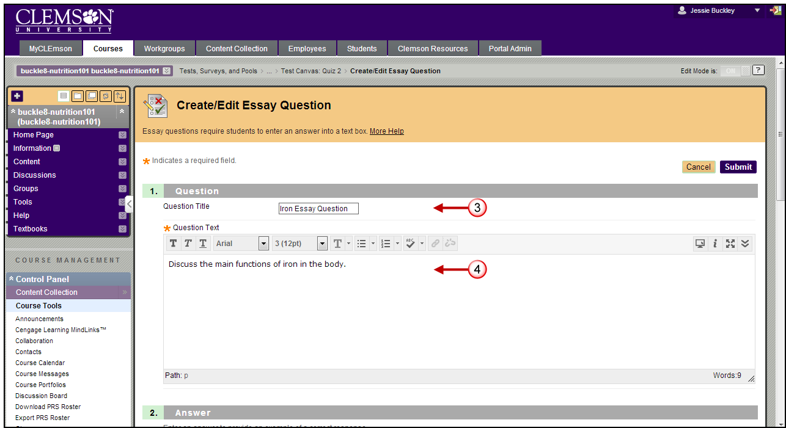
- Enter a Question Title for the question.
- Enter the Question in the Question Text field.
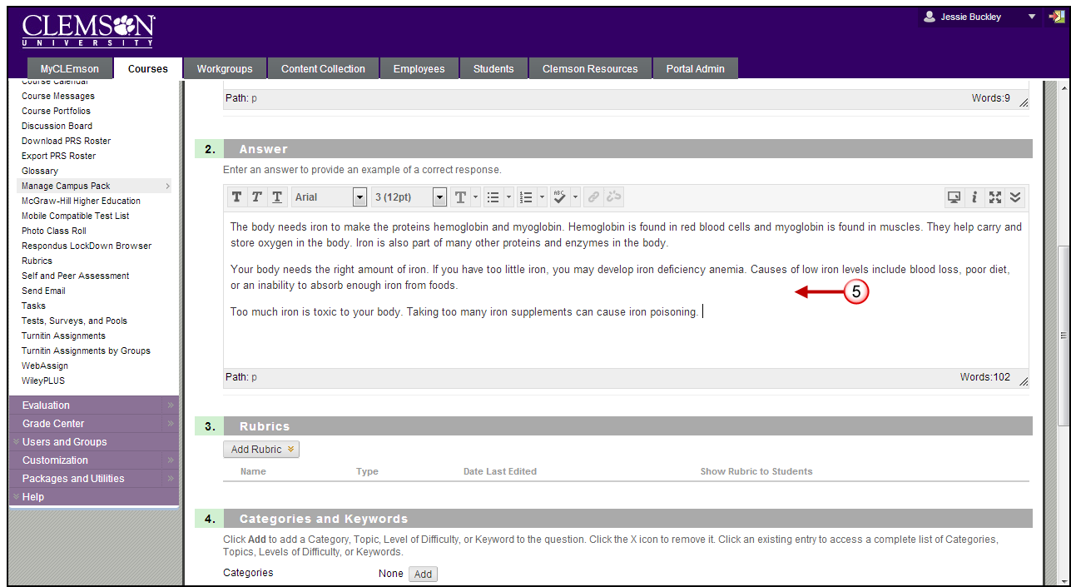
- Next, enter an example answer in the Answer field.
Note: Review the document titled Rubrics: Use while Grading for additional information regarding linking rubrics to test questions.
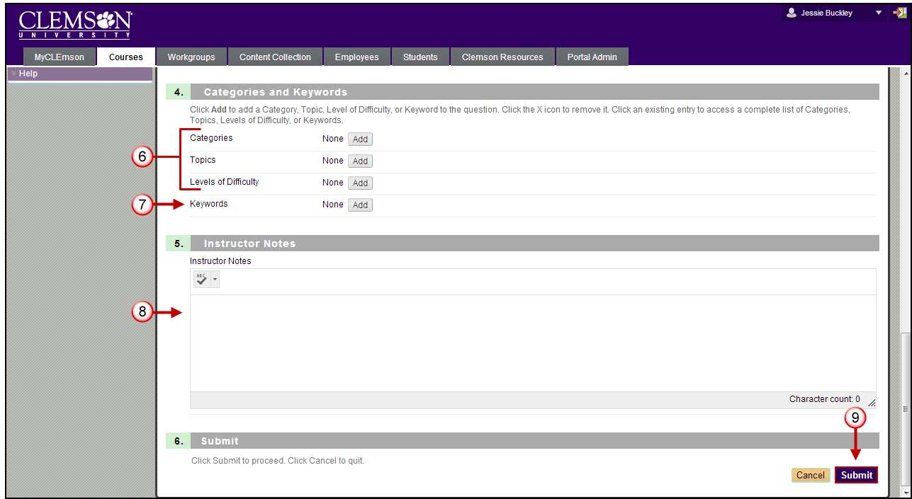
- Click Add to select Categories, Topics, and Level of Difficulty.
Note: Categories, Level of Difficulty and Topics are optional. These fields allow for better filtering of test questions when using Pools.
- Click Add to enter any Keywords for the selected question. This feature can be used to create a bank of test questions.
- Enter Instructor Notes.
- Click Submit.
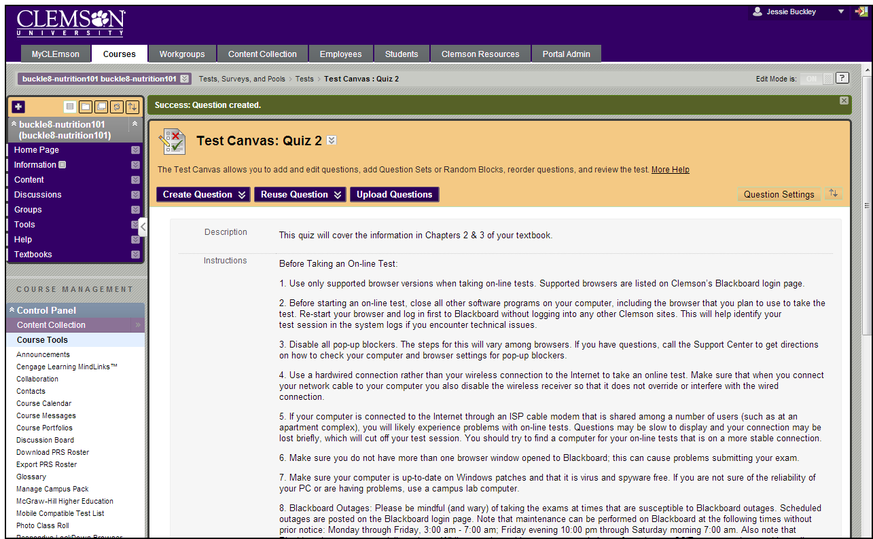
- The system saves the question and displays the Test Canvas page with the new question.

Organizing the Test Canvas
- Hover over the (arrow icon) to the left of the question item to reorder.
- Then drag and drop the item to the desired location in the test.
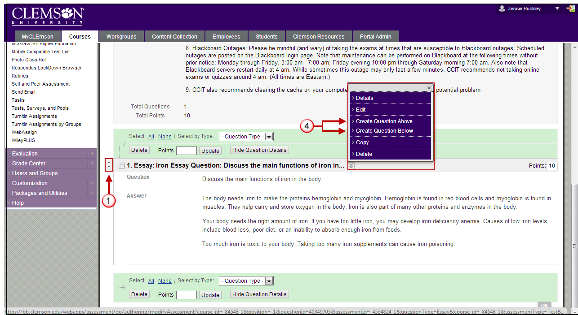
- Create additional questions for the test by selecting the type of question from the Create Question action link and selecting the question type.
- Alternatively you can click the action link to the right of the Question Title. Then select Create Question Above or Create Question Below to create a question above or below the selected question. This allows you to put the question in where it is needed instead of reorganizing them later.

Modifying Test Question Point Value
- To change the point value for one question, click the Point value.
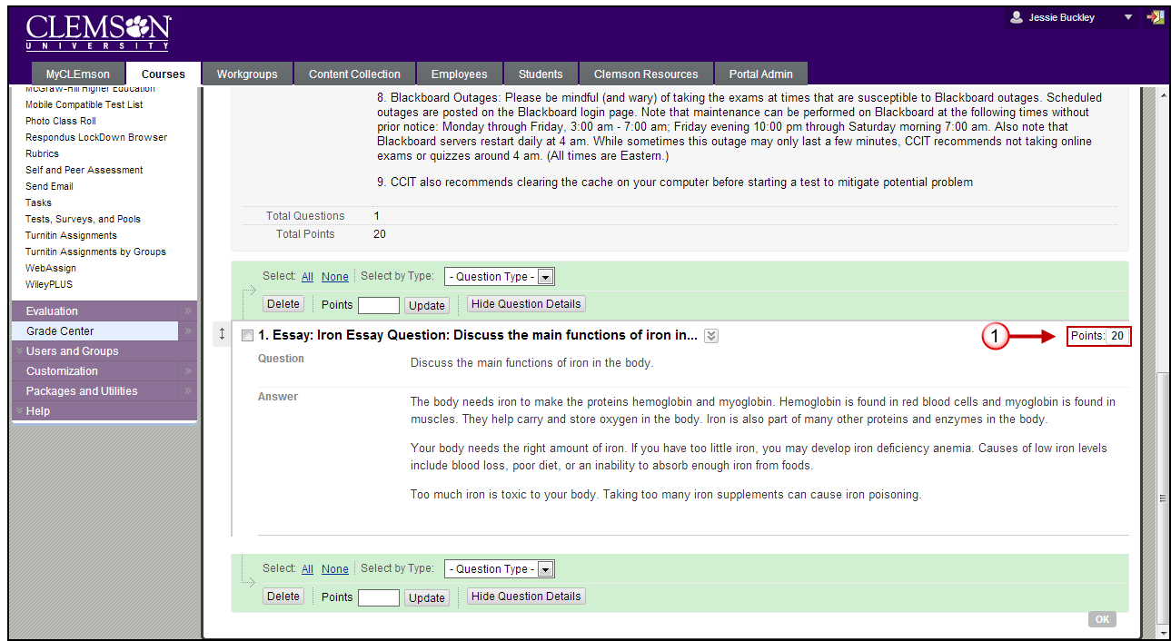
- A pop-up window will be displayed. Enter the new Point value in the Update Points field. Select the checkbox to indicate whether the selected question is an Extra Credit question. Then click Submit.
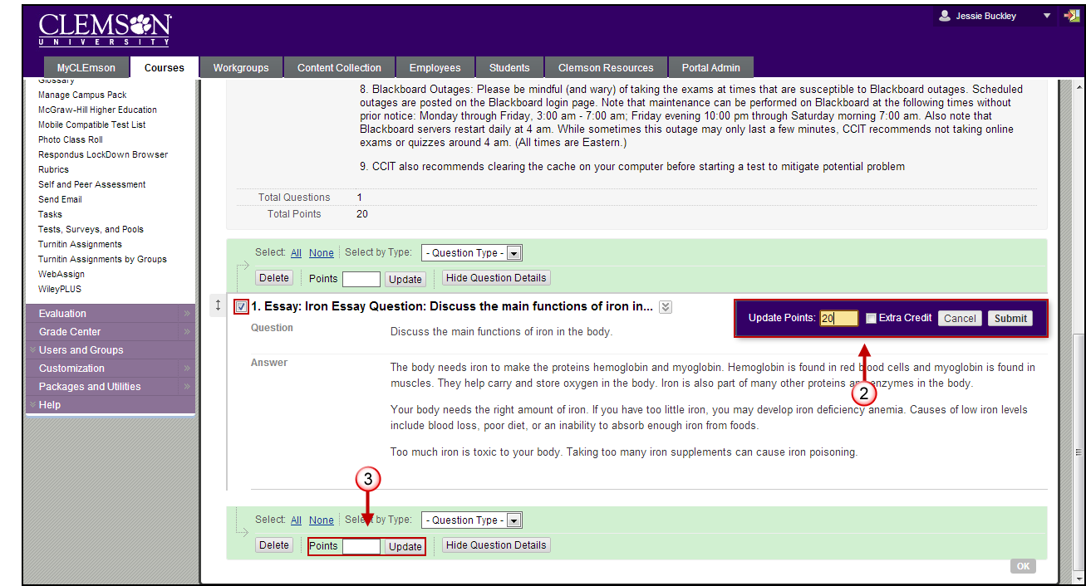
- To change the point value for multiple questions, from the Test Canvas page, select the checkbox for each question to change the point value. Then enter the Points value to update the question to, and click Update. The test will refresh and display the new updated point value.

Add Multiple Choice Questions to a Test
To add Multiple Choice questions to a test from the Test Canvas page:
- Hover your mouse over the Create Question action link and select Multiple Choice.
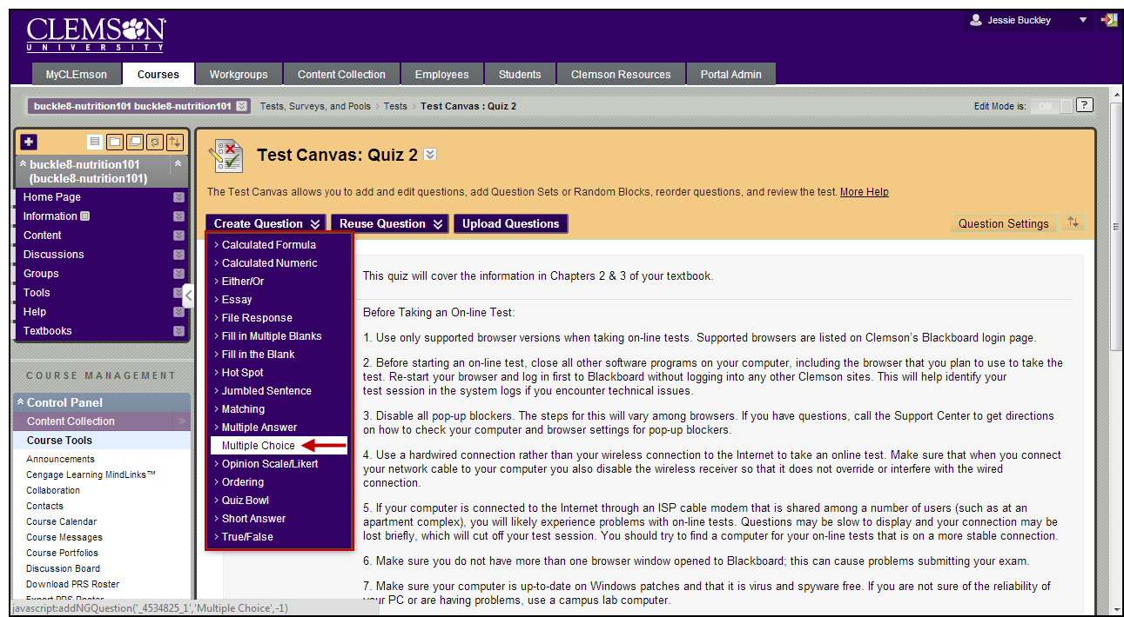
- The system displays the Create/Edit Multiple Choice Question page.
- Enter the Question Title.
- Enter the Question Text.

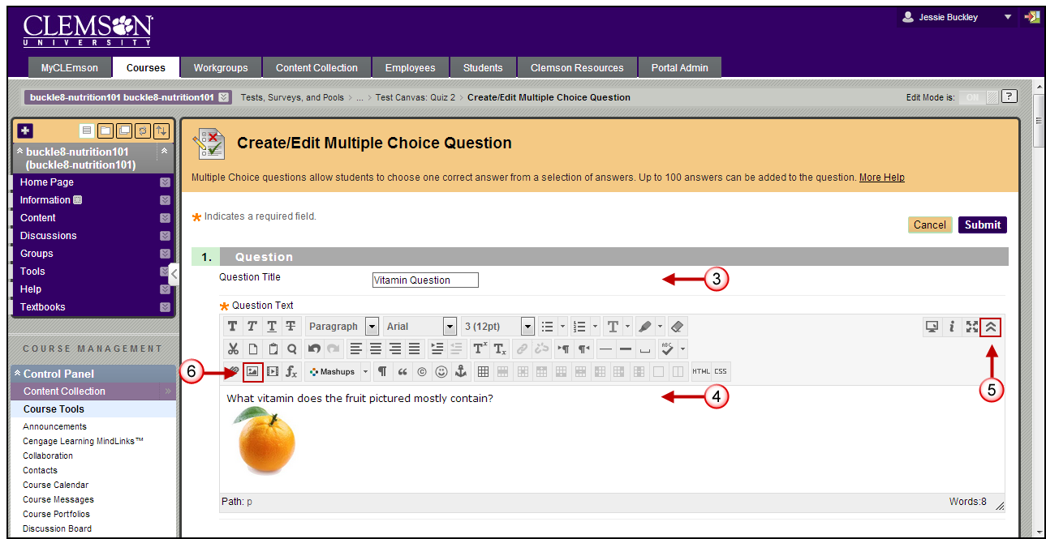
- If you want to add an image to the question, click the Show More action link to the far right below the Question field.
- Use the Inset/Edit image icon below the Question field to browse and select the image to attach.

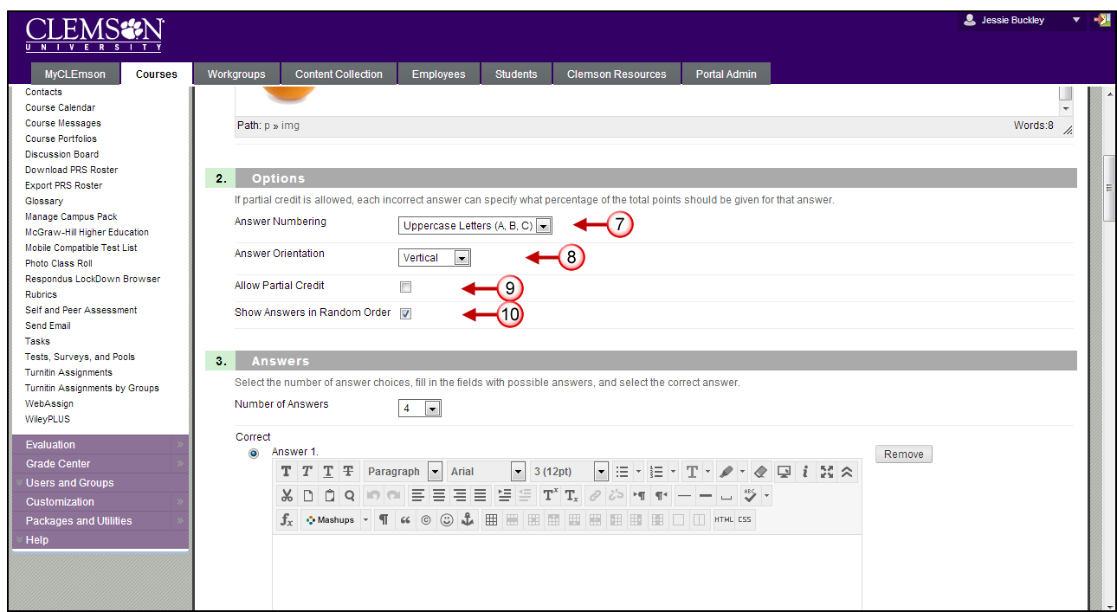
- If you setup answer options on the Test Creation Settings page, they will appear in the Options section of this page. Select how you want answers to be numbered using the drop down menu for the Answer Numbering field.
- Then select how you want answers to be oriented from the Answer Orientation drop down menu.
- Select the Allow Partial Credit checkbox if you want to allow partial credit for answers to this question.
- Select the Show Answers in Random Order checkbox if you want answers to appear in random order each time a student views this question.
- Depending on how your Test Creation Settings are configured the question and answer portion of your screen may appear differently.
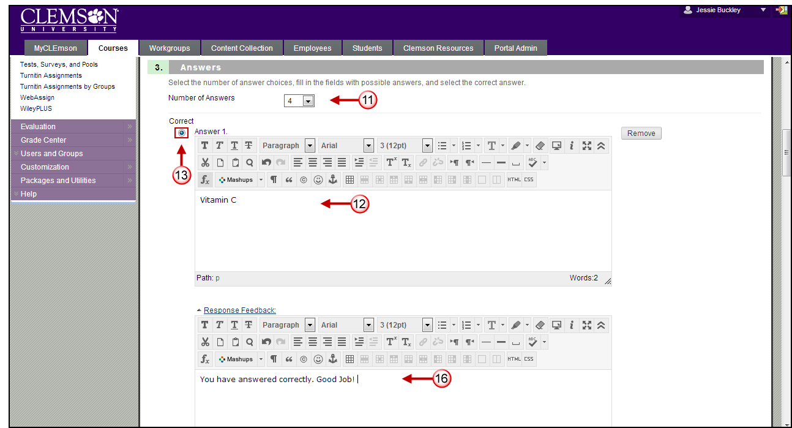
- Select how many options that the students will be given for answers from the Number of Answers drop down menu. For this example we selected 4.
- Enter the Answers in the Answer fields.
- Then select the radio button next to the Correct answer.
- You can attach pictures or media files to each answer by clicking the Browse button at the end of the File field. Then use the Action drop down menu to select whether to Create a link to this media file or Display image within the page.
Note: If you enabled the Add images, files, and web links to answers option in your Question Settings you will be given the option to attach images or links to your test answers.
- Enter Feedback for each answer or navigate to the next section of the page to enter Feedback for the entire question.
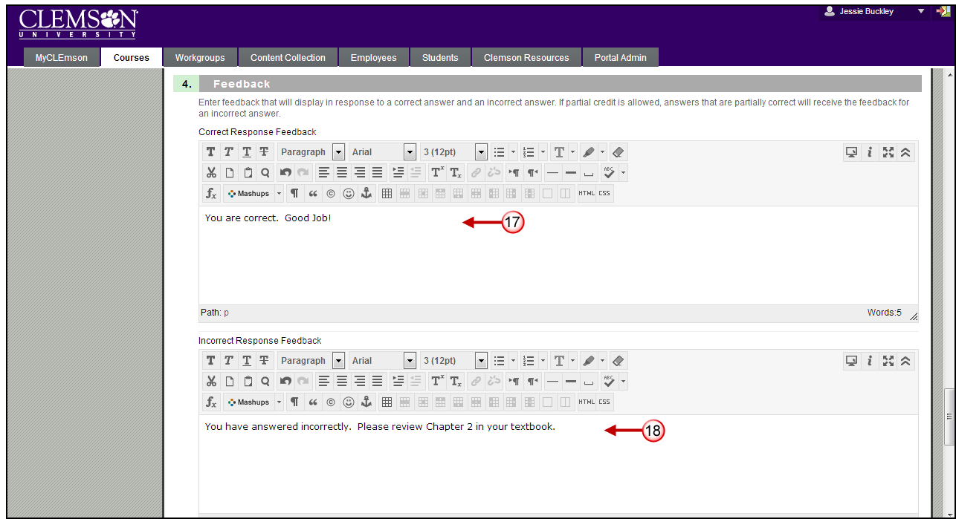
- If selected in the Test Creation Settings, you will be given the option to enter both Correct Response Feedback and/or Incorrect Response Feedback. If the student answers the question correctly and you want to provide feedback, enter this feedback in the Correct Response Feedback field.
- If the student answers the question incorrectly and you want to provide feedback, enter this feedback in the Incorrect Response Feedback field.
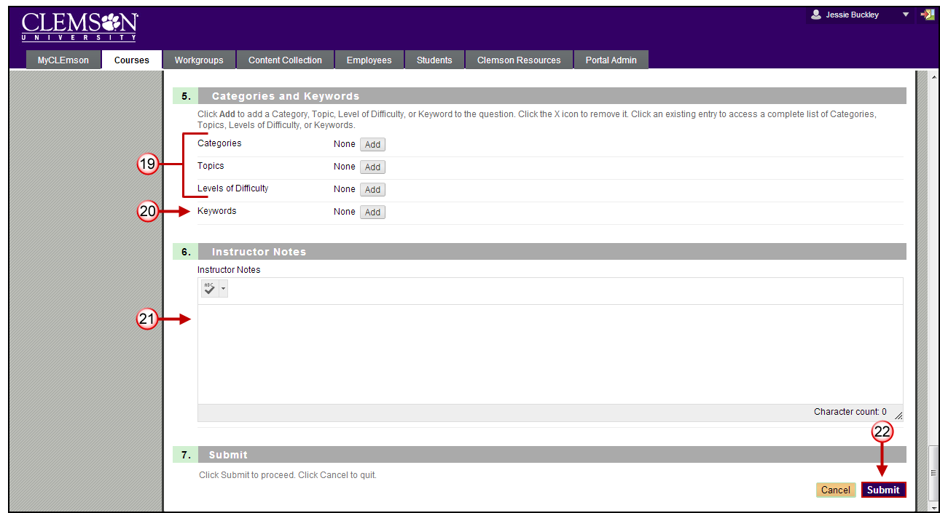
- Click Add to select Categories, Level of Difficulty, and Topics.
Note: Categories, Level of Difficulty and Topics are optional. These fields allow for better filtering of test questions when using Pools.
- Click Add to enter any Keywords for the selected question. This feature can be used to create a bank of test questions.
- Enter Instructor Notes.
- Click Submit.
- The system saves the question and displays the Test Canvas page with the new question.

Add True/False Questions to a Test
To add questions to a test from the Test Canvas page:
- Hover your mouse over the Create Question action link and select True/False.
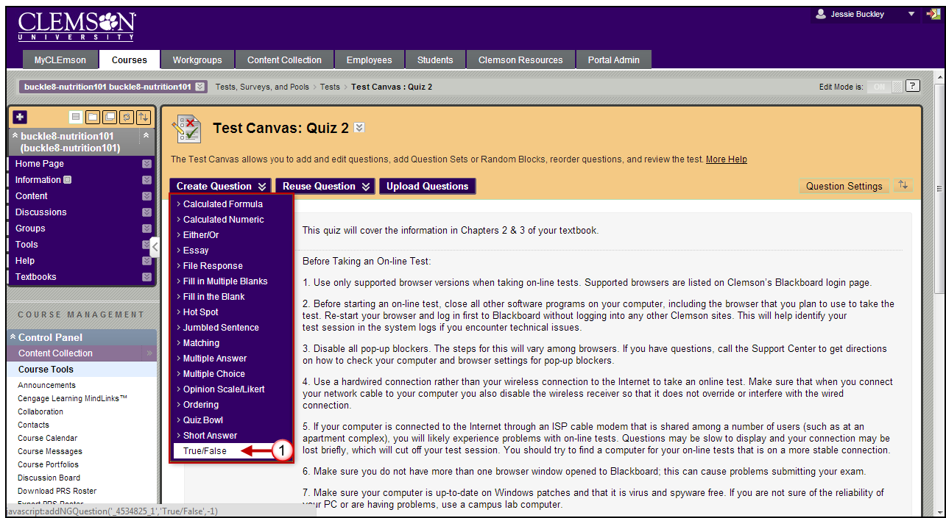
- The system displays the Create/Edit True/False Question page.
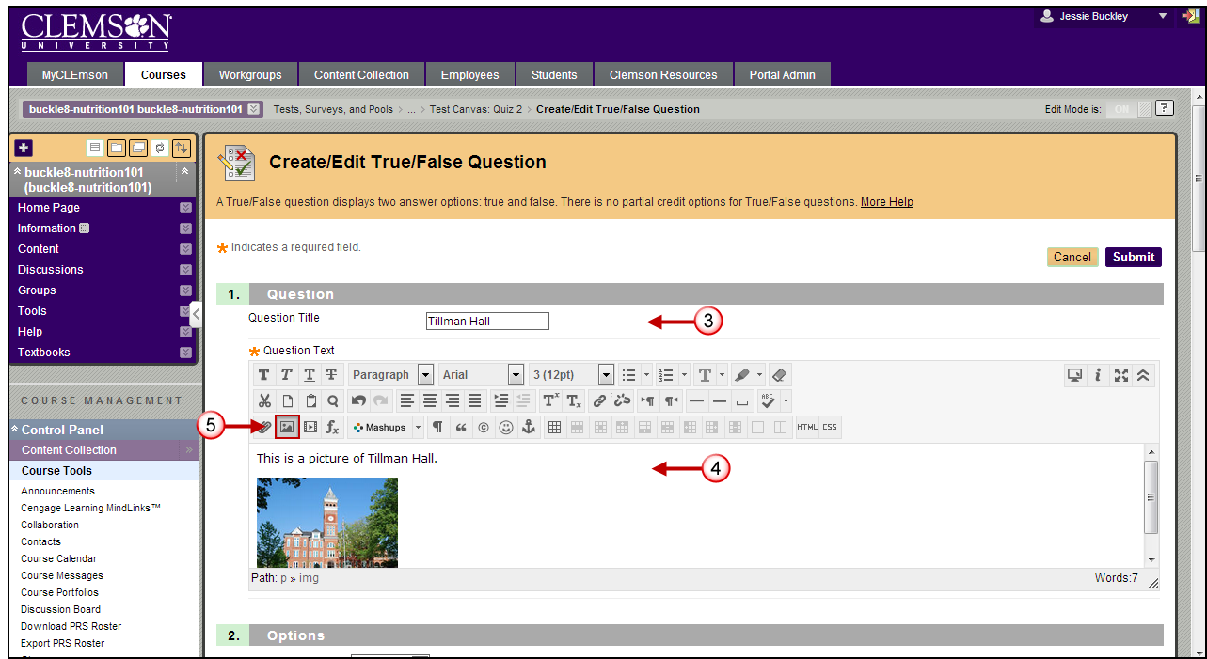
- Enter the Question Title.
- Enter the Question Text.
- If you want to add an image to the question, use the Inset/edit Image icon under the Question field to browse and select an image.
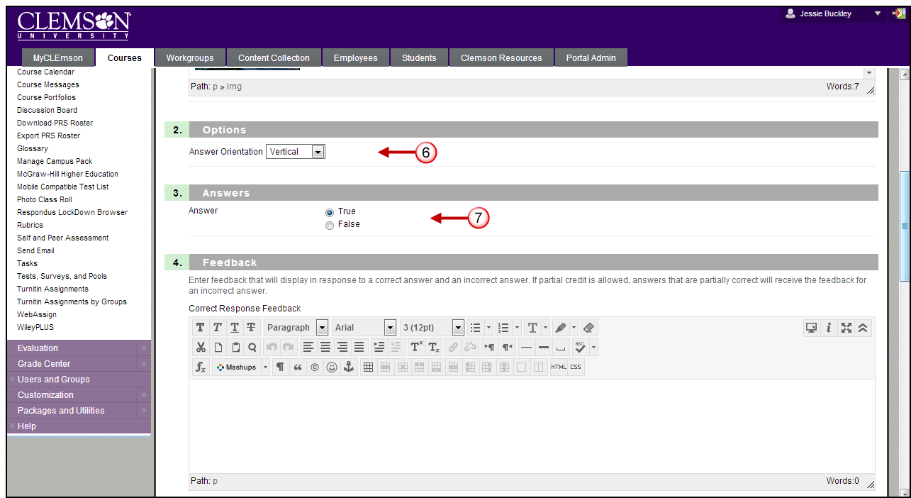
- Select the orientation for your test answers.
- Select whether the statement provided is True or False.
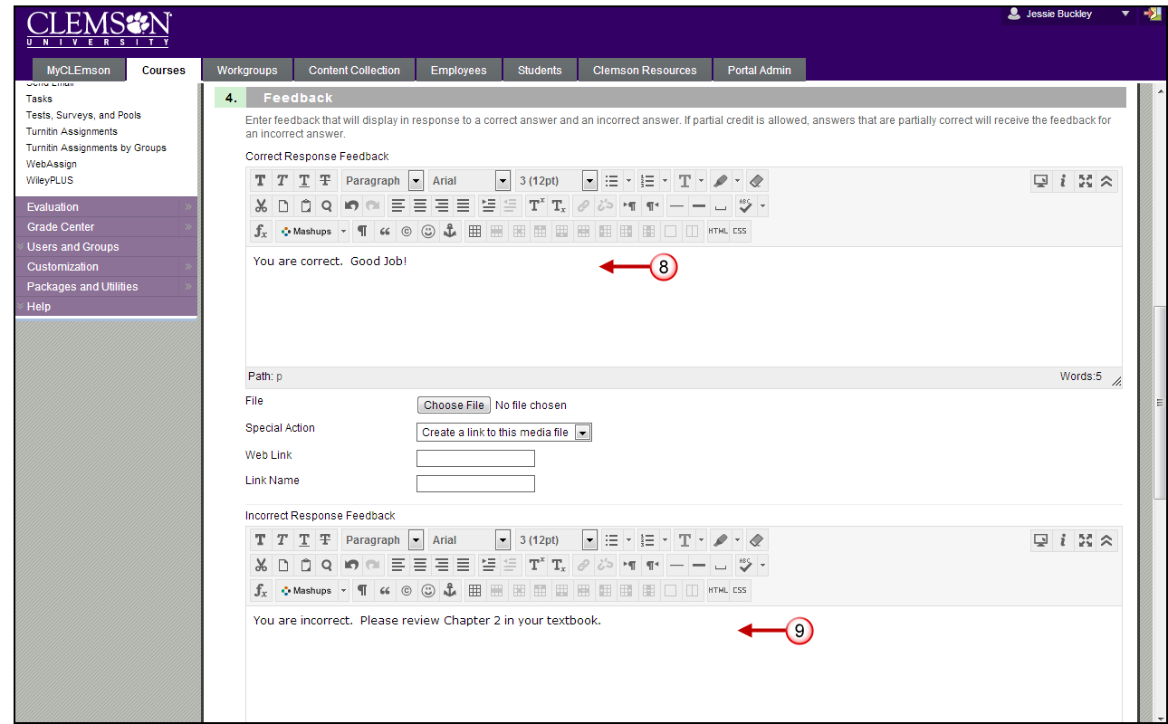
- If selected in the Test Creation Settings, you will be given the option to enter both Correct Response Feedback and/or Incorrect Response Feedback. If the student answers the question correctly and you want to provide feedback, enter this feedback in the Correct Response Feedback field.
- If the student answers the question incorrectly and you want to provide feedback, enter this feedback in the Incorrect Response Feedback field.
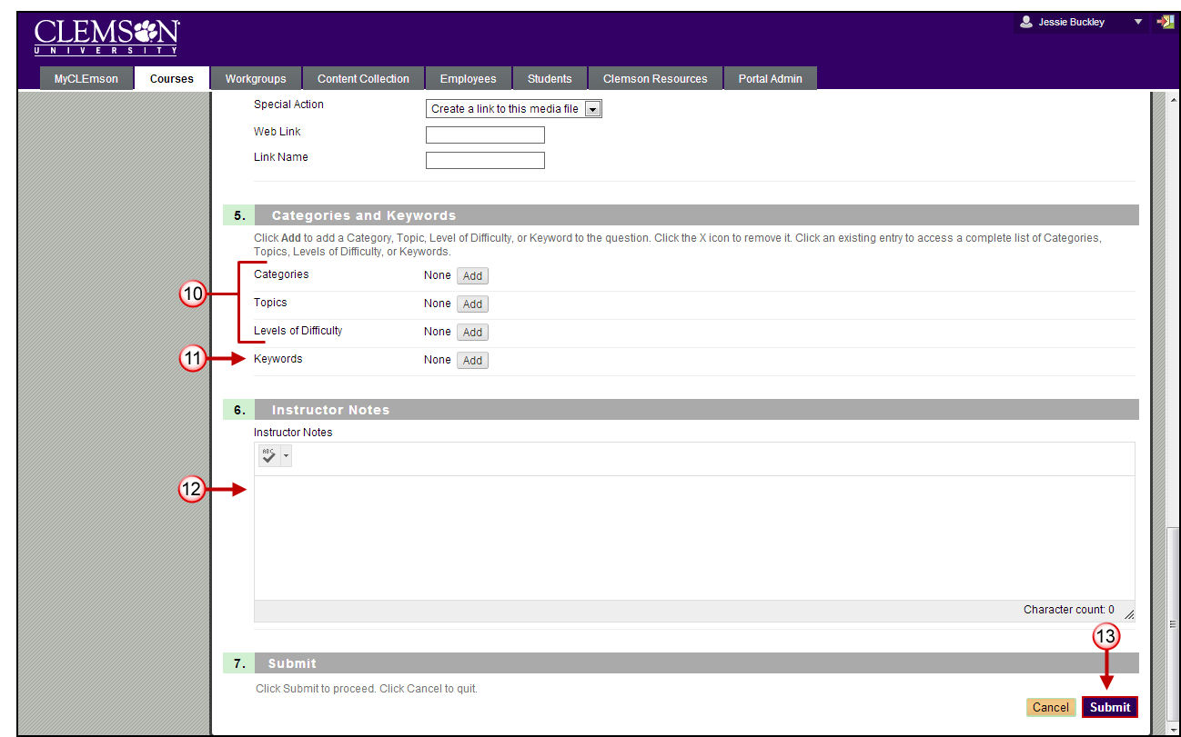
- Click Add to select Categories, Level of Difficulty, and Topics.
Note: Categories, Level of Difficulty and Topics are optional. These fields allow for better filtering of test questions when using Pools.
- Click Add to enter any Keywords for the selected question. This feature can be used to create a bank of test questions.
- Enter Instructor Notes.
- Click Submit.
- The system saves the question and displays the Test Canvas page with the new question.

Add Matching Questions
To add Matching questions to a test from the Test Canvas page:
- Hover your mouse over the Create Question action link and select Matching.
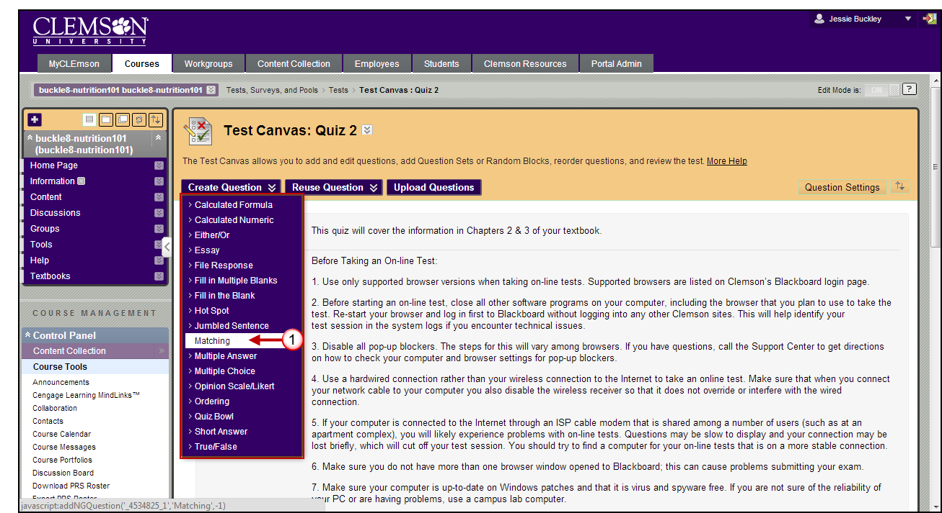
- The system displays the Create/Edit Matching Question page.
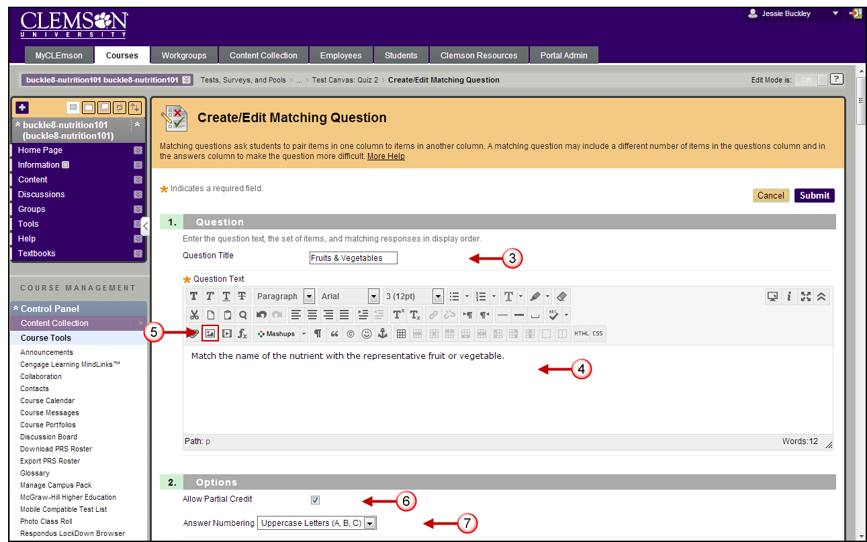
- Enter the Question Title.
- Enter the Question Text.
- If you want to add an image to the question, use the Insert/Edit Image icon under the Question field to browse and select an image.
Note: If you enabled the Add images, files, and web links to answers option in your Question Settings you will be given the option to attach images or links to your test answers.
- Select the Allow Partial Credit checkbox if you want to allow partial credit for answers to this question.
- Select how you want answers to be numbered using the drop down menu for the Answer Numbering field.
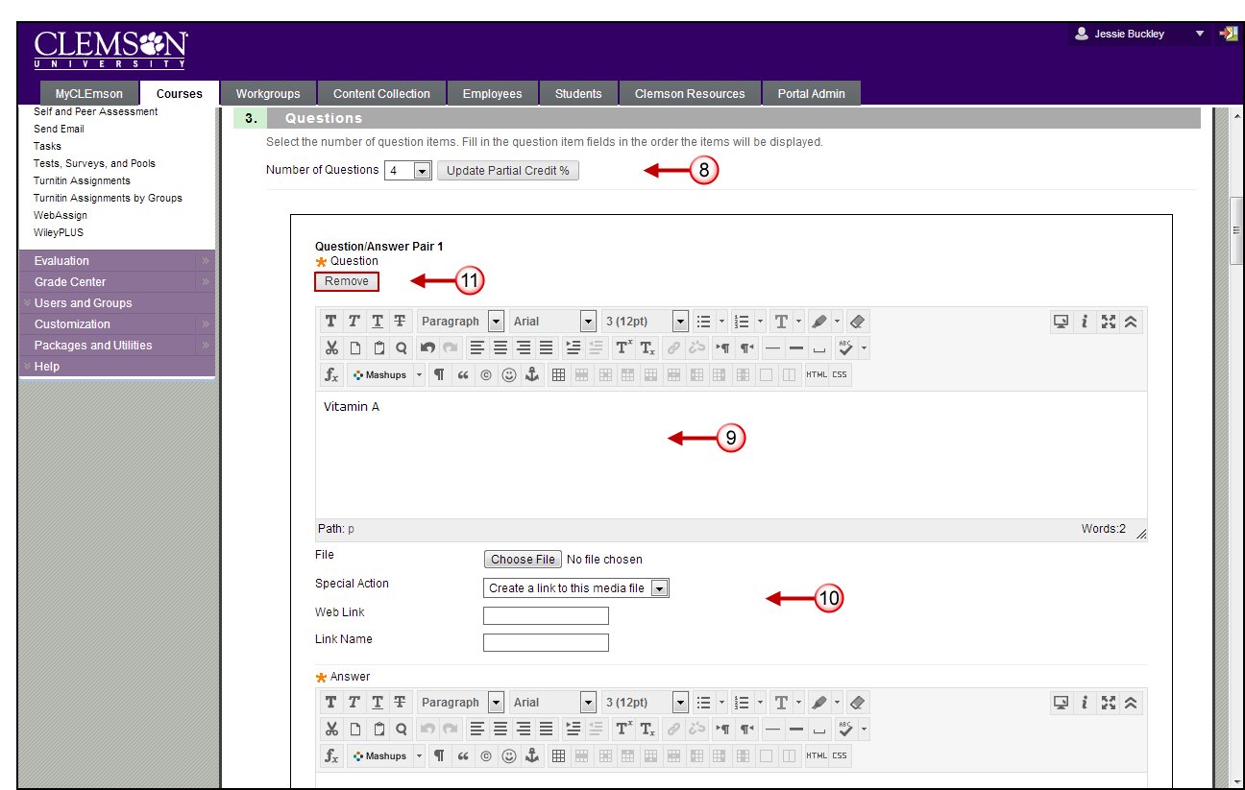
- Select the Number of Question options from the available drop down menu.
- Enter the text of the question in the Question fields.
- If you setup question options on the Test Creation Settings page, they will appear below the question field. These options can be used to attach images, files, an external link or multimedia to the test question.
- Click Remove to discard any extra test questions.
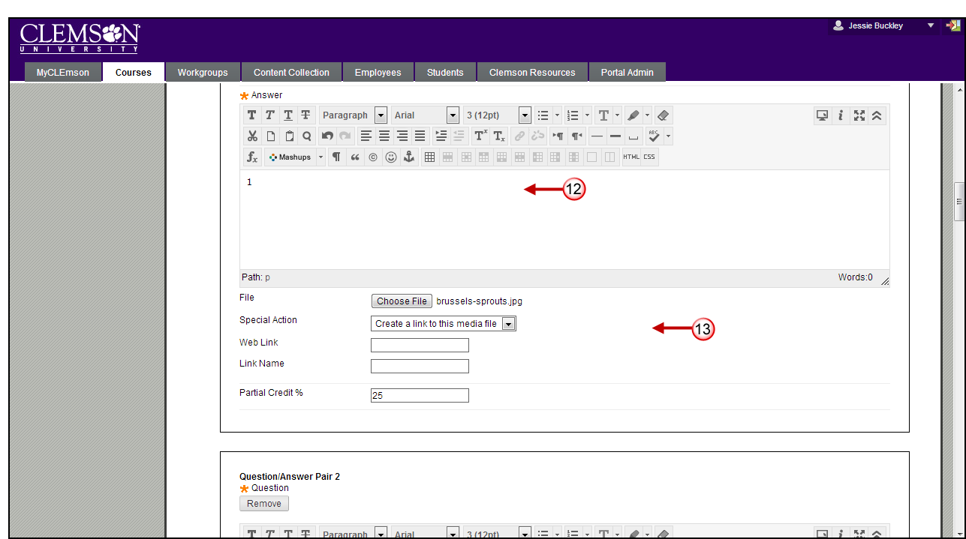
- Enter the text of the answers in the Answer fields.
- If you setup answer options on the Test Creation Settings page, they will appear below the question field. These options can be used to attach images, files, an external link or multimedia to the test answer. In this example we used an image of the state flag.
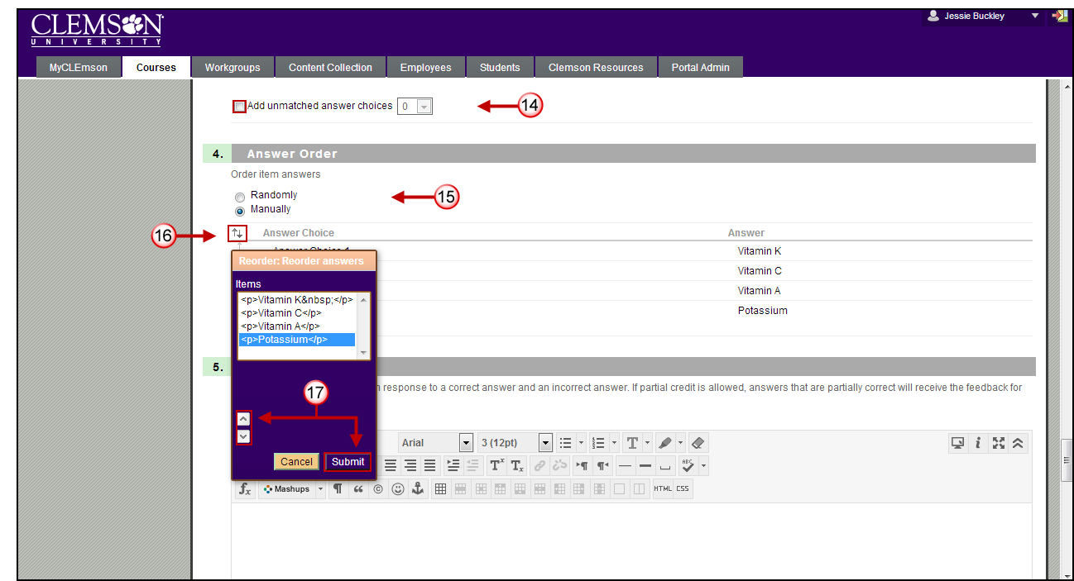
- After adding all Question/Answer pairs select the Add unmatched answer choices checkbox and a dropdown menu to choose how many unmatched answers to add.
- In the Answer Order field, select if the answers should be ordered randomly or manually ordered.
- If the manual option is selected, clicking the up and down arrows will bring up a menu to manually order the answers
- Use the up and down arrows in the Reorder: Reorder answers menu to change the order of the answers. Click Submit.

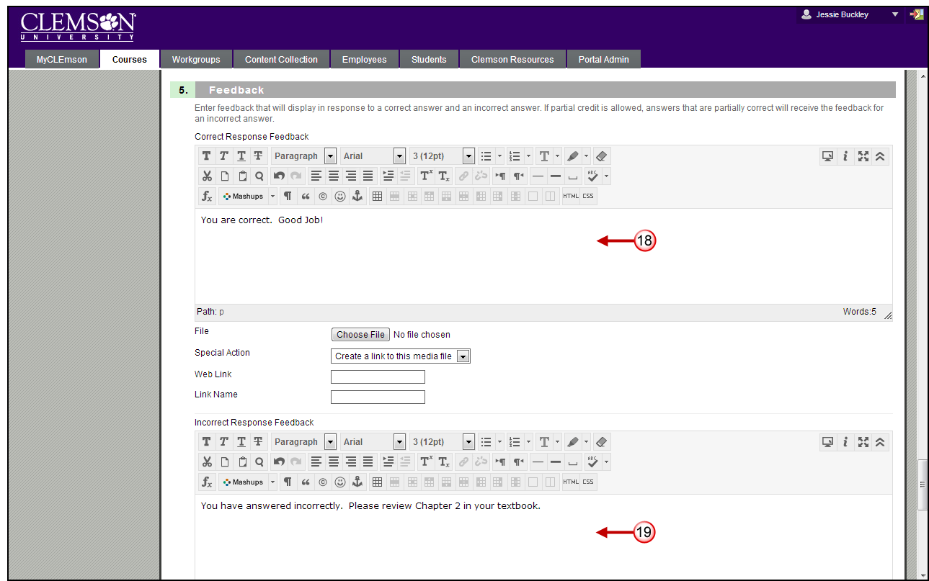

- If selected in the Test Creation Settings, you will be given the option to enter both Correct Response Feedback and/or Incorrect Response Feedback. If the student answers the question correctly and you want to provide feedback, enter this feedback in the Correct Response Feedback field.
- If the student answers the question incorrectly and you want to provide feedback, enter this feedback in the Incorrect Response Feedback field.
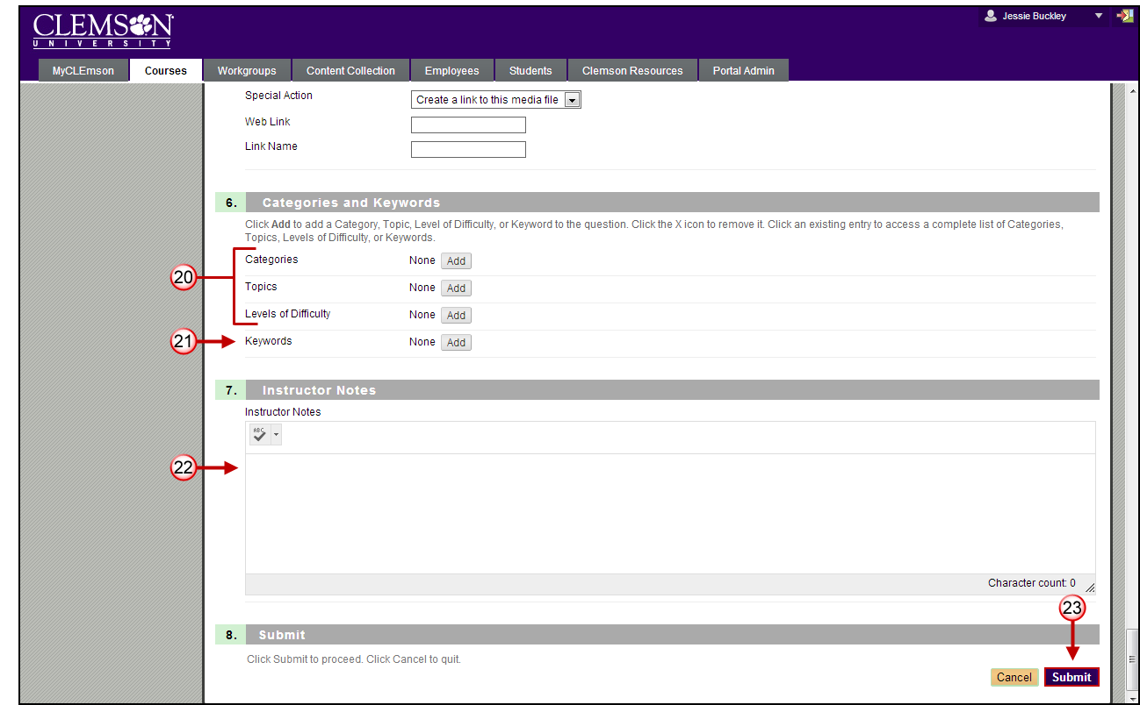
- Click Add to select Categories, Level of Difficulty, and Topics.
Note: Categories, Level of Difficulty and Topics are optional. These fields allow for better filtering of test questions when using Pools.
- Click Add to enter any Keywords for the selected question. This feature can be used to create a bank of test questions.
- Enter Instructor Notes.
- Click Submit.
- The system saves the question and displays the Test Canvas page with the new question.

Add Fill-in Multiple Blank Questions
To add Fill in Multiple Blank questions to a test from the Test Canvas page:
- Hover your mouse over the Create Question action link and select Fill in Multiple Blanks.
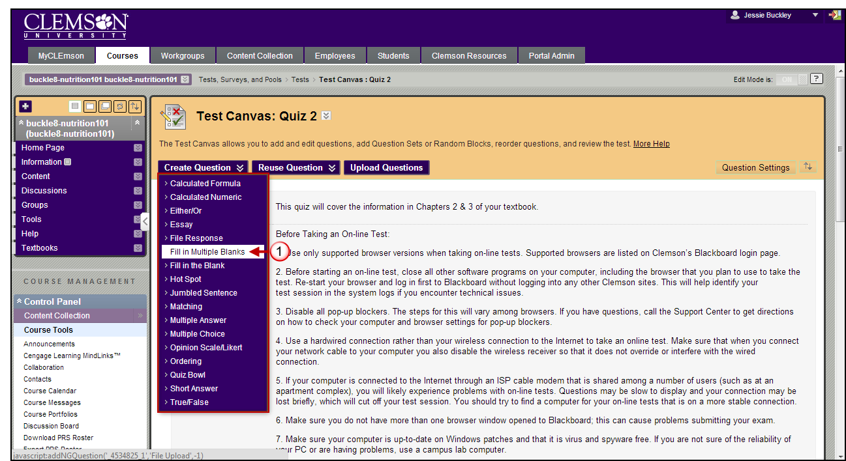
- The system displays the Create/Edit Fill in Multiple Blanks Question page.
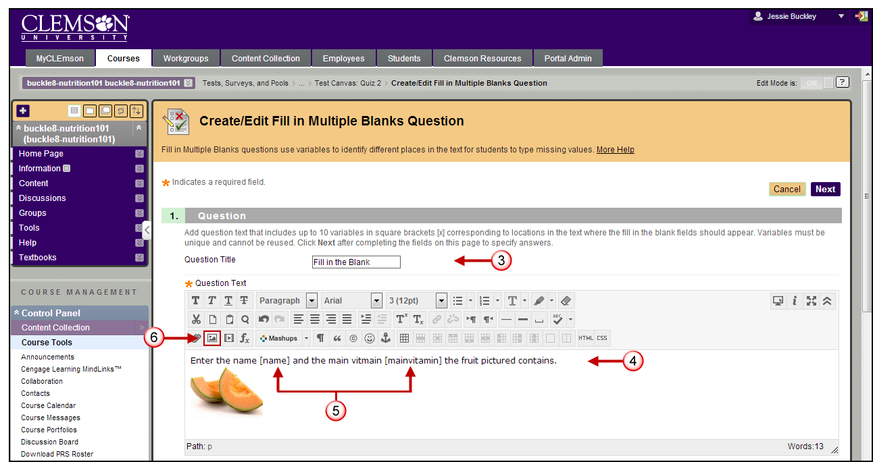
- Enter the Question Title.
- Enter the Question Text.
- In the question text, insert a variable for each blank. Use the square brackets [variable name] to identify the blanks in the question. Variables must be unique and cannot be reused. A maximum of 10 variables is allowed per question.
- Click the Insert/Edit Image icon in the Question field to browse and select the image to attach to the question.
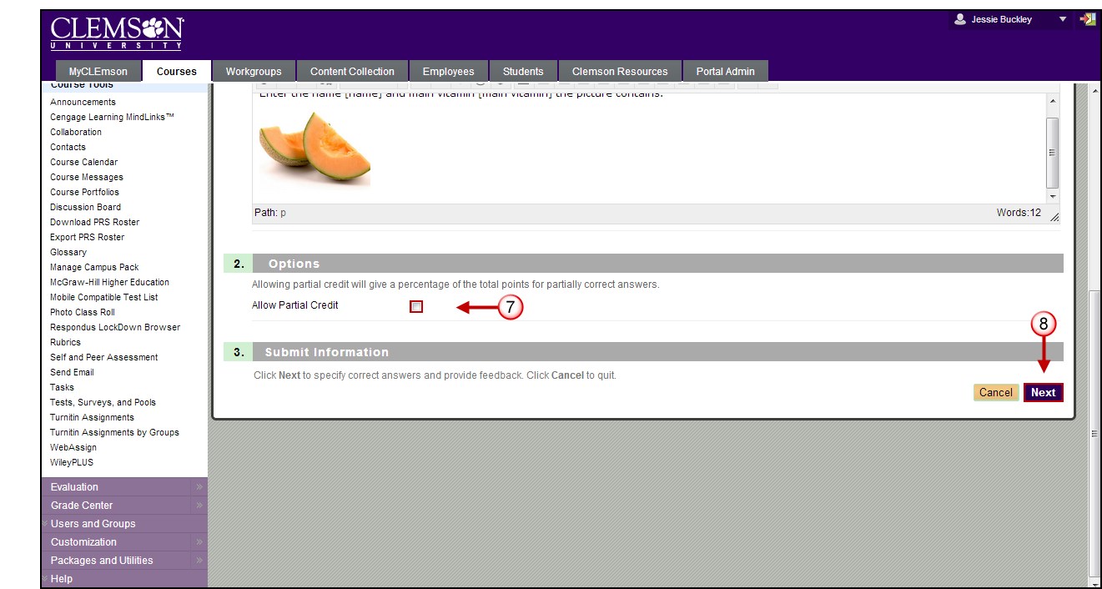
- If you want to accept partial credit for answers, enable the Allow Partial Credit checkbox in the Options section.
Note: Partial Credit is only available for the following question types: Calculated Formula, Fill in Multiple Blanks, Jumbled Sentence, Matching, Multiple Answer, Multiple Choice, Opinion Scale/Likert, Ordering, and Quiz Bowl.

- Click the Next button.

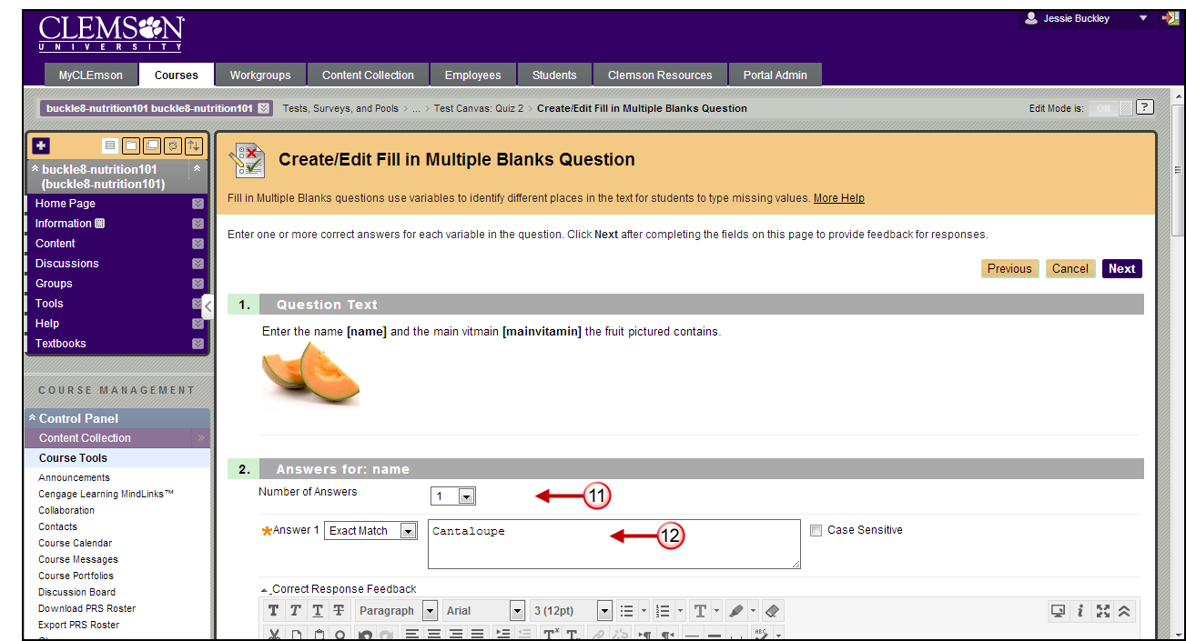
- This page displays the question with the image embedded.
- In Step 2 the system allows you to provide answers for the first variable. In this example the first variable is [name].
- Select the Number of Answers from the available drop down menu. In this example, we selected 1. Therefore there is only 1 Answer field.
- Enter the answer in the Answer 1 field.
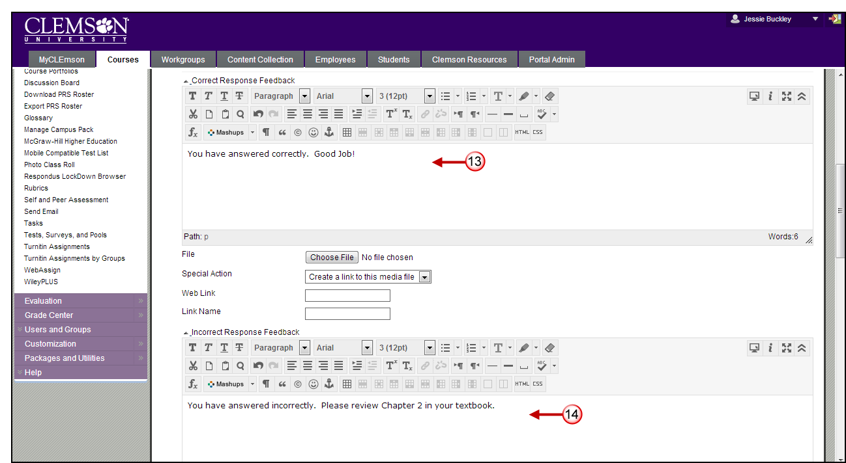
- If enabled in the Test Creation Settings, you will be given the option to enter both Correct Response Feedback and/or Incorrect Response Feedback. If the student answers the question correctly and you want to provide feedback, enter this feedback in the Correct Response Feedback field.
- If the student answers the question incorrectly and you want to provide feedback, enter this feedback in the Incorrect Response Feedback field.
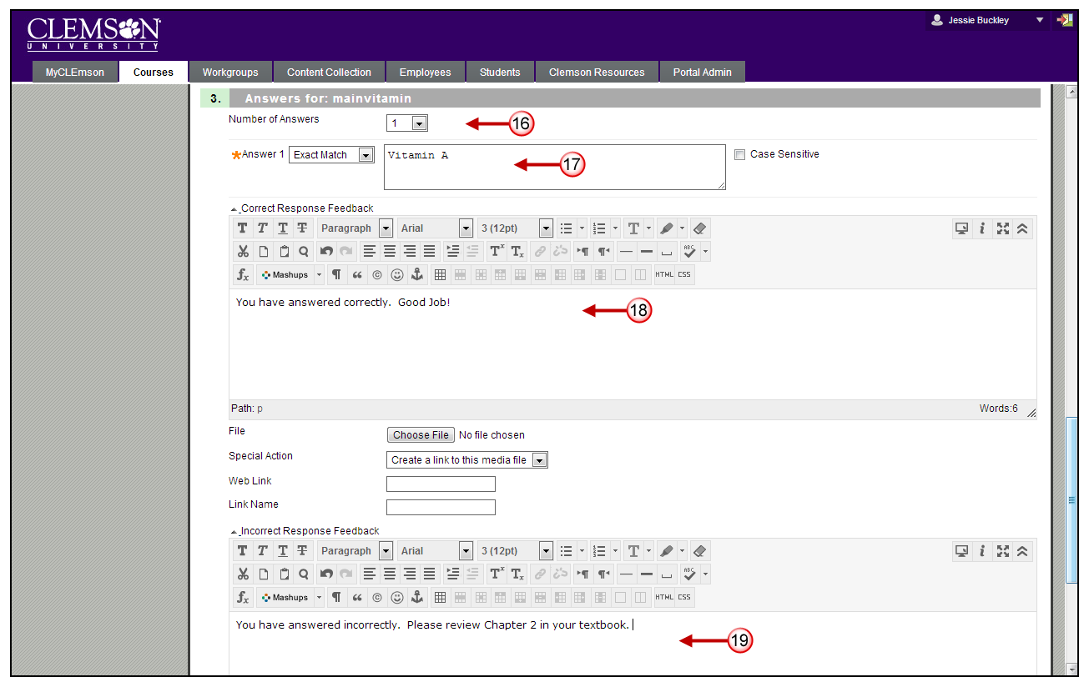
- In Step 3 the system allows you to provide answers for the second variable. In this example the second variable is [mainvitamin].
- Select the Number of Answers from the available drop down menu. In this example, we selected 1. Therefore there is only 1 Answer field.
- Enter the answer in the Answer 1 field.
- If enabled in the Test Creation Settings, you will be given the option to enter both Correct Response Feedback and/or Incorrect Response Feedback. If the student answers the question correctly and you want to provide feedback, enter this feedback in the Correct Response Feedback field.
- If the student answers the question incorrectly and you want to provide feedback, enter this feedback in the Incorrect Response Feedback field.
- Then click the Next button.
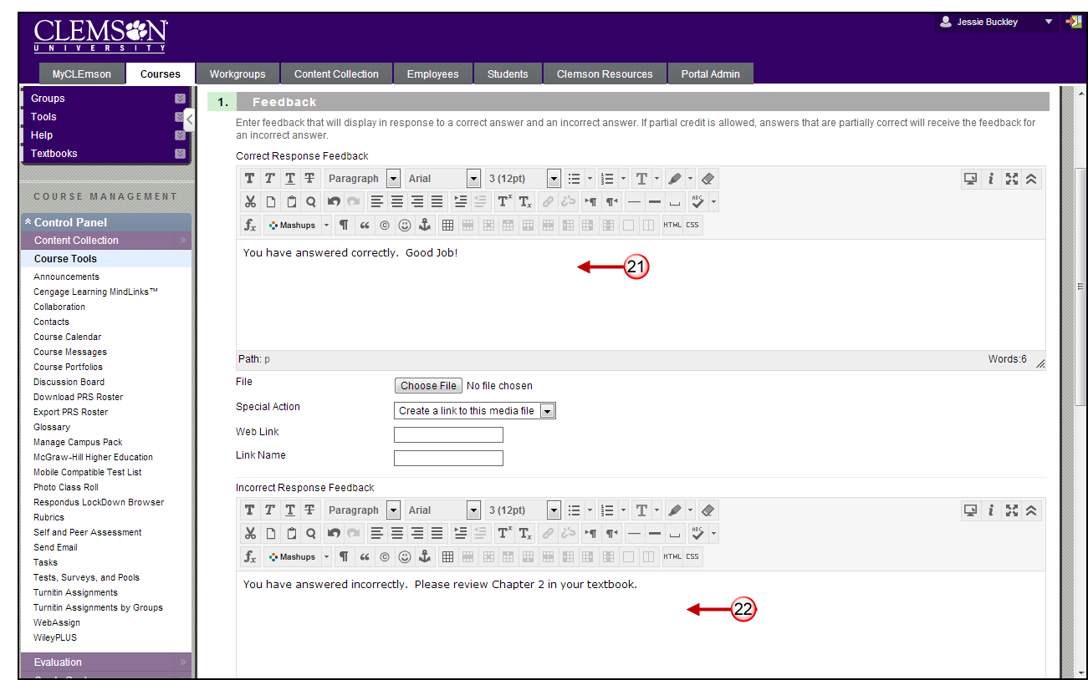
- If enabled in the Test Creation Settings, you will be given the option to enter both Correct Response Feedback and/or Incorrect Response Feedback. If the student answers the question correctly and you want to provide feedback, enter this feedback in the Correct Response Feedback field.
- If the student answers the question incorrectly and you want to provide feedback, enter this feedback in the Incorrect Response Feedback field.
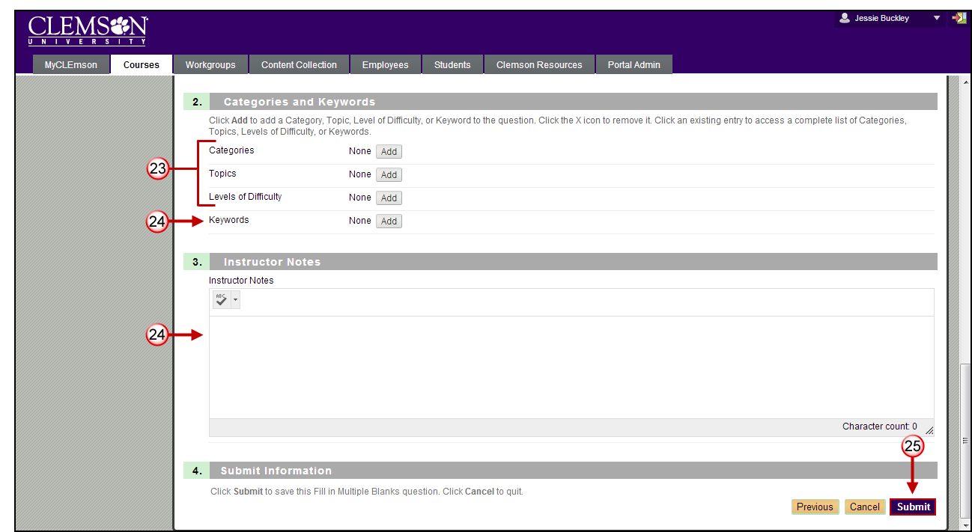
- Click Add to select Categories, Topics, and Level of Difficulty.
Note: Categories, Level of Difficulty and Topics are optional. These fields allow for better filtering of test questions when using Pools.
- Click Add to enter any Keywords for the selected question. This feature can be used to create a bank of test questions.
- Enter Instructor Notes.
- Click Submit.
- The system saves the question and displays the Test Canvas page.

Select Questions from a Question Pool or Assessment
To select questions from a Question Pool or Assessment to add to a Question Pool:
- Navigate to the Test Canvas page.
- Then hover your mouse over the Reuse Questions action link.
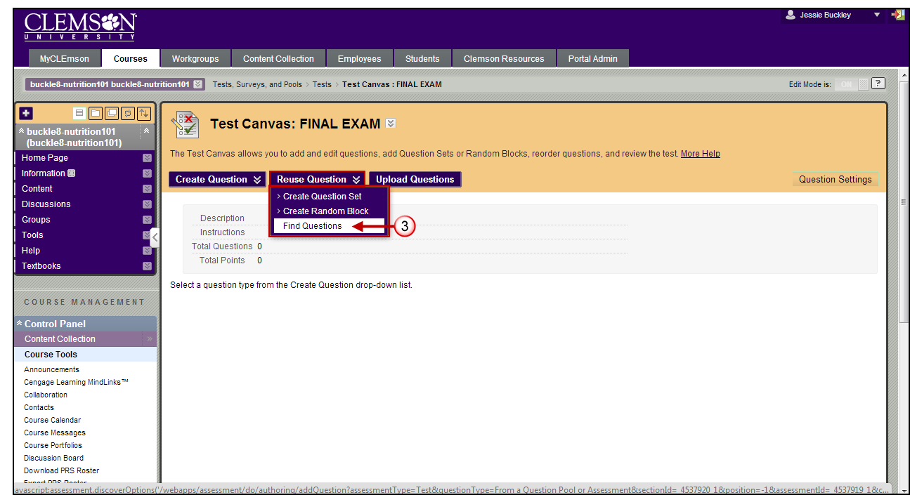
- Select Find Questions.
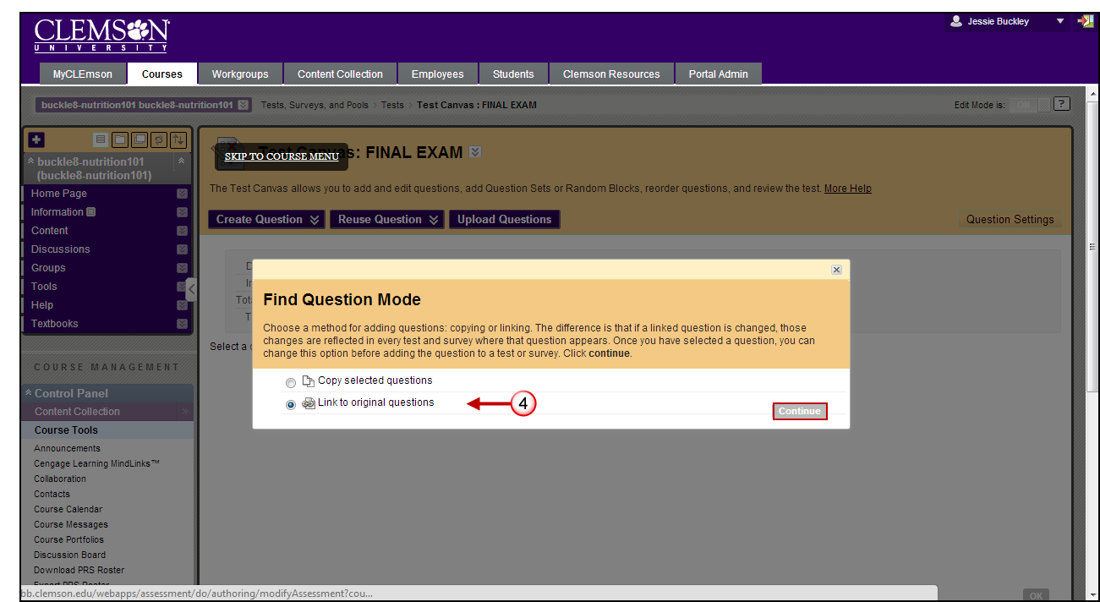
- The Find Question Mode pop-up window is displayed. Select which mode to use when adding questions from a pool or test.
Note: The Find Question Mode pop-up window is only displayed the first time you select this option. In future searches, you can enable this feature on the Find Questions page, at the top of the table.
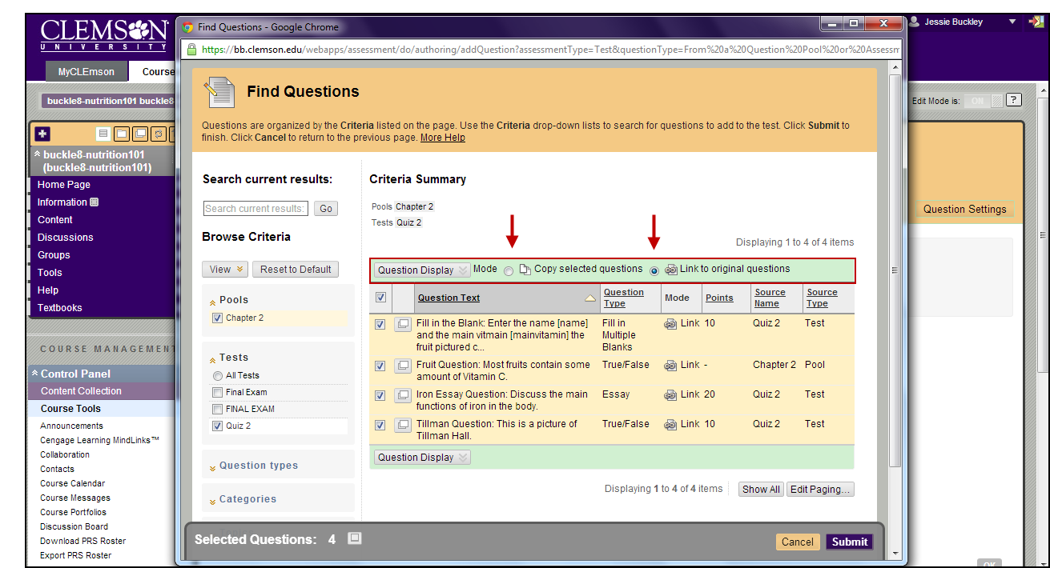
- Copy selected questions – this option will actually copy the question from a test or pool into the current test. If updates are made to this question on the existing exam, those changes will not be reflected in the current exam.
- Link to original questions – this option will actually link the question from the current test or pool into the current test. If updates are made to this question on the existing exam, those changes are reflected in every test and survey where that question appears.
- The Find Questions page is displayed.
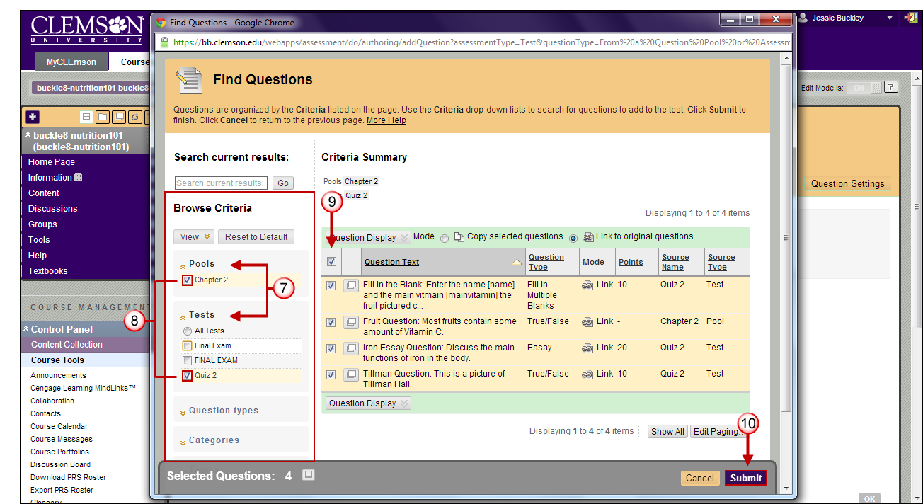
- Questions are organized by Criteria listed on the page.
- Click the Criteria name to expand the drop down list. Expand the Pools and Tests criteria.
- Then select the checkbox for the Criteria to filter by.
Note: The list of questions on the right side of the page narrows or expands as additional Criteria are selected.
- Select the checkbox for the questions to import into the Pool. To select all the questions, click the checkbox at the top of the checkbox column.
- Then click Submit.
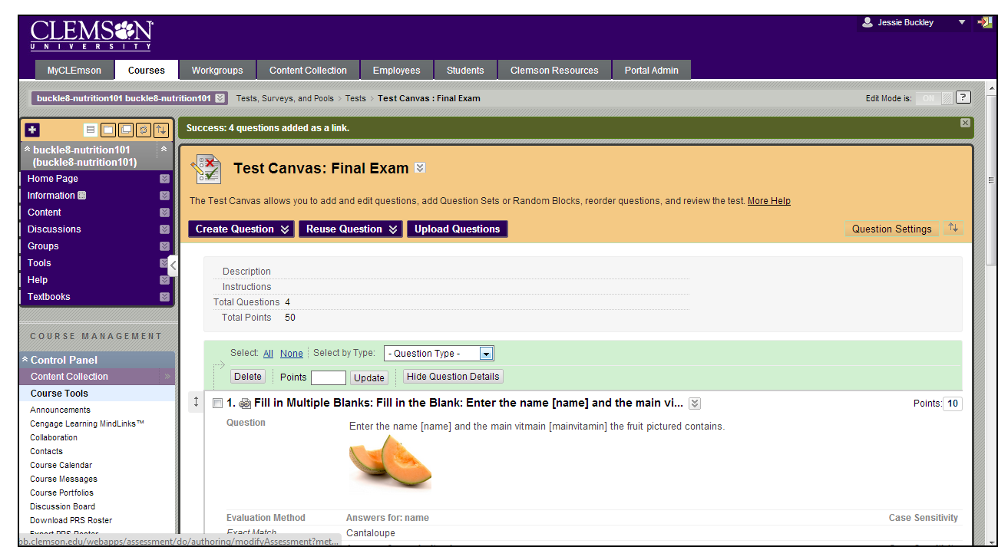
- The system displays the Test Canvas with the new questions added to it.

