Creating Groups

Beginner

About Course Group Membership 1
Creating a Group 1
Creating a Single Group with Self-Enroll 3
Creating a Single Group with Manual Enroll 6
Creating a Group Set 8
Creating a Group Set with Self-Enroll 8
Creating a Group Set with Manual Enroll 12
Creating a Group Set with Random Enroll 15
Group Settings 18

About Course Group Membership
Faculty can create a single Group or multiple Groups in which students can be enrolled manually, automatically, or by allowing the students to enroll themselves. These enrollments can be changed at any time. Faculty can add a Tool link to their course menu for Groups. These Groups can also be accessed through the default Tools link in the course menu.
- Manual Enrollment involves the faculty selecting each member one at a time from a list of all the students in the Course.
- Random Enrollment is best suited for multiple Groups, where the faculty allows the system to divide up all the members of the Course among all the Groups based on Number of Students per Group or Number of Groups. For example, if there are 24 students enrolled in a Course, and the faculty wanted four students per Group, the system would create six Groups. If the faculty wanted four Groups, the system would randomly enroll six students per Group.
- Self Enrollment allows the students themselves to become members of Groups by using Sign-Up Sheets that Instructors create for each Course Group.
Each Group has its own space, or homepage, in the course with links to tools to help students collaborate. Only the instructor and the Group members can access the Group tools. For instance, each Group can have a private Discussion Board that is only accessible to a Group’s members.

Creating a Group
To create a Group:
- Login to Blackboard Learn.
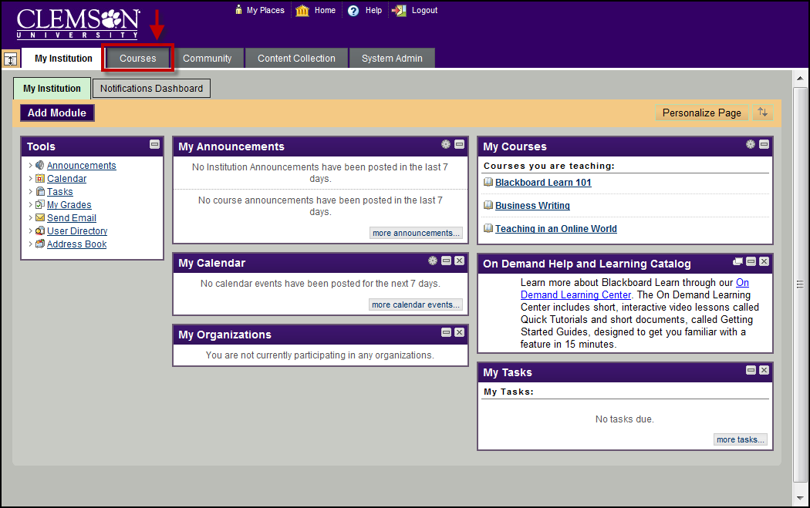
- Click the Courses tab.
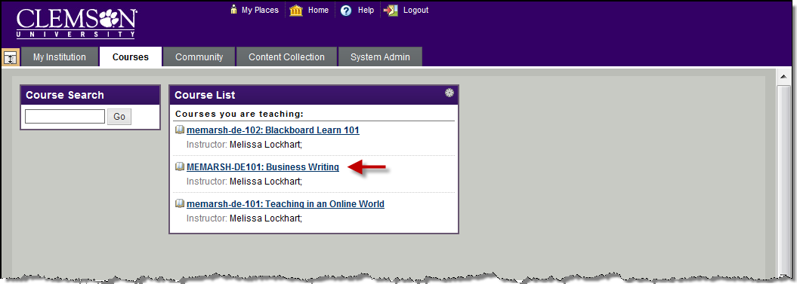
- Click the course to open from the Course List module.
- The course entry page will be displayed. From the Control Panel, click the chevron to expand Users and Groups.
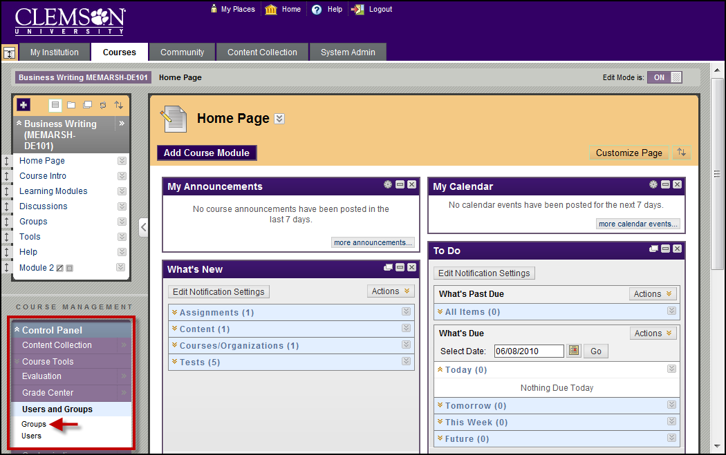
- Click Groups. The Groups page is displayed.

Creating a Single Group with Self-Enroll
The Self Enroll option allows you to create a single Group with a Sign-Up Sheet. Then students can choose which Group they want to enroll in.
To create a Single Group with Self-Enroll:
- Hover your mouse over the Create action link and select Self-Enroll under Single Group.
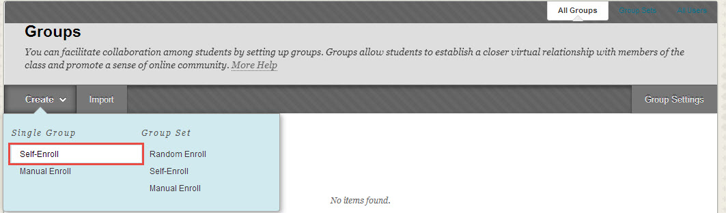
- The Create Self-Enrollment Group page is displayed.
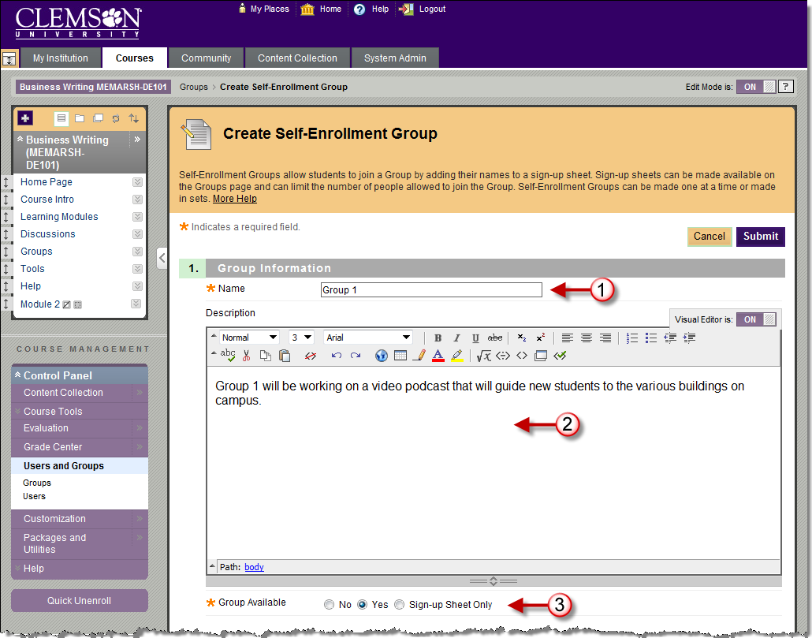
- Enter a Name and Description for the Group.
- Then select the Group Availability.
- Select No to hide the Group. If you are creating a Group to use in the Grade Center in a Smart View, you may not want to have the Groups visible to students.
- Select Yes to make the Group available.
- Select Sign-up Sheet Only to create a Sign-up Sheet for the Group that allow students to sign-up for the Group.
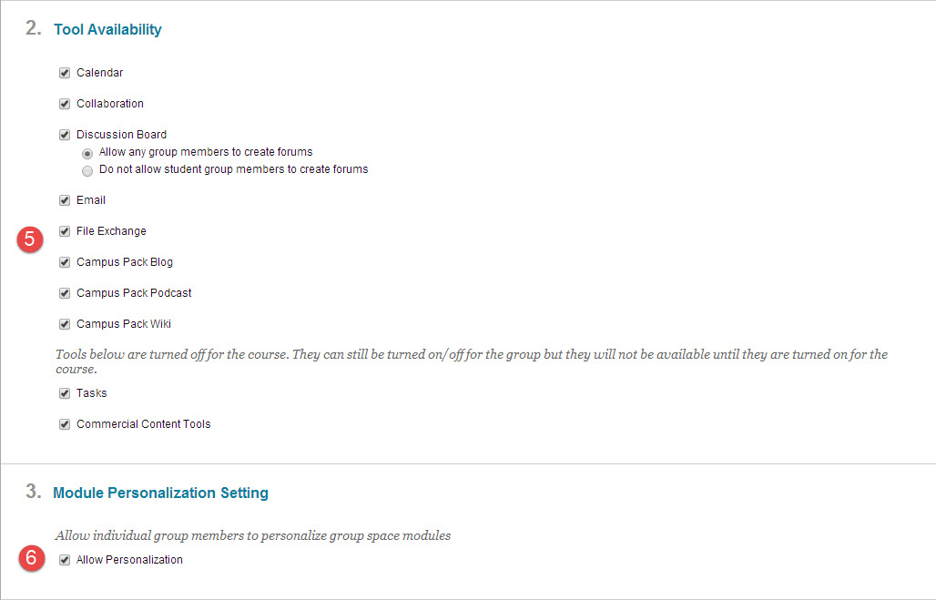
- Select which Tools will be available to members of the Group. Tools that can be made available to a Group include:
- Calendar – Users within the group can view important dates in a calendar format.
- Collaboration – Users within the Group can create and attend Chat sessions and Virtual Classroom sessions.
- Discussion Board – Users within the Group can create and manage their own Forums.
- Email – Users within the Group can email individual members or the entire Group.
- File Exchange – Users within the Group and the Instructor can upload files to the Group space and organize them through the creation of folders.
- Campus Pack Blog - Users within the Group can edit their group’s Campus Pack Blog. All students within the course can view a group’s blog. The Instructor can view and edit a group’s Blog and select the Grading option for Campus Pack Blogs.
- Campus Pack Podcast - Users within the Group can edit their group’s Campus Pack Podcast. All students within the course can view a group’s Podcast. The Instructor can view and edit a group’s Podcast and select the Grading option for Campus Pack Podcasts.
- Campus Pack Wiki – Users within the Group can edit their group’s Wiki. All students within the course can view a group’s Wiki. The Instructor can view and edit a group’s Wiki and select the Grading option for Campus Pack Wikis.
- Tasks – Users within the Group can create Tasks that are distributed to all Group members.
- Selecting Allow Personalization permits individuals in the Group to customize the Group space by adding personal modules such as What's New, Alerts or Dictionary.
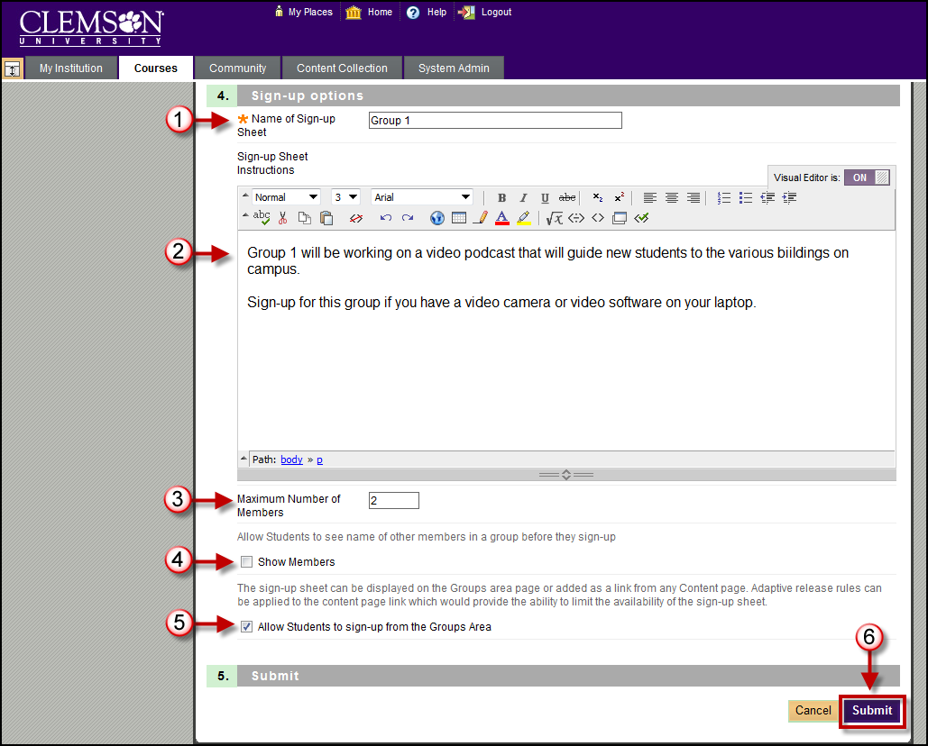
- Enter a Name for the Sign-up Sheet. Be sure the name is descriptive so that users will understand the nature of the Sign-up Sheet.
- Use the Text Box to enter a Description of the Sign-up Sheet and any instructions for signing up. This information is optional, but can help users understand expectations and any limitations to signing up.
- Enter the Maximum Number of Members for the Group. Once this number has been reached, other users will not be able to join the Group.
- Allow users to see the others who have already signed up by selecting Show Members.
- Allow users to access the Sign-up Sheet from the Groups Area page by selecting Allow Students to Sign-up from the Groups Area.
- Then click Submit. The Groups page is displayed with the new Group listed.

Creating a Single Group with Manual Enroll
To create a Single Group with Manual Enroll:
- Hover your mouse over the Create Single Group action link and select Manual Enroll.
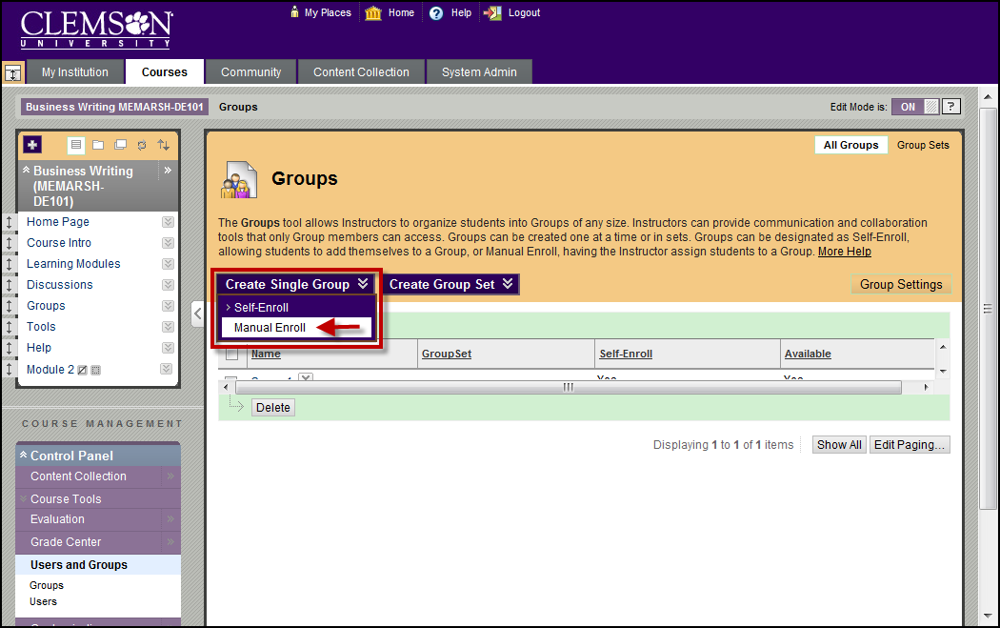
- The Create Group page is displayed.
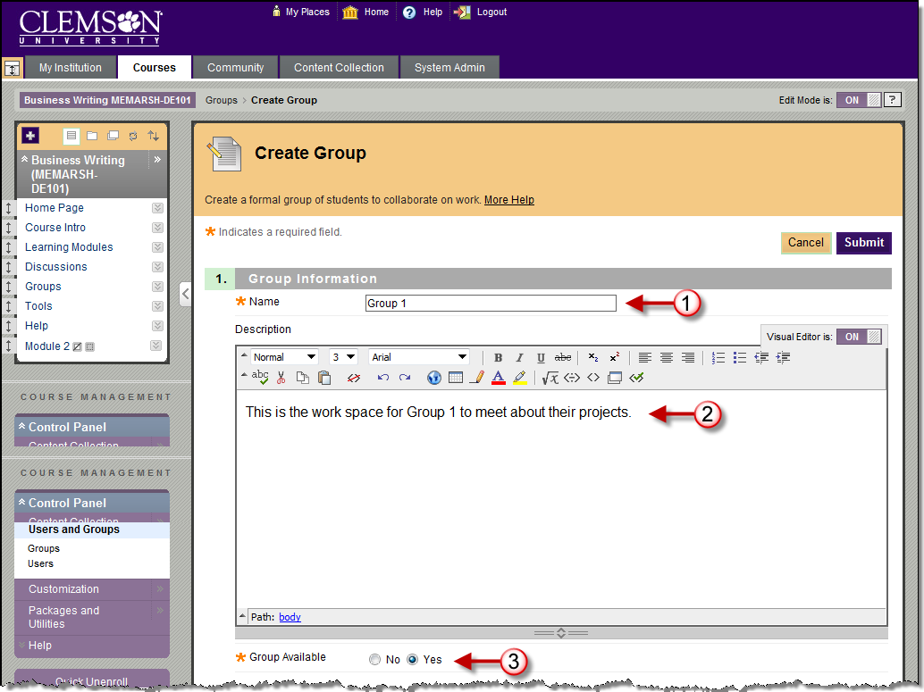
- Enter a Name and Description for the Group.
- Then select the Group Availability.
- Select No to hide the Group. If you are creating a Group to use in the Grade Center in a Smart View, you may not want to have the Groups visible to students.
- Select Yes to make the Group available.
- Select which Tools will be available to members of the Group. Tools that can be made available to a Group include:
- Collaboration – Users within the Group can create and attend Chat sessions and Virtual Classroom sessions.
- Discussion Board – Users within the Group can create and manage their own Forums.
- Email – Users within the Group can email individual members or the entire Group.
- File Exchange – Users within the Group and the Instructor can upload files to the Group space and organize them through the creation of folders.
- Journals – All members of a Group can view each other's entries, but the Group Journal can only be viewed by the Group and the Instructor. Instructors can select the Grading option for Journals.
- Tasks – Users within the Group can create Tasks that are distributed to all Group members.
- Wikis – Users within the Group can edit their Group Wiki. All students within the course can view a Group Wiki. The Instructor can view and edit a Group Wiki and select the Grading option for Group Wikis.
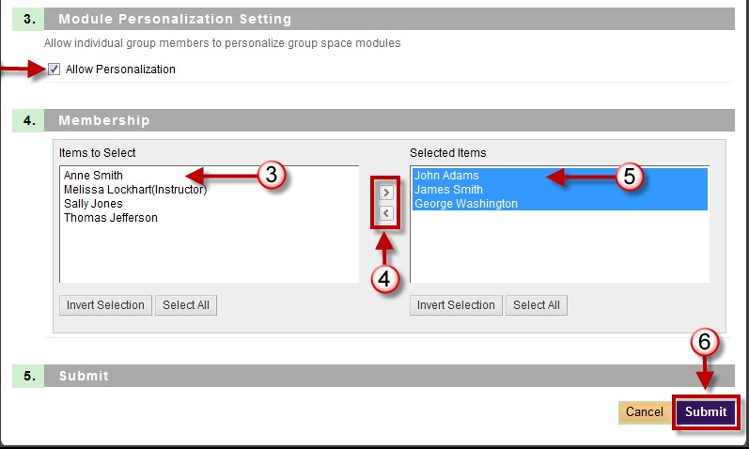
- Selecting Allow Personalization permits individuals in the Group to customize the Group space by adding personal modules such as What's New, Alerts or Dictionary.
- To enroll students manually to each Group, click the students name in the Items to Select list.
- Then click the right arrow to move the student to the Selected Items list.
- Once all Groups members have been selected click Submit. The Groups page is displayed with the new Group listed.

Creating a Group Set
You can generate several Groups at one time by using Group Sets. In addition to Manual and Self-Enrollment, you can select Random Enrollment for Group Sets. This option populates the Groups automatically—you simply choose the number of Groups or members per Group.

Creating a Group Set with Self-Enroll
The Self Enroll option allows you to create a single Group with a Sign-Up Sheet. Then students can choose which Group they want to enroll in.
To create a Group Set with Self-Enroll:
- Hover your mouse over the Create Group Set action link and select Self-Enroll.
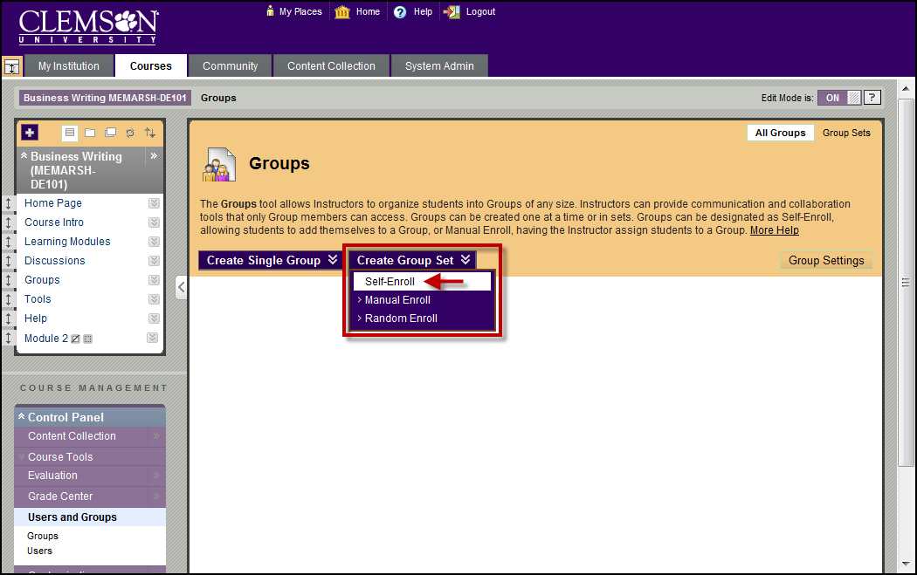
- The Create Self-Enrollment Group Set page is displayed.
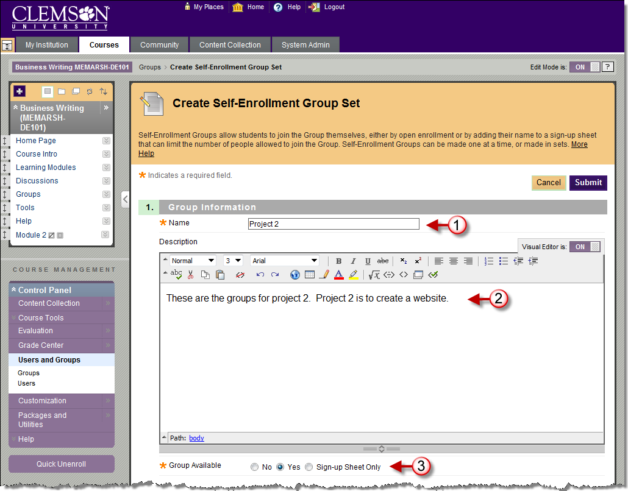
- Enter a Name and Description for the Group. When naming a set of Groups, the name of each Group has a number added to it when they are first created. For example, a Set of Groups named “Intro to Biology” results in Groups named “Intro to Biology 1”, “Intro to Biology 2”, “Intro to Biology 3”, depending on the number of Groups in the set. The Group names can be edited after they are created.
- Then select the Group Availability.
- Select No to hide the Group. If you are creating a Group to use in the Grade Center in a Smart View, you may not want to have the Groups visible to students.
- Select Yes to make the Group available.
- Select Sign-up Sheet Only to create a Sign-up Sheet for the Group that allow students to sign-up for the Group.
- Select which Tools will be available to members of the Group. Tools that can be made available to a Group include:
- Calendar – Users within the group can view important dates in a calendar format.
- Collaboration – Users within the Group can create and attend Chat sessions and Virtual Classroom sessions.
- Discussion Board – Users within the Group can create and manage their own Forums.
- Email – Users within the Group can email individual members or the entire Group.
- File Exchange – Users within the Group and the Instructor can upload files to the Group space and organize them through the creation of folders.
- Campus Pack Blog - Users within the Group can edit their group’s Campus Pack Blog. All students within the course can view a group’s blog. The Instructor can view and edit a group’s Blog and select the Grading option for Campus Pack Blogs.
- Campus Pack Podcast - Users within the Group can edit their group’s Campus Pack Podcast. All students within the course can view a group’s Podcast. The Instructor can view and edit a group’s Podcast and select the Grading option for Campus Pack Podcasts.
- Campus Pack Wiki – Users within the Group can edit their group’s Wiki. All students within the course can view a group’s Wiki. The Instructor can view and edit a group’s Wiki and select the Grading option for Campus Pack Wikis.
- Tasks – Users within the Group can create Tasks that are distributed to all Group members.
- Selecting Allow Personalization permits individuals in the Group to customize the Group space by adding personal modules such as What's New, Alerts or Dictionary.
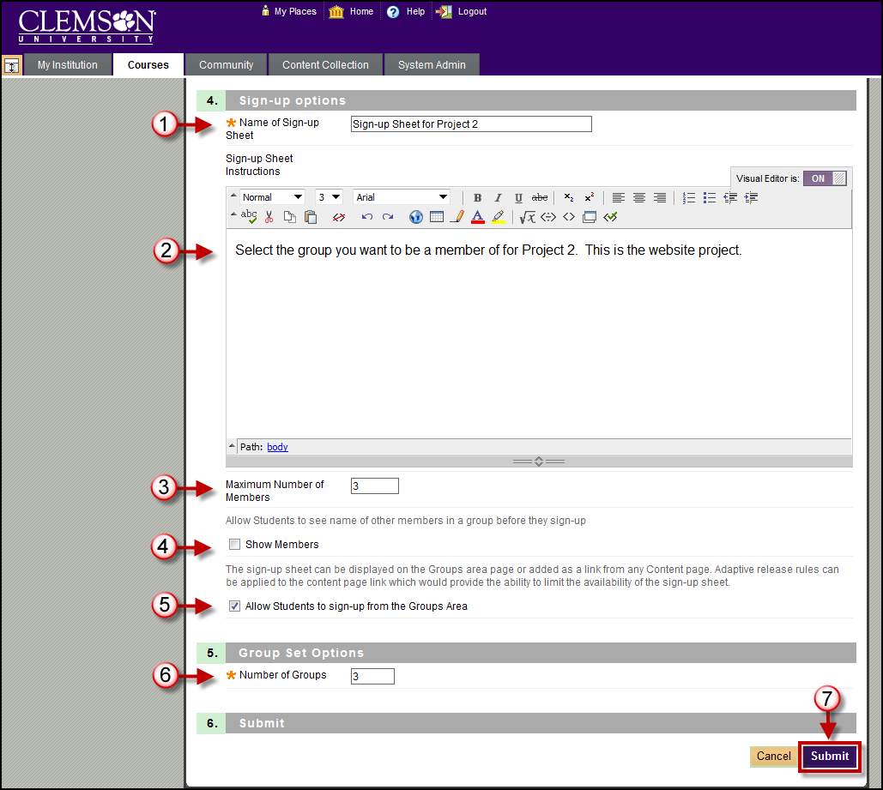
- Enter a Name for the Sign-up Sheet. Be sure the name is descriptive so that users will understand the nature of the Sign-up Sheet.
- Use the Text Box to enter a Description of the Sign-up Sheet and any instructions for signing up. This information is optional, but can help users understand expectations and any limitations to signing up.
- Enter the Maximum Number of Members for the Group. Once this number has been reached, other users will not be able to join the Group.
- Allow users to see the others who have already signed up by selecting Show Members.
- Allow users to access the Sign-up Sheet from the Groups Area page by selecting Allow Students to Sign-up from the Groups Area.
- Enter the Number of Groups to create.
- Then click Submit. The Groups page is displayed with the new groups listed.

Creating a Group Set with Manual Enroll
To create a Group Set Group with Manual Enroll:
- Hover your mouse over the Create Group Set action link and select Manual Enroll.
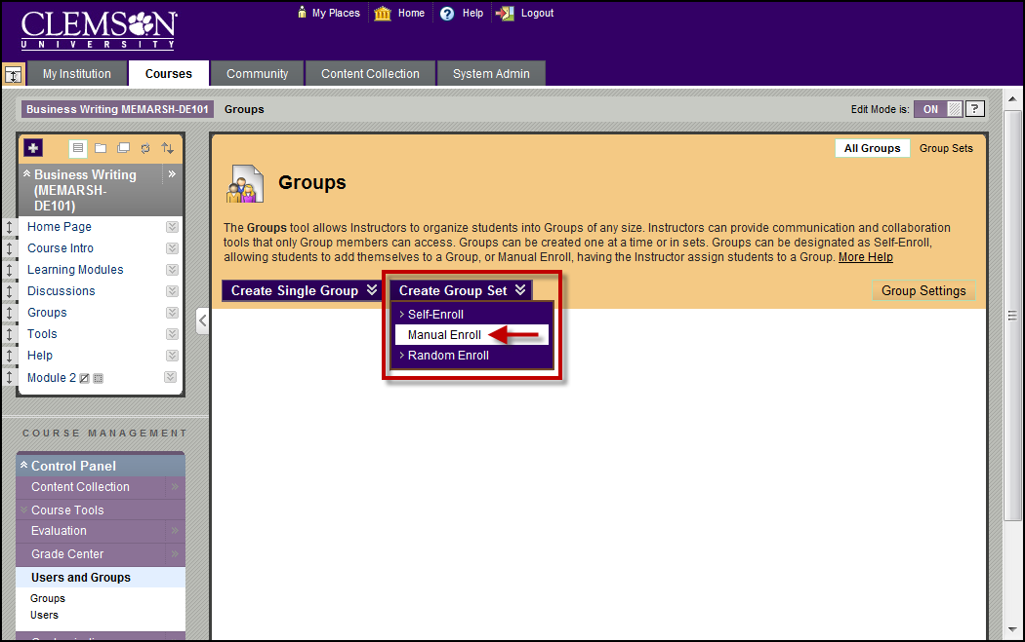
- The Create Group Set page is displayed.
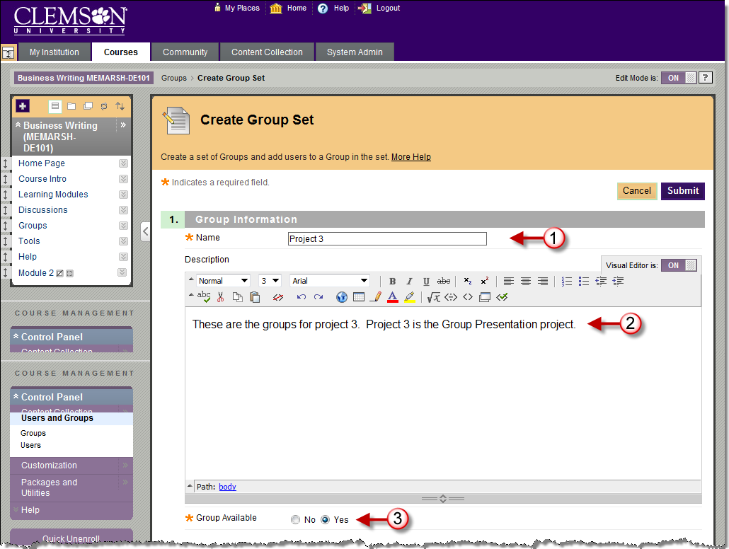
- Enter a Name and Description for the Group. When naming a set of Groups, the name of each Group has a number added to it when they are first created. For example, a Set of Groups named “Intro to Biology” results in Groups named “Intro to Biology 1”, “Intro to Biology 2”, “Intro to Biology 3”, depending on the number of Groups in the set. The Group names can be edited on the Edit Group Set Enrollments page.
- Then select the Group Availability.
- Select No to hide the Group. If you are creating a Group to use in the Grade Center in a Smart View, you may not want to have the Groups visible to students.
- Select Yes to make the Group available.
- Select which Tools will be available to members of the Group. Tools that can be made available to a Group include:
- Calendar – Users within the group can view important dates in a calendar format.
- Collaboration – Users within the Group can create and attend Chat sessions and Virtual Classroom sessions.
- Discussion Board – Users within the Group can create and manage their own Forums.
- Email – Users within the Group can email individual members or the entire Group.
- File Exchange – Users within the Group and the Instructor can upload files to the Group space and organize them through the creation of folders.
- Campus Pack Blog - Users within the Group can edit their group’s Campus Pack Blog. All students within the course can view a group’s blog. The Instructor can view and edit a group’s Blog and select the Grading option for Campus Pack Blogs.
- Campus Pack Podcast - Users within the Group can edit their group’s Campus Pack Podcast. All students within the course can view a group’s Podcast. The Instructor can view and edit a group’s Podcast and select the Grading option for Campus Pack Podcasts.
- Campus Pack Wiki – Users within the Group can edit their group’s Wiki. All students within the course can view a group’s Wiki. The Instructor can view and edit a group’s Wiki and select the Grading option for Campus Pack Wikis.
- Tasks – Users within the Group can create Tasks that are distributed to all Group members.
- Selecting Allow Personalization permits individuals in the Group to customize the Group space by adding personal modules such as What's New, Alerts or Dictionary.
- Enter the Number of Groups to create.
- Then click Submit.
Note: At this point the Groups have been created. So if you cancelled the Group setup at this point you would see the Groups that have been created on the Groups page.
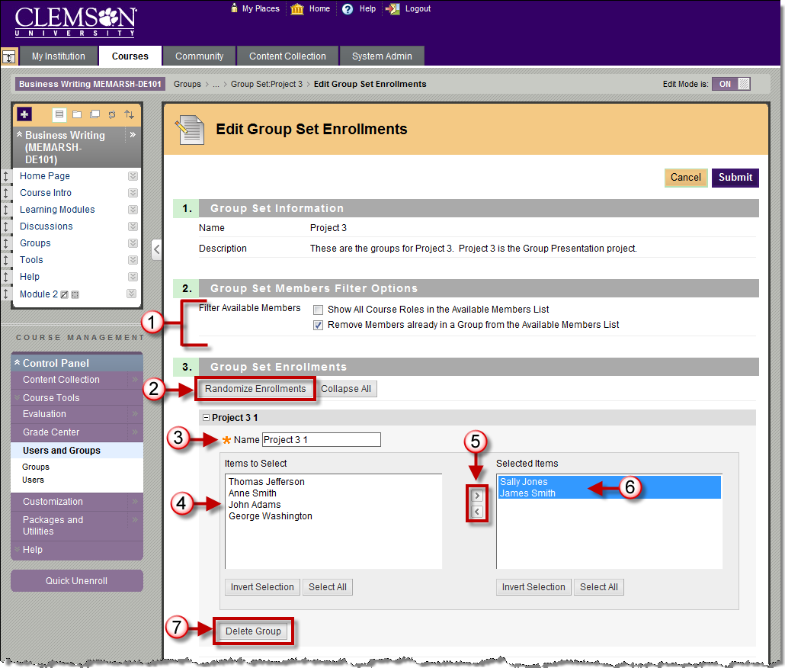
- The Edit Group Set Enrollments page is displayed.
- To show all users in the current course, including the instructor and TA’s, select Show All Course Roles in the Available Members List.
- Select Remove Members already in a Group from the Available Members List. This will ensure that you do not put a student in two Groups. If you want to have a member be able to participate in more than one Group, unselect this option.
- Click Randomize Enrollments to divide up all the members of the Course among all the Groups based on criteria chosen by the faculty.
Note: The Groups must be equal for random enrollment to work properly. For example, if you have 5 students in the class and you are creating 3 Groups, 3 students will be assigned(one to each Group). Then you will have to manually assign the remaining two people to a Group.
- At this point you can rename the individual Groups in the set by modifying the Group Name.
- To enroll students manually to each Group, click the students name in the Items to Select list.
- Then click the right arrow to move the student to the Selected Items list.
- To remove excess Groups, click Delete Group for the Group to remove.
- To create an additional Group in the Group Set, click Add Group.
- Once all students are enrolled in a Group, click Submit. The Groups page is displayed with the new Groups listed.

Creating a Group Set with Random Enroll
To create a Group Set Group with Random Enroll:
- Hover your mouse over the Create Group Set action link and select Random Enroll.
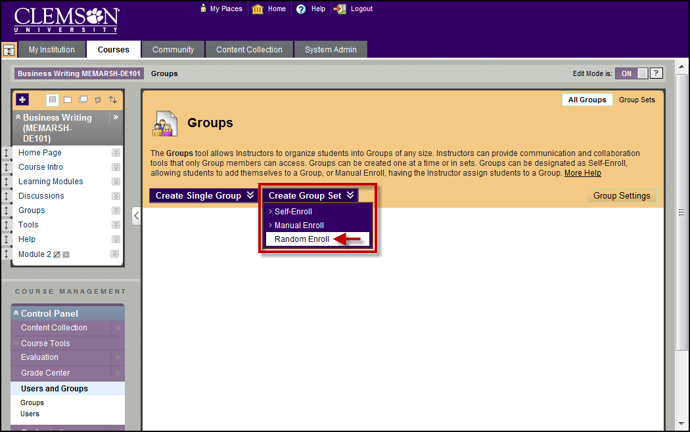
- The Create Random Enrollment Group Set page is displayed.
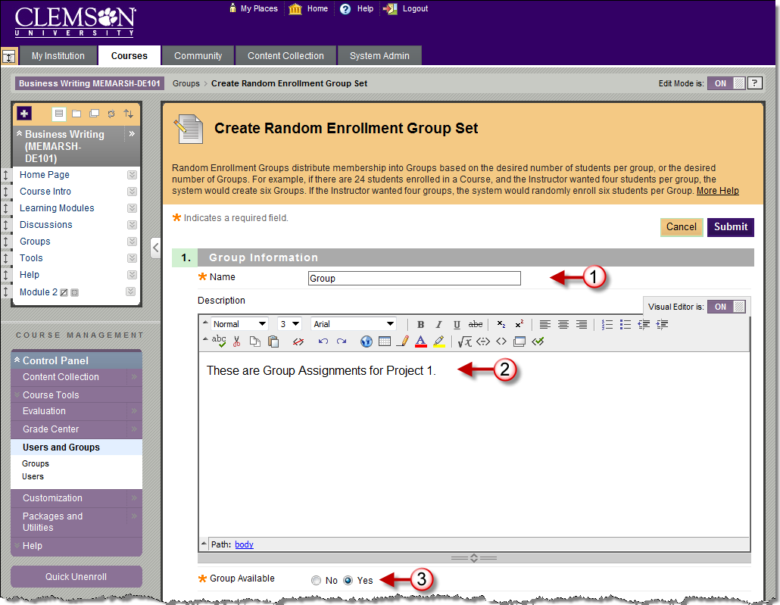
- Enter a Name and Description for the Group. When naming a set of Groups, the name of each Group has a number added to it when they are first created. For example, a Set of Groups named “Intro to Biology” results in Groups named “Intro to Biology 1”, “Intro to Biology 2”, and “Intro to Biology 3”, depending on the number of Groups in the set.
- Then select the Group Availability.
- Select No to hide the Group.
- Select Yes to make the Group available.
- Select which Tools will be available to members of the Group. Tools that can be made available to a Group include:
- Collaboration – Users within the Group can create and attend Chat sessions and Virtual Classroom sessions.
- Discussion Board – Users within the Group can create and manage their own Forums.
- Email – Users within the Group can email individual members or the entire Group.
- File Exchange – Users within the Group and the Instructor can upload files to the Group space and organize them through the creation of folders.
- Journals – All members of a Group can view each other's entries, but the Group Journal can only be viewed by the Group and the Instructor. Instructors can select the Grading option for Journals.
- Tasks – Users within the Group can create Tasks that are distributed to all Group members.
- Wikis – Users within the Group can edit their Group Wiki. All students within the course can view a Group Wiki. The Instructor can view and edit a Group Wiki and select the Grading option for Group Wikis.
- Selecting Allow Personalization permits individuals in the Group to customize the Group space by adding personal modules such as What's New, Alerts or Dictionary.
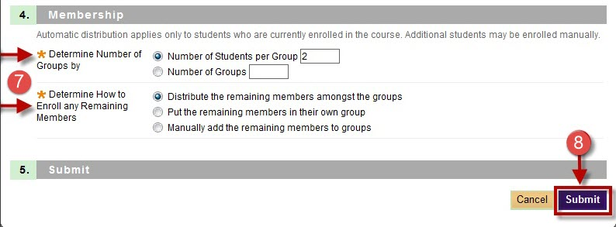
- Select Group Membership.
- Determine Number of Groups By
  - Choose Number of Students per Group to divide the enrolled students by a number of students per Group.
  - Choose Number of Groups to divide the enrollment students by the number of Groups in the course.
- Determine how to enroll any remaining members
- Choose Distribute the remaining members amongst the Groups to enroll remaining members automatically.
- Choose Put the remaining members in their own Group to create a new Group containing the remaining members.
- Choose Manually add the remaining members to Groups to permit the instructor to enroll the remaining members.
- Then click Submit. If you selected to Distribute the remaining members amongst the Groups or Put the remaining members in their own Group in Step 7b, the Groups page is displayed with the new Groups listed. The students are randomly assigned to their respective Groups.
- However, if you selected to Manually add the remaining members to Groups in 7b, the Edit Group Set Enrollments page will be displayed.
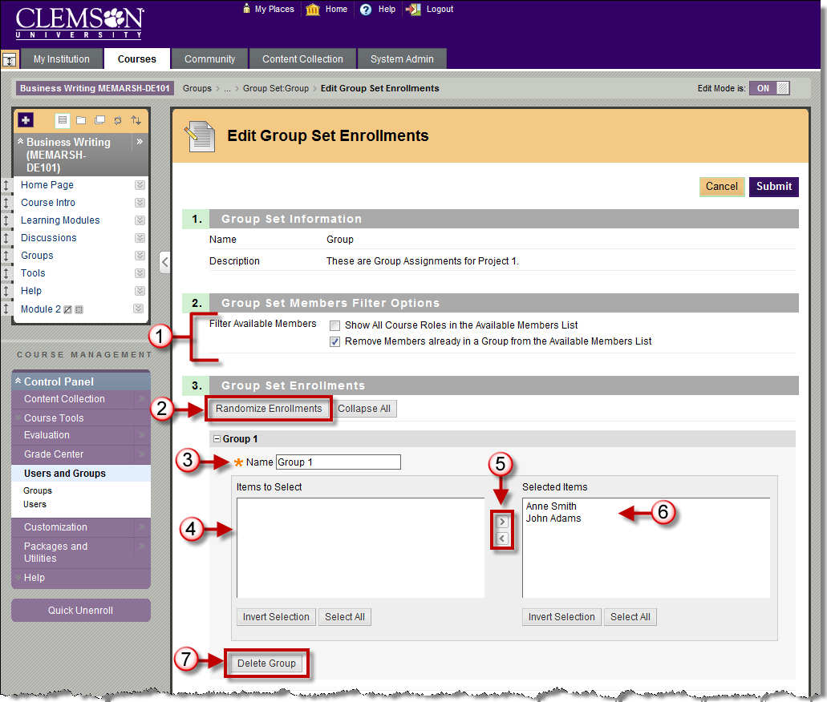
- To show all users in the current course, including the instructor and TA’s, select Show All Course Roles in the Available Members List.
- Select Remove Members already in a Group from the Available Members List. This will ensure that you do not put a student in two Groups. If you want to have a member be able to participate in more than one Group, unselect this option.
- At this point you can rename the individual Groups in the set by modifying the Group Name.
- Click the students name in the Items to Select list, to enroll the remaining students manually to a Group.
- Then click the right arrow to move the student to the Selected Items list.
- Once the remaining students are enrolled in a Group, click Submit. The Groups page is displayed with the new Groups listed.

Group Settings
Group Settings provide the Instructor with the options of allowing students to create their own Self-Enrollment Group from the Groups page and allowing students to edit the name, description, and maximum number of students able to join the Group.
To modify Group settings:
- From the Groups Page, click Group Settings.
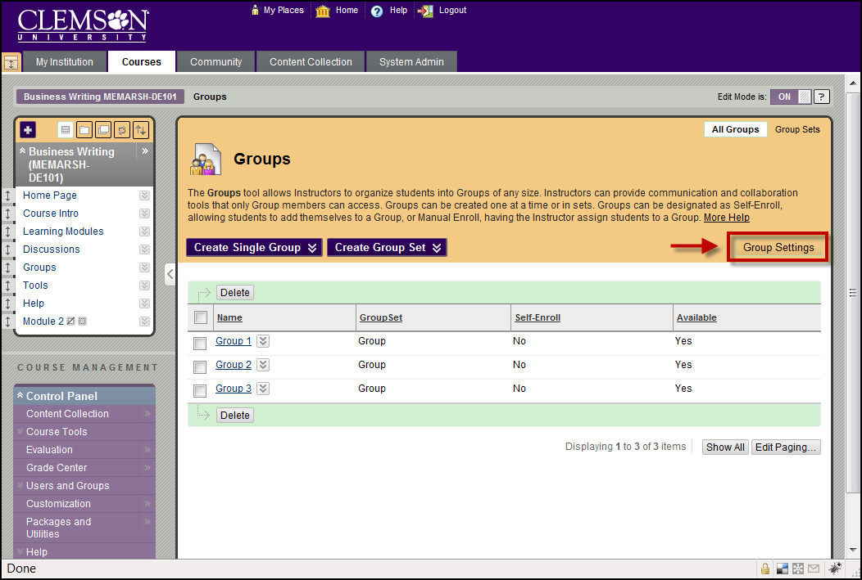
- The Group Settings page is displayed.
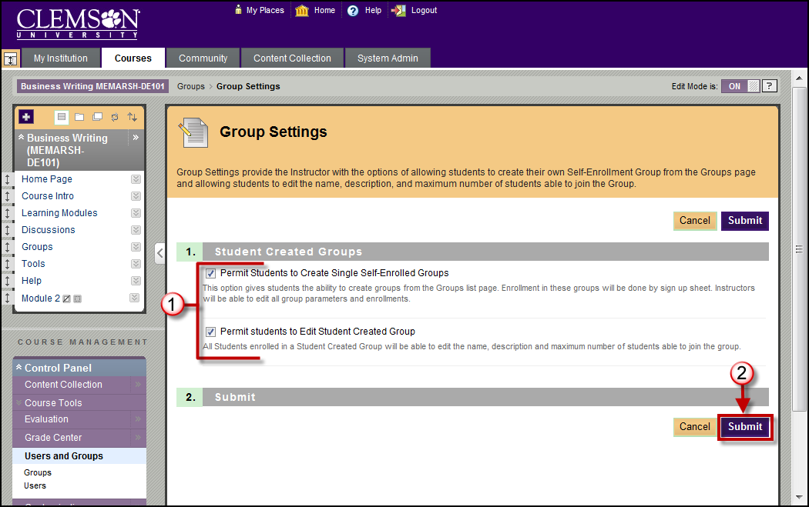
- To allow students to create Groups from the Group list page select Permit Students to Create Single Self-Enrolled Groups. Enrollment in these Groups will be done by sign-up sheets. Instructors will be able to edit all Group parameters including enrollment.
- To allow students to modify student created Groups, select Permit students to Edit Student Created Group. This will allow students enrolled in a Student Created Group to edit the name, description and maximum number of students able to join the Group.
- Click Submit. The Groups page is displayed.

