Deploying a Test

Blackboard Beginners

Deploying the Test into a Content Area 1
Modifying the Test Options 7

Deploying the Test into a Content Area
- Login to MyCLE.
- Click the Courses tab.
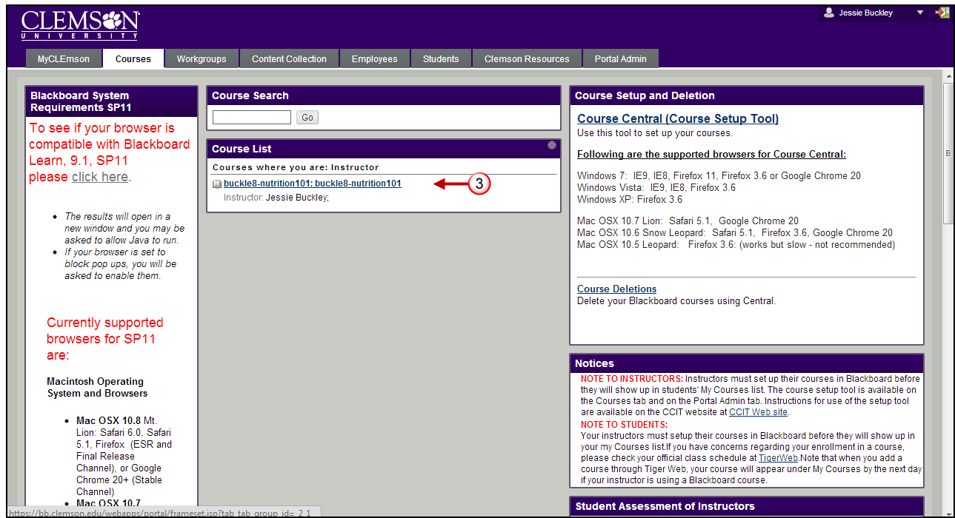
- Click the course link. The system navigates you to the course home page.

- From the course menu, click the Content Area where the test should be deployed. For this example we will use the Quizzes/Tests Content Area.
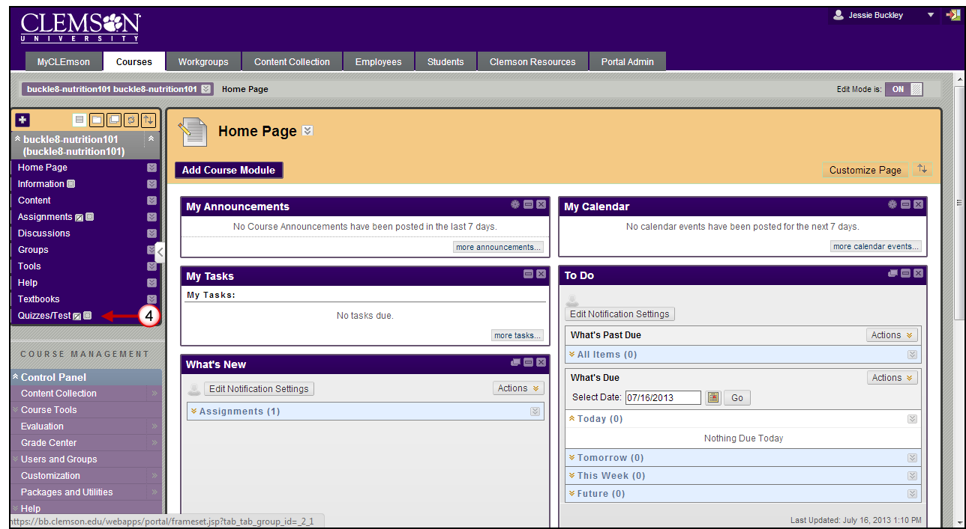
- Then hover your mouse over the Assessments action link and select Test.
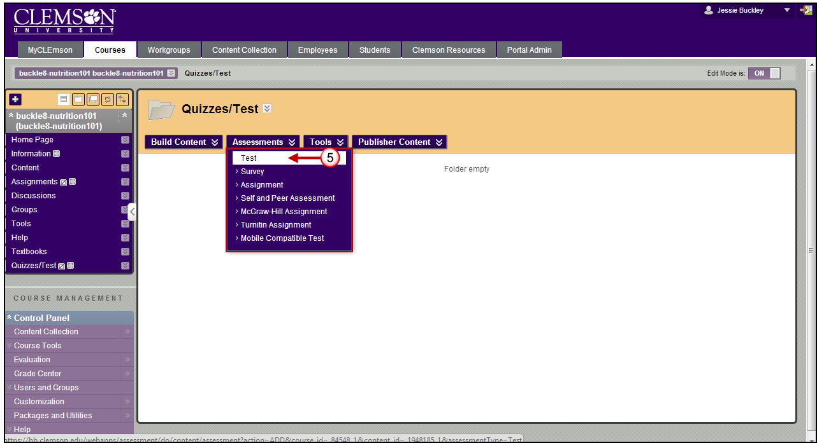
- The Create Test page is displayed.
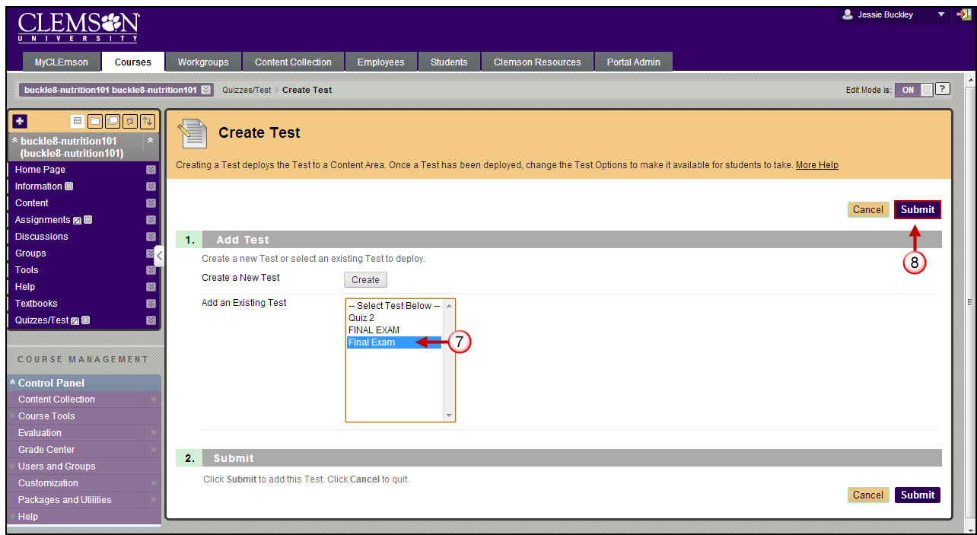
- Select the test you want to deploy.
- Then click the Submit button.
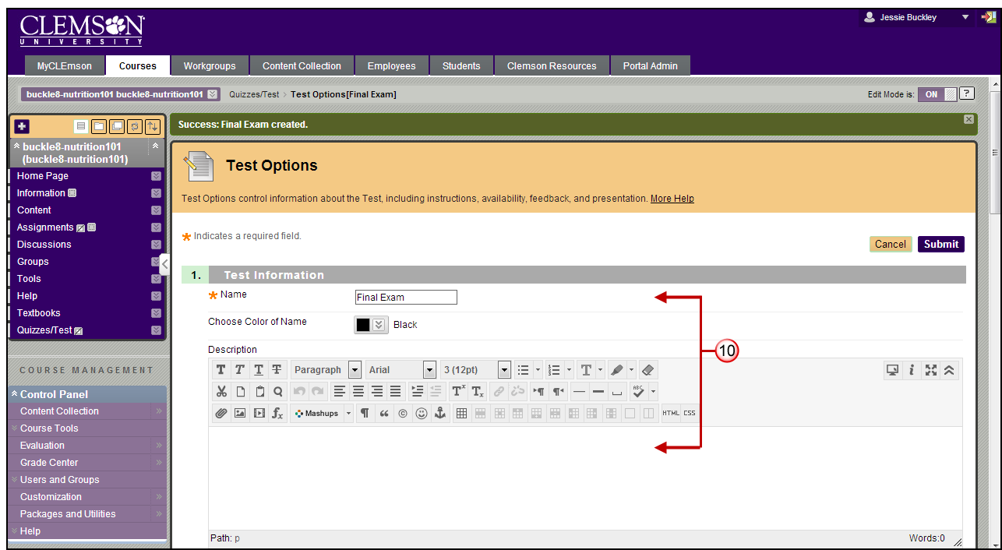
- The Test Options page is displayed.
- The Name and Description are brought in from the test properties.
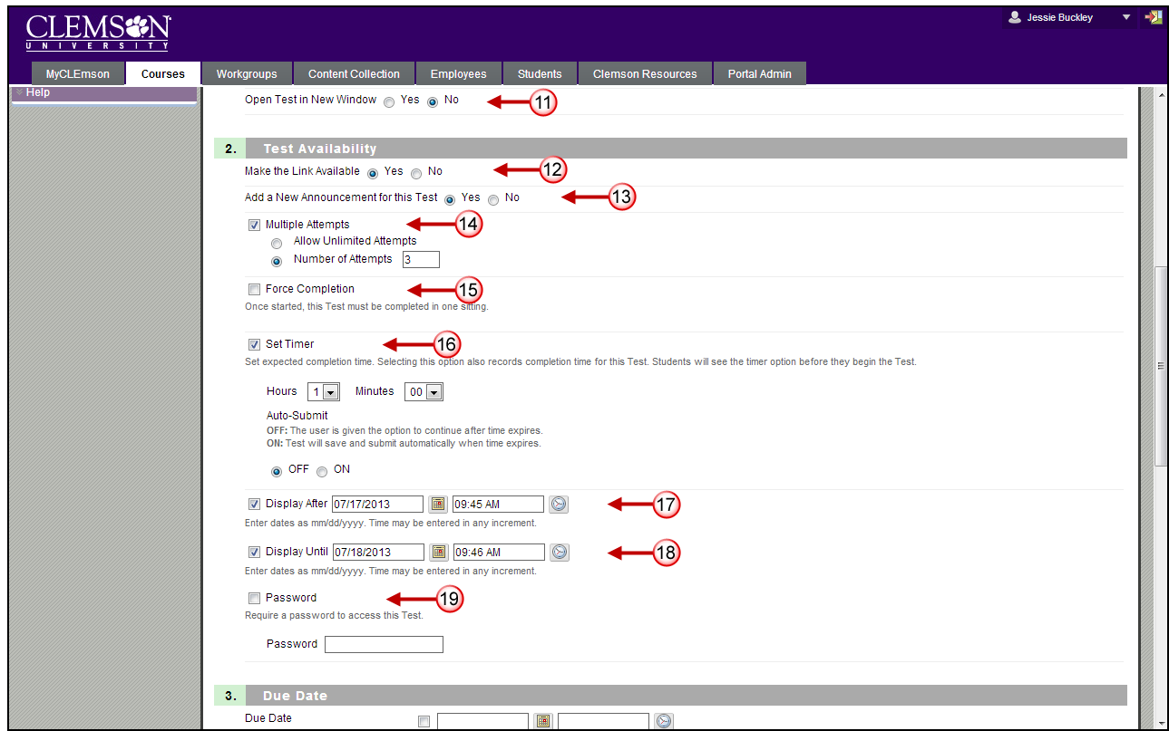
- Select No for the Open Test in New Window radio button. If students have pop-up blockers turned on, and the Yes radio button is selected, it may prevent the test from opening for students.
- In the Test Availability section, select the Yes radio button to make the test link available.
- Select the Yes radio button to Add a new announcement for this test.
- By default students will be allowed to take the test once. If faculty prefer for students to be able to attempt the test more than once, they can select the Multiple Attempts checkbox. There are two options available:
- Allow unlimited Attempts – this option when selected allows students to take the Test an unlimited number of times.
- Number of Attempts – this options when selected allows students to take the Test a specific number of times.
- CCIT strongly recommends not selecting the Force Completion checkbox. If a student inadvertently exits or is timed out of a test s/he cannot return to complete the test. This feature does not serve as a good substitute for an enforced timer. Selecting the Force Completion checkbox makes students complete the test the first time it is launched. Students may not exit the Test and continue working on it at a later date. This option will not allow students to exit and re-enter the test. When enabled, Force Completion is explained to the students at the top of the test.
- Select the Set Timer checkbox. Then specify the number of hours and minutes they will be allowed to complete the test. If students go beyond the set timer, they will not be forced out of the test. However, a green exclamation mark will appear in the Grade Center to let you know the test has to be graded manually.
NOTE: Selecting the On button under the Set Timer field will auto submit the test when the time window has completed. If the Off button is selected it will allow the student to complete the test, but mark it with a green exclamation point and require the teacher to grade as previously described.
- Select the checkbox for Display After. Then enter the date and time to begin displaying the test link.
- Select the checkbox for Display Until. Then enter the date and time to end displaying the test link.
- If you have just one student who needs to make up the exam or needs additional time to take the exam, you can select the Password checkbox. Then enter a password that you will share with select students. (The password option is also used for electronic tests taken in person. The instructor will give the password to the students during the class.)
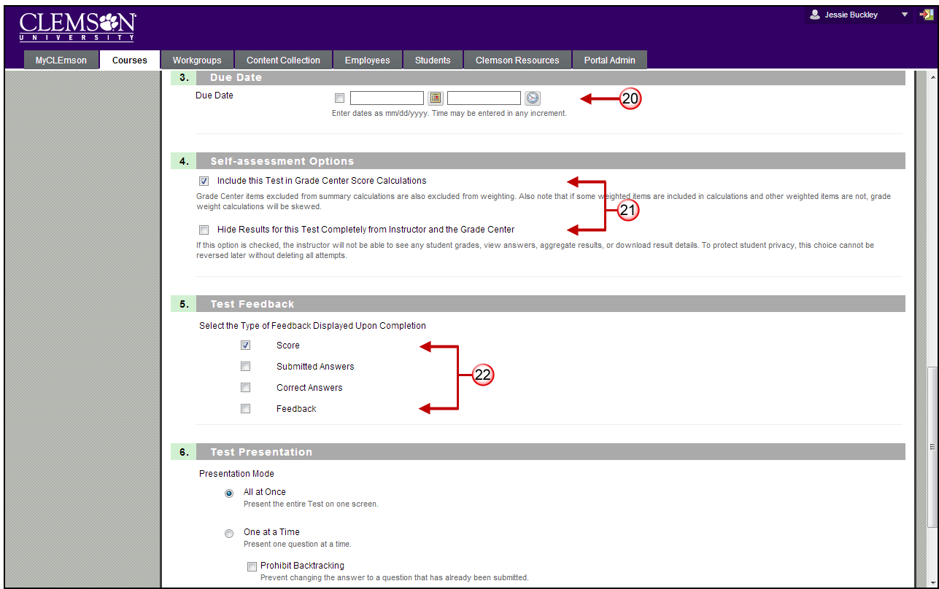
- Select the checkbox in the Due Date section. Then enter a date and time the assignment is due. The Due Date shows up on the Homepage.
- In the Self-assessment Options section, select the checkbox to Include this test in Grade Center Score Calculations. If you choose the second option (Hide Results for this Test Completely from Instructor and the Grade Center), the computer will automatically grade the test, but the professor will not be able to view the student responses or scores. The second option is meant for self-assessments.
- Select the type of feedback to provide students in the Test Feedback section.
- Score - Shows the score the Student achieved out of points possible.
- Submitted Answers - Shows the student all the answers they submitted.
- Correct Answers - Shows the student all of the correct answers for each question.
- Feedback - Shows the student Instructor generated feedback messages for each question.
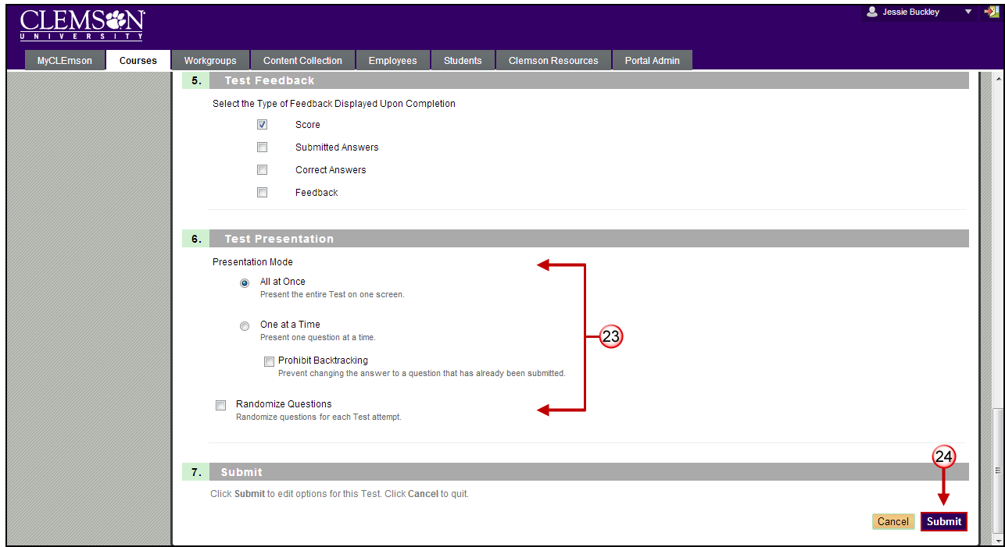
- Select how the test will be presented to students in the Test Presentation section.
- All at once - The entire test is displayed on one screen. Students can scroll up and down to answer questions. This option does not require the student to save after answering each question. Therefore, if they accidentally get taken out of the test, they may lose the work they have done so far.
- One at a time - Each question is displayed alone on the screen. Students control going to the next question. This option requires students to save each time they move on to the next question. If they accidentally get taken out of the test, and the test is set to multiple attempts, they can resume the test where they left off.
- Prohibit Backtracking - The setting is only used when questions are displayed one at a time. Students are not allowed to go back and change the answer to a question that has already been answered. The problem that we often encounter when this setting is turned on, is that students tend to press the back button on their web browser. This can accidentally take them out of the test. If the test is not set to multiple attempts, they then have used their one attempt.
- Randomize Questions - Tests with multiple questions will be displayed in a random order to Students. Different Students see the questions in a different order. The same Student will see questions in a different order when multiple attempts are permitted.
- Then click the Submit button.

Modifying the Test Options
To modify the test options:
- Navigate to the Content Area where the test is deployed.
- Click the action link at the end of the test name.
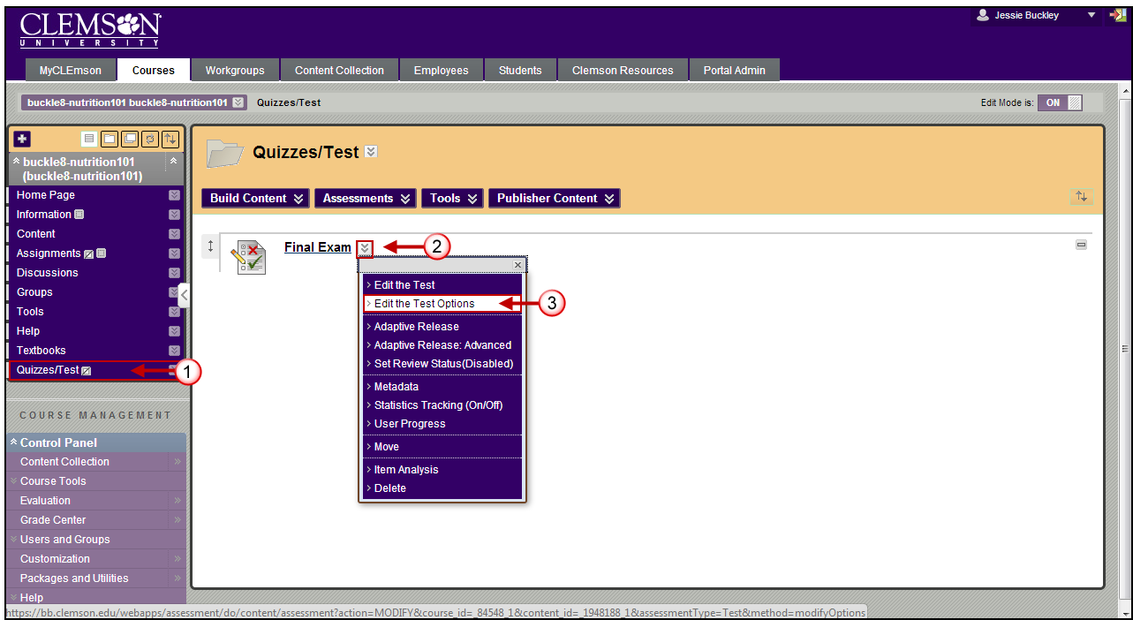
- Select Edit the Test Options.
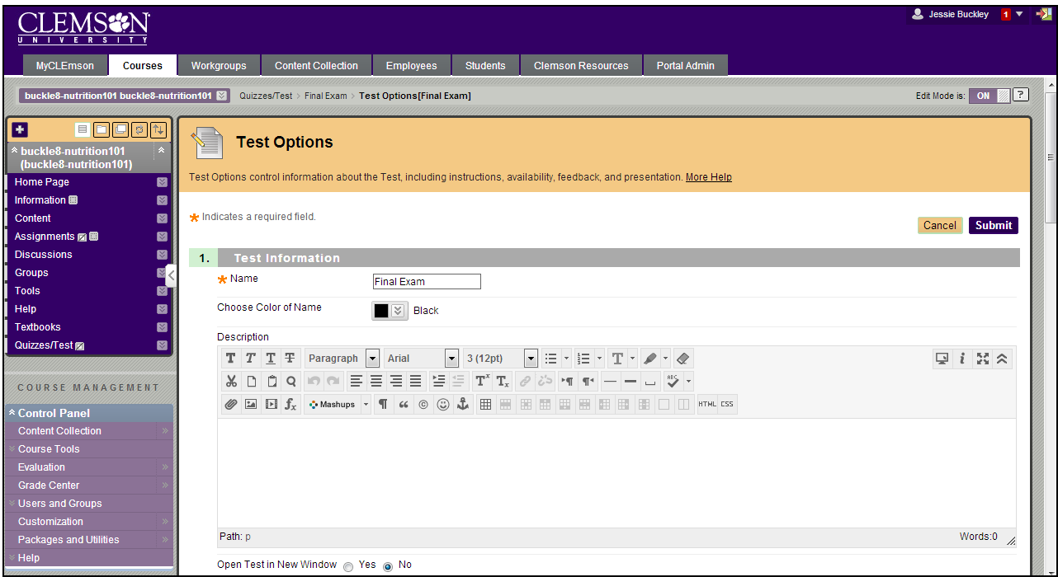
- The Test Options page is displayed.
- Modify the Test Options as needed.
- Then click the Submit button to save your changes.

