Grading Group Assignments

Intermediate

Grading a Group Assignment with Single Attempt 1
Grading a Group Assignment with Multiple Attempts 4
Downloading Multiple Group Assignments 7
Edit a specific User Attempt 9
Reverting an Individual Grade to a Group Grade 12
Clearing All Attempts for a specific Group Member 14
Clear Attempts for All Users for an Assignment 17

After receiving and reviewing submissions from Group Assignments, Instructors can grade and offer comments on the submissions. The grade and comments are then returned to the entire Group.
Grades for Assignments are entered in the corresponding Column and row in the Grade Center or from the Grade Detail page.

Grading a Group Assignment with Single Attempt
To grade a Group Assignment:
- From the Control Panel, click the chevron to expand Grade Center.
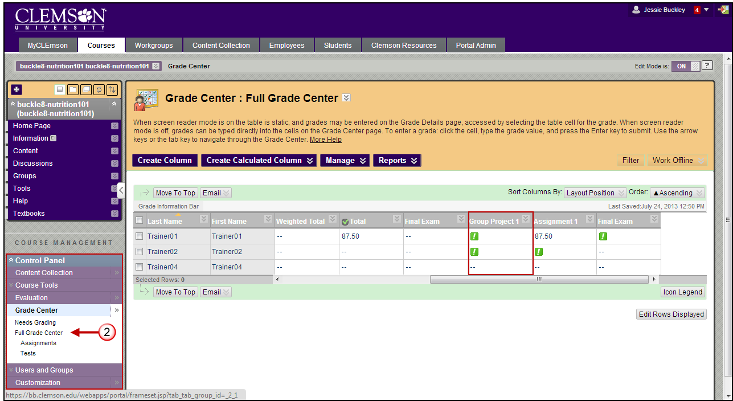
- Click Full Grade Center.
- Then in the Group Assignment column, click the chevron next to the exclamation point to view the options for the submitted assignment.
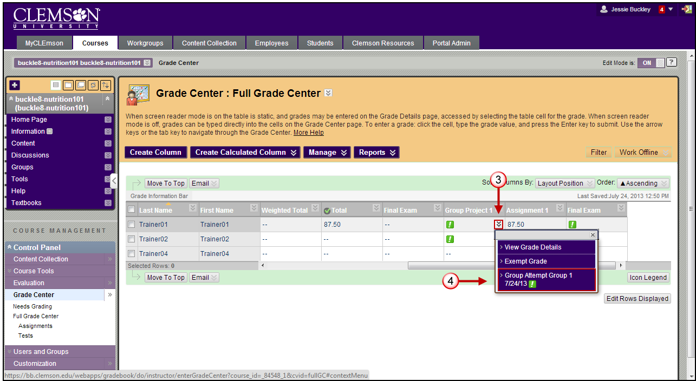
- Select an attempt to grade. The Grade Group Attempt page is displayed.
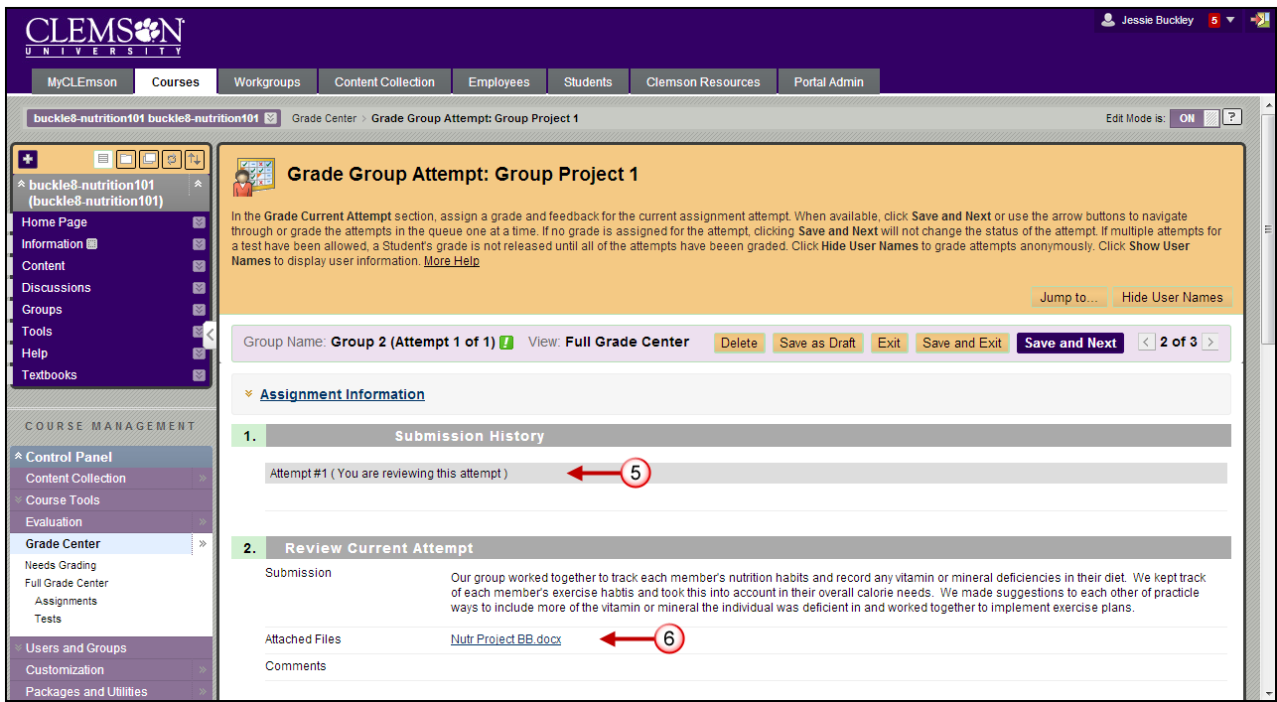
- In the Submission History area, you can see which attempt you are currently viewing.
- In the Review Current Attempt area, click the links for the Attached Files to download the documents the Group submitted for the selected assignment.
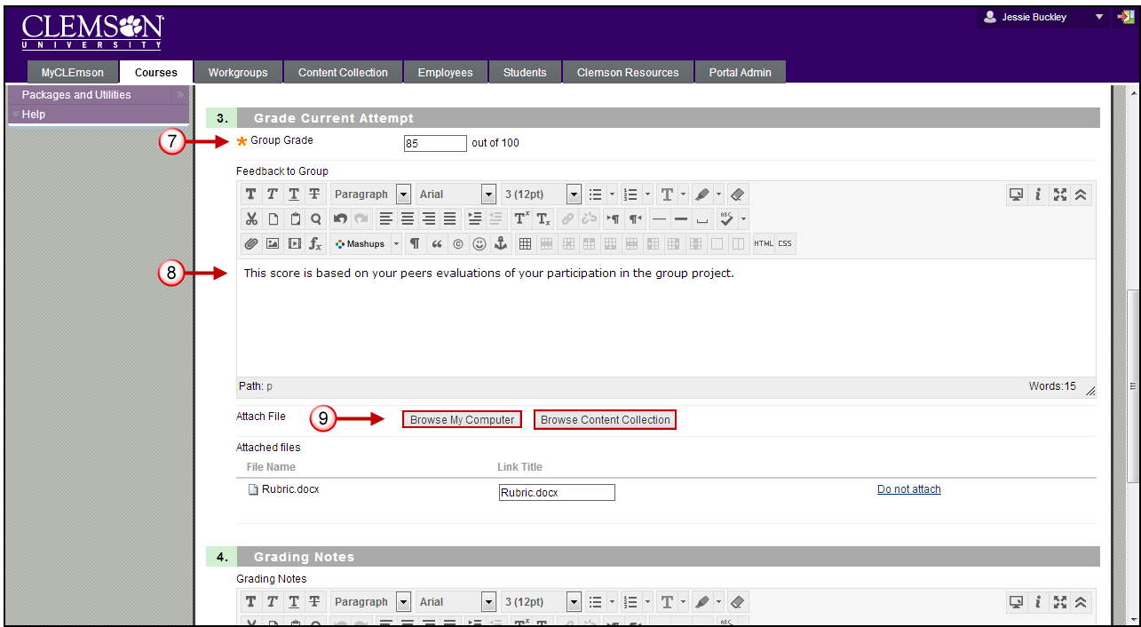
- In the Grade Current Attempt area, enter the Group Grade.
- Enter Feedback to Group.
- Click Browse My Computer and select and files that contain information that needs to be shared with the Group. This can be their document with markups or a copy of the rubric with notes attached.
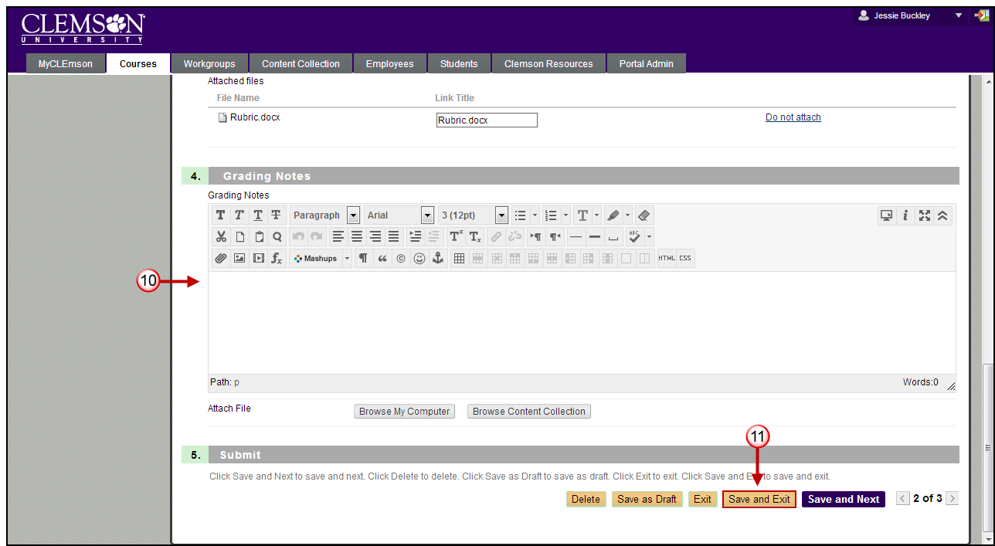
- Enter Grading Notes. These are notes that only the instructor can see.
- Click Save and Exit to return to the Grade Center.
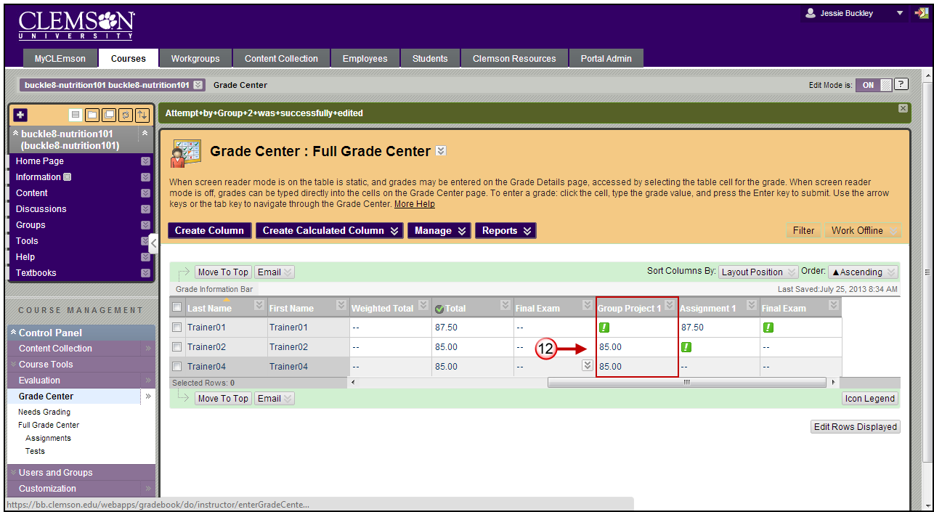
- The Grade Value assigned to the Group will be displayed in the grade column for all members of the Group.

Grading a Group Assignment with Multiple Attempts
To grade a Group Assignment with multiple attempts:
- From the Control Panel, click the chevron to expand Grade Center.
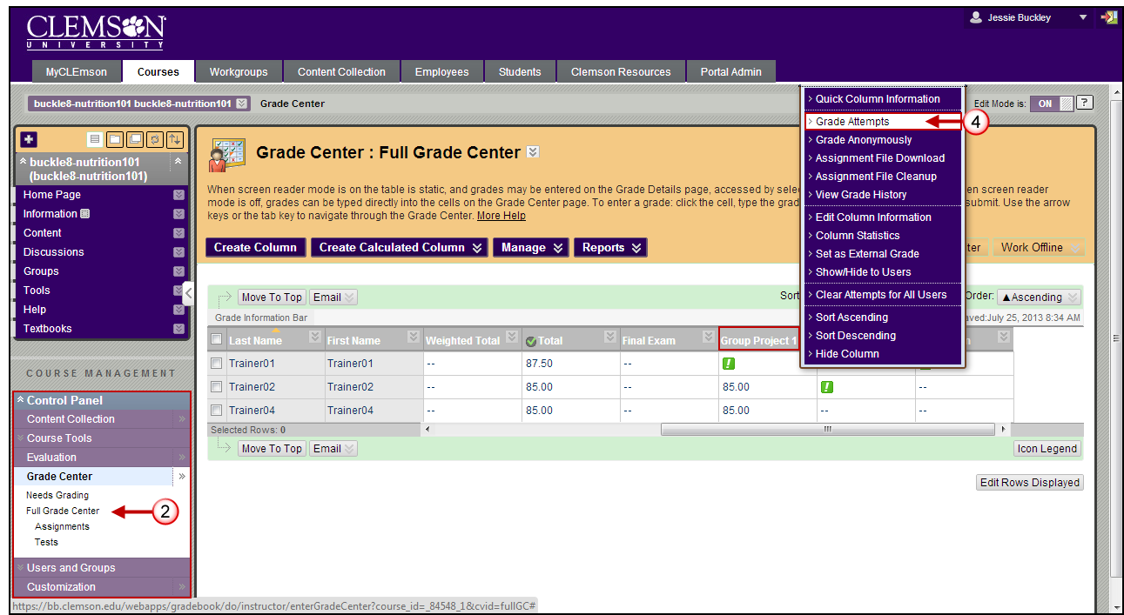
- Click Full Grade Center.
- Then in the Group Project column, click the chevron next to the column title to view the options for the selected column.
- Select Grade Attempts.
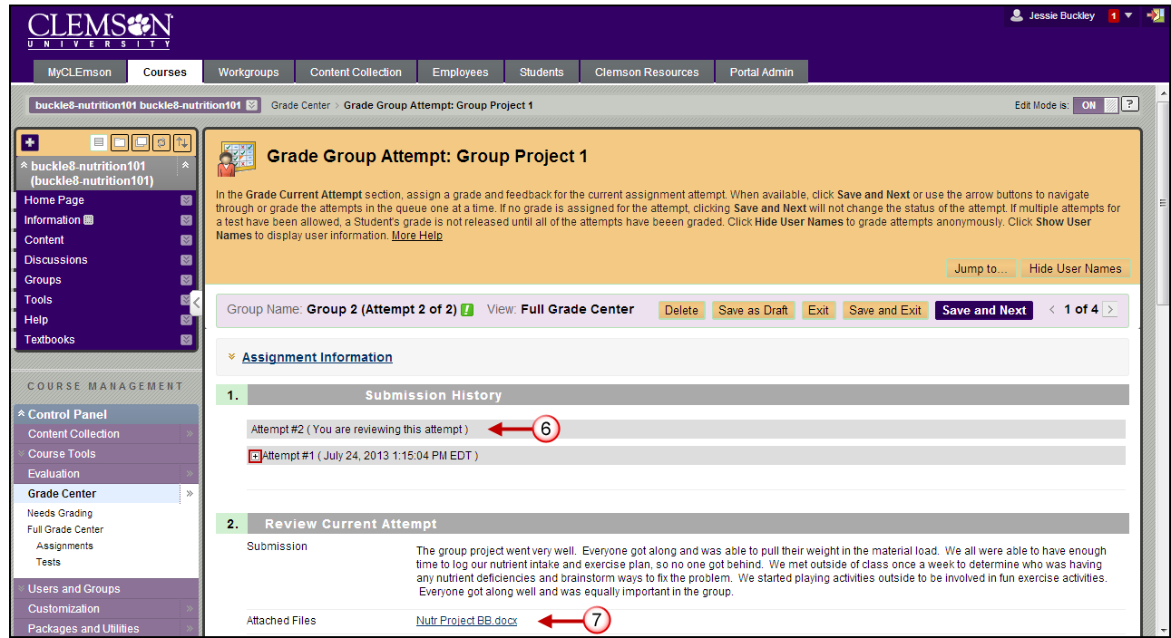
- The Grade Group Attempt page is displayed.
- In the Submission History area, you can see which attempt you are currently viewing. Click the plus sign to view the details of a previous attempt.
- In the Review Current Attempt area, click the links for the Attached Files to download the documents the Group submitted for the selected assignment.
- In the Grade Current Attempt area, enter the Group Grade.
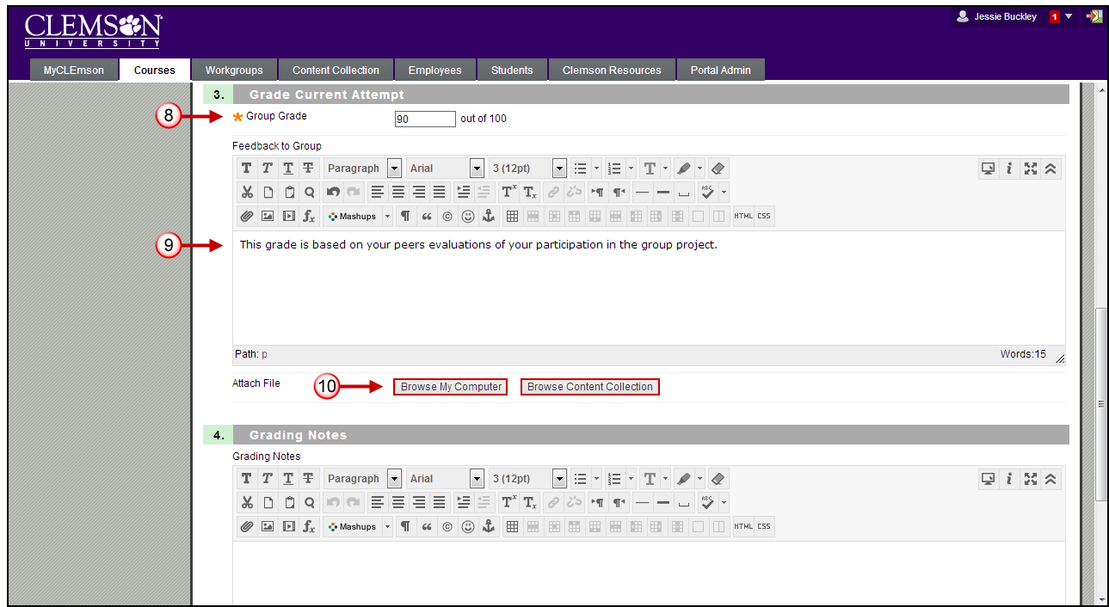
- Enter Feedback to Group.
- Click Browse My Computer to find and select an files that contain information that needs to be shared with the Group. This can be their document with markups or a copy of the rubric with notes attached.
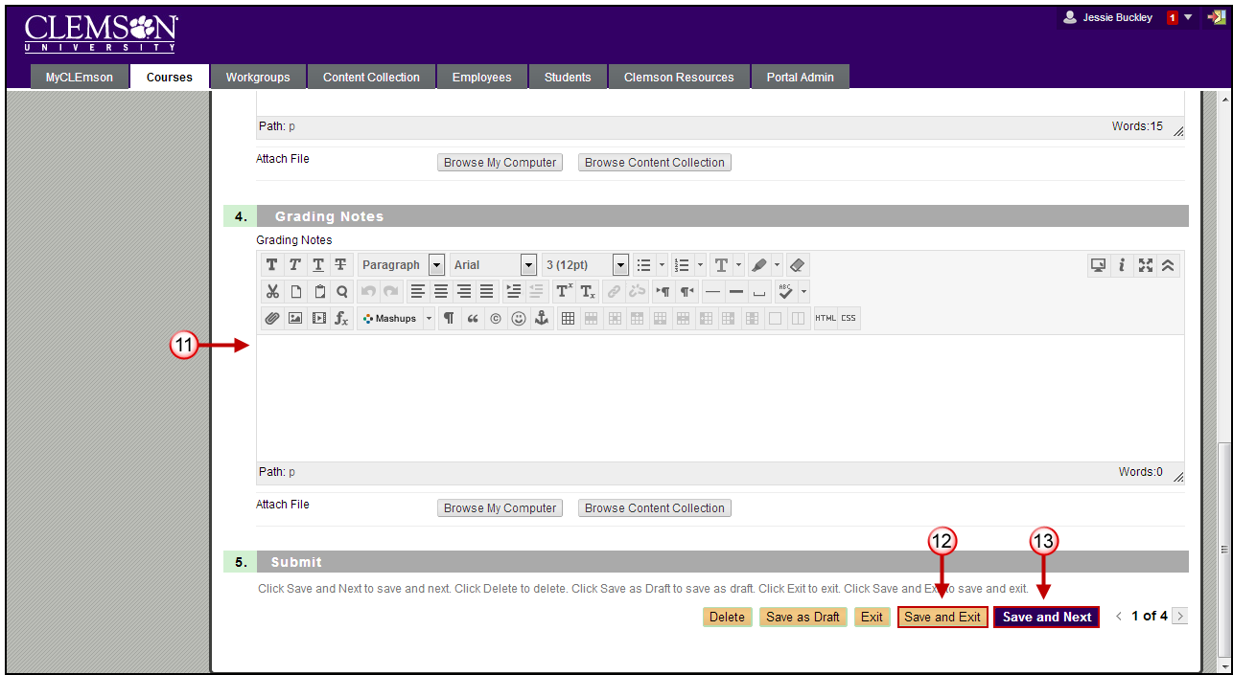
- Enter Grading Notes. These are notes that only the instructor can see.
- Click Save and Exit to return to the Grade Center.
- Click Save and Next to view the next submission to grade.
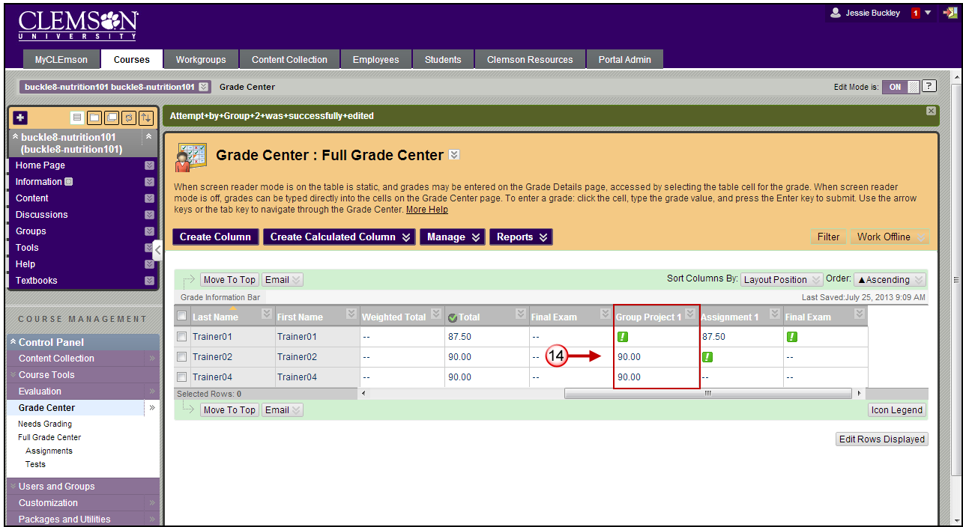
- The Grade Value assigned to the new Group Attempt will be displayed in the grade column for all members of the Group.

Downloading Multiple Group Assignments
- From the Grade Center, click the chevron for the Group Assignment column.
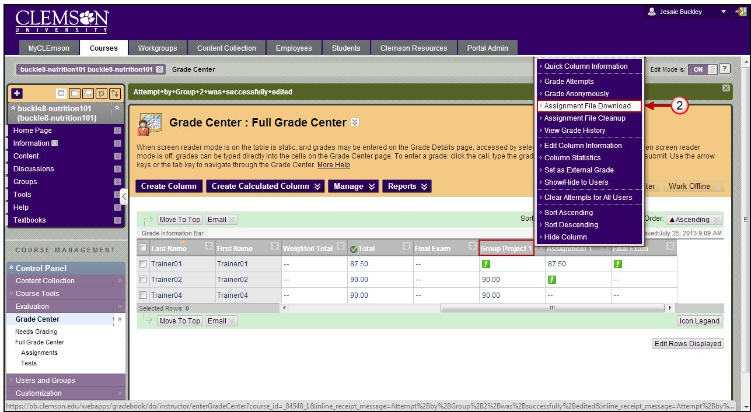
- Then select Assignment File Download.
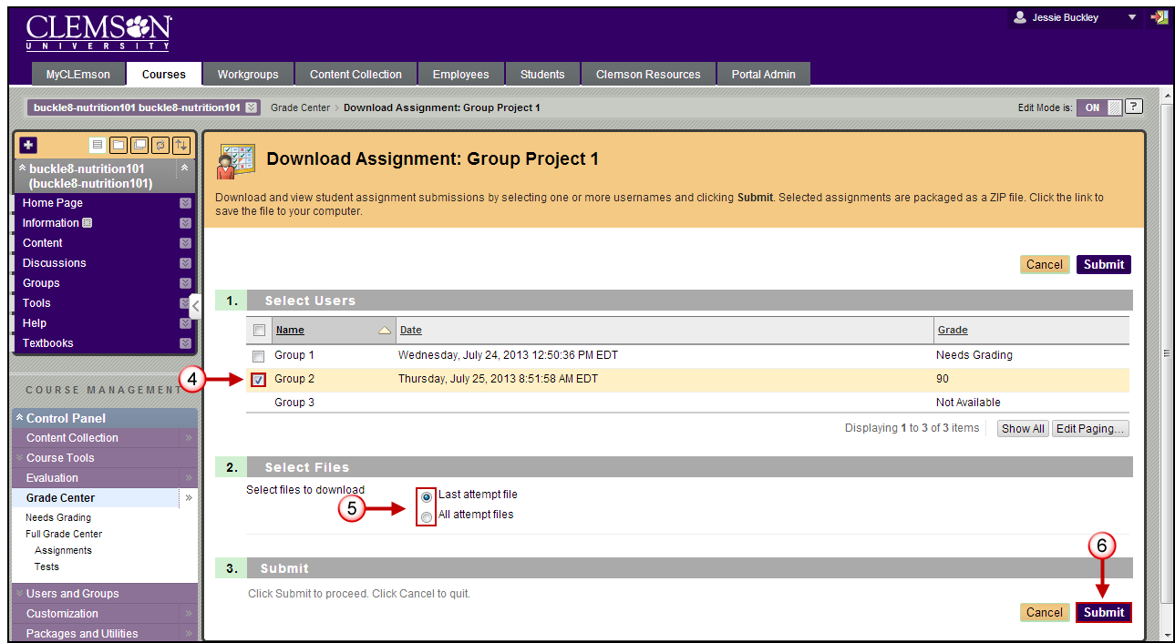
- The Download Assignment page is displayed.
- Select the Groups assignments to download.
- Select if you would like to download the Last attempt file, or All attempt files.
- Then click Submit.
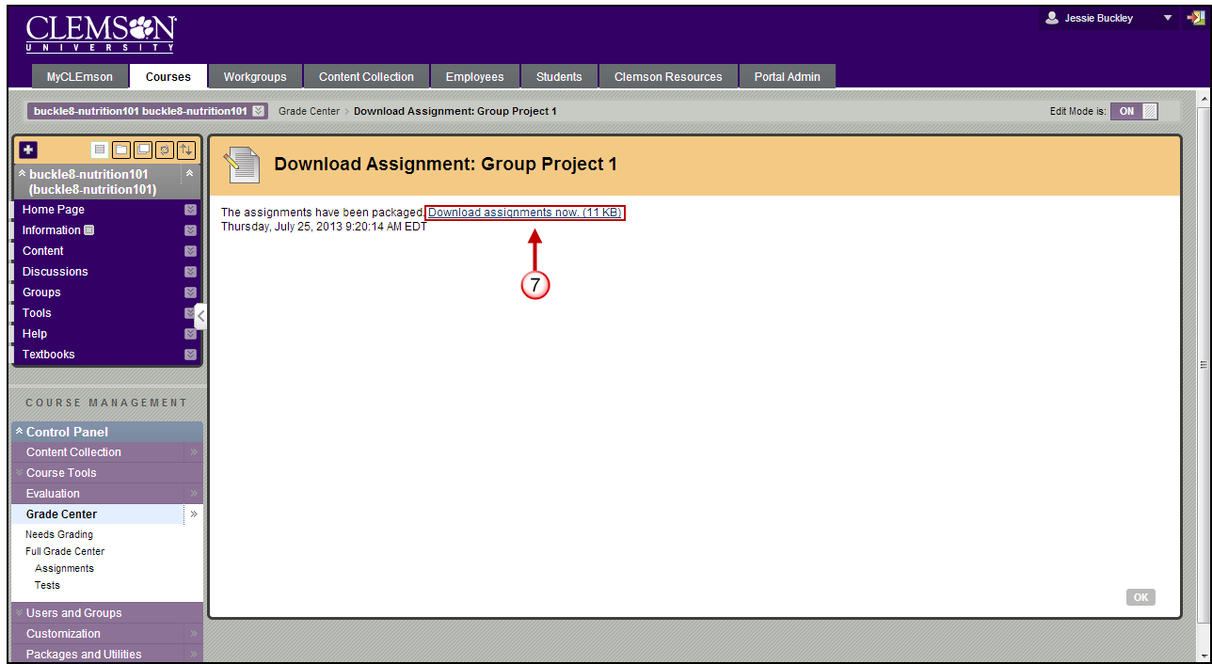
- A link will be displayed to Download assignments now. Click this link.
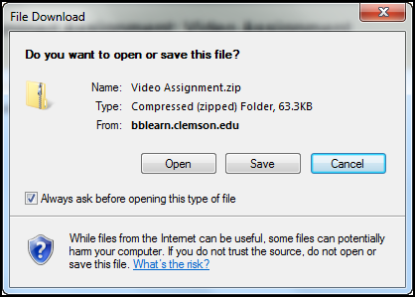
- The File Download window will be displayed.
- Click Save to download the zip file to your computer. Then click Open to open the zip file.
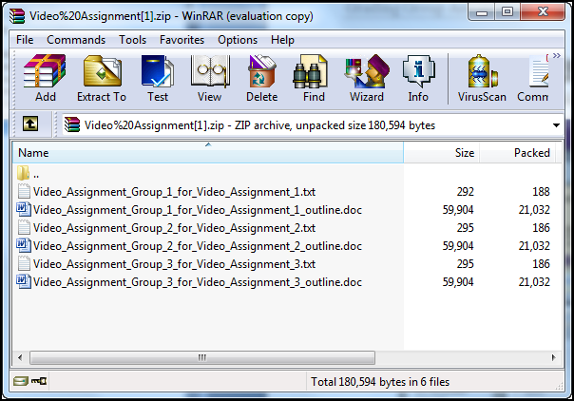
- For each assignment there may be a .txt file. This file will only appear if the students entered a Comment or Submission details.
- If students have attached files with their submission, those files will be included in the zip file with the Group Name and the File Name as well. In the example above all three Groups entered Submission details, so a .txt file appears for each Group. Then each Group submitted a Microsoft Word document titled “outline.doc”.

Edit a specific User Attempt
To edit a specific User Attempt for a Group:
- From the Control Panel, click the chevron to expand Grade Center.
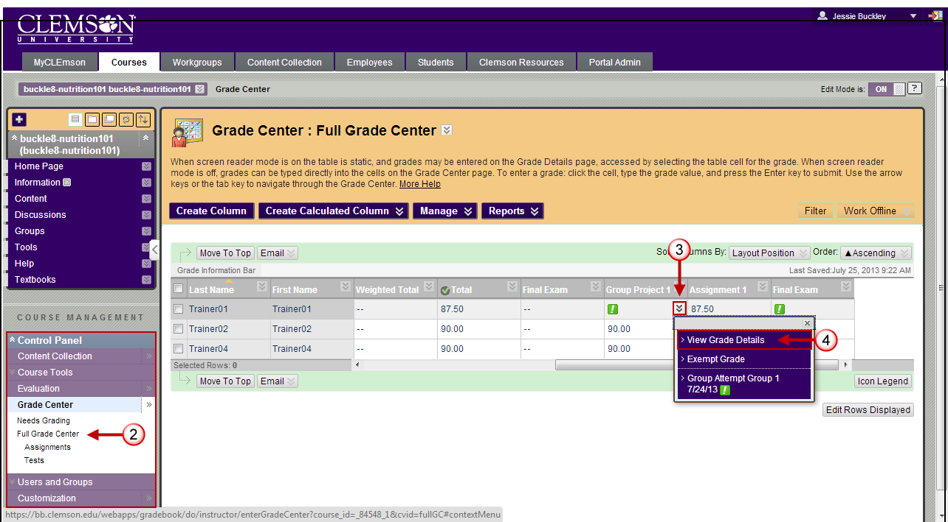
- Click Full Grade Center.
- Then in the Group Assignment column, click the chevron next to the exclamation point to view the options for the submitted assignment.
- Select View Grade Details.

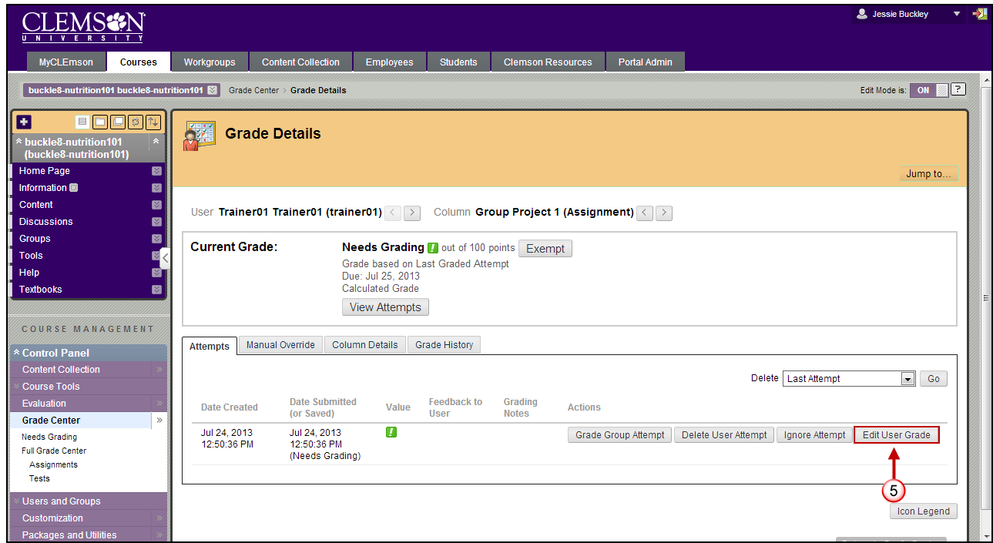
- Click Edit User Grade.
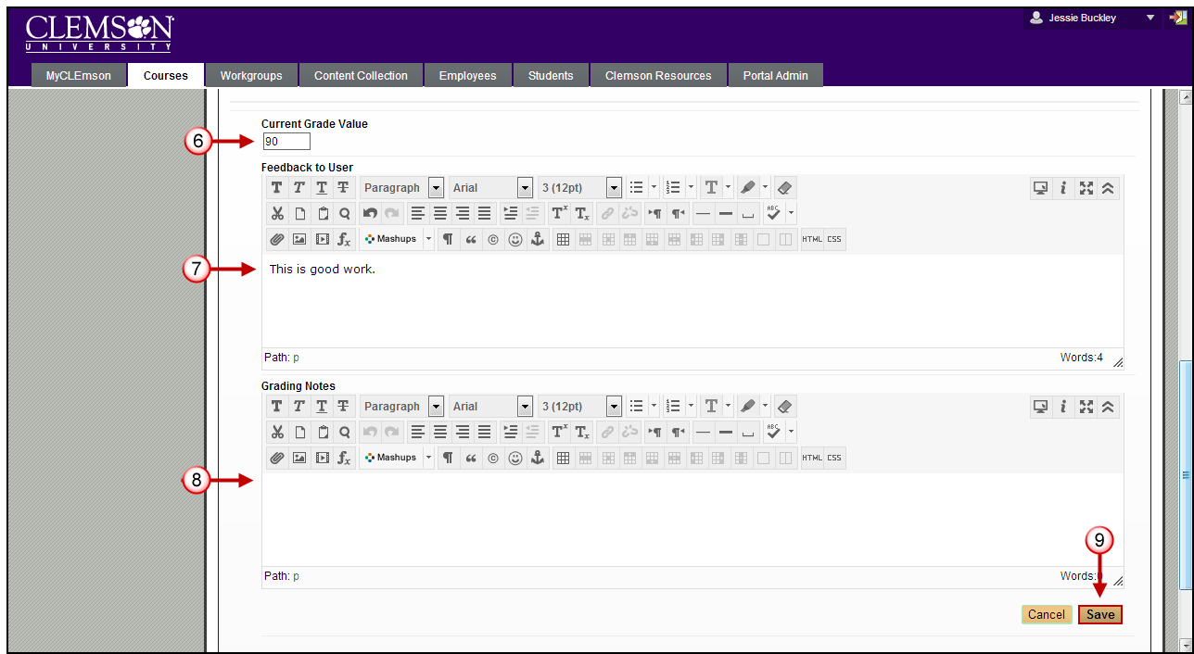
- Enter a Current Grade Value for the students score.
- Then enter Feedback to User.
- Enter Grading Notes.
- Then click Save.
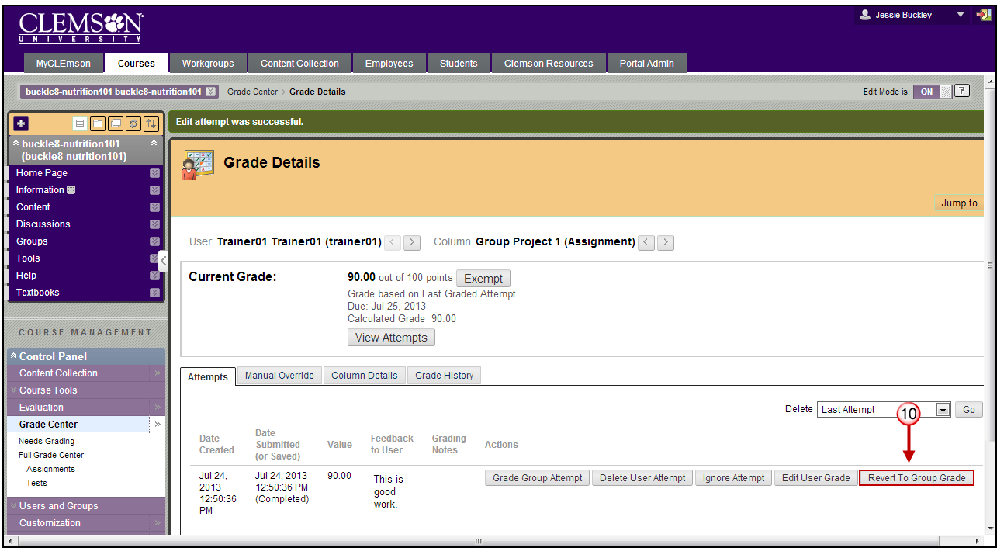
- The Grade Details page is displayed with the new student grade displayed. If at any point you want the student’s grade to be reverted to the original Group grade, click Revert to Group Grade.

Reverting an Individual Grade to a Group Grade
To revert an individual grade to a Group Grade:
- From the Control Panel, click the chevron to expand Grade Center.
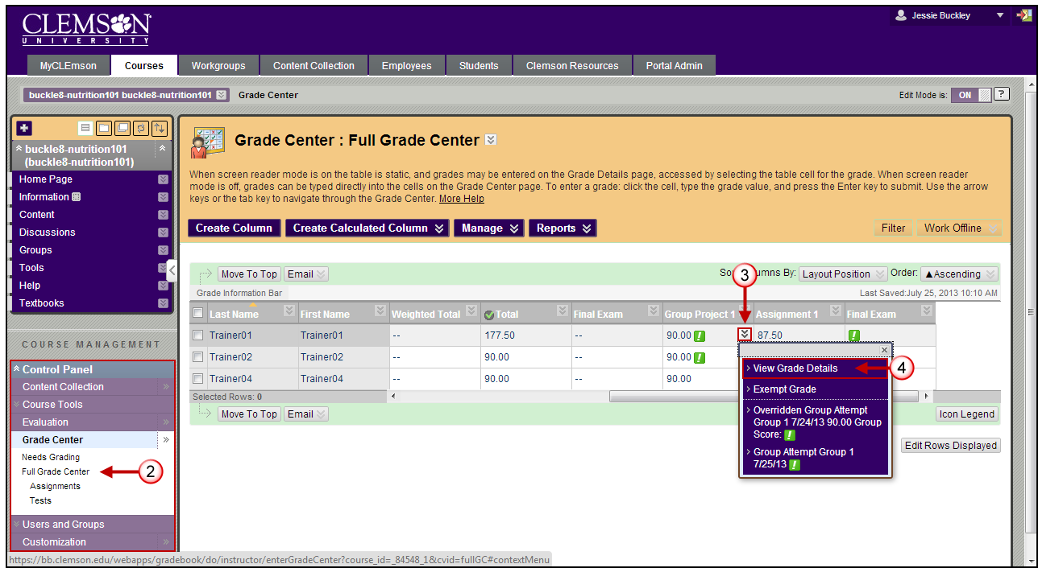
- Click Full Grade Center.
- Then in the Group Assignment column, click the chevron next to the exclamation point to view the options for the submitted assignment.
- Select View Grade Details.
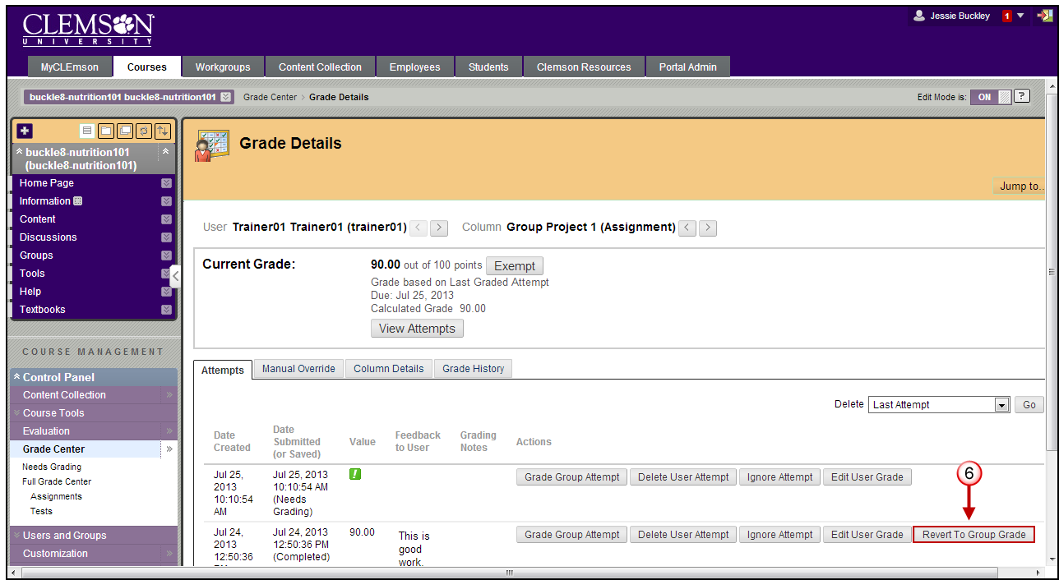
- The Grade Details page is displayed.
- Click Revert to Group Grade.
- A pop-up message will be displayed asking if you want to “Revert this Grade Value?” Click OK.
- The Grade Details page will be displayed with the students Current Grade Value reflecting the score that was given to the Group.

Clearing All Attempts for a specific Group Member
To clear attempts for a specific Group member:
- From the Control Panel, click the chevron to expand Grade Center.
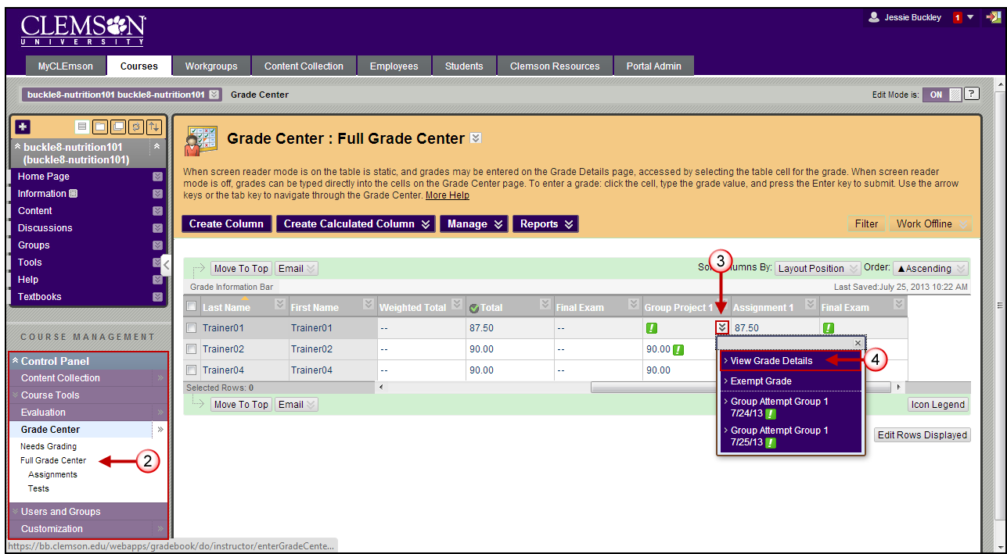
- Click Full Grade Center.
- Then in the Group Assignment column, click the chevron next to the exclamation point to view the options for the submitted assignment.
- Select View Grade Details.
- The Grade Details page is displayed.
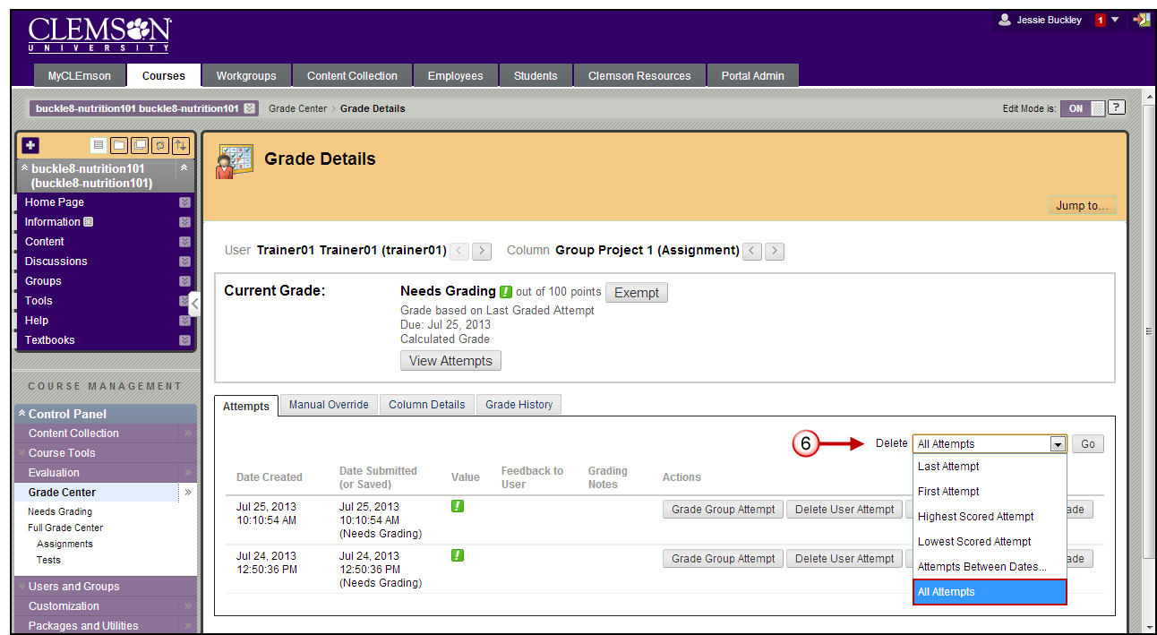
- From the Delete drop down menu, select All Attempts.
- Then click Go.
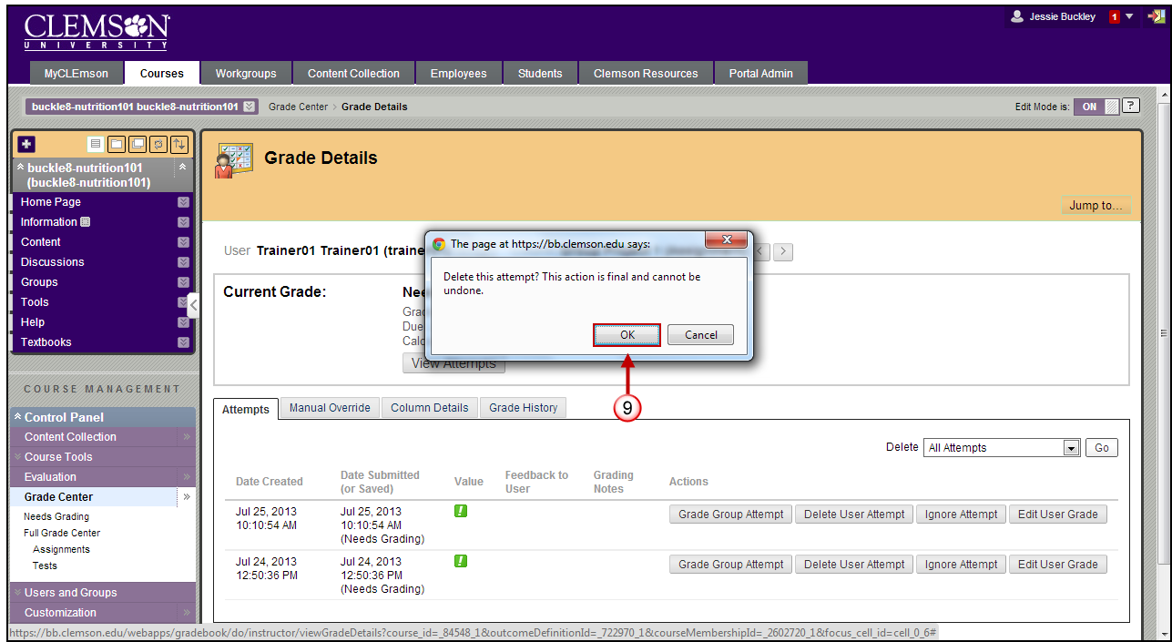
- A pop-up message will display to warn you that this action is final and cannot be undone.
- Click OK.

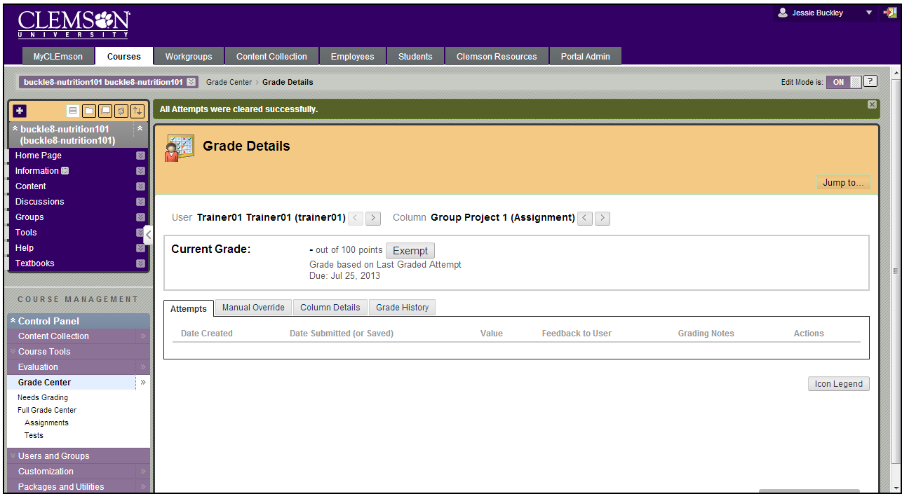
- All submissions for the Group will be removed for the selected user. The other Group members scores will remain intact.
- The Grade History for the Group will remain intact as well.

Clear Attempts for All Users for an Assignment
To clear attempts for all users for an assignment:
- From the Grade Center, click the chevron for the Group Assignment column.
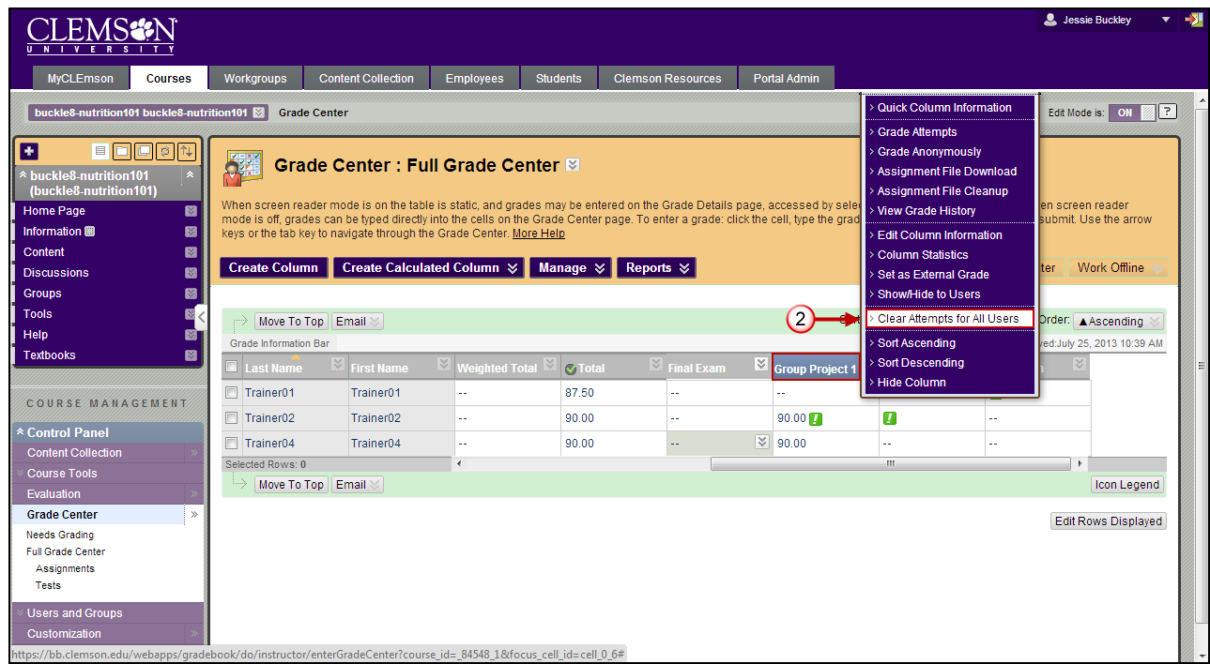
- Then select Clear Attempts for All Users.
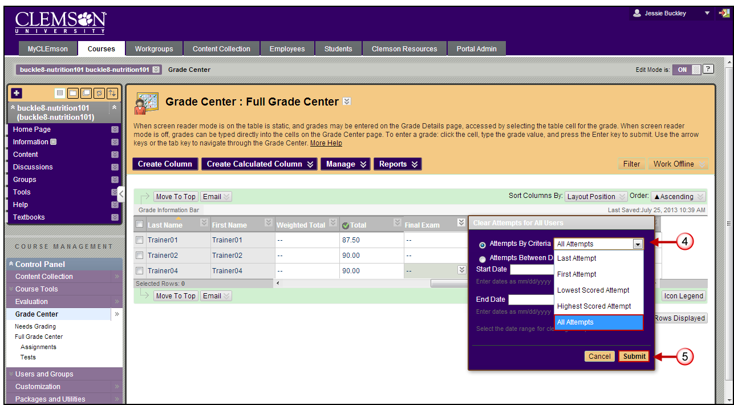
- The Clear Attempts for All Users pop-up window is displayed.
- Select All Attempts from the Attempts By Criteria drop down menu.
- Then click Submit.
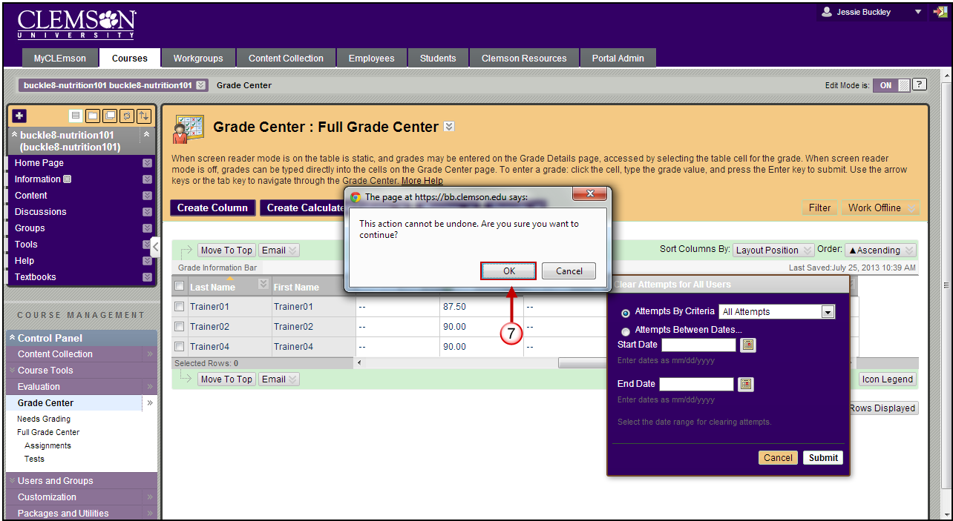
- A pop-up message will display to warn you that this action is final and cannot be undone.
- Click OK.
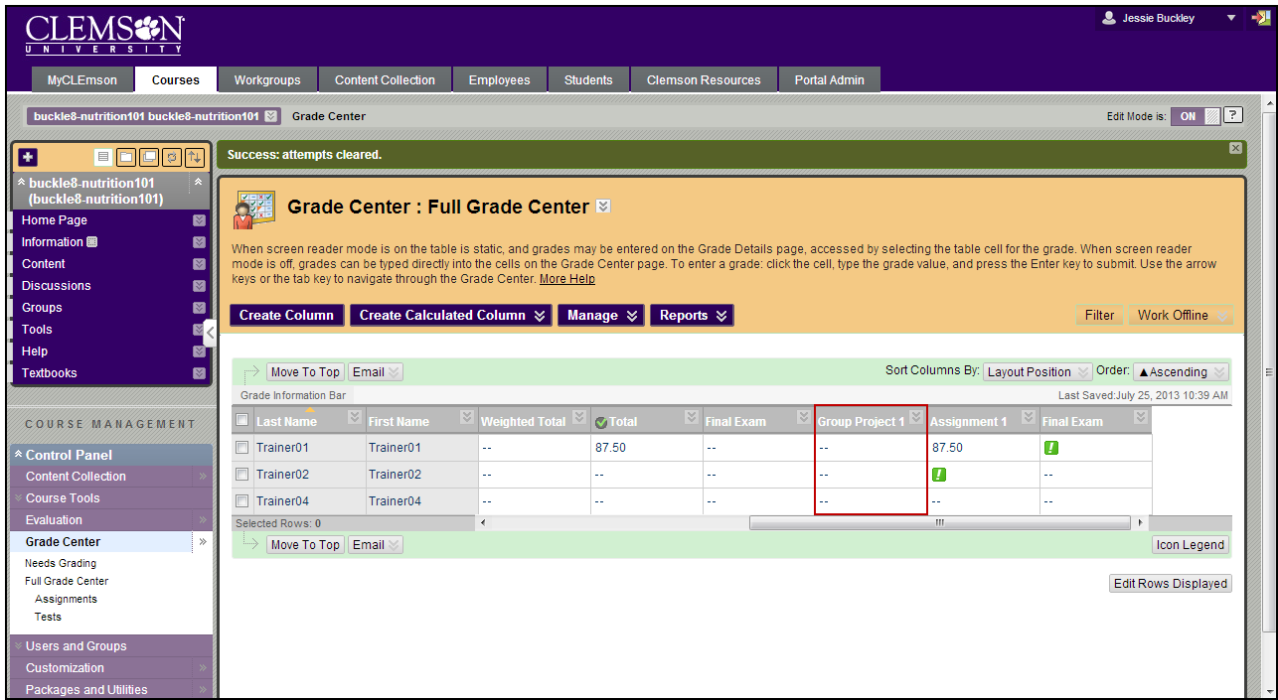
- The Grade Center will display with all user attempts for the selected assignment removed.

