Group Central

Supported Web Browsers & Windows Operating Systems 1
Supported Web Browsers & Mac Operating Systems 1
Navigating to Group Central 1
Create a Group 3
Add Owners to a Group 4
Add Members to a Group 5
Batch Add Members to a Group 7
Add Resources to a Group 9
Filtering Groups 9
Remove Members from a Group 11
Deleting a Group 11

Group Central is the new tool that you can be used to create, delete and manage workgroups. Group Central enables you to create online groups and then add members and owners to them. From there you can customize each group by choosing network resources (Blackboard Organization, shared file spaces, email lists, etc.) that the group members can share online.

Supported Web Browsers & Windows Operating Systems
Windows OS | Internet Explorer 8 | Internet Explorer 7 | Firefox 3.6x | Firefox 3.5x
Windows XP | Supported | Supported | Supported | Supported
Windows Vista | Supported | Supported | Supported | Supported
Windows 7 | Supported | Supported | Supported | Supported

Supported Web Browsers & Mac Operating Systems
Mac OS | Safari 5.x | Firefox 3.6x | Firefox 3.5x
Mac OSX 10.5 “Leopard” | Supported | Supported | Supported
Mac OSX 10.6 “Snow Leopard” | Supported | Supported | Supported

Navigating to Group Central
Group Central can be accessed by navigating to the following URL: http://central.clemson.edu . Alternatively, it can be accessed through Blackboard Learn.
To navigate to Group Central from within Blackboard Learn:
- Open your web browser and navigate to Blackboard Learn (http://bb.clemson.edu).
- Click the Courses tab.
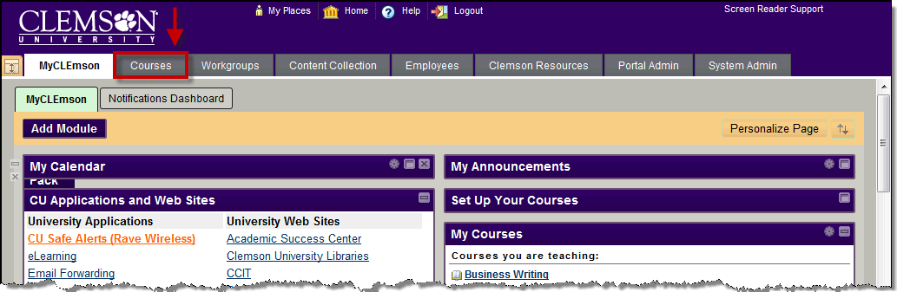
- On the right side of the Courses tab, click the Course Central (Course Setup Tool) link.
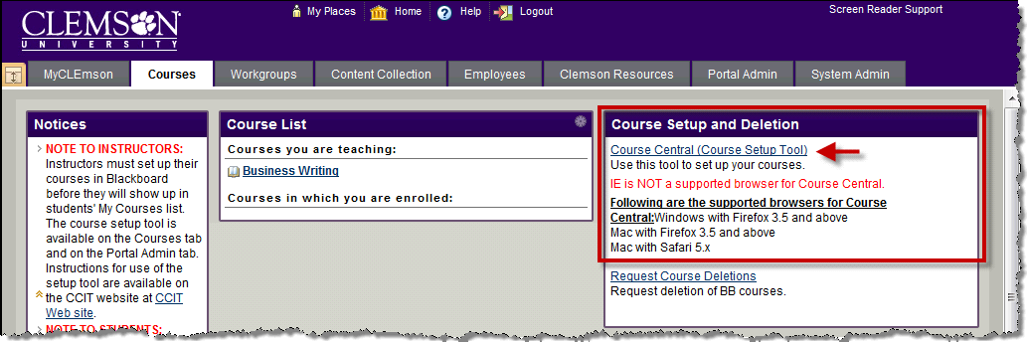
- This will open the Course Central login page in a separate tab or window.
- Enter your network Userid and Password.
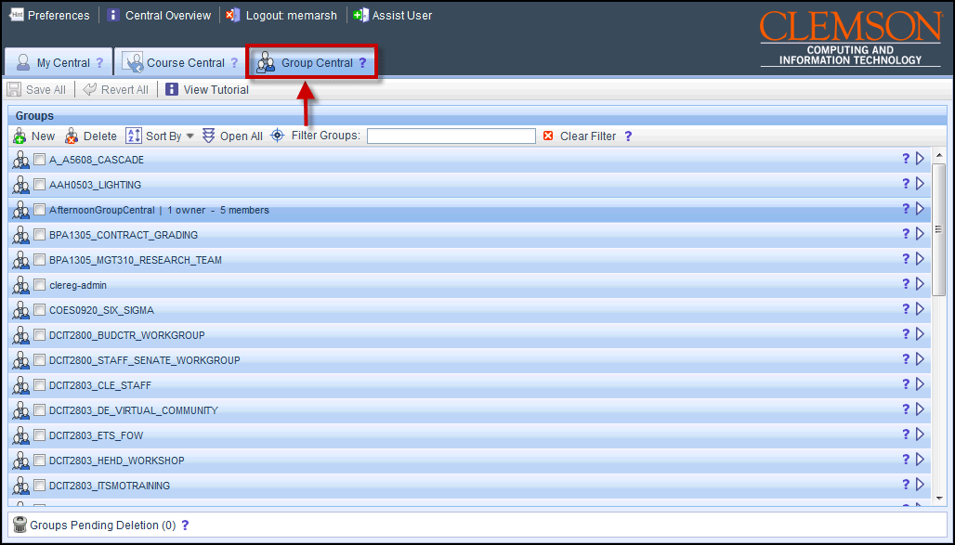
- Course Central will load with the Course Central page displayed.
- Click the Group Central tab, to manage your group.

Create a Group
To create a workgroup from Group Central:
- Click the New button in the Groups area toolbar.
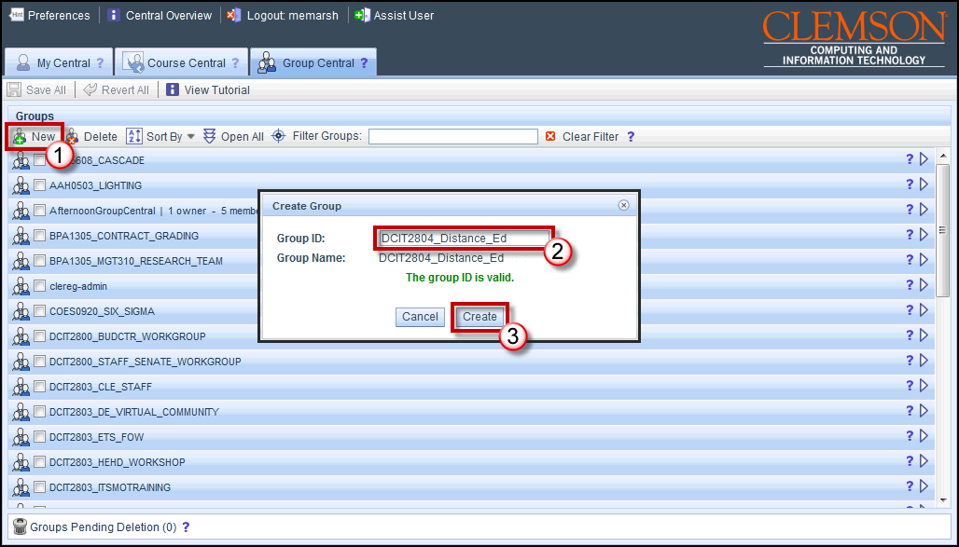
- The Create Group pop-up window is displayed.
- Enter a Group ID in the field provided. The Group ID must be a minimum of 9 characters long and no greater than 26 characters long. Hyphen (-) and underscore (_) are the only special characters supported. Spaces are not acceptable.
- Then click the Create button.
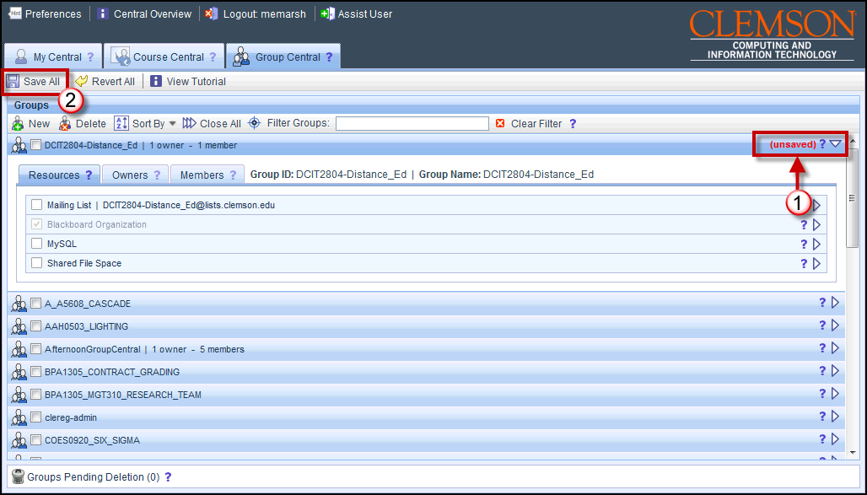
- The new group will be displayed in the Groups area. Notice that on the right side of the group the word (unsaved) is highlighted in red. At this point this group has not been saved.
- To save this new group, click Save All.

Add Owners to a Group
Note: Owners are called Workgroup leaders in Blackboard Learn.
To add an owner to a group:
- In the Groups area, locate the group to add an owner.
- Click the triangle at the right to expand the group.
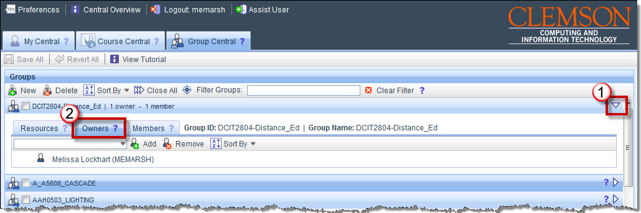
- Then click the Owners tab for the selected group.
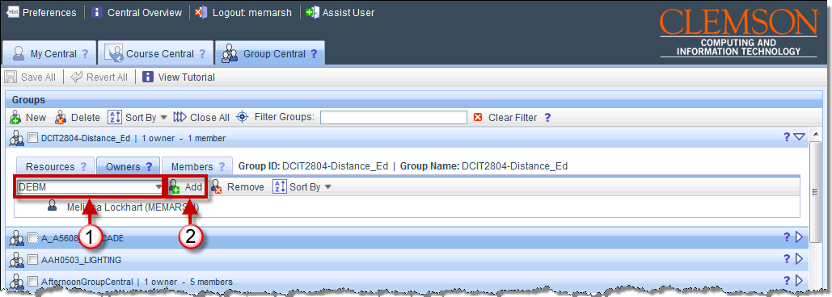
- Enter the persons Clemson user ID in the field provided.
- Then click Add.
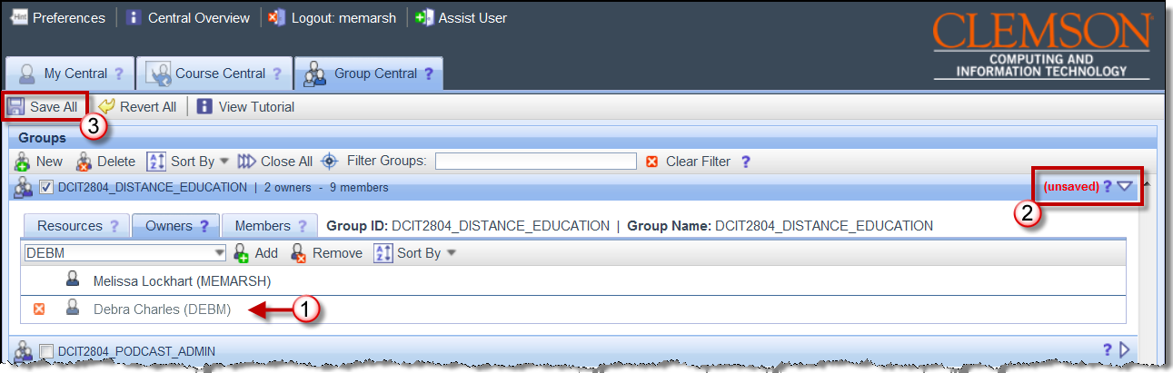
- The new owner will be displayed on the Owners tab. Notice that on the right side of the group the word (unsaved) is highlighted in red. At this point the new owner has not been saved.
- To save the new owner, click Save All.

Add Members to a Group
To add a member to a group:
- In the Groups area, locate the group to add a member.
- Click the triangle at the right to expand the group.
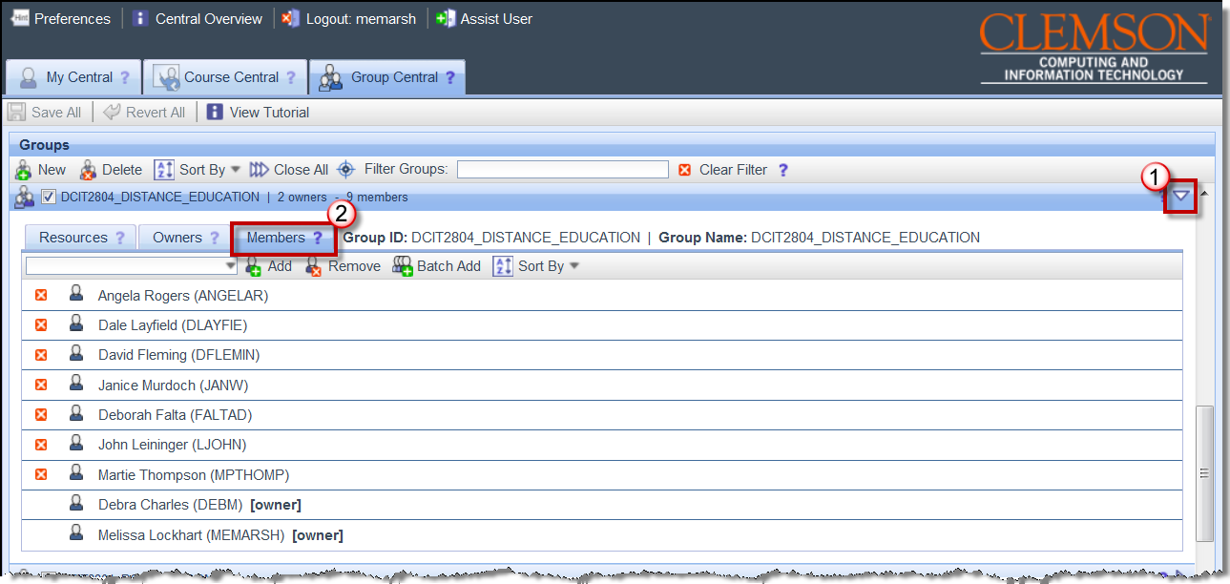
- Then click the Members tab for the selected group.
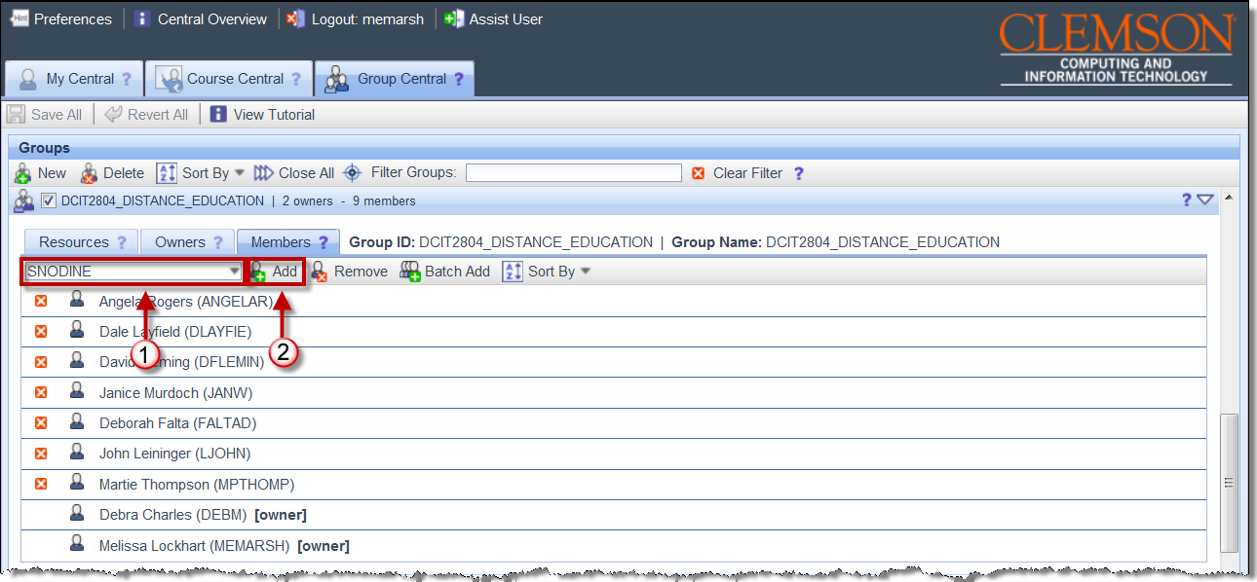
- Enter the persons Clemson user ID in the field provided.
- Then click Add.
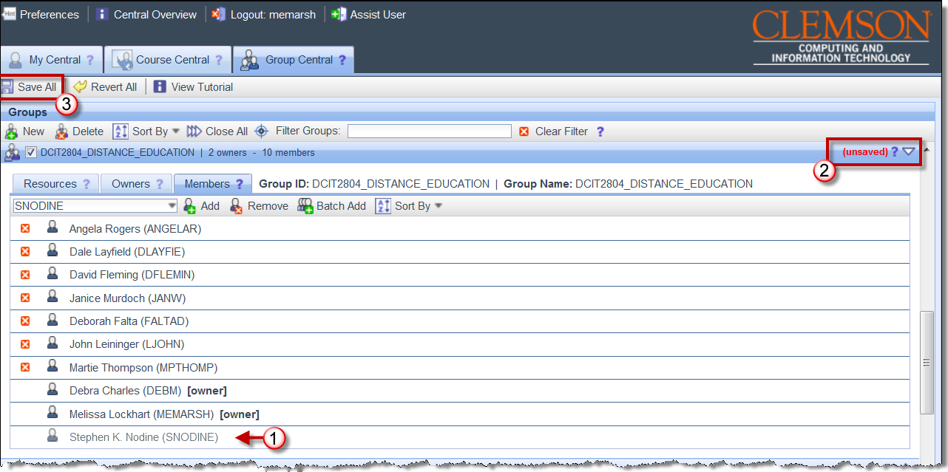
- The new member will be displayed on the Members tab. Notice that on the right side of the group the word (unsaved) is highlighted in red. At this point the new member has not been saved.
- To save the new member, click Save All.

Batch Add Members to a Group
To add members in a batch to a group:
- In the Groups area, locate the group to add members.
- Click the triangle at the right to expand the group.
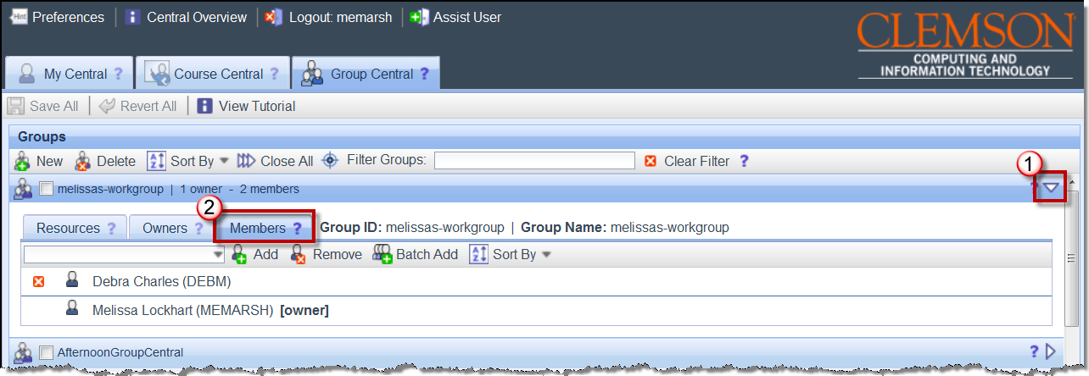
- Then click the Members tab for the selected group.
- Then click Batch Add.
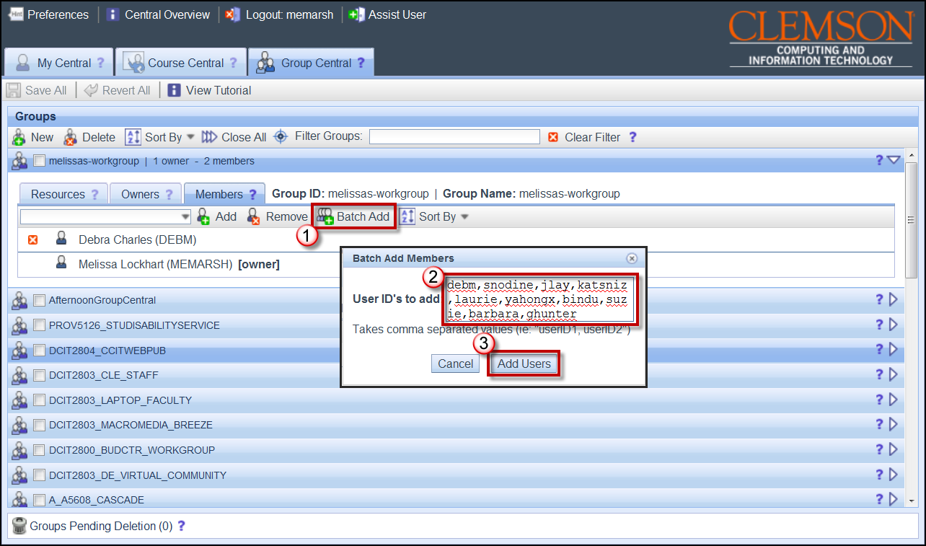
- The Batch Add Members pop-up window is displayed.
- Enter the Clemson UserID for each person to include in the group, separated by a comma. For example, “UserID1,UserID2, UserID3, etc.”
- Then click Add Users.
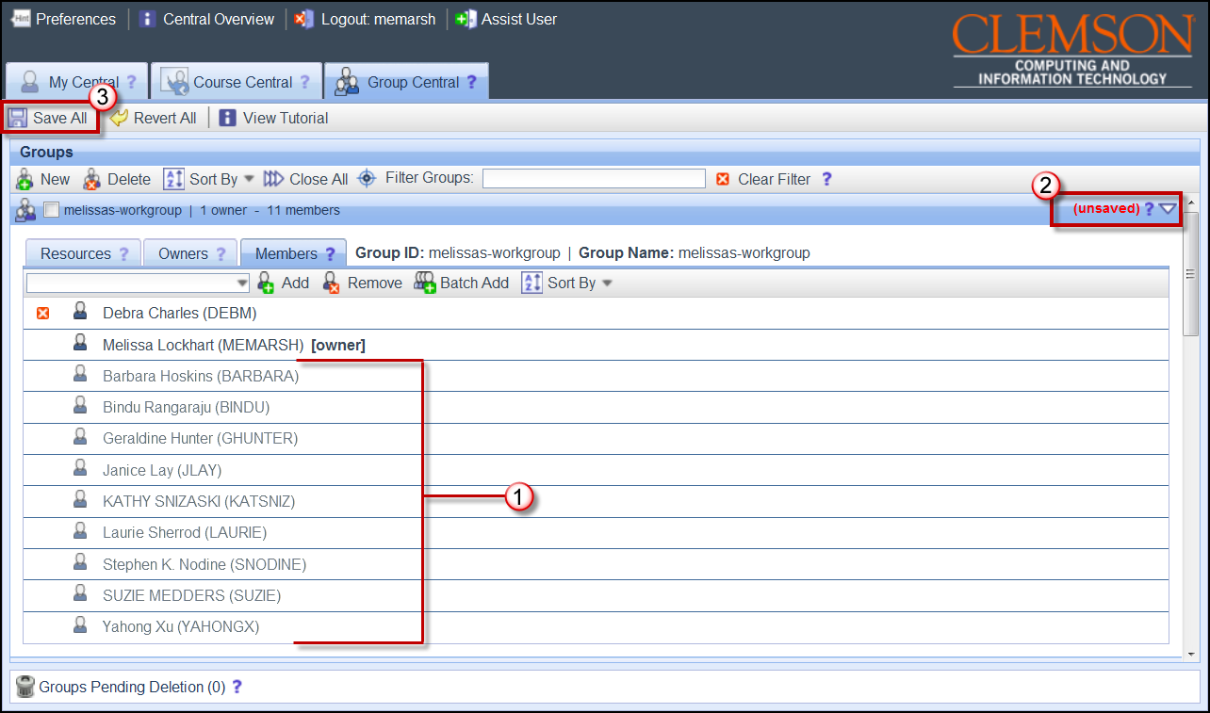
- The new members will be displayed on the Members tab. Notice that on the right side of the group the word (unsaved) is highlighted in red. At this point the new members have not been saved.
- To save the new members, click Save All.

Add Resources to a Group
There are 4 different resources that are currently available to groups: MySQL, Mailing List, Blackboard Organization and Shared File Space. To make any of these resources available for a group:
- In the Groups area, locate the group to add resources.
- Click the triangle at the right to expand the group.
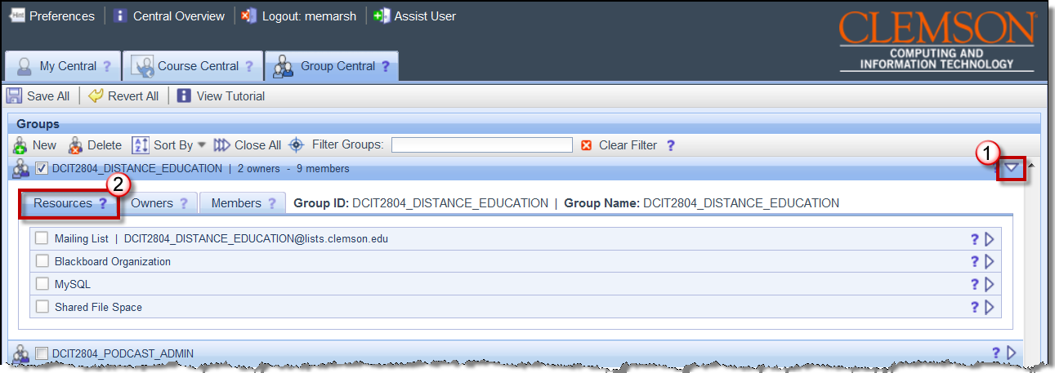
- Then click the Resources tab.
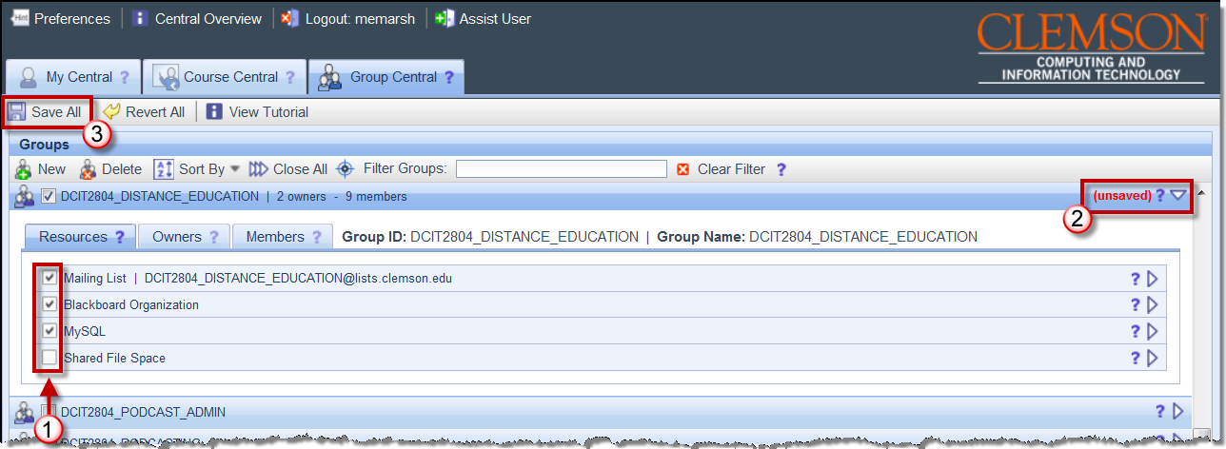
- Select the checkbox for each resource you want to make available to the group.
- Notice that on the right side of the group the word (unsaved) is highlighted in red. At this point the resources have not been saved and turned on for the group members.
- To add these resources for the group members, click Save All.

Filtering Groups
To filter the Groups list:
- In the Groups area, enter criteria to filter your list of Groups. The criteria are case sensitive. For example, I will get different results for the filter criteria “POD” than I will for “pod”.
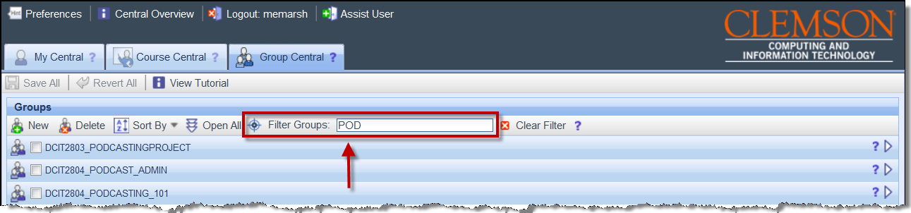
- As you type, the system will automatically begin filtering your Groups list.
- To remove the filter criteria and return to the full list of your Groups, click the Clear Filter button.

Remove Members from a Group
To remove members from a group:
- In the Groups area, locate the group to add resources.
- Click the triangle at the right to expand the group.
- Then click the Members tab for the selected group.
- Locate the member to remove. Then click the Remove () button in front of the members name to remove from the group.
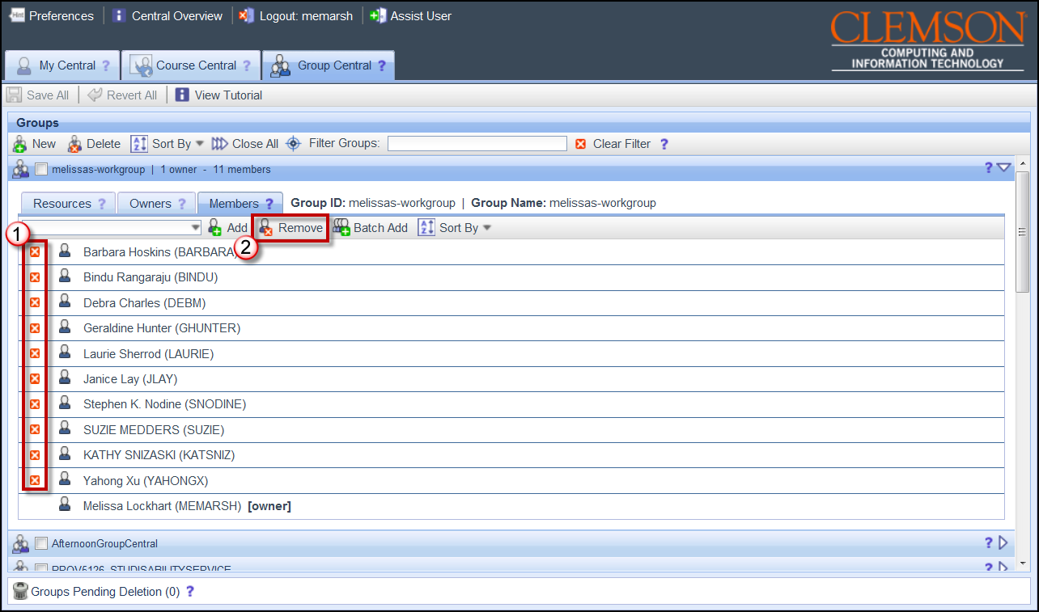
- Alternatively, you can select a member in the list. Then click the Remove button on the toolbar on the Members tab to remove a member from the group.

Deleting a Group
To delete a group:
- In the Groups area, locate the group to delete.
- Then click the group icon (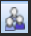) for the group to delete and drag and drop it onto the Groups Pending Deletion text at the bottom of the screen.
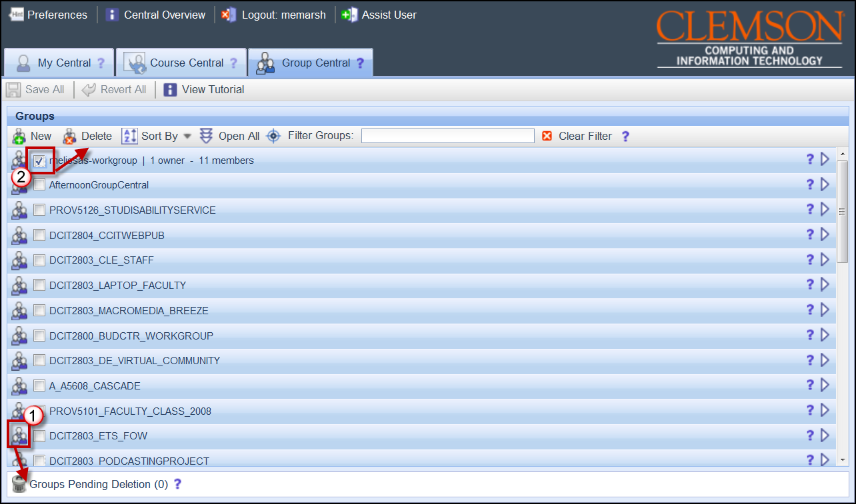
- Alternatively, you can select the checkbox for the group and then click the Delete button on the Groups area toolbar.
- If you are the only owner assigned to the workgroup you will receive a message allowing you to Trash Group or Reassign. To delete the group, click Trash Group.
- To Reassign the group to another owner, click Reassign.
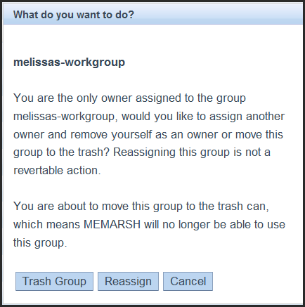
- To cancel the deletion, click Cancel.
- If you are not the only Owner of the group, you will receive a message allowing you to Trash Group or Remove Self. To delete the group, click Trash Group.
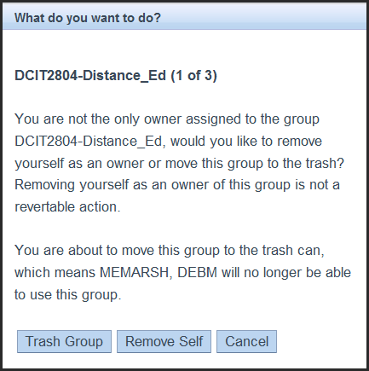
- To remove yourself from the group, click Remove Self.
- To cancel the deletion, click Cancel.
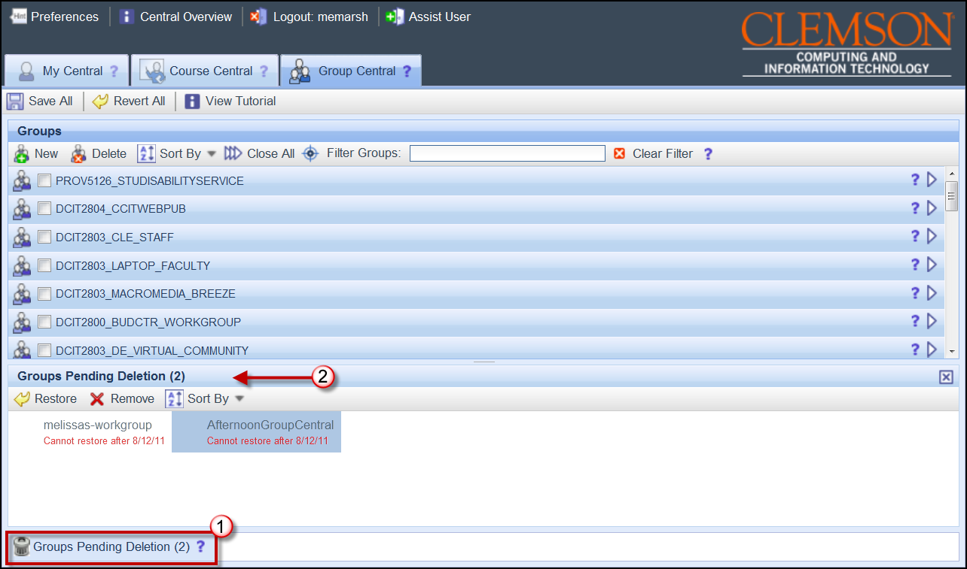
- To view the workgroups that are pending deletion, click the Groups Pending Deletion button at the bottom of the screen.
- To permanently delete a group, select the group in the Groups Pending Deletion area. Then click Remove.
- If you are the only owner assigned to the workgroup you will receive a message allowing you to Delete Group or Reassign. To delete the group, click Delete Group.
- To Reassign the group to another owner, click Reassign.
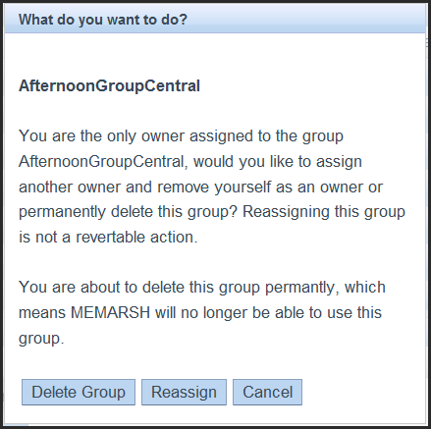
- To cancel the deletion, click Cancel.
- If you are not the only Owner of the group, you will receive a message allowing you to Delete Group or Remove Self. To delete the group, click Delete Group.
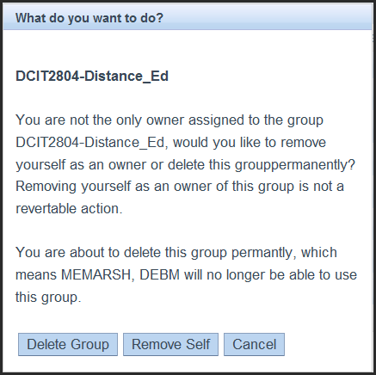
- To remove yourself from the group, click Remove Self.
- To cancel the deletion, click Cancel.
- To restore a workgroup from the Groups Pending Deletion area, select the group to restore.
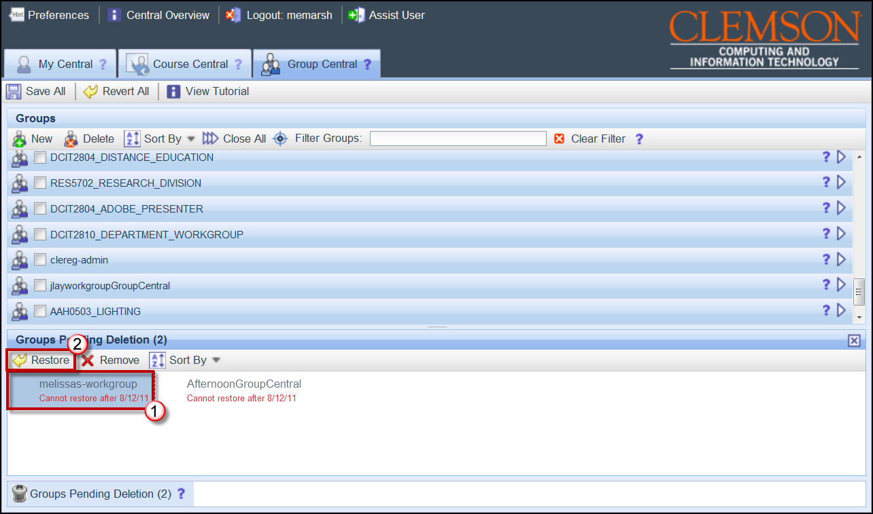
- Then click Restore.
- The course is restored to the Groups area. Click Save All to save your changes.

