Assigning Negative Points

Level #Intermediate

Negative Points Overview 1
How to Enable and Assign Negative Points 1
Enable Negative Points on the Test 1
Assign Negative Points to a Question 3

Negative Points Overview
To deter guessing and penalize students for incorrect answers, you can assign negative points to test questions. The following question types allow for negative points:
- Matching
- Multiple answer
- Multiple choice
Example:
If a multiple choice question is worth 10 points for a correct answer, you can assign -100% to the question. If the student guesses the incorrect answer, their score will be -10 instead of 0.
A few things to keep in mind, you cannot use this option for pools and if you need to remove the negative points, you will have to do so on a question by question basis.
Follow the directions below to enable the negative points option and add negative points to a question.

How to Enable and Assign Negative Points

Use the following steps to enable the negative points option on an existing test and use it for individual questions. (The same options can be found when creating a new test)

Enable Negative Points on the Test
- On the Control Panel, expand the Course Tools section.
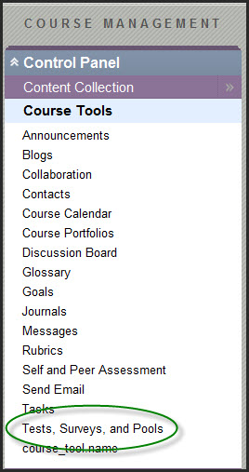

- Select Tests, Surveys, and Pools.
- On the Tests, Surveys, and Pools page, select Tests.
- On the Tests page, locate the test that you are editing and click the action link to the right of a test's title to access the menu.
- Select Edit.
- On the Test Canvas, click on Question Settings in the upper right hand corner as shown below:

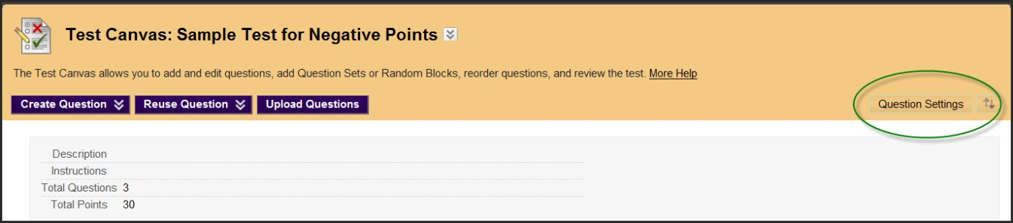

- Under number 4, select the check box for Specify partial credit options for answers, which will trigger the display of Specify negative points options for answers, select both.

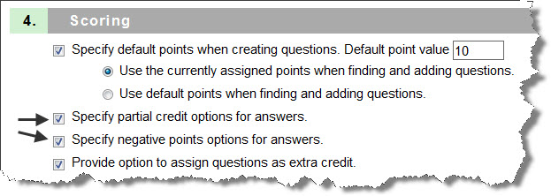

- Click Submit to save the settings change.

Assign Negative Points to a Question
- For each question you want to have negative grading, select the action link to the right of the question, Choose Edit in the Menu
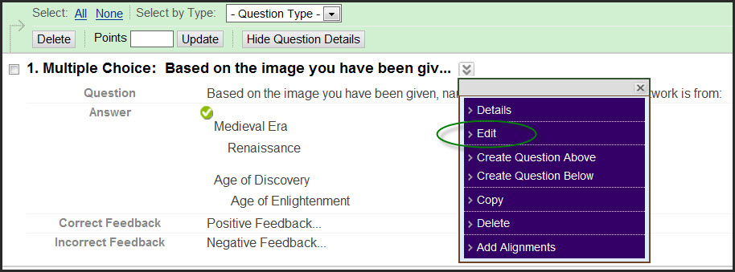
- and then scroll down to the Options area. Check the box to Allow Partial Credit which then displays Allow Negative Scores for Incorrect Answers. Check both.
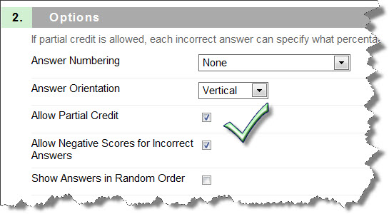
- For each incorrect answer, type a negative percentage in the Partial Credit % box.
* Note – If negative grading is enabled, you can enter a percentage between -100% and 100%.
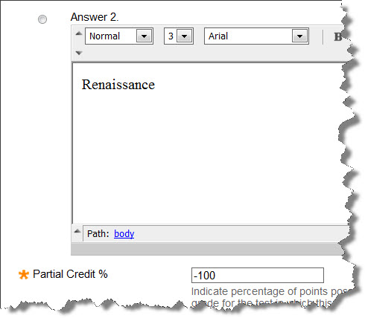
- Click Submit.

