Uploading to the Grade Center

Blackboard Learn Beginners

To upload to the Grade Center:
- Login to Blackboard Learn.
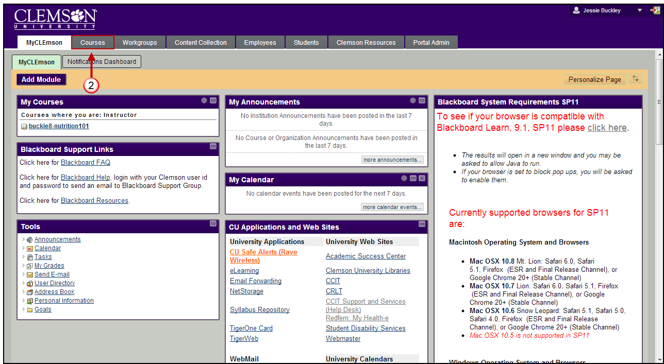
- Click the Courses tab.
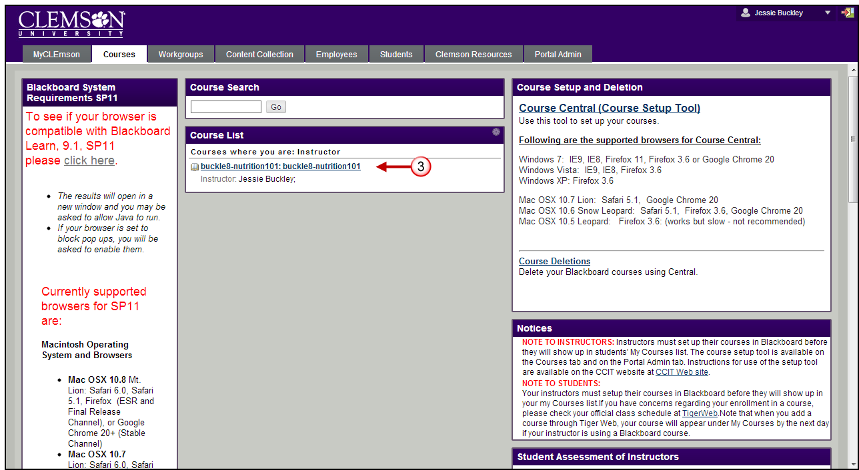
- Click the course to open from the Course List module.
- The course entry page will be displayed. From the Control Panel, click the chevron to expand Grade Center.
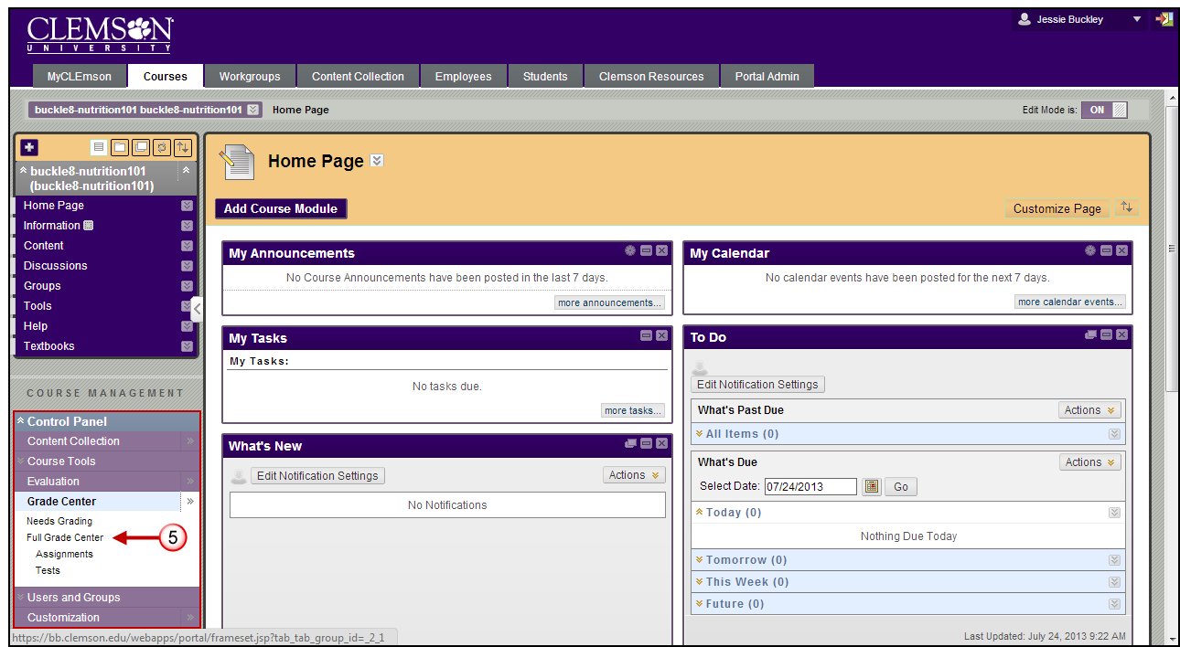
- Click Full Grade Center.
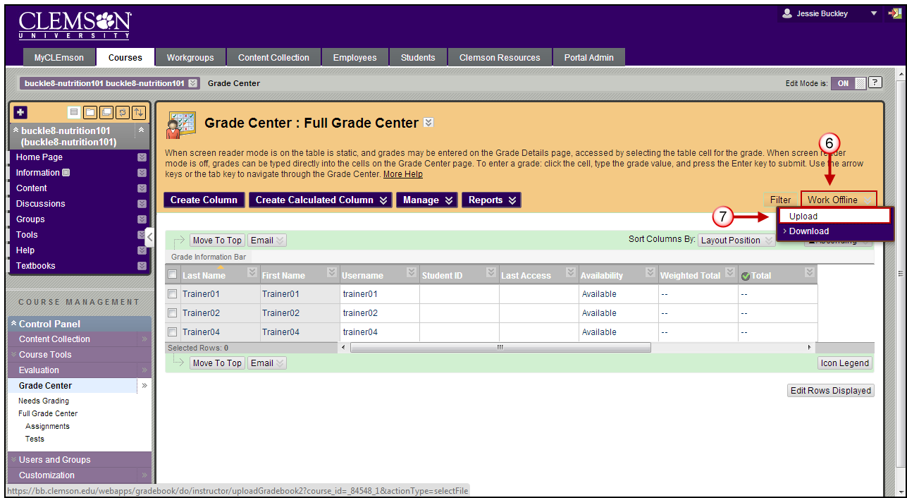
- The Grade Center page is displayed. Hover your mouse over Work Offline.
- Then select Upload. The Upload Grades page is displayed.
Note: The format of the data files uploaded to the Grade Center is determined by the type of delimiter that is used to parse the data into separate columns. Data files can be tab delimited with a file extension of .txt or .xls. Comma delimited data files with a file extension of .csv.
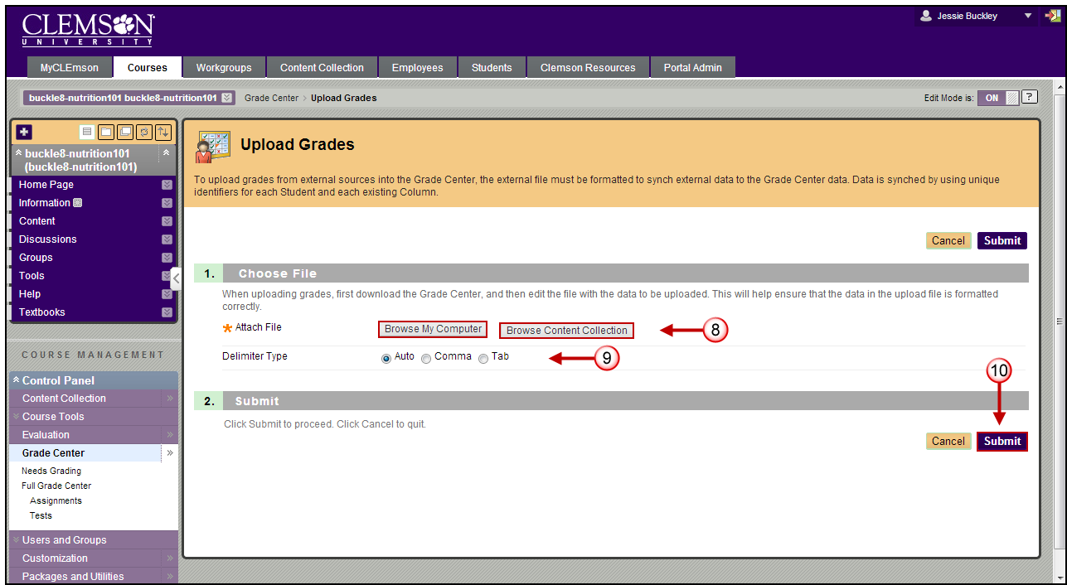
- Click Browse My Computer to browse for a file to attach from your local computer or Browse Content Collection.
Warning: Any columns that are added to the Grade Center download file from an external source are added as Text columns with Points Possible equaling zero. Text columns cannot be included in Calculated Columns such as Weighted Grade, Total Points, Average Grade, and Minimum/Maximum grades. From the Grade Center you can select to Edit Column Information. By editing column information you can change Text columns to Score columns and add Points Possible. This will add the new column to the Calculated Columns.
- Click a Delimiter Type.
- Then click Submit. The Upload Grades Confirmation page is displayed.
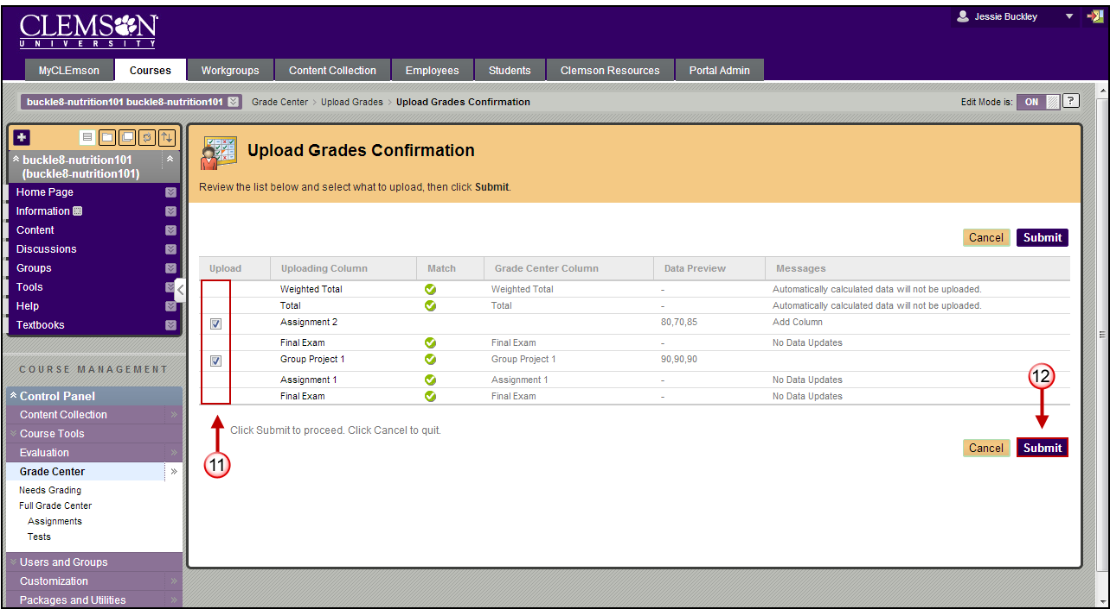
- Under Upload, select the checkbox(s) for the columns to upload to the Grade Center. Only the selected columns will be updated in the Grade Center.
NOTE: Columns with a checkbox indicate a change to an existing column or a new column.
- Then click Submit.
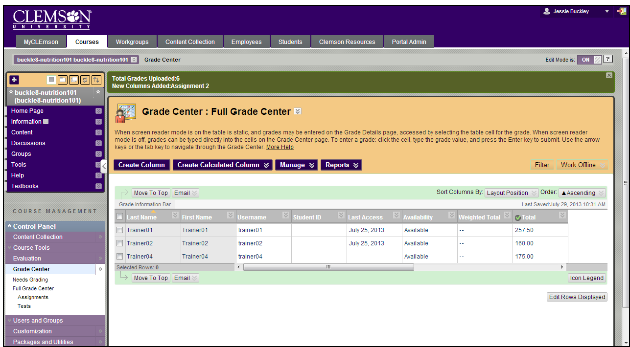
- The columns will be updated or added to the Grade Center.
NOTE: Any new columns will be added to the Grade Center as Text columns. This will need to be changed to Score for Weights and Calculations to work properly.

