Associating and Grading a Rubric with an Assignment

Associating a Rubric to an Assignment 1
Grading an Assignment associated with a Rubric 6
Rubrics help students organize their efforts to meet the requirements of an assignment while instructors interact with an associated rubric to explain their evaluation to students. Once you create a rubric, you may link that rubric to an assignment.

Associating a Rubric to an Assignment
- Go to your Blackboard course.
- Select the Content link on the course menu.
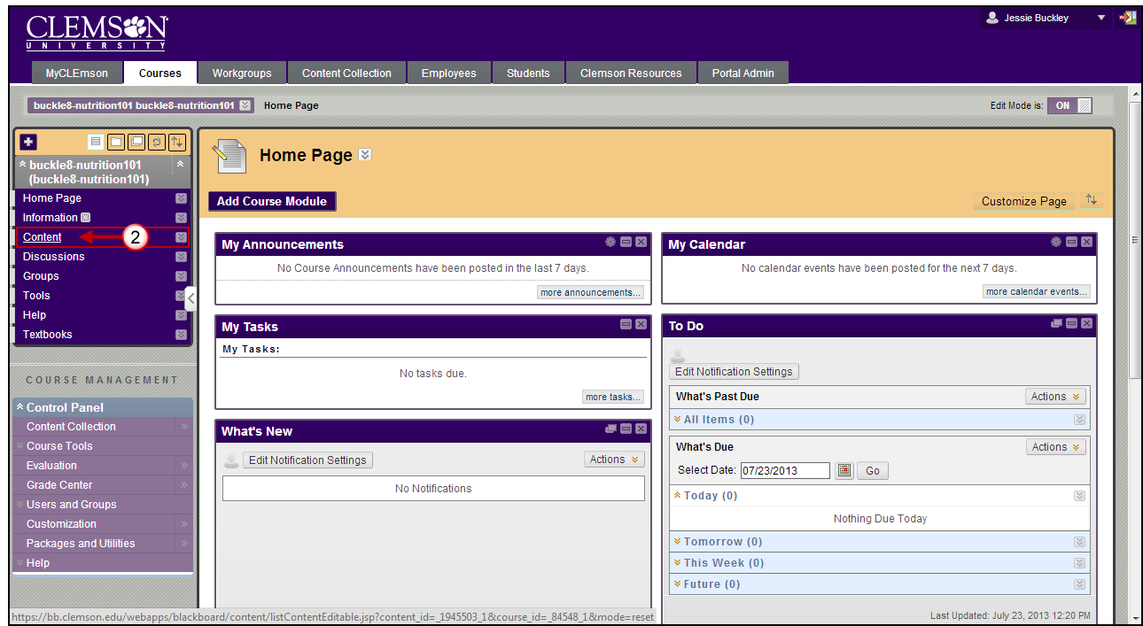
- Hover over the Assessments tab and select Assignment.
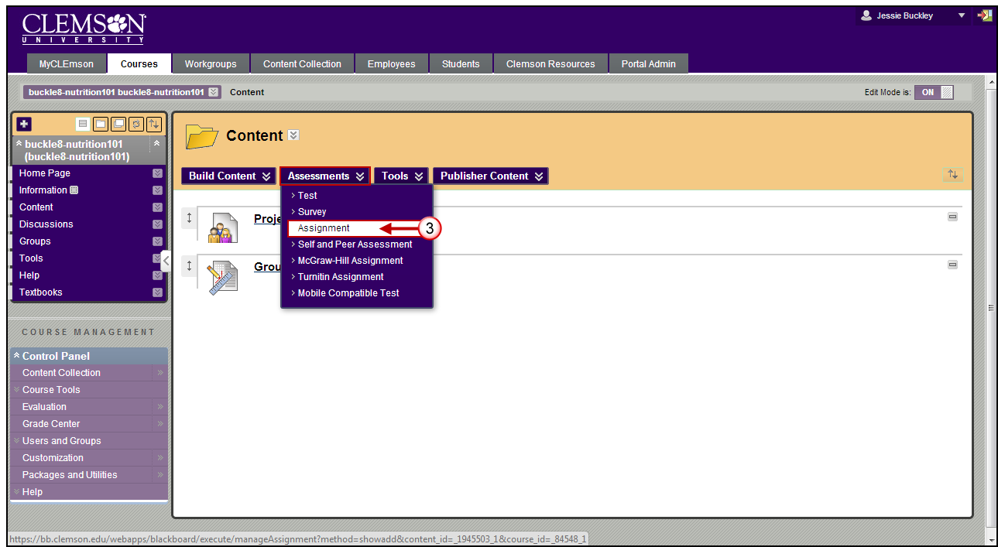
- Enter the Name and Color and Instructions for the assignment.
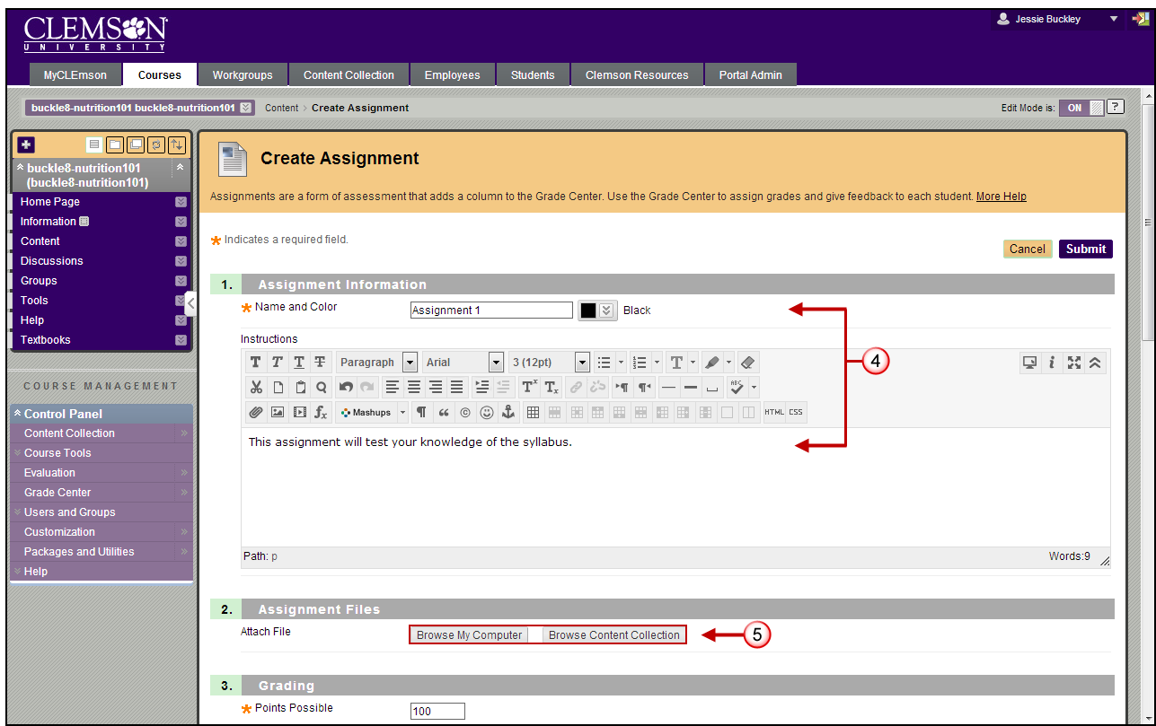
- In Section 2: Assignment Files click Browse My Computer or Browse Content Collection to attach a file if necessary.
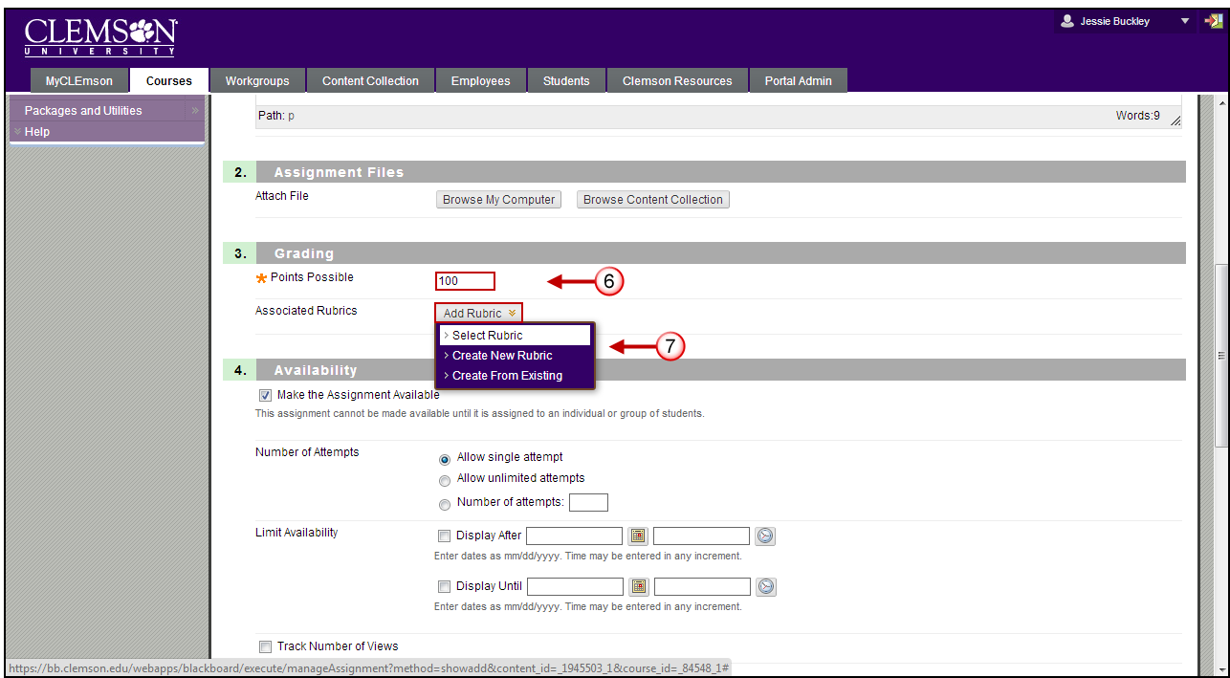
- In Section 3: Grading enter in the Points Possible for the assignment.
- Hover your mouse over Add Rubric. You have three choices for the rubrics option:
- Select Rubric to use an existing rubric.
- Create New Rubric, which will allow you to create a new rubric.
- Create From Existing, which will give you a copy of an existing rubric that you can alter for this rubric.
- For this example, we chose Select Rubric option. The Select Rubrics window is displayed.
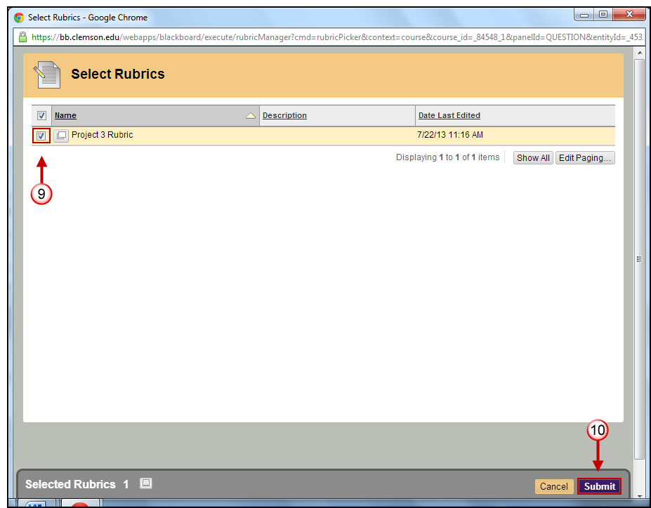
- Select the rubric to use with this test question.
- After selecting a rubric, click Submit.
- Click OK In the pop up window to assign the rubric’s maximum points as the point value.
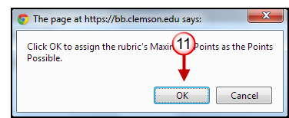
- Click the red X next to the rubric name to remove rubric association, click the middle button to view rubric, click the last button with the pencil to edit the rubric.
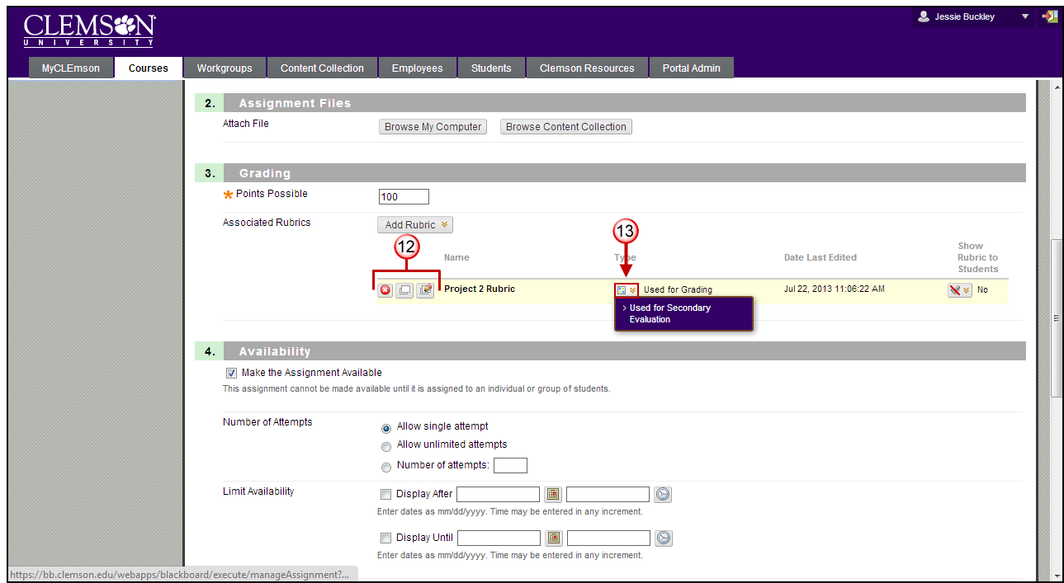
- Under Type, Used for Grading is selected.
Note: Multiple rubrics can be associated with an item. Rubrics can be designated as Used for Grading or Used for Secondary Evaluation. If you associate multiple rubrics, only one can be the primary grading rubric, designated as Used for Grading.
- You have three options in the Show Rubric to Students area (at the end of the associated rubric area). By default it is set to No. To display the rubric to students select either Yes (With Rubric Scores) or Yes (Without Rubric Scores). You can also select to show the rubric to students After Grading.
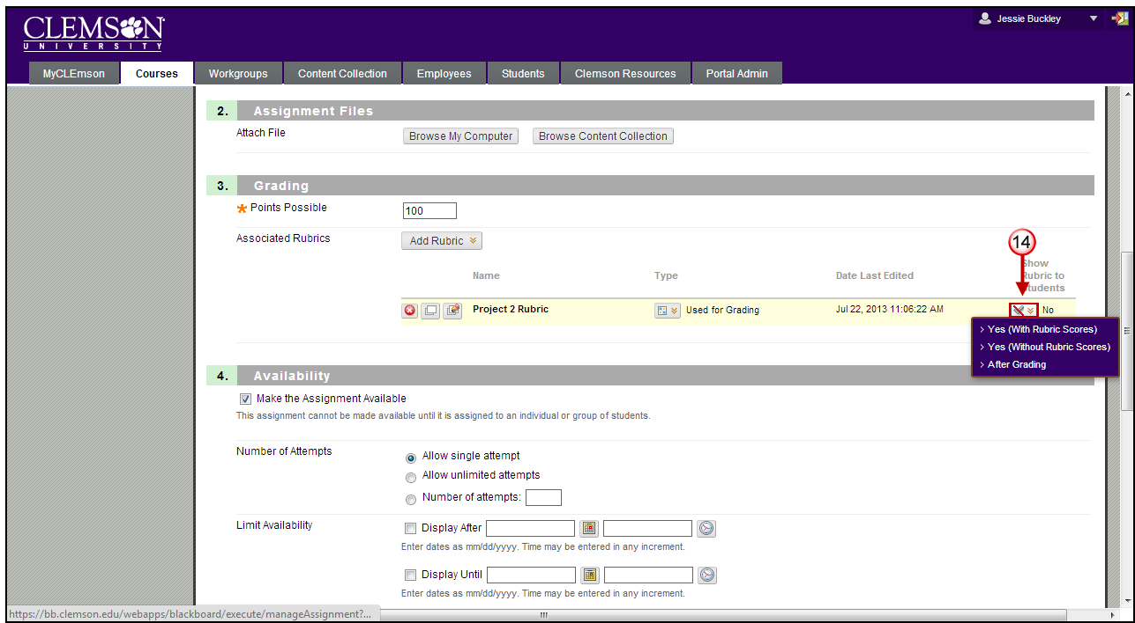
- Click Submit.
- In section 4: Availability select the checkbox next to Make the Assignment Available.
- The Number of Attempts can be set to Allow single attempt, Allow unlimited attempts, or designate a specific Number of attempts.
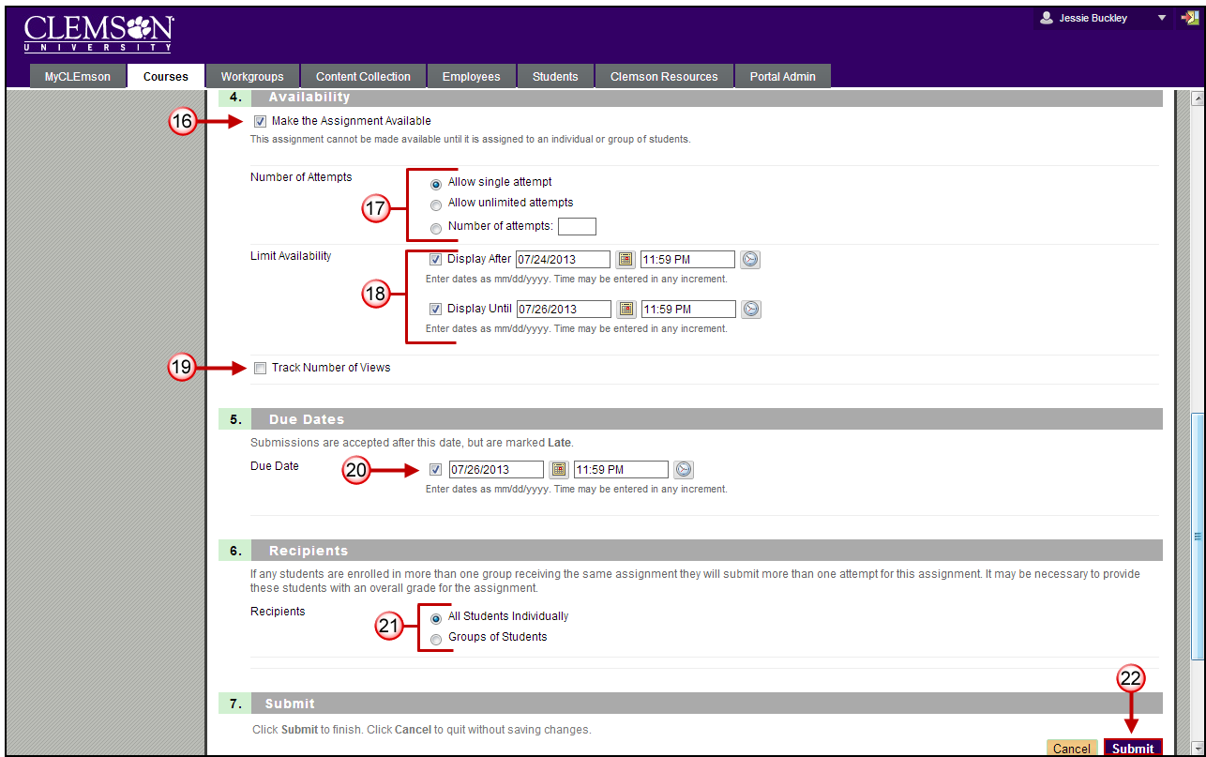
- Next to the Limit Availability section, designate when the assignment should be displayed by choosing a Display After date and time along with a Display Until date and time.
- Select the checkbox to Track Number of Views.
- In Section 5: Due Dates enter the due date for the submission if necessary, this is what will appear on the Blackboard Home page under Announcements.
- In Section 6: Recipients select recipients for the assignment, All Students Individually or Groups of Students.
- Click Submit

Grading an Assignment associated with a Rubric
- Go to your Blackboard course.
- From the Control Panel expand the chevron next to Grade Center and select Full Grade Center.
- Find the assignment column on the Grade Center. Locate the green exclamation mark which indicates student submission on the assignment column.
- Expand the chevron and click View Grade Details.
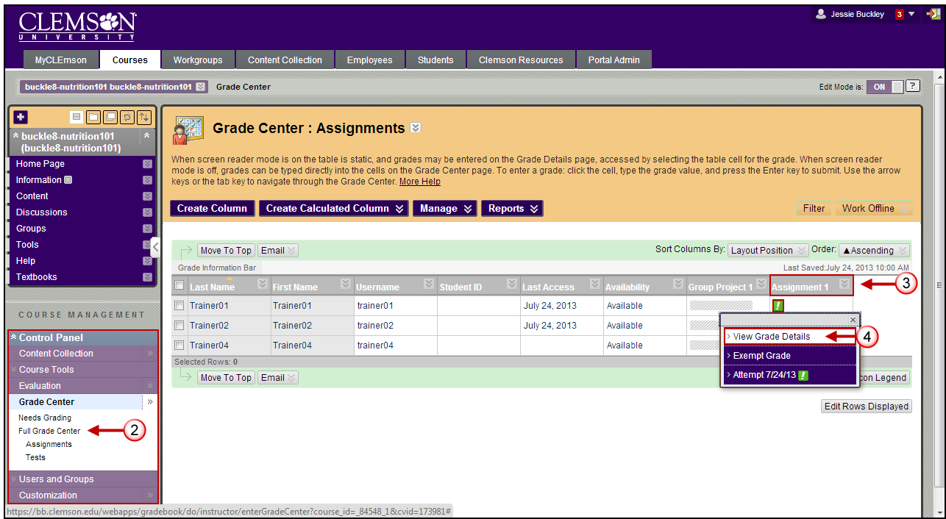
- Click Grade Attempt button.
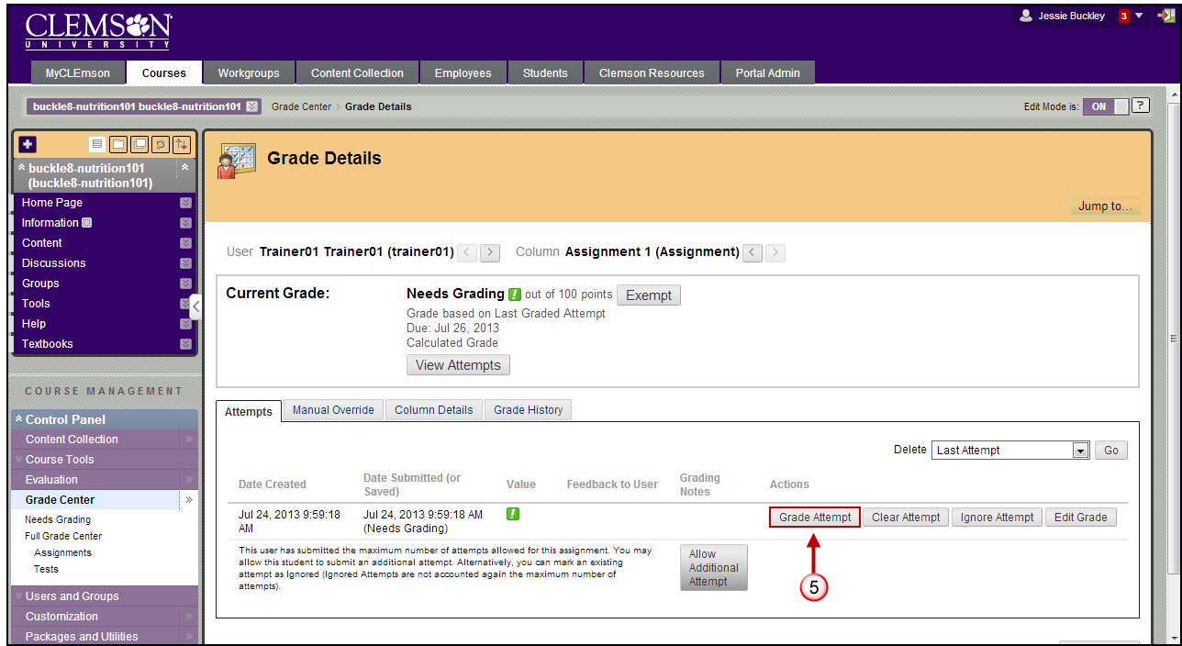
- Now you will see student submitted assignment. Click View Rubric button, a new screen displays the rubric detail.
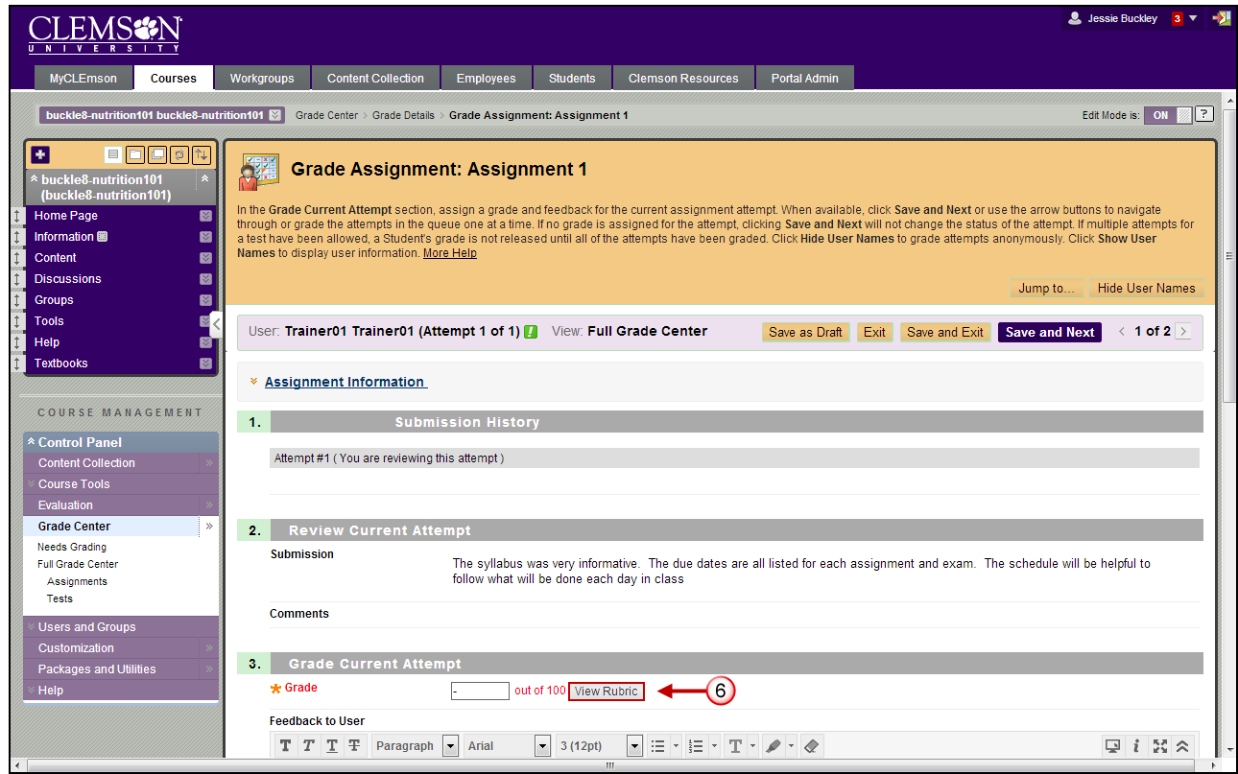
- You have the option to use the rubric in List View display. You can choose to view descriptions of the grading criteria and the feedback text boxes.
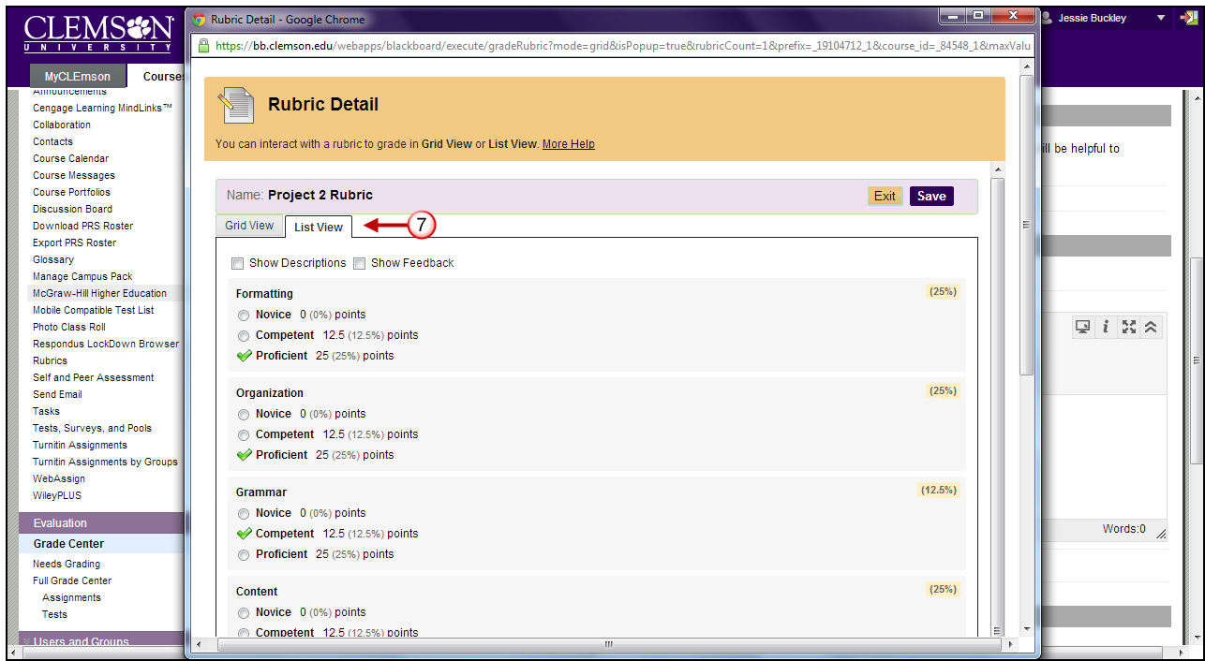
- In Grid view display, rubrics are made up of rows and columns. The rows correspond to the various criteria of an assignment, while the columns correspond to the levels of achievement expressed for each criterion. Select a radio button for each cell to apply the point value to the criterion. You can provide feedback in the text box when a cell is selected.
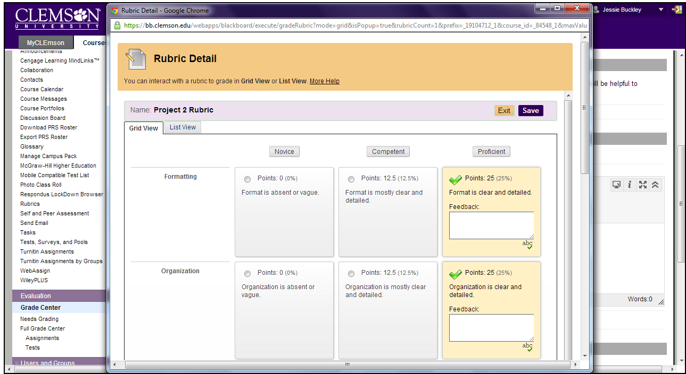
- Continue grading using the rubric.
- A running raw total score is displayed as points are selected. If you want to override the total score, provide a new score in the Change the number of points box.
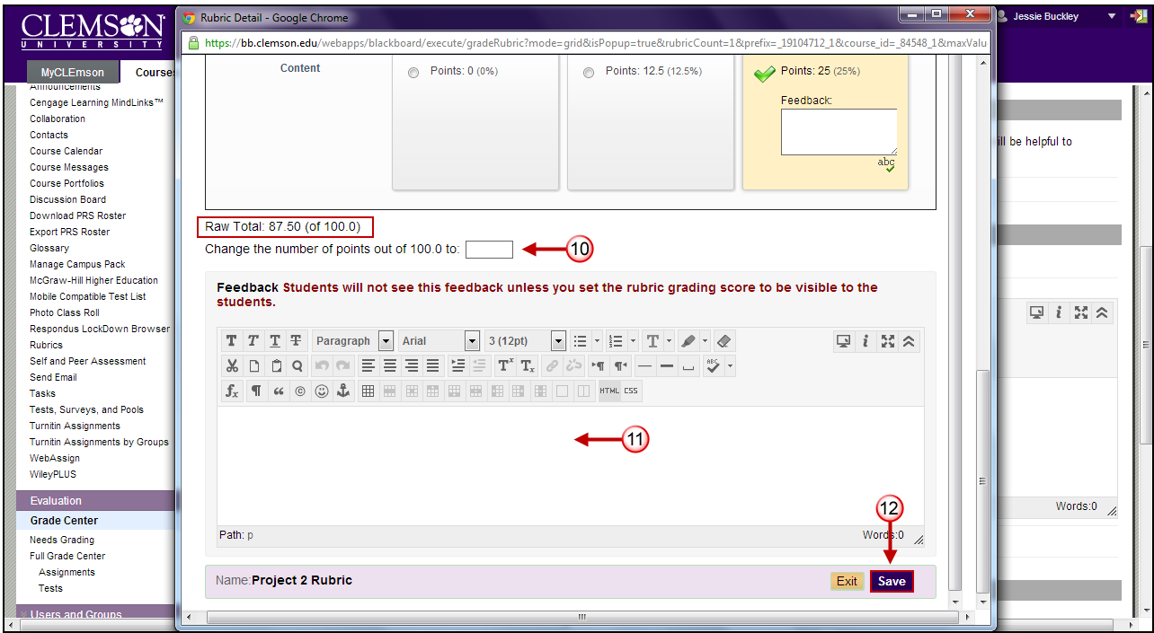
- You can also provide overall feedback in the rubric.
- Click Save to exit the Rubric Detail page.
- In Section 3: Grade Current Attempt you may also include Feedback to User or attach a feedback file.
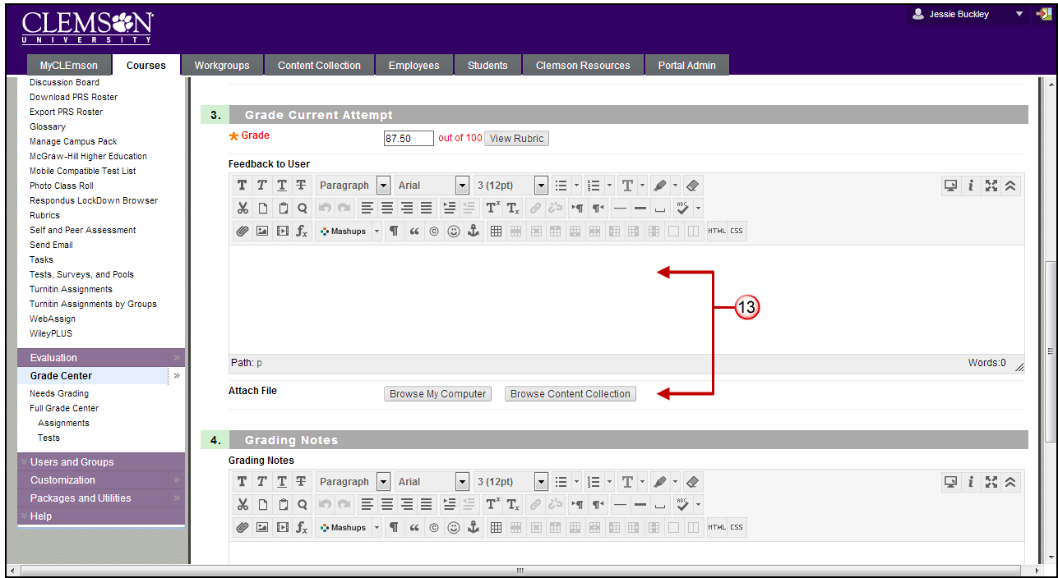
- In Section 4: Grading Notes you may provide Grading Notes for the Instructor. Grading Notes are only visible to the Instructor or Teaching Assistant.
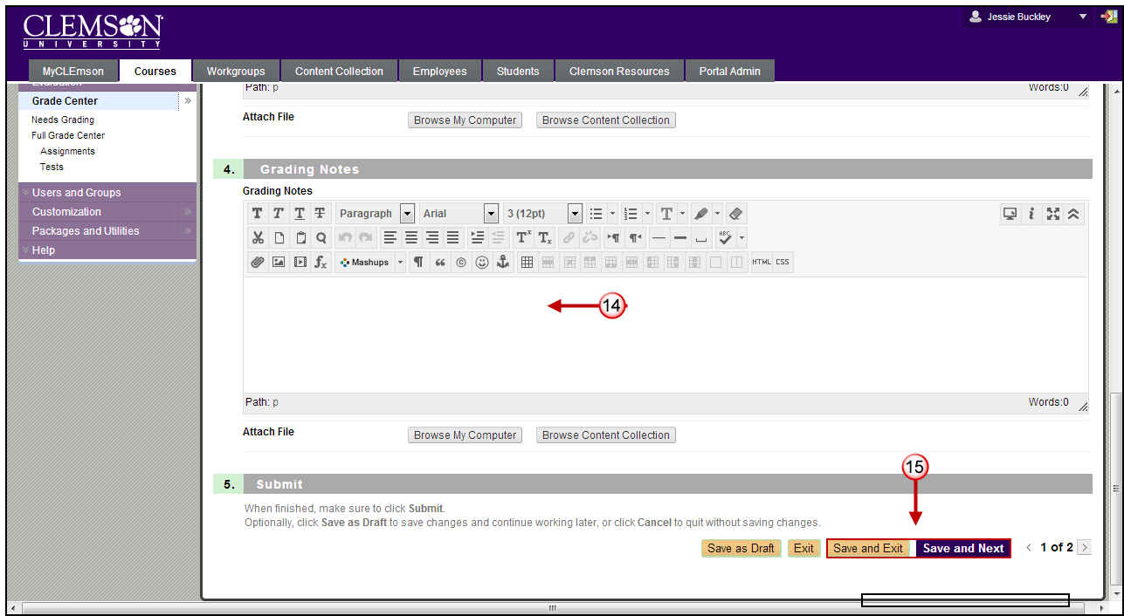
- Click Save and Exit to finish grading, or Save and Next to continue grading the next submission.

