Creating a Test Question for Extra Credit

Blackboard Beginners

Modifying the Question Settings 1
Creating Questions worth Extra Credit 3

Modifying the Question Settings
To modify the Question Settings:
- From the Tests page, click the action link at the end of the test Name.
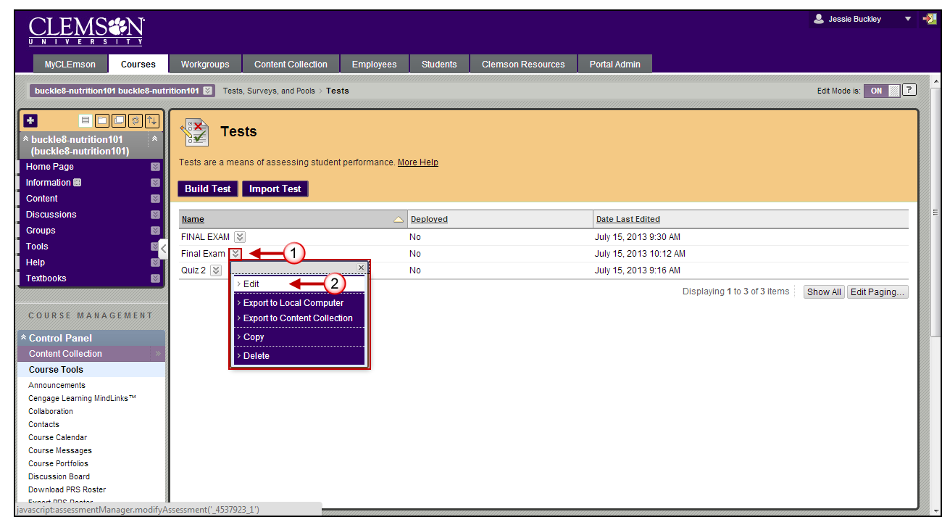
- Then click Edit.
- The Test Canvas page is displayed.
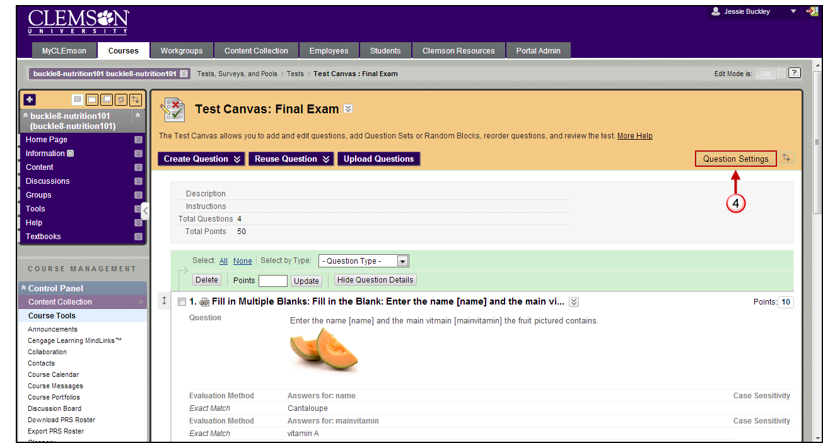
- Click the Question Settings button.
- The Test Question Settings page is displayed.
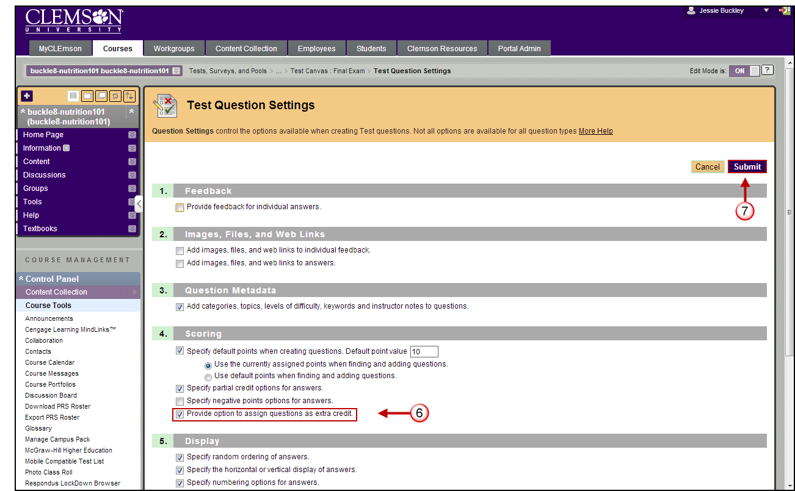
- In the Scoring section, select the checkbox to Provide option to assign questions as extra credit.
- Then click Submit.
- The Test Canvas page is displayed.

Creating Questions worth Extra Credit
To make a specific question worth extra credit:
- Locate the question on the Test Canvas page.
- Then click the Points field at the end of the question. (the actual number)
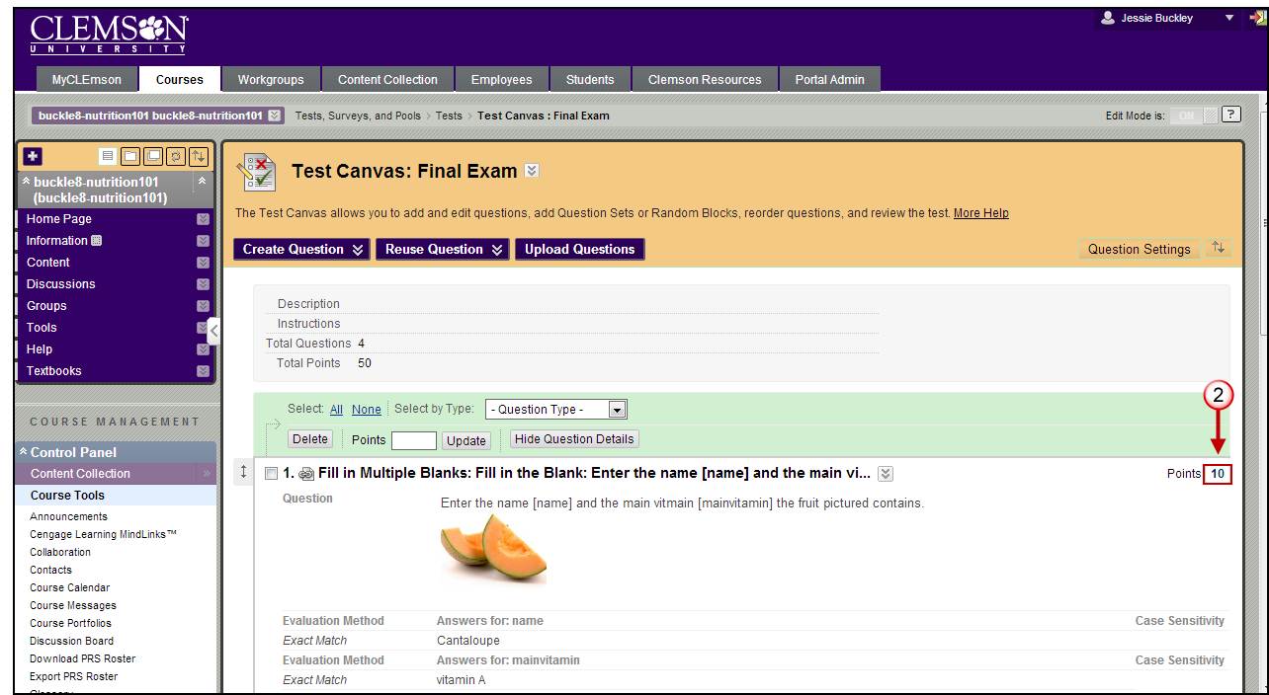
- A pop-up window is displayed.
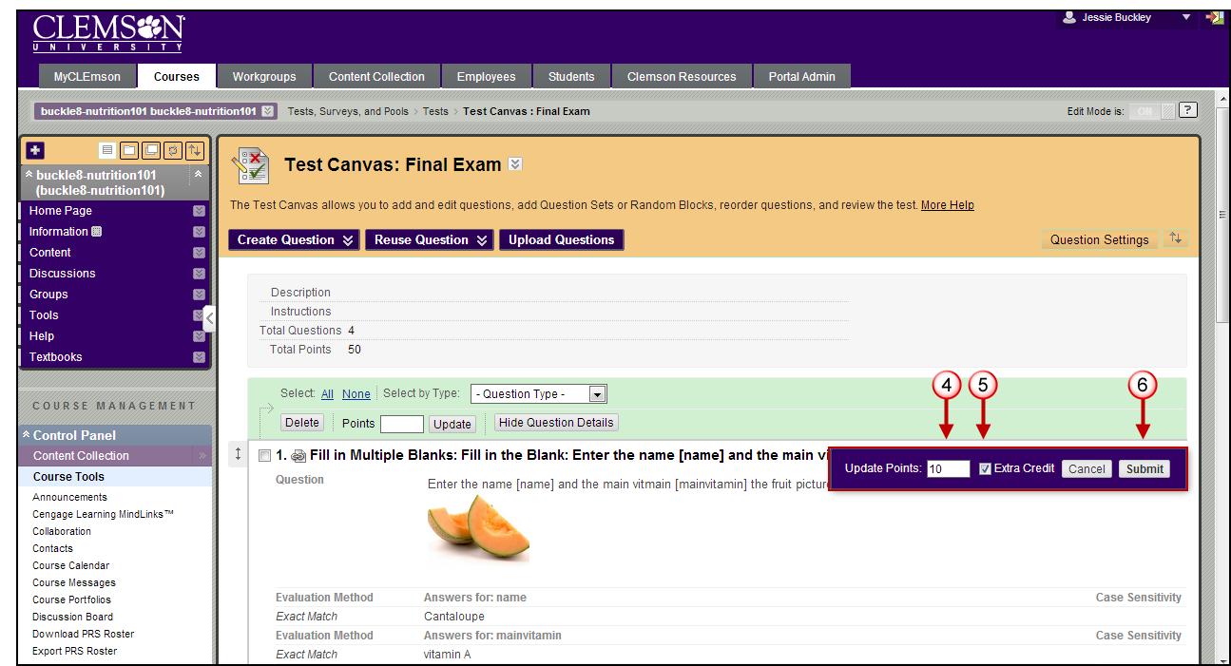
- Enter the point value to assign for Extra Credit.
- Select the Extra Credit checkbox.
- Then click the Submit button.

