Deleting an Adobe Connect Meeting

Intermediate

Downloading or Saving a Meeting Recording 1
Moving Content from an Adobe Connect Meeting 2
Deleting a Meeting 4

NOTE: Once a Meeting has been deleted all Recordings and Content (such as any Power Point files) for that Meeting are also permanently deleted!

Downloading or Saving a Meeting Recording
If you made a Recording of your Meeting then you can save it to your own computer by following these instructions:
- Open your web browser and navigate to the Adobe Connect Enterprise Server (https://connect.clemson.edu).
- Click the Meetings link in the gray menu bar.
- Click the Name of the meeting for which to download a recording.
- Click the Recordings link.
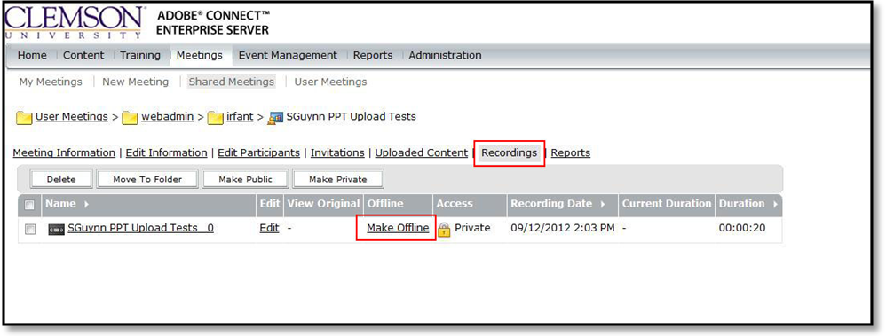
NOTE: Recordings are downloaded in real time. If the recording is an hour in duration, it will take an hour to download.
- A pop-up message will be displayed. When prompted, click Proceed with Offline Recording.
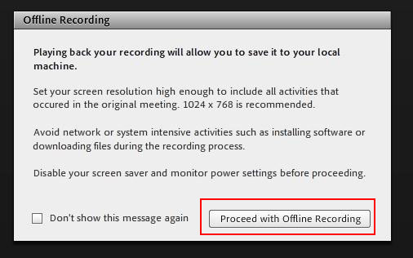
- Select the location of where the file should be stored.
- Enter a name for the file.
- Click Save.

Moving Content from an Adobe Connect Meeting
If you uploaded any Content (such as Power Point files) to an Adobe Connect Meeting it can be moved from your meeting to your Adobe Connect Content folder. This content will be accessible from any Meetings for which you are a Host.
- Open your web browser and navigate to the Adobe Connect Enterprise Server (https://connect.clemson.edu).
- Click the Meetings link in the gray menu bar.
- Click the Name of the meeting for which to move meeting content.
- Click the Uploaded Content link.
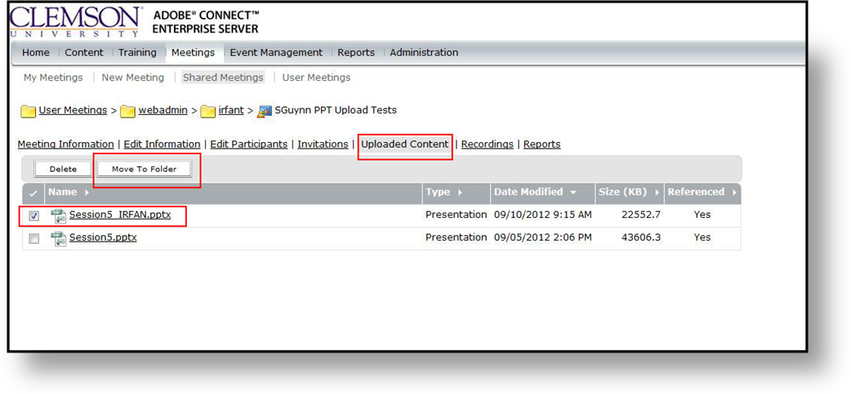
- Select the checkbox for the content to move.
- Then click Move to Folder.
- Select the location to move the file in your User Content folder.
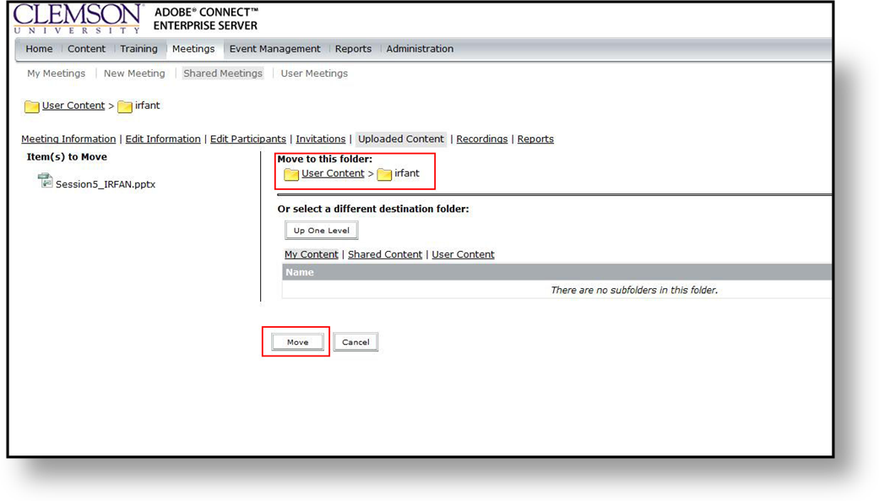
- Then click Move.
- A message will be displayed to let you know that the file(s) were moved successfully. Click OK.

Deleting a Meeting
NOTE: Only the original Host who created the Meeting is the only one who can delete a Meeting.
- Open your web browser and navigate to the Adobe Connect Enterprise Server (https://connect.clemson.edu).
- Click the Meetings link in the gray menu bar.
- Find the meeting you want to delete. Then click the Delete button to the right of the meeting name.
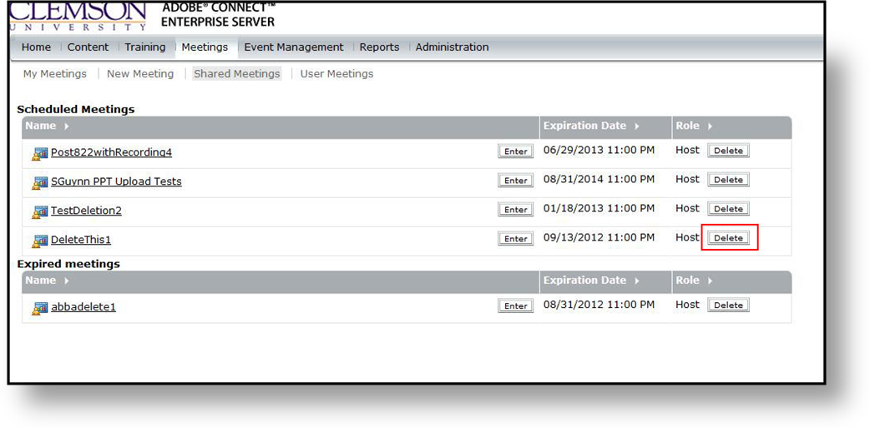
- Confirm that you want to delete the selected meeting.
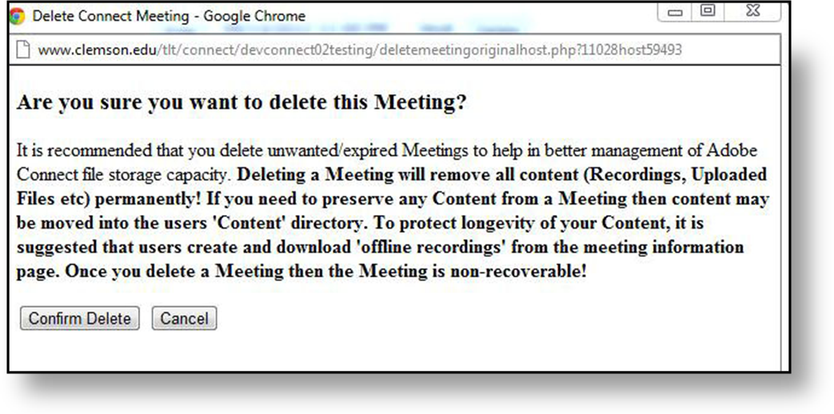
- The Meeting Deletion will be confirmed. Click Close to return to Adobe Connect Enterprise Server.
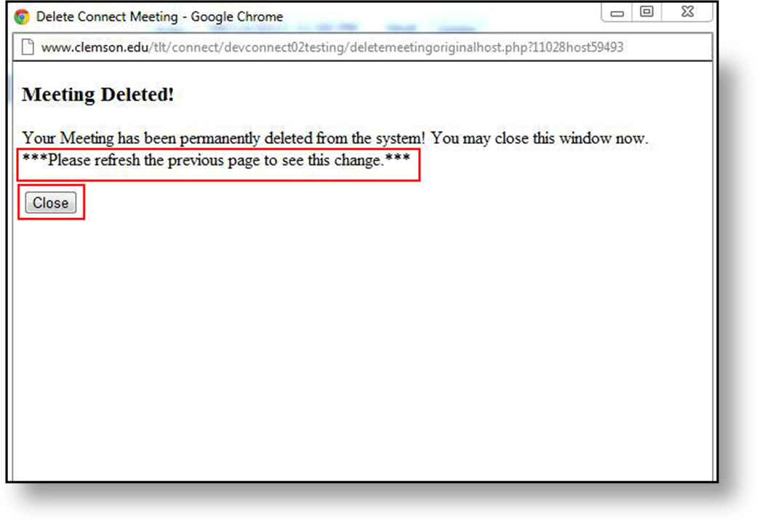
NOTE: You may need to refresh the window to see the change in your list of Meetings.

