Linking your Adobe Connect recording to
your Blackboard Course

Adobe Connect Beginners

Finding your Adobe Connect Recording 1
Linking your Adobe Connect Recording to Blackboard 5

Finding your Adobe Connect Recording
- Open your web browser and navigate to the Adobe Connect Enterprise Manager (https://connect.clemson.edu).
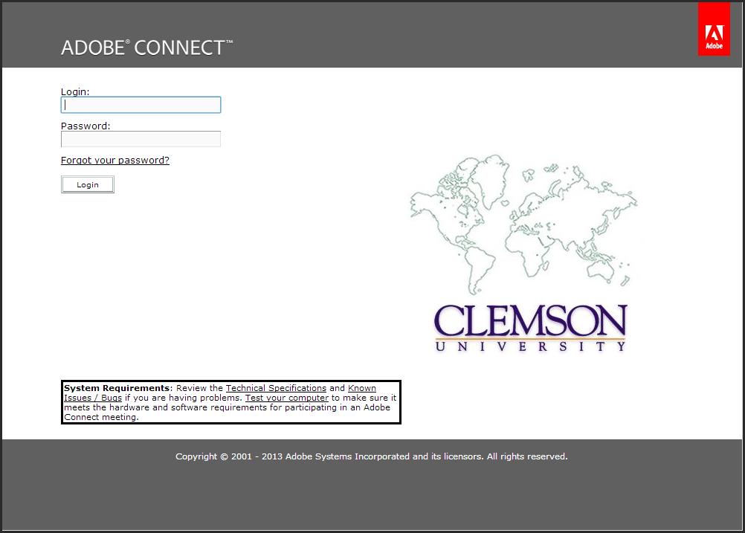
- Login using your Clemson employee username and password.
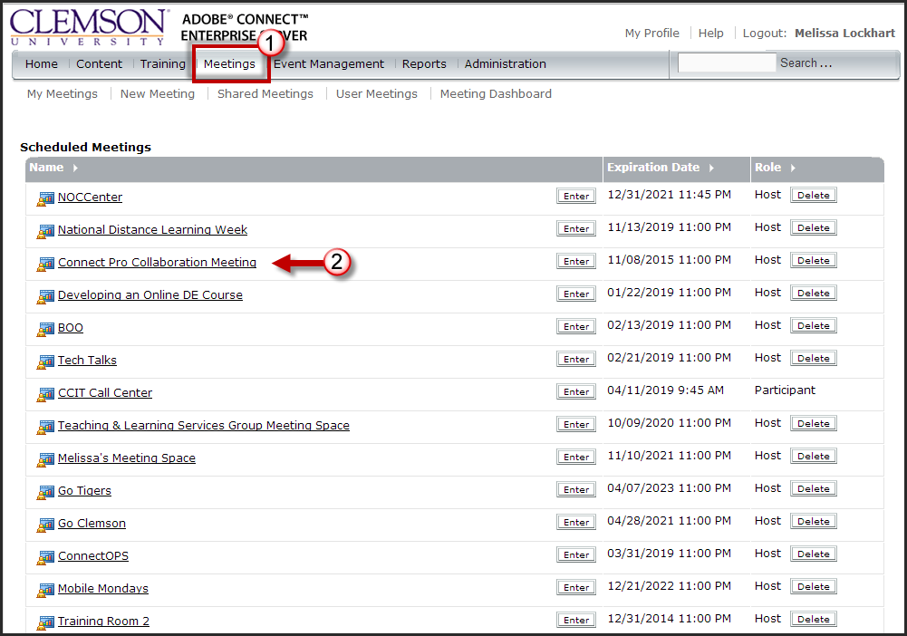
- Click the Meetings link in the gray menu bar.
- Then click the link for the name of your meeting space.
- The Meeting Information page is displayed.
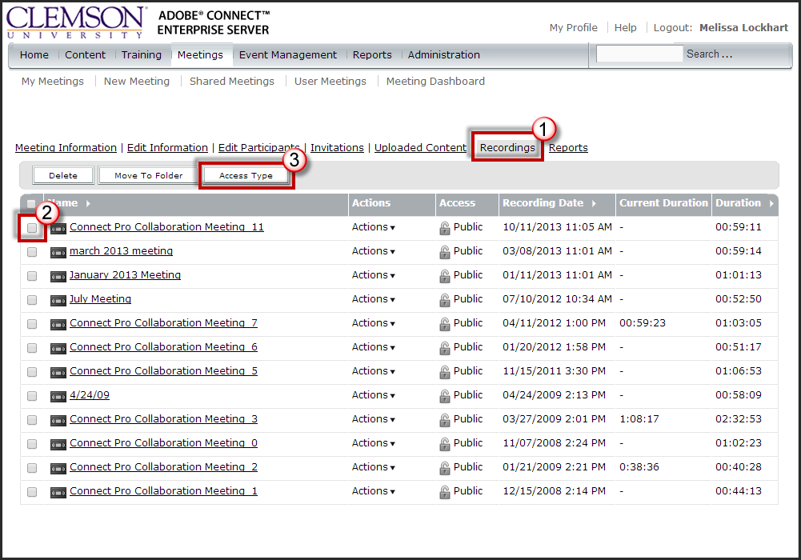
- Click the Recordings tab for the selected meeting.
- Enable the checkbox for the recording that will be shared with your students.
- Then click Access Type.
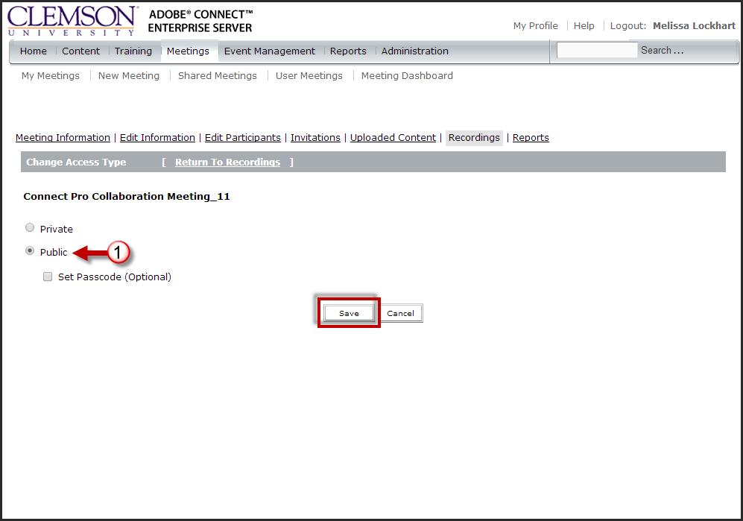
- Select the Public radio button.
- If you want to only allow specific people access, you can select the Set Passcode(Optional) radio button. Then enter a passcode that you will provide to people attempting to access the recordings.
- Next click Save.
- Next click the Name of the recording.
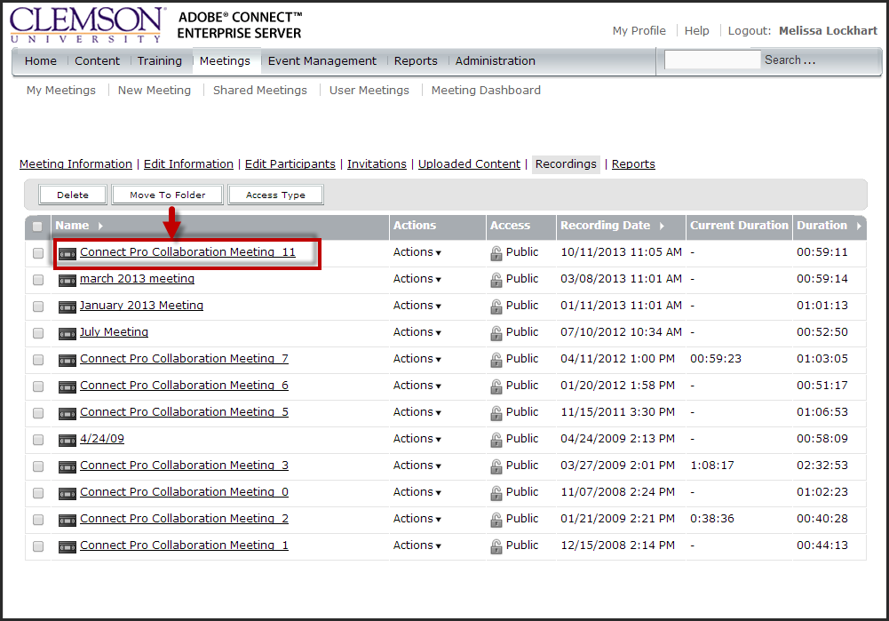
- This will take you to the Recording Information page.
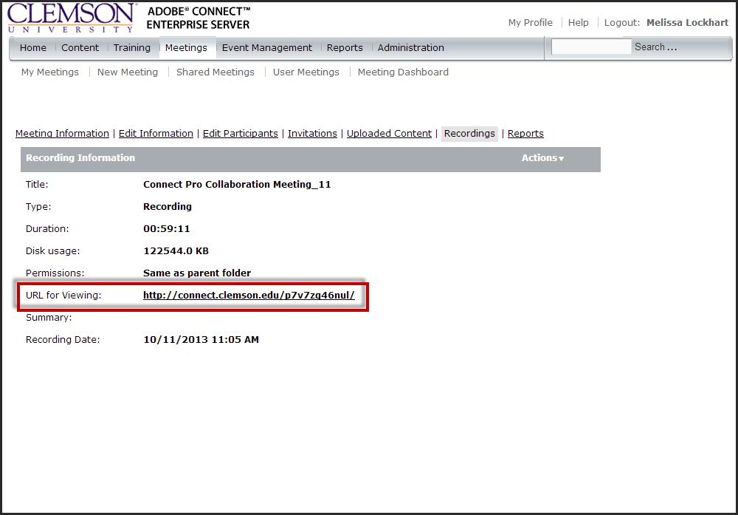
- Select and copy the URL for Viewing (CTRL + C).

Linking your Adobe Connect Recording to Blackboard
- Login to Blackboard Learn.
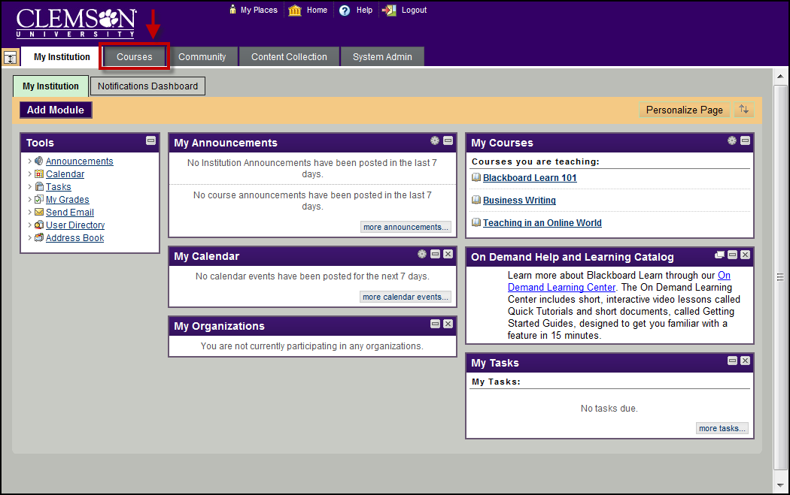
- Click the Courses tab.
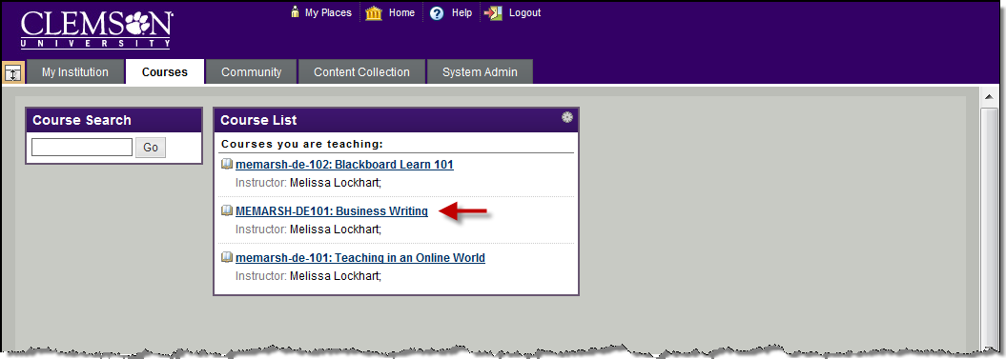
- Click the course to open from the Course List module.
- The course entry page will be displayed.
- Select the Content Area for which to add the External link.
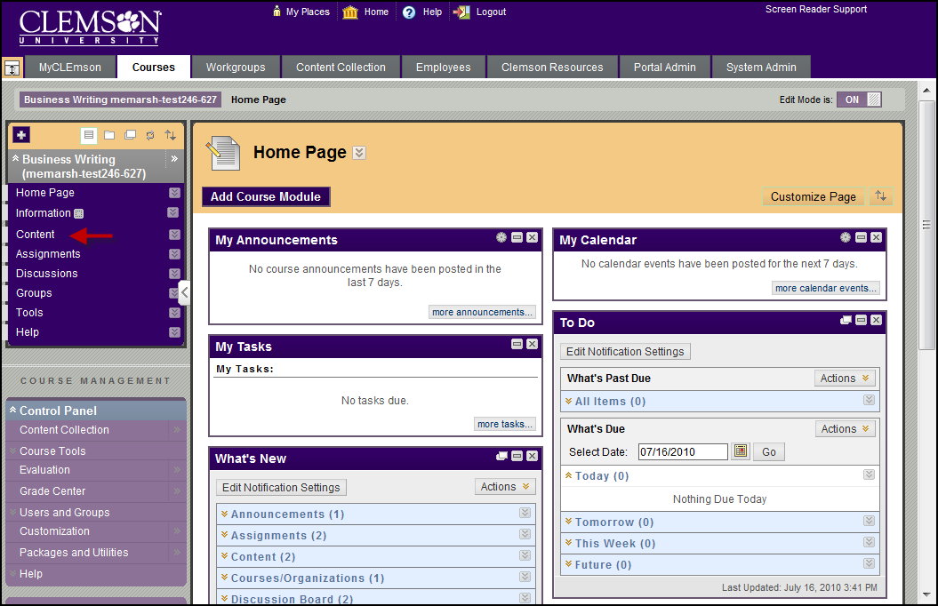
- Hover your mouse over the Build Content action link and select Web Link.
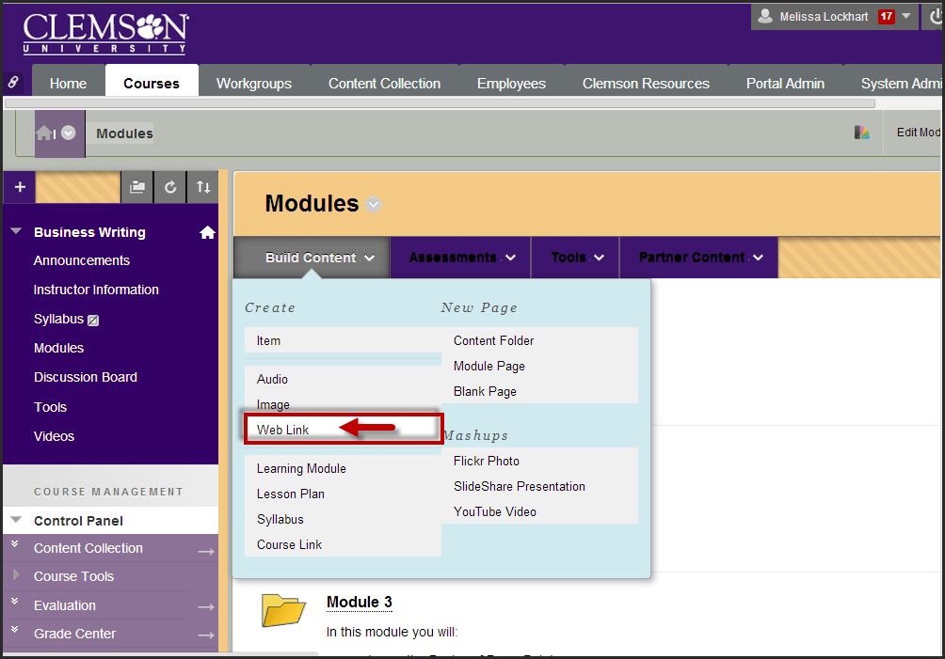
- The Create URL page is displayed.
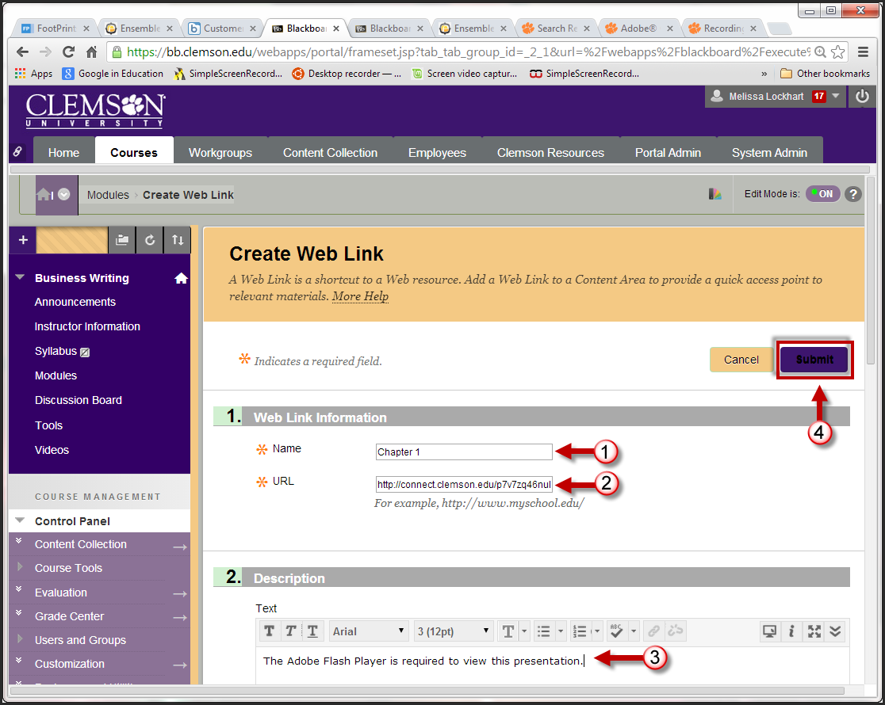
- Enter the Name of your recording.
- Then paste the URL for Viewing your recording into the URL field (CTRL + V).
- Enter additional information regarding this website in the Text field.
- Then click Submit.
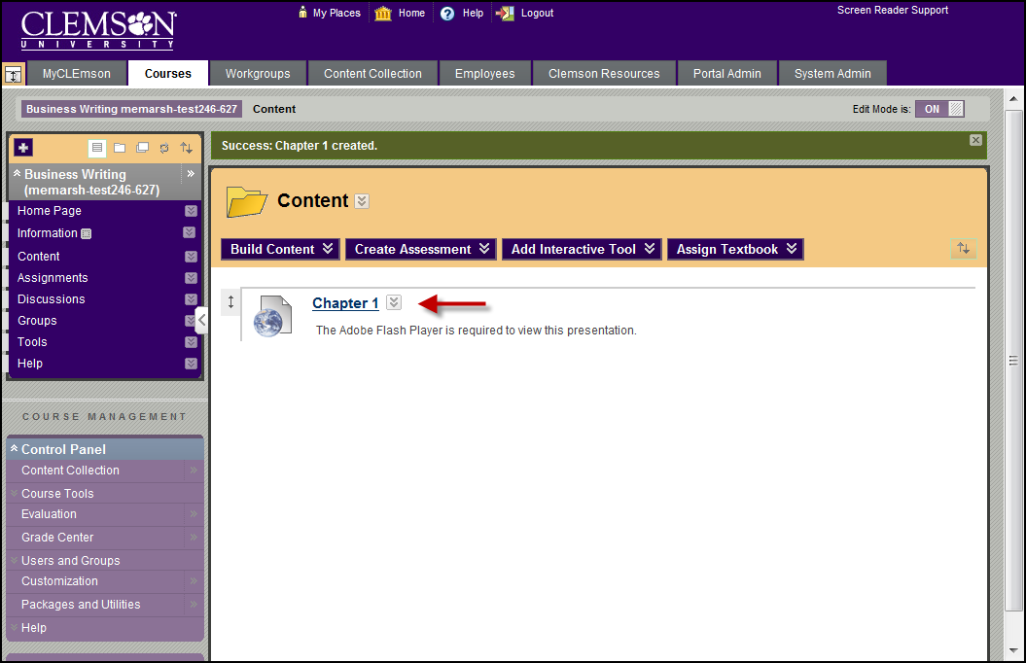
- The recording is now provided as a link in your Blackboard course.
- Students can click the link to watch the recording.

