Adobe Connect Shared Content

Intermediate

Adding Shared Content to a Meeting 1
Adding Shared Background Images to a Meeting 3

Adding Shared Content to a Meeting
- Open your Adobe Connect Meeting.
- From the Pods menu select Share and then click Add New Share.
- Click the drop down menu to the right of the Share My Screen button.
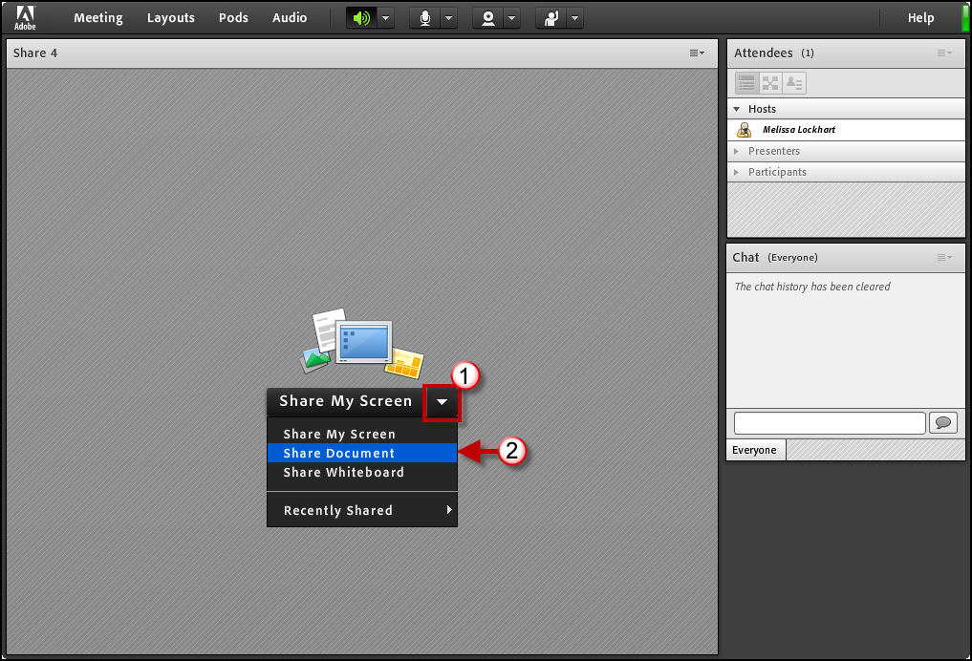
- Then select Share Document.
- Then click the Shared Content link on the left side of the menu.
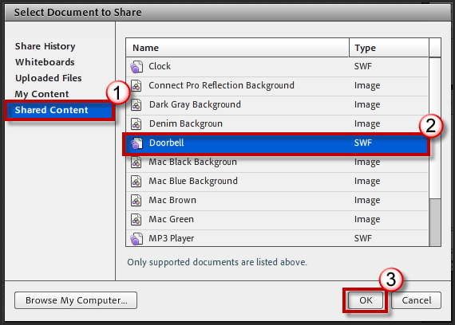
- Select the Shared Content item. (Doorbell, Clock, MP3 Player, etc.)
- Then click OK.
- The Shared Content will be displayed in the Share Pod.
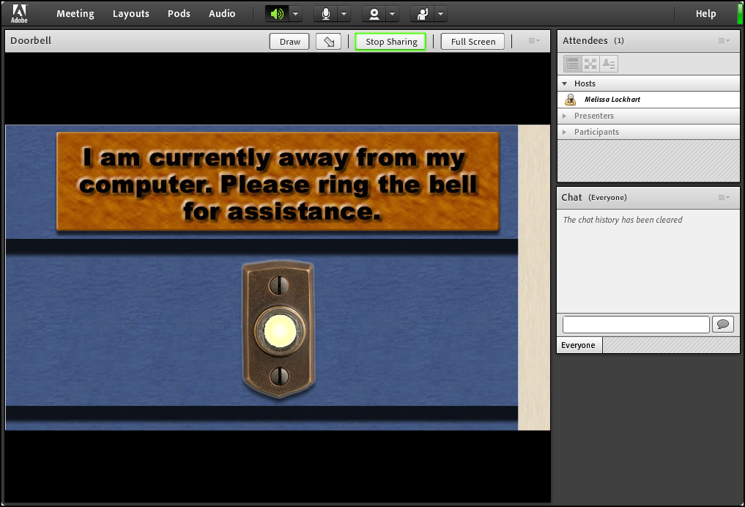
- Then resize the Share pod as necessary.

Adding Shared Background Images to a Meeting
- Open your Adobe Connect Meeting.
- From the Meeting menu, select Preferences.
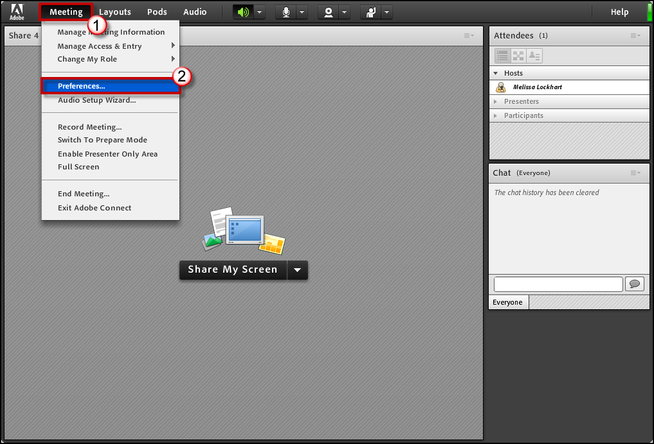
- Click the General link from the menu on the left.
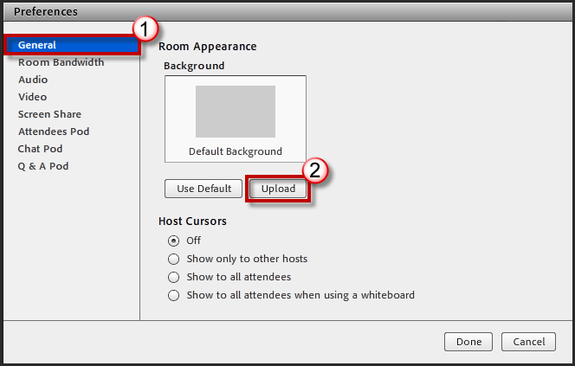
- Then click Upload.
- Next, click the Shared Content link on the left side of the menu.

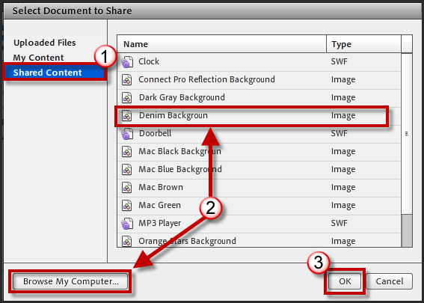
- Select the Shared Content item (Background image) or click Browse My Computer and select an image that can be used for the background.
- Then click OK.
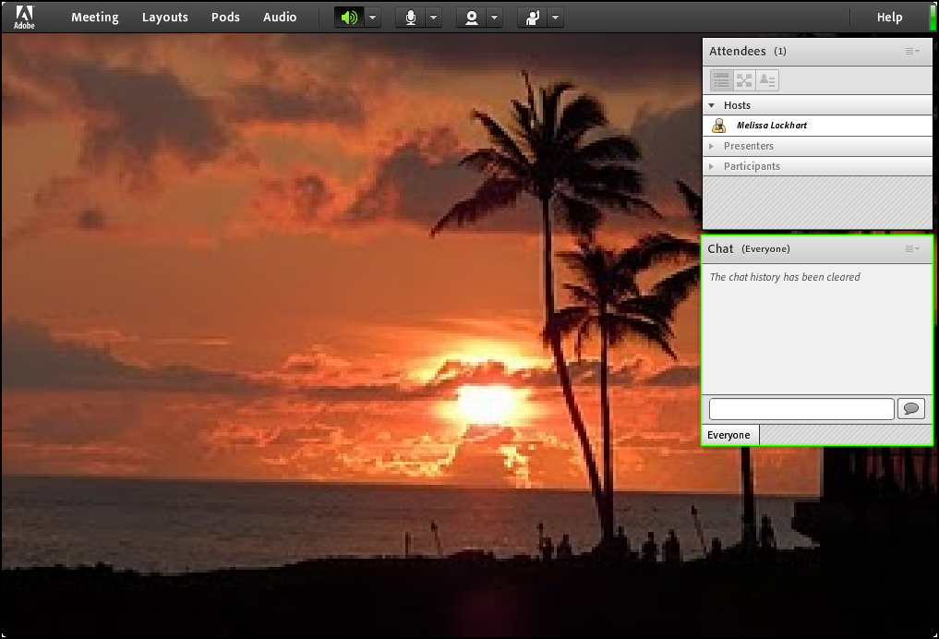
- The new background image will be displayed in your meeting space.

