Publishing & Linking your Adobe Presenter Files

Adobe Connect Beginners

Add Content from PowerPoint to Adobe Connect 1
Setup Adobe Connect Server 1
Publish an Adobe Presenter file from PowerPoint to Adobe Connect 2
Linking your Adobe Presenter file to Blackboard 11

Add Content from PowerPoint to Adobe Connect

Setup Adobe Connect Server
- Open your PowerPoint presentation.
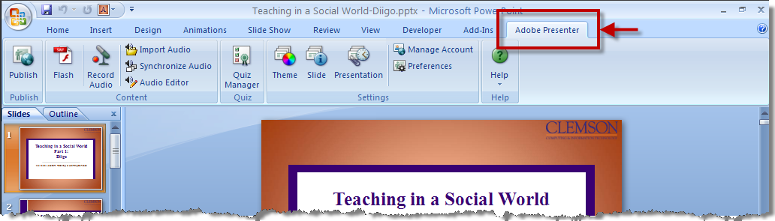
- Click the Adobe Presenter ribbon.
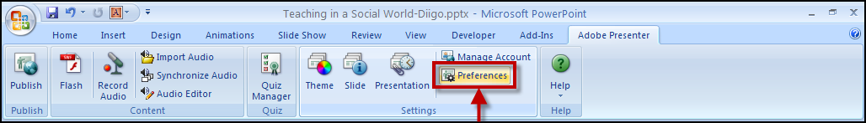
- Click the Preferences button in the Adobe Presenter Ribbon.
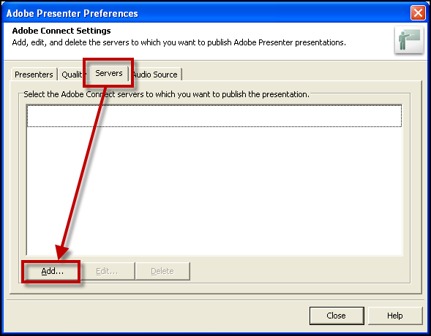
- Click the Servers tab.
- Then click the Add button.
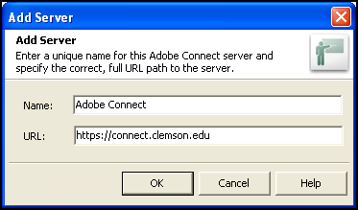
- Type a name for the Adobe Connect server.
- Enter the following URL: https://connect.clemson.edu.
- Then click the OK button.
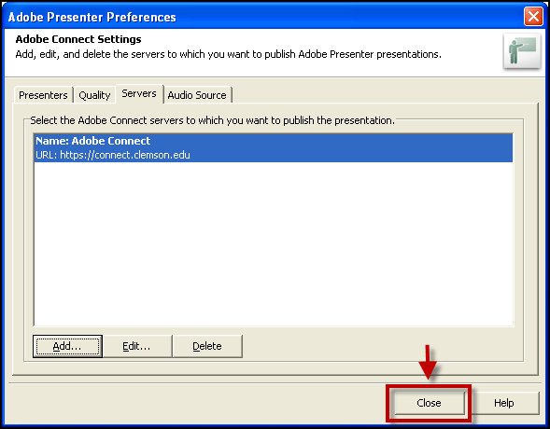
- Then click the Close button.

Publish an Adobe Presenter file from PowerPoint to Adobe Connect
- Open your PowerPoint presentation.
- Click the Adobe Presenter ribbon. NOTE: Your PowerPoint file should be saved in the PowerPoint 97-2003 file format of .PPT before you can publish your file.
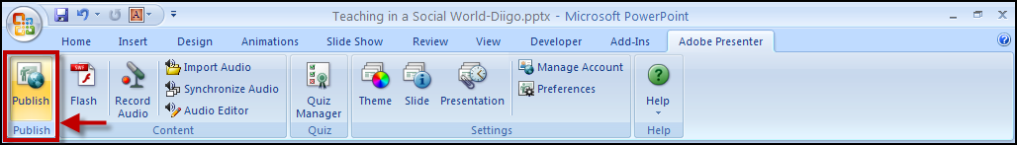
- Click the Publish button in the Adobe Presenter ribbon.
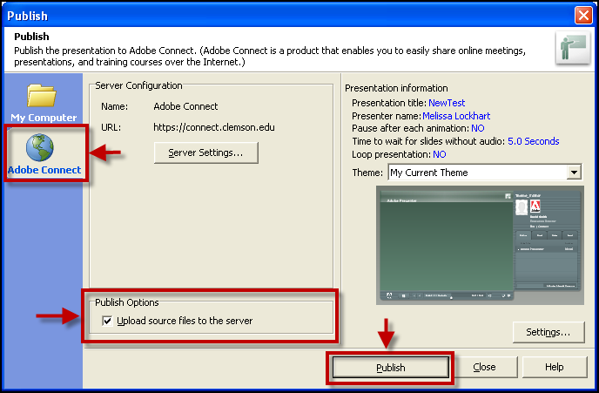
- Select the Adobe Connect tab on the left side of the Publish window.
- Enable the Upload source files to the server checkbox.
- Then click Publish.
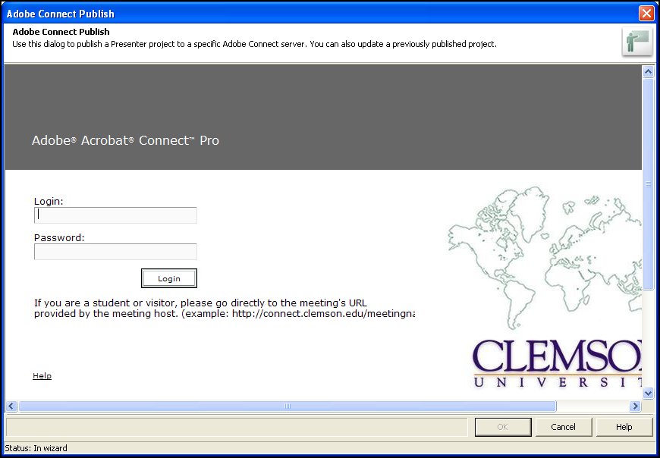
- You will be prompted for a Login and Password. Use your Clemson Network login and password.
- Then click the Login button.
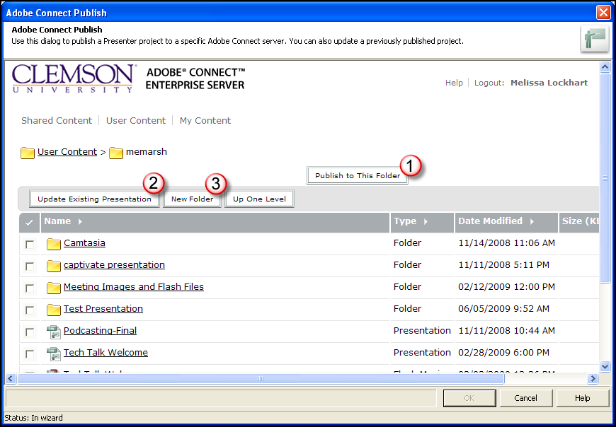
- This will display your Adobe Connect Content Collection. From here you have 3 options:
- Publish to This Folder
- Update Existing Presentation
- New Folder

Publish to This Folder
- If you click the Publish to This Folder button, the system will prompt you to enter a Title for the file you are uploading.
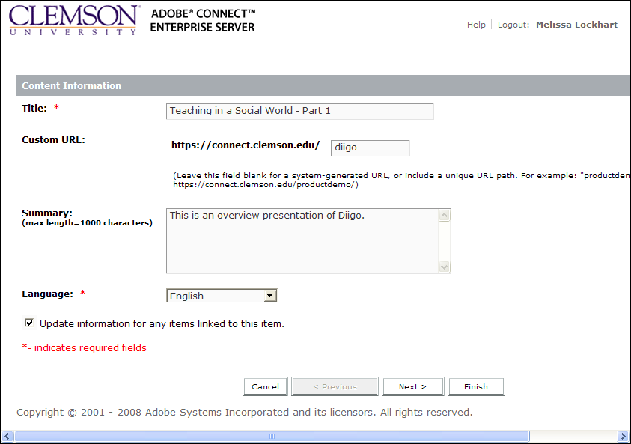
- Then you can create a custom URL for the content being uploaded.
- Enter a brief Summary regarding the file.
- Enable the Update information for any items linked to this item checkbox.
- Then click Next.
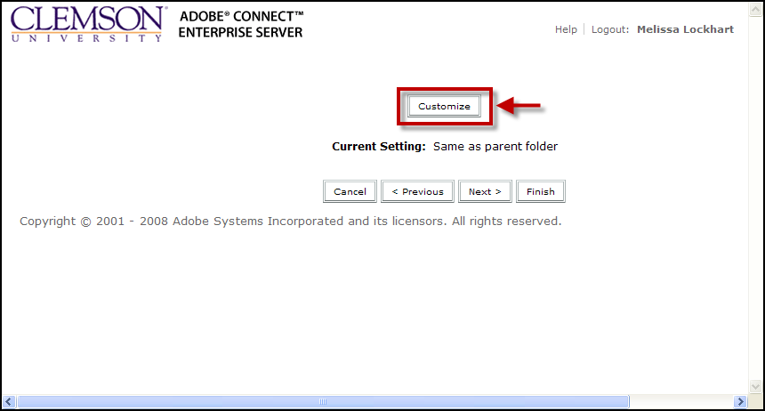
- Click the Customize button.
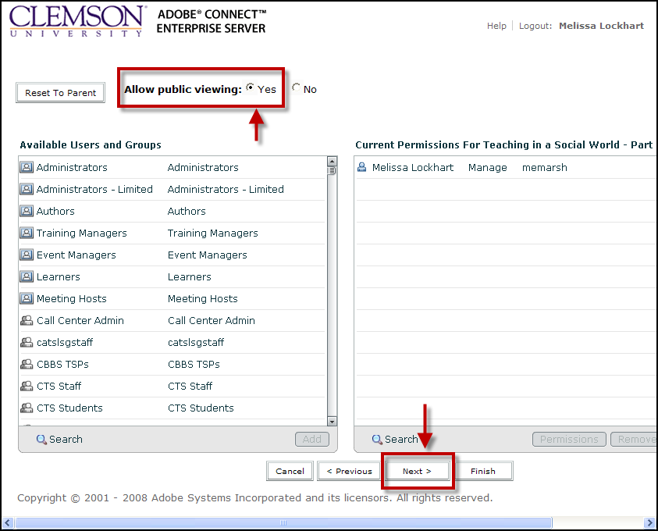
- Enable the Yes radio button to Allow public viewing.
- Then click Next.
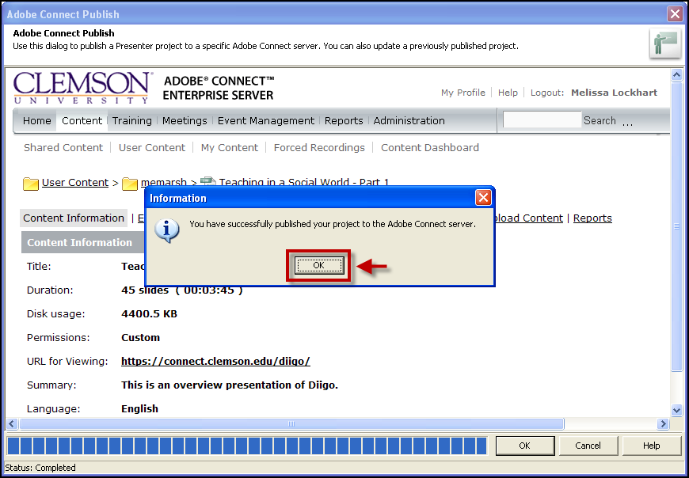
- Click the OK button.
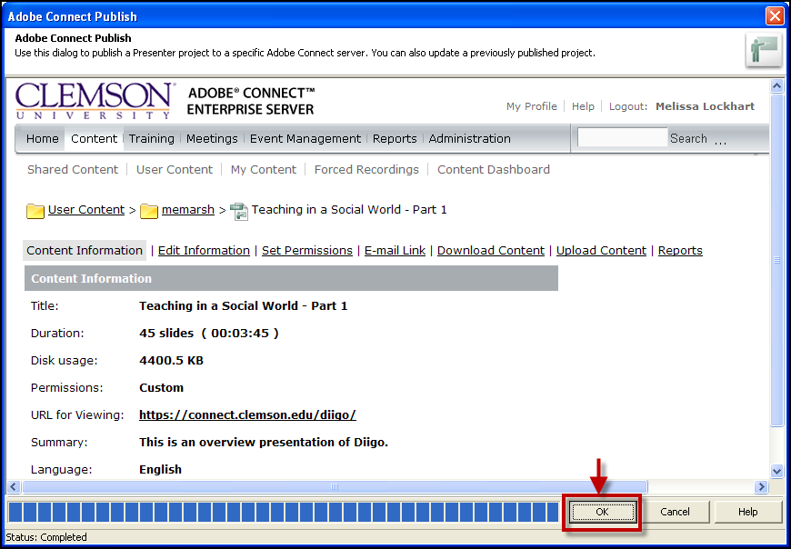
- Click the OK button.
- You will then be returned to your PowerPoint presentation.

Update Existing Presentation
- If you click the Update Existing Presentation button, it will display a message regarding the process of updating an existing presentation.
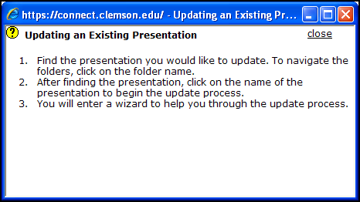
- Click Close.
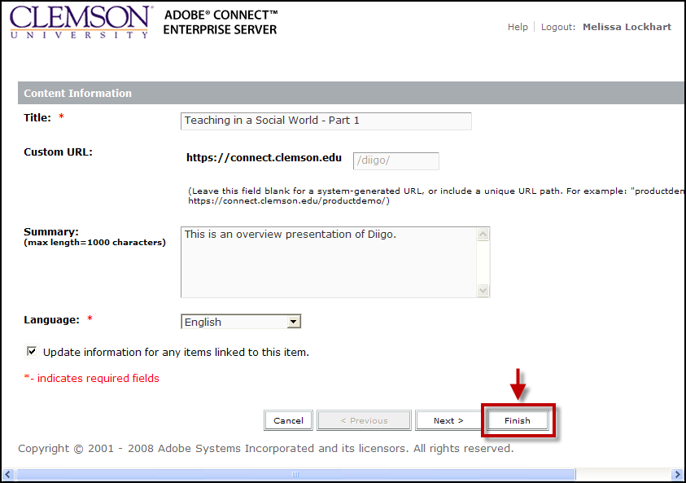
- Then click the link of the presentation you want to update.
- Click Finish. The presentation will upload and overwrite the existing presentation.
- Click the OK button.
- Click the OK button.
- You will then be returned to your PowerPoint presentation.

New Folder
- If you click the New Folder button, you will be prompted to enter a name for the folder.
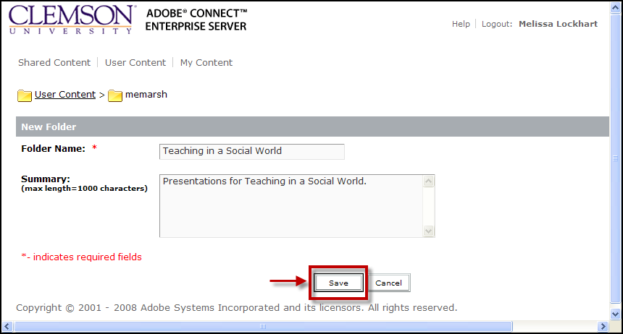
- Enter a Folder Name and Summary.
- Then click Save.
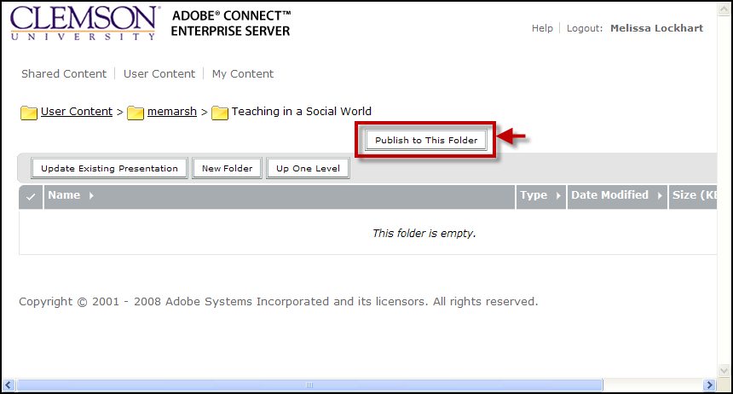
- Click the Publish to This Folder button.
- Enter a Title for your presentation.
- Then you can create a Custom URL for the content being uploaded.
- Enter a brief Summary regarding the file.
- Enable the Update information for any items linked to this item checkbox.
- Then click Next.
- Click the Customize button.
- Enable the Yes radio button to Allow public viewing.
- Then click Next.
- Click the OK button.
- Right-click on the URL for Viewing link. Select Copy Shortcut (Internet Explorer) or Copy Link Location (Firefox) from the context menu.
- Click the OK button.
- You will then be returned to your PowerPoint presentation.

Linking your Adobe Presenter file to Blackboard
- Login to Blackboard Learn.
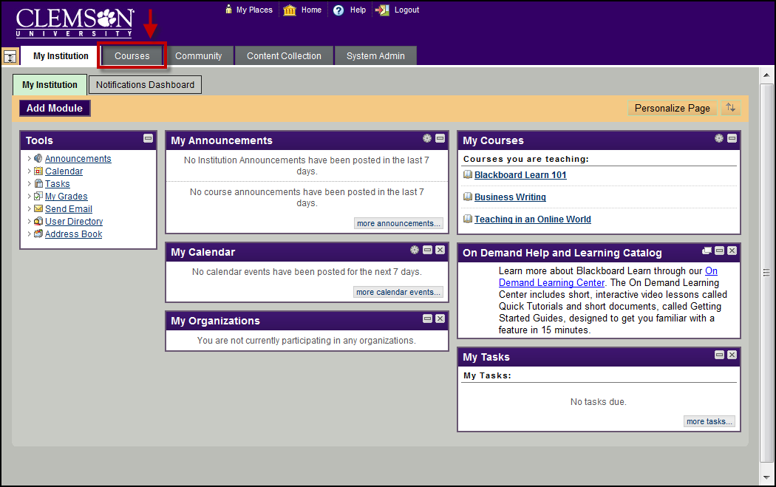
- Click the Courses tab.
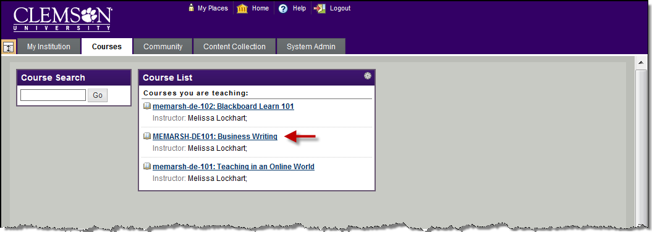
- Click the course to open from the Course List module.
- The course entry page will be displayed.
- Select the Content Area for which to add the External link.
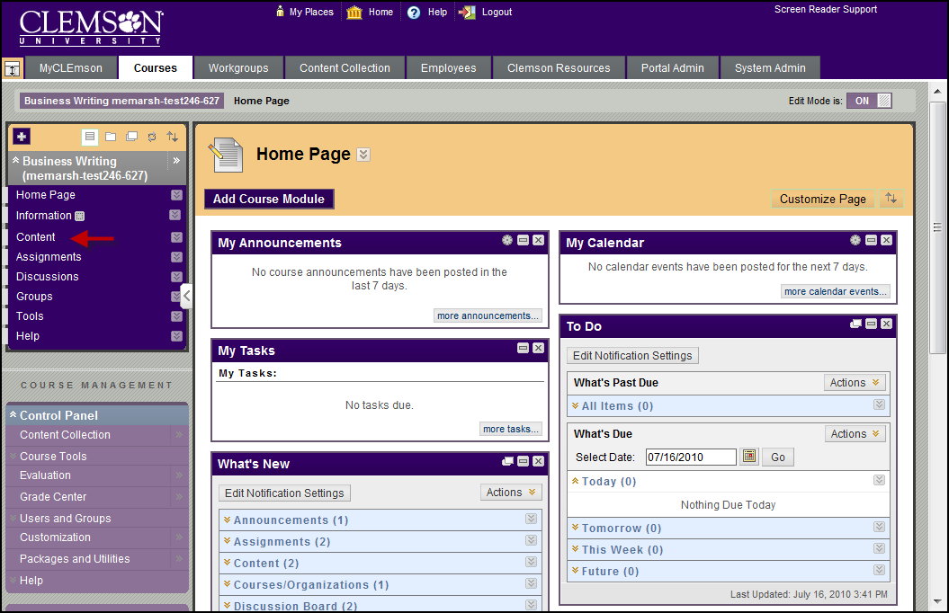
- Hover your mouse over the Build Content action link and select URL.
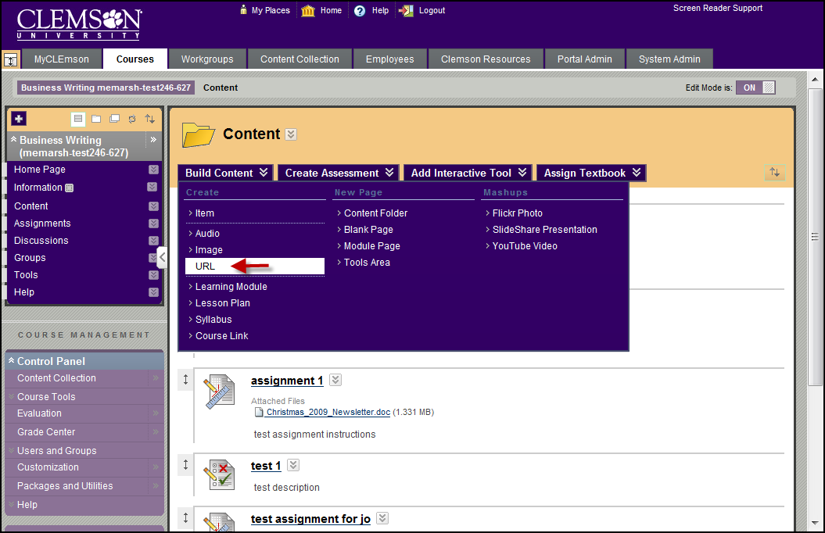
- The Create URL page is displayed.
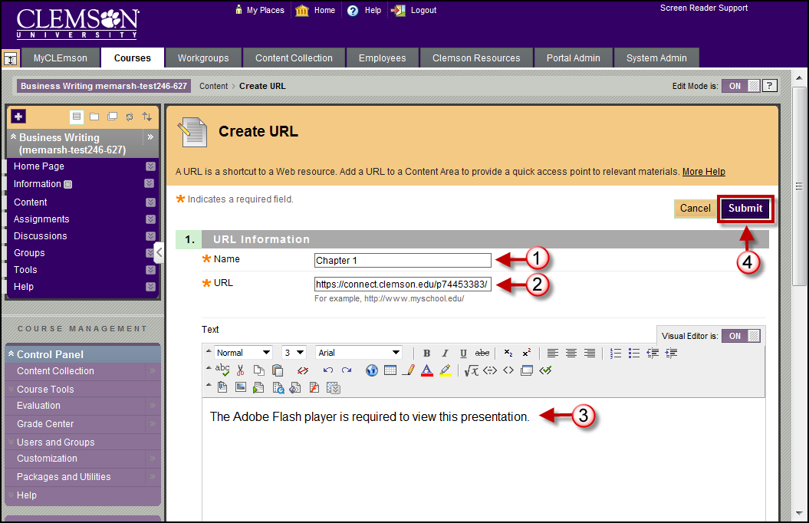
- Enter the Name of your presentation.
- Then paste the URL for Viewing your Adobe Presenter file into the URL field (CTRL + V).
- Enter additional information regarding this website in the Text field.
- Then click Submit.
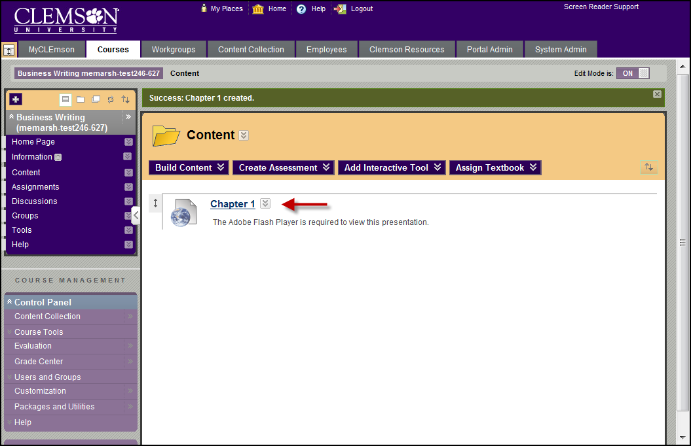
- The recording is now provided as a link in your Blackboard course.
- Students can click the link to watch the recording.

