Turnitin® Assignments

Blackboard Intermediate

Creating Turnitin® Assignments 1
Syncing your Roster 9
Running Student Assignments through Turnitin® 11
Individually as a File Upload 13
Multiple File Upload 15
In a Zip File 16
By Cutting & Pasting 19
Downloading Student Assignments 20
Grading Turnitin® Assignments through the Blackboard Gradebook 24
Viewing the Originality Report through the Turnitin® Tool 29

Creating Turnitin® Assignments

- Login to Blackboard.
- Click the Courses tab.
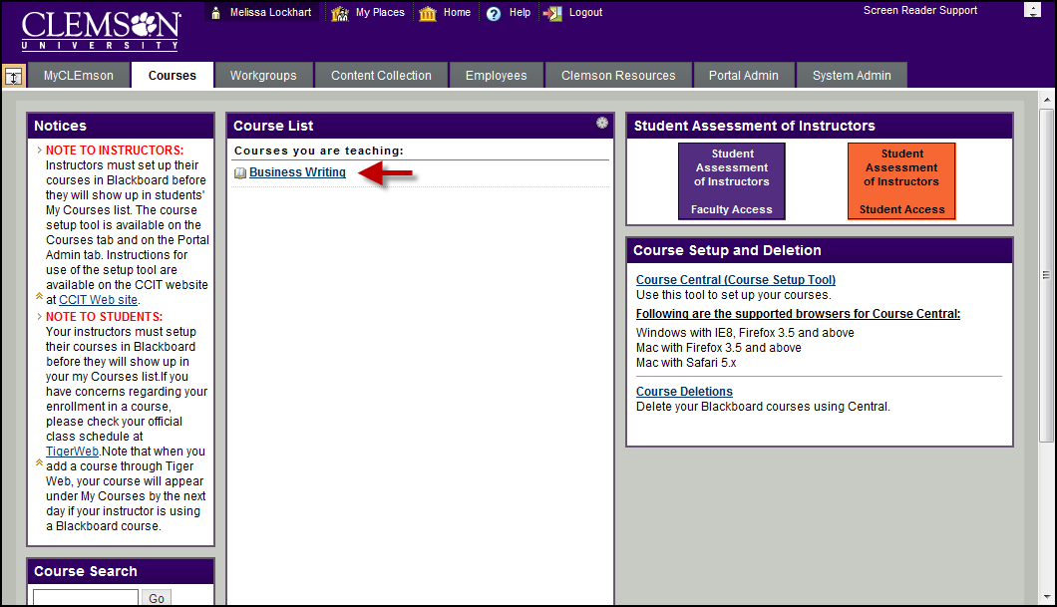
- Click the course link. The system navigates you to the course home page.
- Click the Content Area where you want to link the Turnitin Assignment.
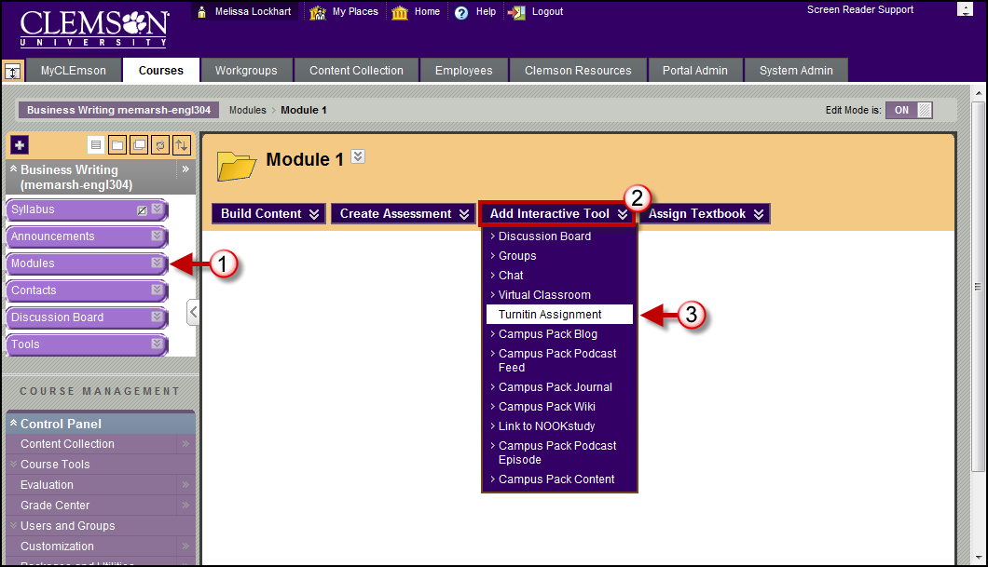
- Hover over or click Add Interactive Tool.
- Select Turnitin Assignment.
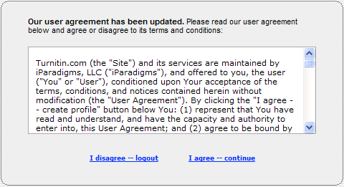
- The system may provide a license agreement. If it does click the I agree – continue link.
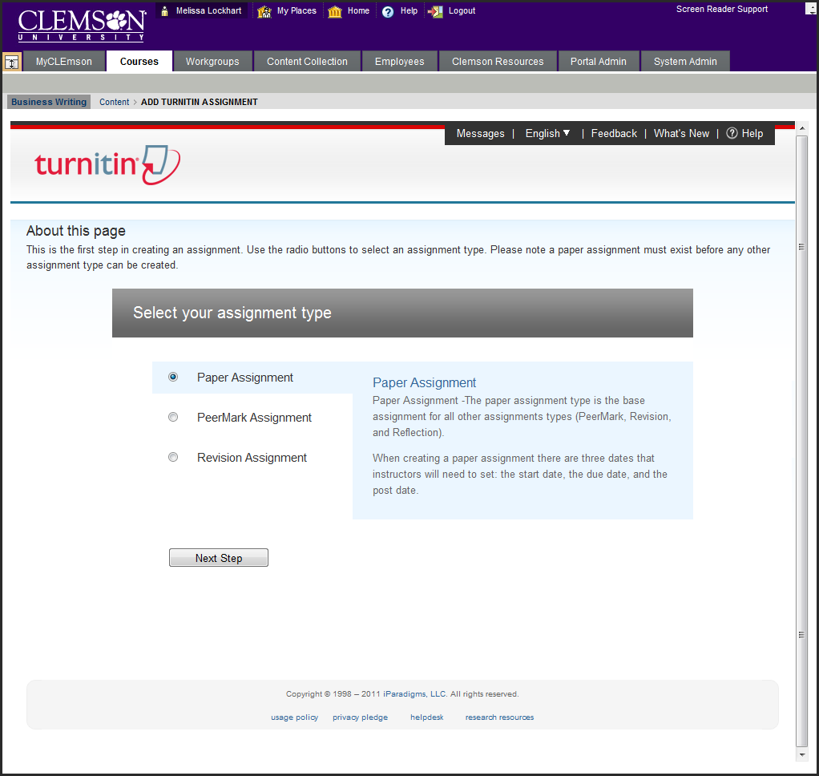
- The system displays the Add Turnitin Assignment page.
- Select the Paper Assignment radio button.
- Then click Next Step.
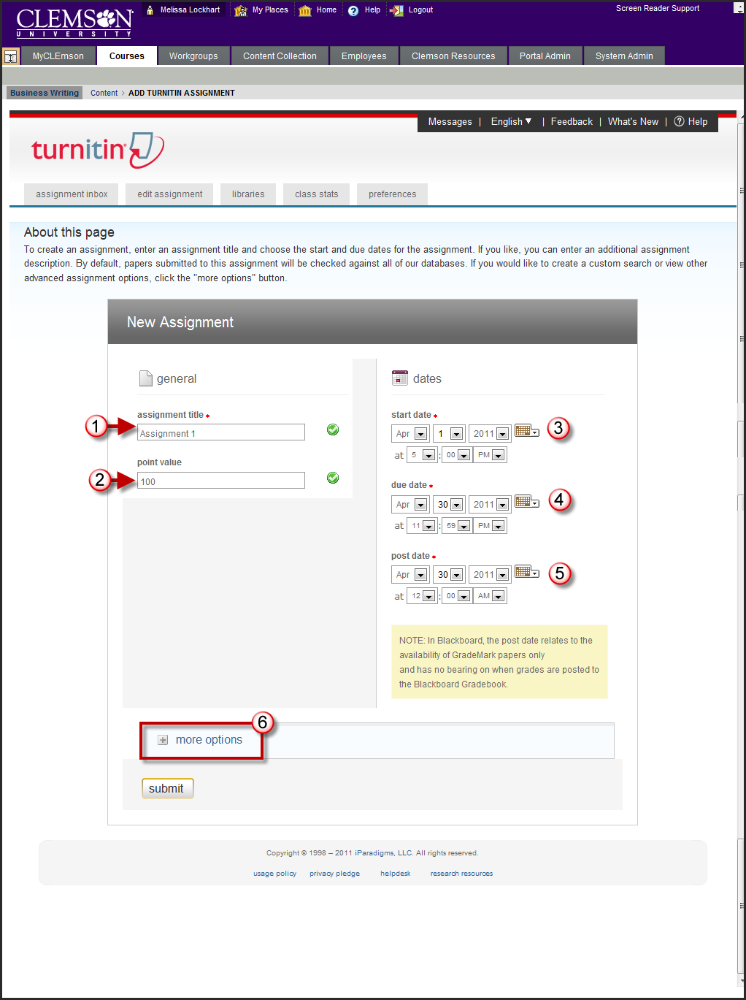
NOTE: There is a known issue with the dates. It is better to save the assignment and the edit the assignment and modify the dates.
- Enter the Assignment Title.
- Enter the number of points possible for this assignment in the Point Value field.
- Enter the start date, due date, and post date for the assignment. Students are only able to submit once the start date and time has passed. After the due date and time, students will be blocked unless late submissions are enabled. In Blackboard, the post date relates to the availability of GradeMark papers. Once the post date of a paper has passed, students are able to access the marked version of the paper and view any grades, comments, marks, or requested changes noted by the instructor.
- To enter any special instructions or create originality reports for the assignment, click More Options.
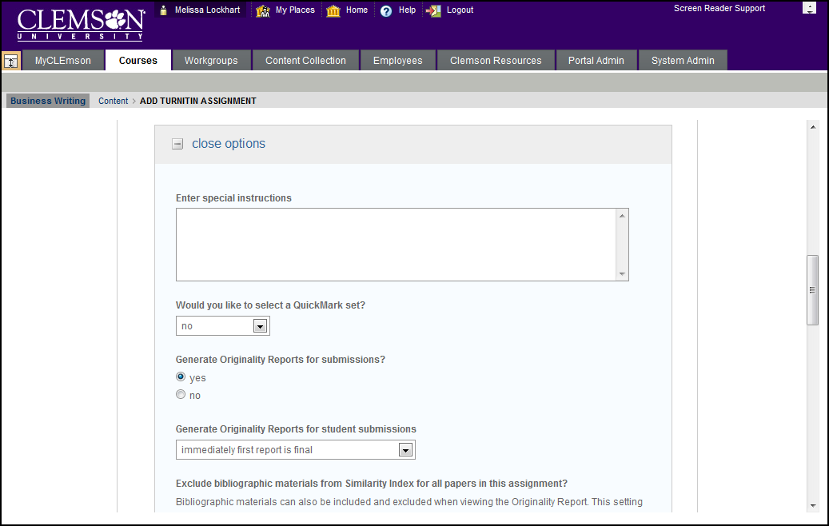
- Enter any Special Instructions in the field provided.
- Select the Yes radio button to have the system generate originality reports for each submission for the selected assignment.
- Generate Originality Reports for student submission:
- Immediately(First report is final) – will generate an originality report upon the assignment being submitted. This will be the only report generated.
- Immediately(Can overwrite reports until due date) – will generate an originality report and continue to update the report until the date the assignment is due.
- On Due Date – will generate an originality report on the date the assignment is due.
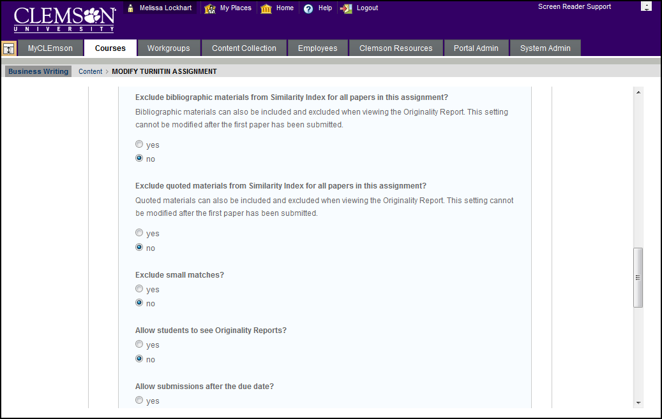
NOTE: The items under More Options are turned off by default. Should you enable them the following actions will occur.
- Select the Yes radio button to Exclude bibliographic materials from Similarity Index for all papers in this assignment. NOTE: This setting cannot be modified after the first paper has been submitted.
- Select the Yes radio button to Exclude quoted materials from Similarity index for all papers in this assignment. NOTE: This setting cannot be modified after the first paper has been submitted.
- Select the Yes radio button to Exclude small matches.
- Select the Yes radio button to Allow students to see the originality report for their assignment.
- Select the Yes radio button to Allow assignments to be submitted after the due date.
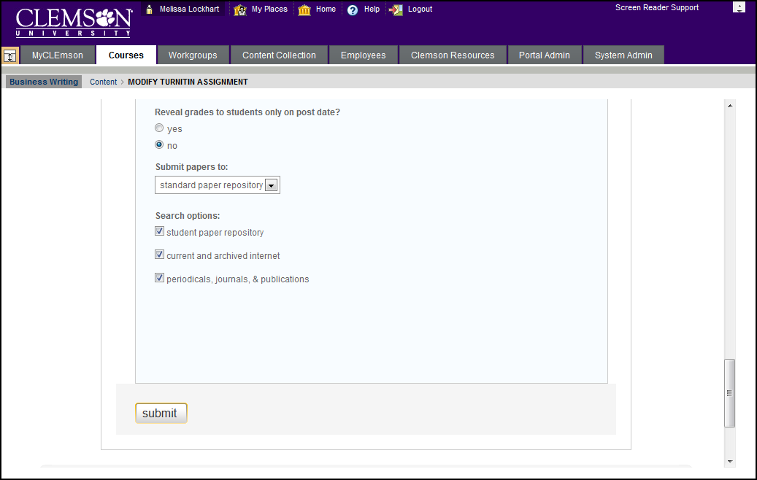
- Select the Yes radio button to only Reveal grades to students only on the post date.
- From the Submit papers to drop drown menu select Standard Paper Repository.
- Enable the checkboxes for the Search Options for which to compare these submissions:
- Student paper database – will compare the assignment against other student paper assignments in the database.
- Current and archived internet – will compare the assignment against current and archived student assignments available on the internet.
- Periodicals, Journals & Publications – will compare the assignment against periodicals, journals and publications.
- Then click Submit.
- A success message will be displayed. Click OK.
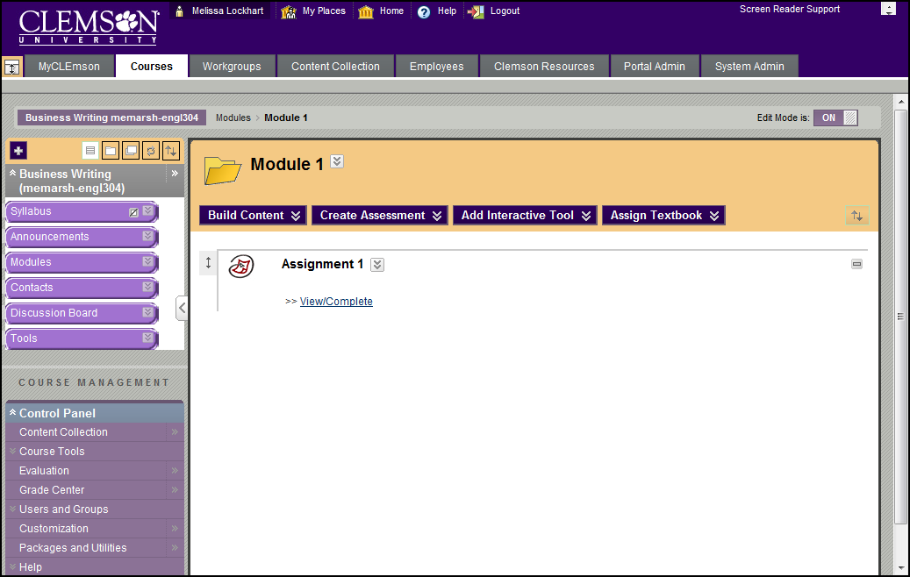
- The system returns you to the Assignments page. The assignment now appears in your list of assignments.

Syncing your Roster
Before your students can submit their assignment, you have to sync your roster. If you do not sync your roster students will not be able to submit their assignment. The sync gives them the permission to access the Turnitin® assignment. To sync your roster:
- Click the action link to expand the Course Tools section of the Control Panel.
- Then click the Turnitin Assignments link.
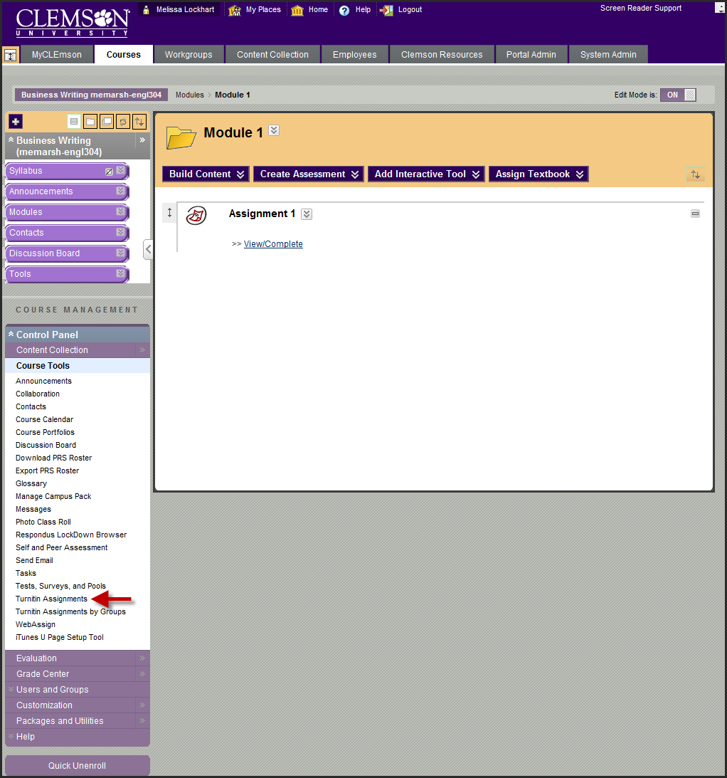
- Click the View link under the Assignment for which you want to view submissions.
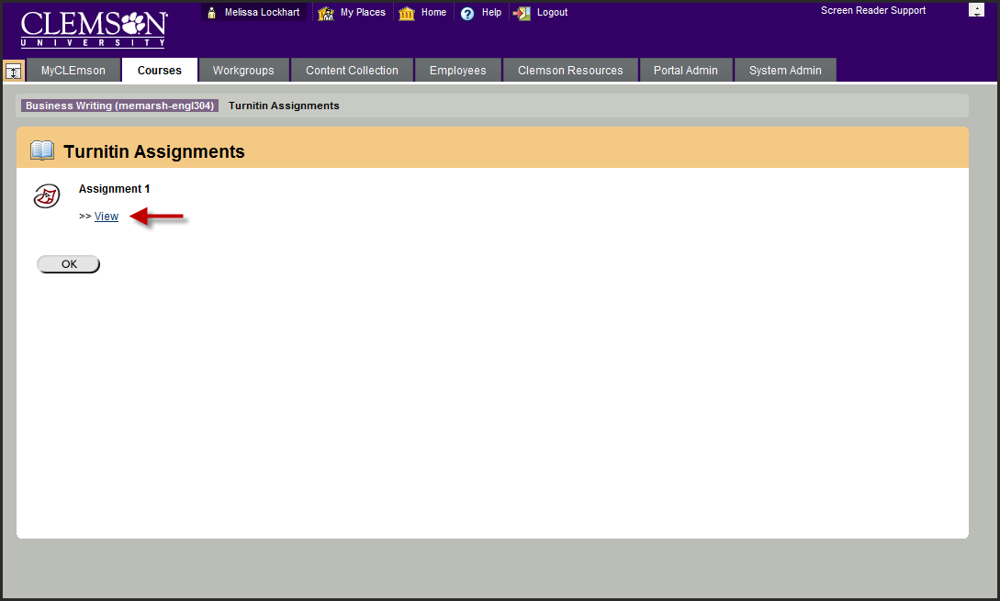
- Click Roster Sync.
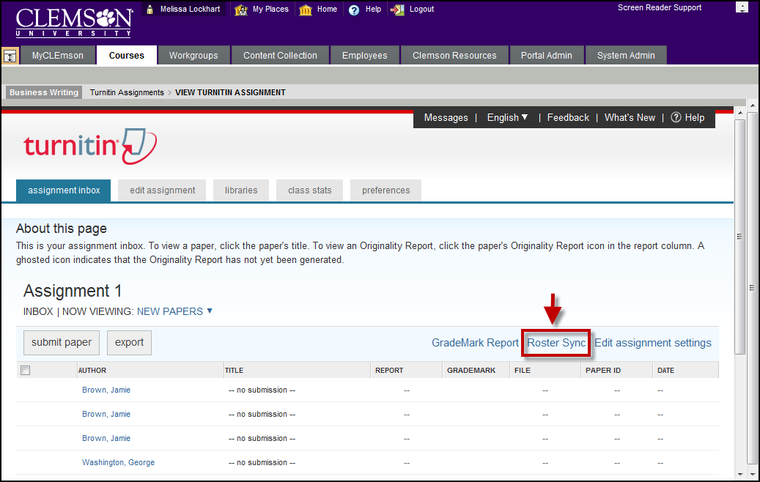
- The Turnitin® system will synchronize with Blackboard and grant your students access to submit their assignments. A list of all of your students is displayed. If you have multiple students, you may not see them all at once. Page numbers will appear in the top left corner of the Inbox. Click each page to navigate to additional student assignments.

Running Student Assignments through Turnitin®
Sometimes faculty will setup their student assignments as normal Blackboard assignments or even have students email them their assignments. Then decide later that they want to run them through Turnitin. Faculty can submit assignments through Turnitin at any time. They can manually upload the text, file or a zip file that contains the students work to be checked for originality using the proceeding steps.
- Click the action link to expand the Course Tools section of the Control Panel.
- Then click the Turnitin Assignments link.
- Click the View link under the Assignment for which you want to make submissions.
- The Turnitin Assignment Inbox is displayed.
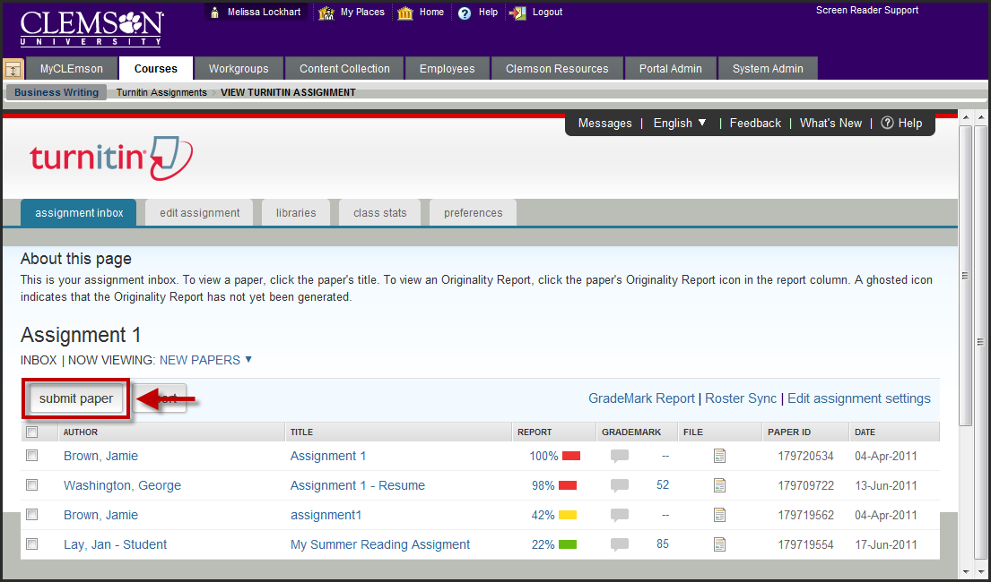
- Click the Submit Paper button to begin the upload process.

Individually as a File Upload
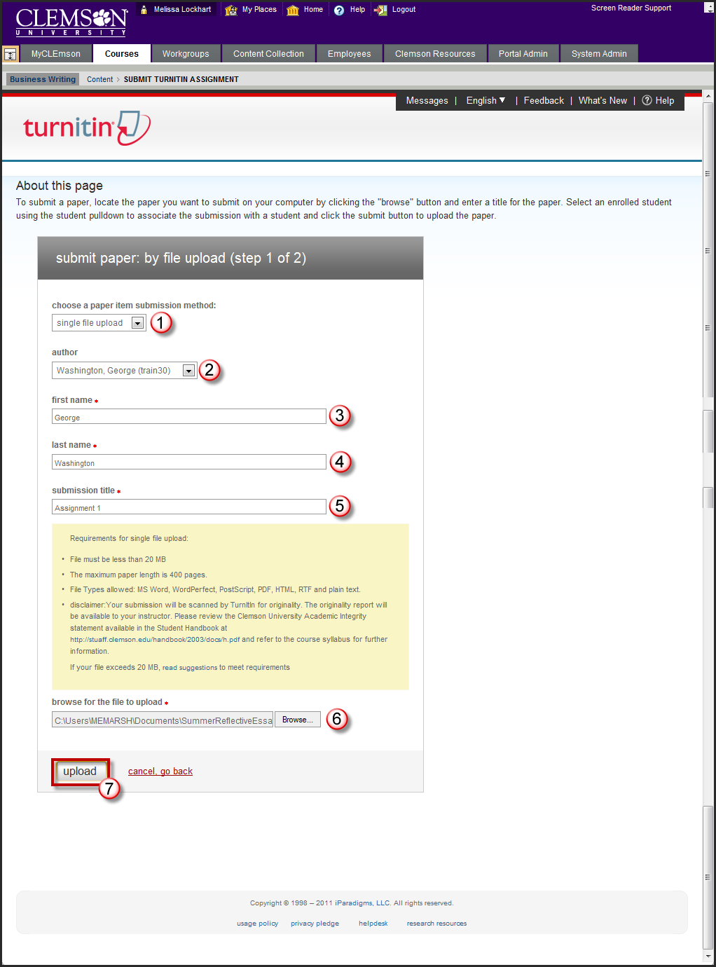
- Select single file upload from the Paper Item Submission drop down menu.
- Select the author of the paper from the available drop down menu. You can select non-enrolled student or you can select from students enrolled in the course. Once you select the student their First and Last Name will appear. If you select non-enrolled student you will need to enter a First and Last Name.
- Enter a submission title for the student’s paper.
- Then click Browse to select the student’s paper from your local hard drive.
- Click Upload.
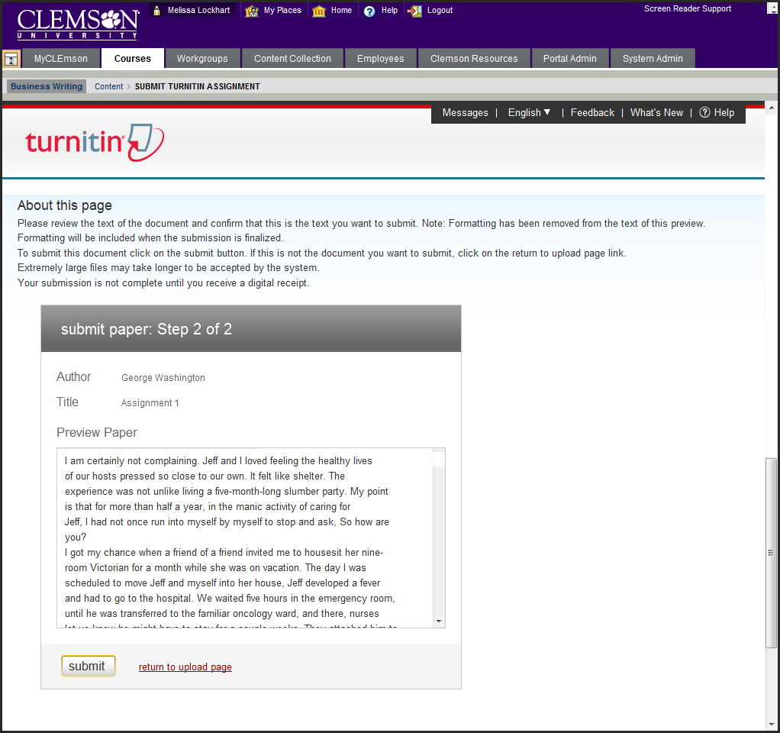
- The system will display a preview of the contents of the assignment.
- Review the paper. If this is the correct paper, click yes, submit. If you selected the wrong paper, click the return to upload page link to select a different paper.
- Click OK.

Multiple File Upload
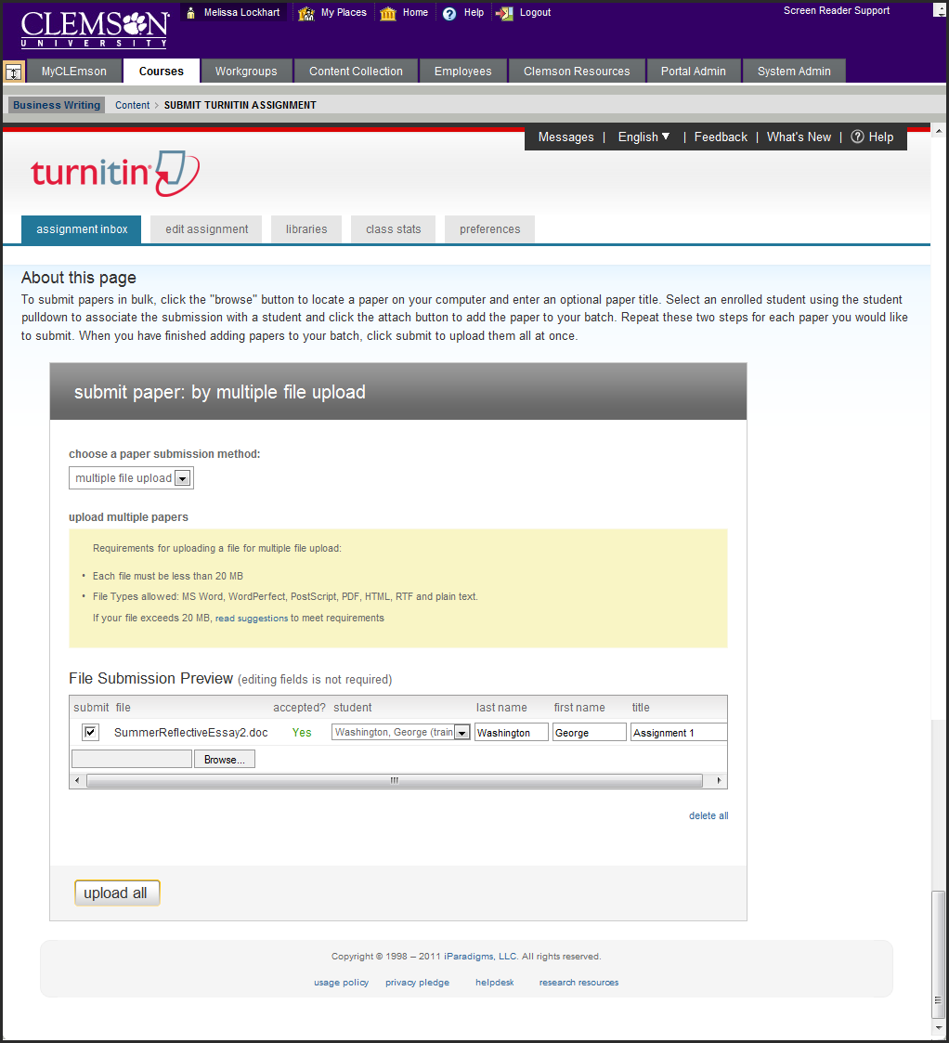
- Select multiple file upload from the paper submission method drop down menu.
- Then click Browse. Select the first paper to upload.
- Select the Student who is the author of the paper. The system automatically fills in the First Name and Last Name of the author if it is a registered student.
- Enter a Title.
- Click Browse to search for additional papers from other students to submit.
- Continue the same process until all papers have been submitted.
- Then click Upload All.
- Confirm that the files are uploaded are the files to submit to Turnitin. To change files click the Go Back link.
- If the files selected are correct click Submit.

In a Zip File
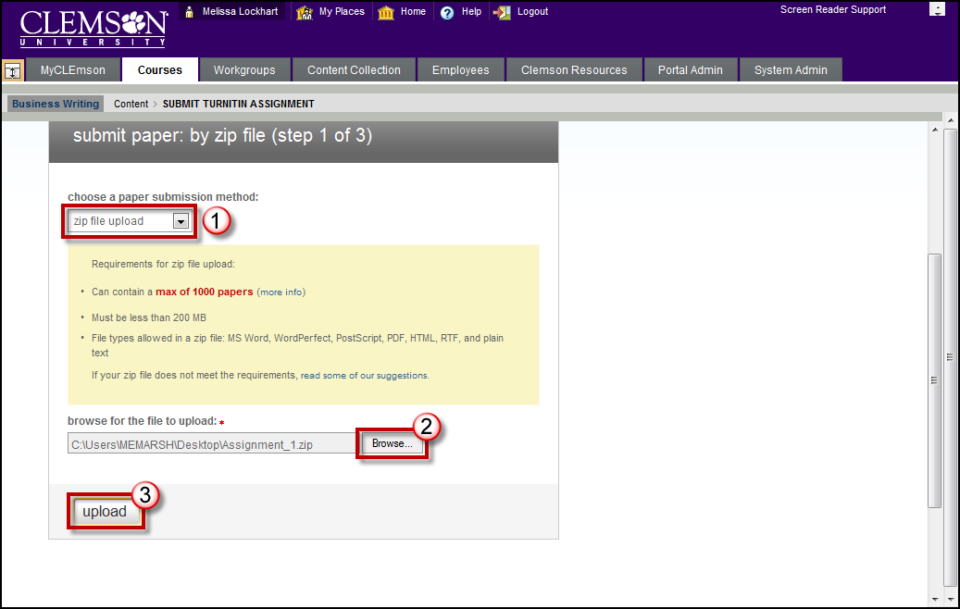
- Select Submit Papers by Zip File Upload.
- Then click Browse and select the Zip file.
- Click Upload.
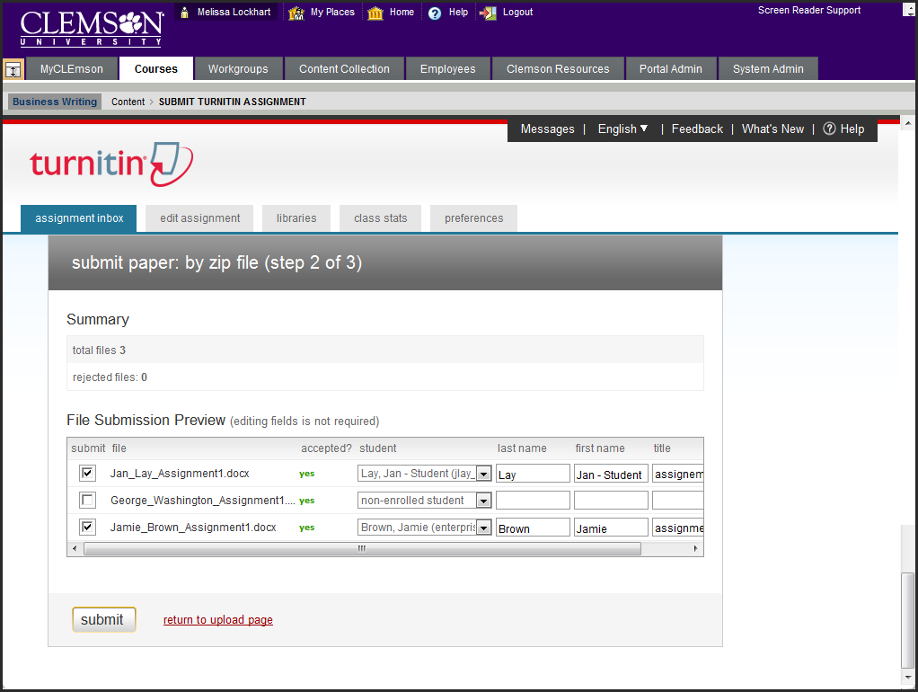
- A list of the documents in the zip file is displayed.
- Select the student that the assignment belongs to from the available drop down menu. Their first name and last name will automatically be populated.
- Enter a title for their assignment.
- Enable the Submit checkbox for each assignment.
- Click Submit.
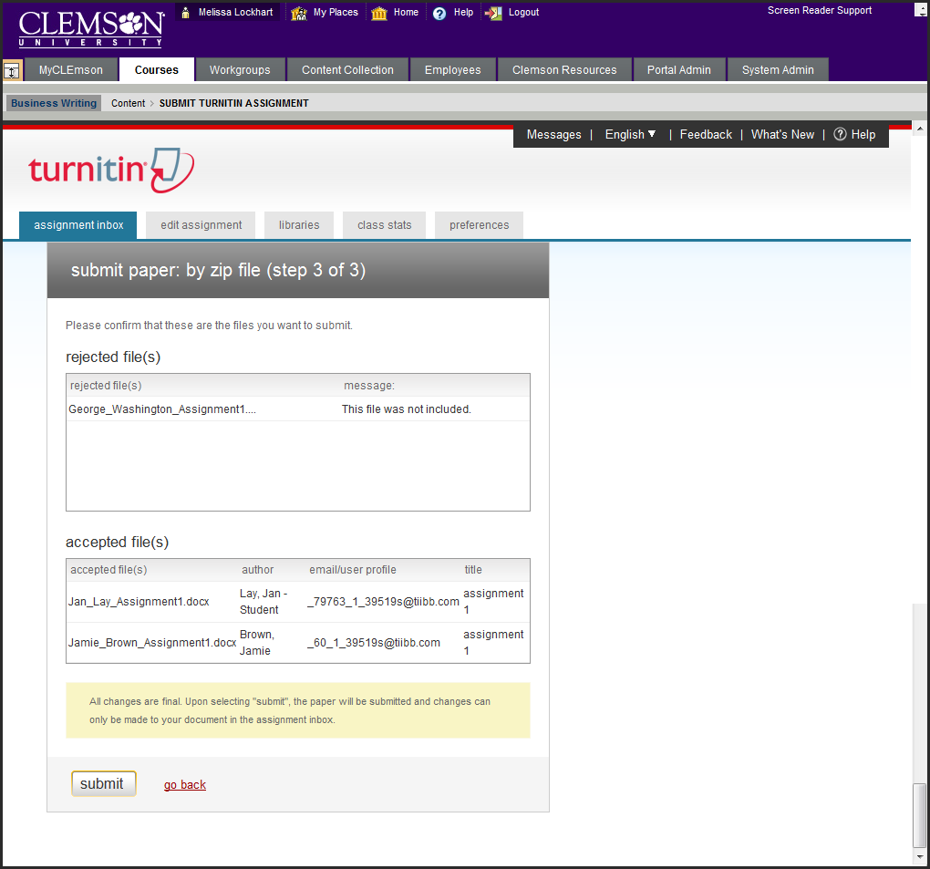
- The system will ask you to confirm that these are the files you want to submit. Click the go back link to change the submissions.
- Click Submit to accept the selected submissions.
- Then click OK.

By Cutting & Pasting
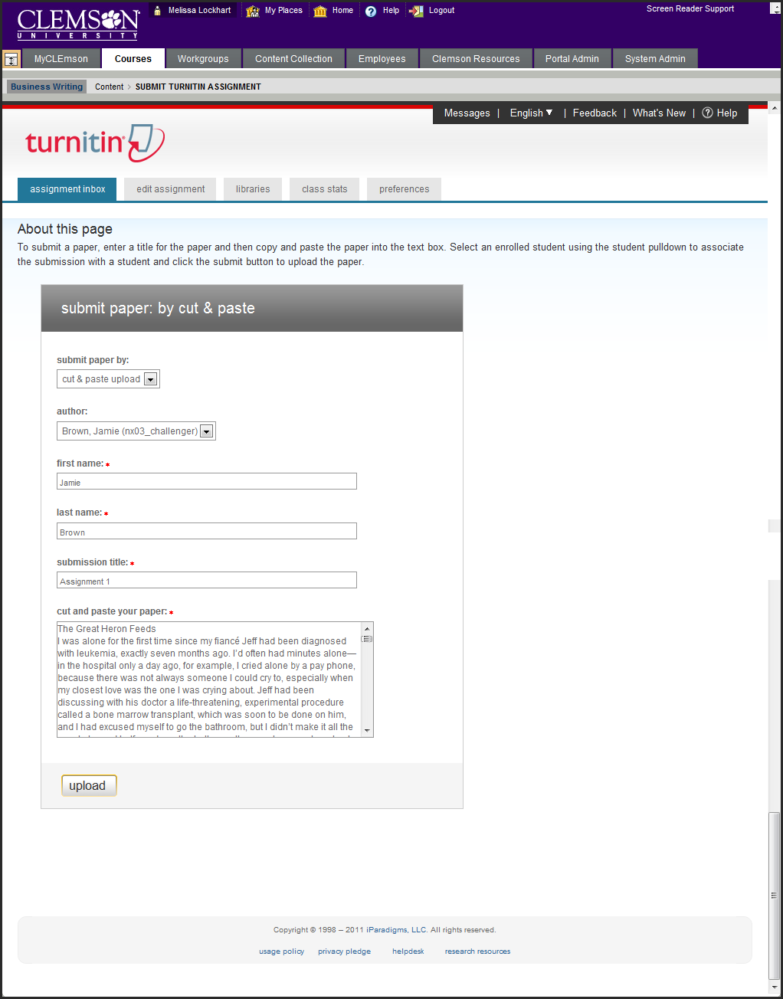
- Select Cut & Paste from the Submit Paper by drop down menu.
- Select the Author of the paper. The system automatically populates the authors First and Last Name.
- Enter a Submission Title.
- Cut and paste the text into the field provided.
- Click Upload.
- Click OK.

Downloading Student Assignments
- Login to Blackboard.
- Click the Courses tab.
- Click the course link. The system navigates you to the course home page.
- Click the action link to expand the Course Tools section of the Control Panel.
- Then click the Turnitin Assignments link.
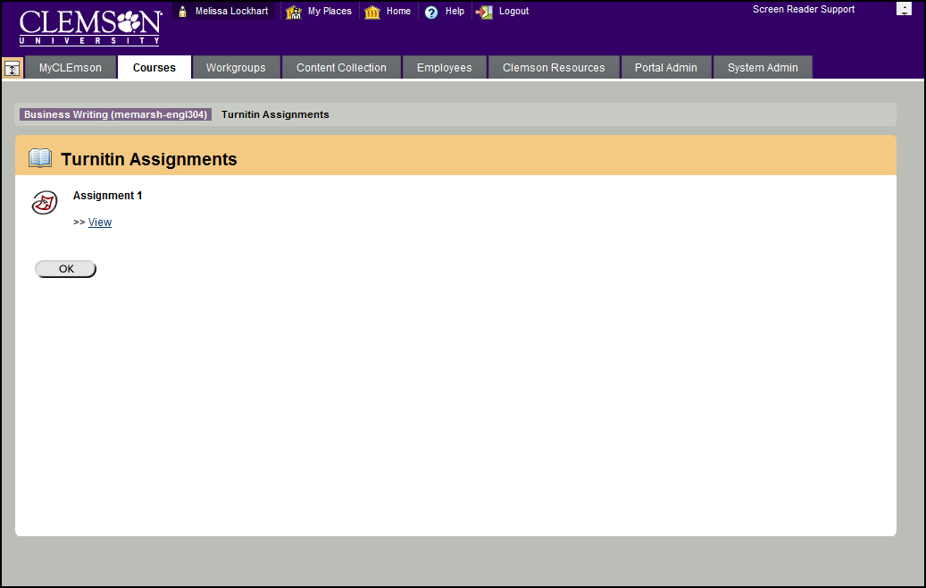
- Click the View link under the Assignment for which you want to view submissions.
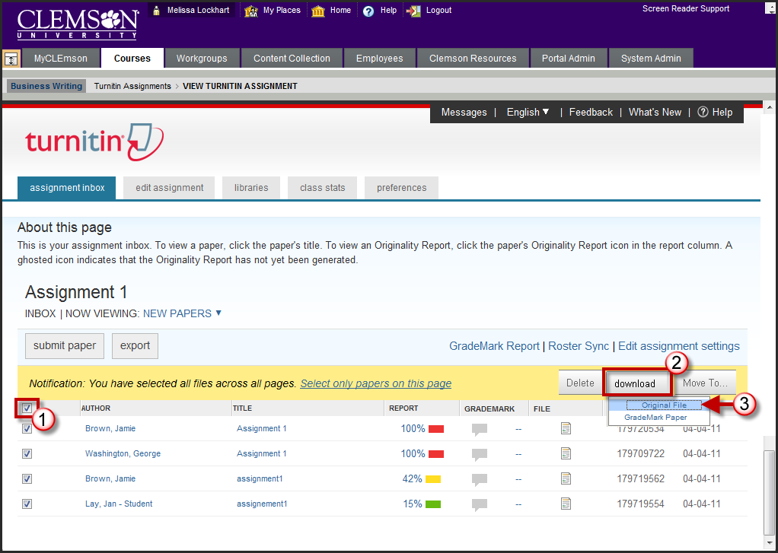
- Select the checkbox for the student assignments to download.
- Then click download.
- Select Original File.
- The system will display a message stating that this action will compress the selected files and download them to your computer. Click OK.
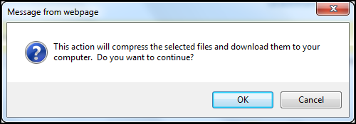
- The system will display a pop-up window with two links. To download the students assignments in the original file format, click the Originally submitted format(s) link. To download the students assignments in PDF file format, click the PDF Format link.
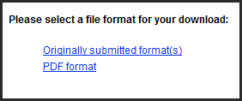
- A message is displayed that says “Preparing for Download.”
- Then another message is displayed that says “Your Download is ready. Please click here to begin download.” Click the here link to begin downloading.
- A message is displayed requesting to save or open the zip file.
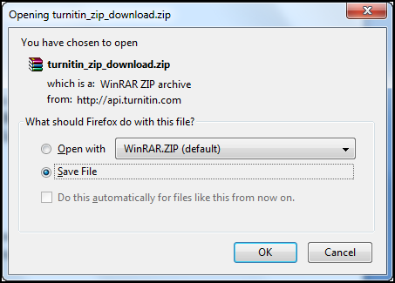
- Click Save File to save the zip file to your computer.
- The file is downloaded to your computer. Extract the contents of the zip file to begin reviewing.

NOTE: If you are using Internet Explorer, click the yellow bar at the top and select Download File.

Grading Turnitin® Assignments through the Blackboard Gradebook
- Login to Blackboard.
- Click the Courses tab.
- Click the course link. The system navigates you to the course home page.
- Click the action link for the Grade Center.
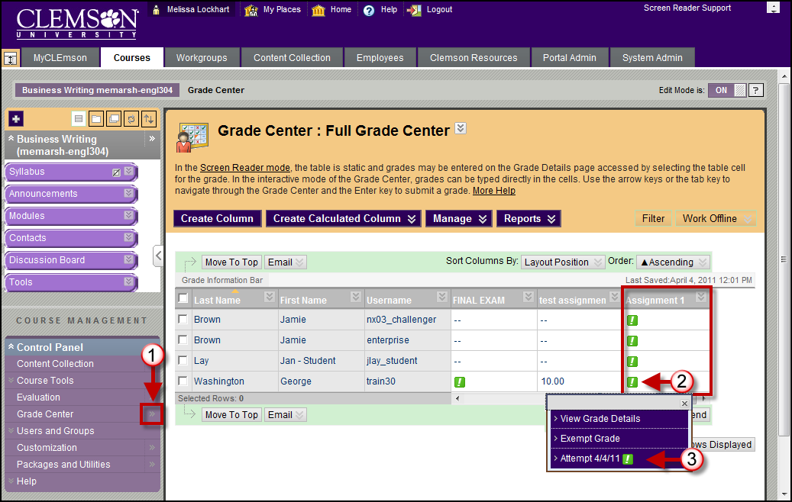
- Then find the column for the Turnitin Assignment in the Grade Center.
- Hover over the green exclamation mark in the grade center for the selected student. Then click the Action link.
- The Modify Grade page is displayed.
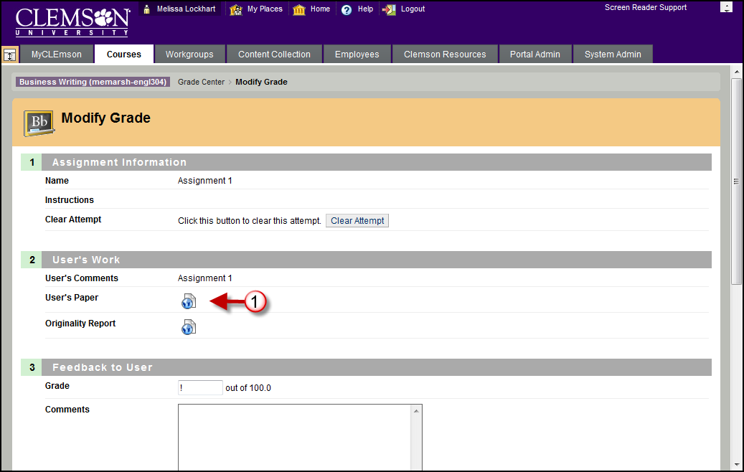
- In section 2, User’s Work, click the icon next to User’s Paper to view, comment and grade the student’s paper.
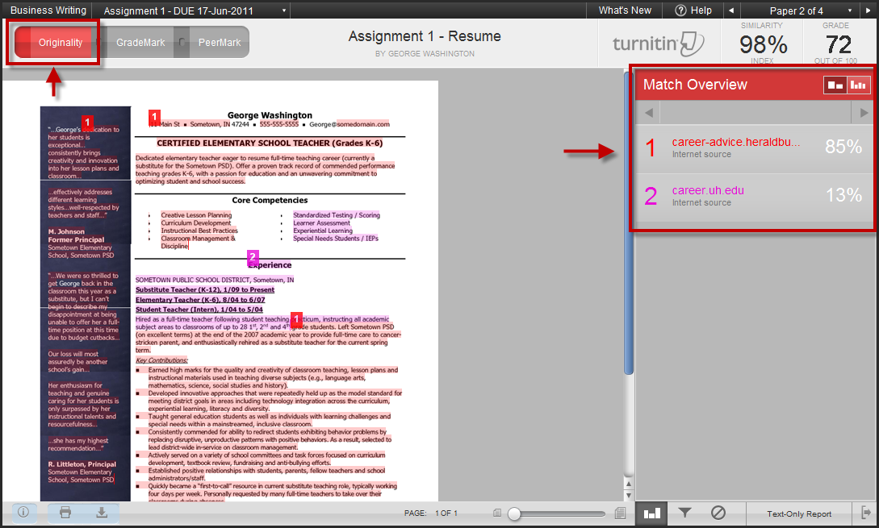
- Click the Originality button at the top of the window to view the Originality Report.
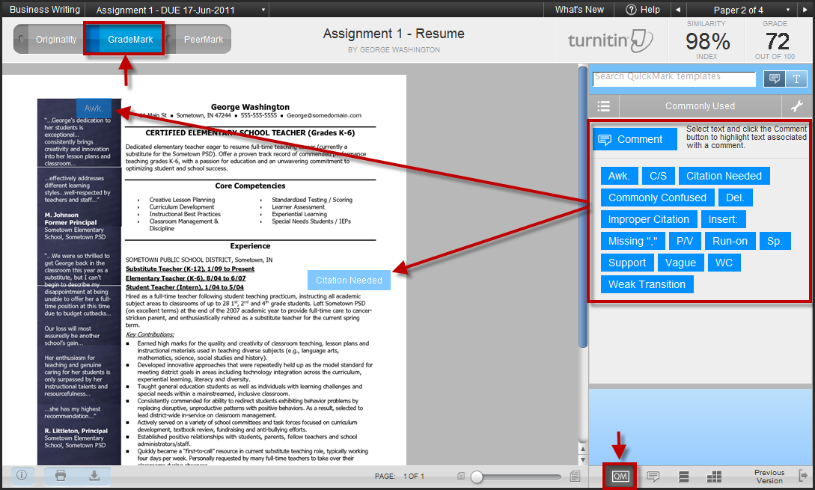
- Click the GradeMark button at the top of the window to insert comments and feedback using QuickMarks for the student.
- Click the QuickMarks button in the bottom right corner.
- Then drag and drop the blue QuickMarks from the right side of the screen to the document on the left side of the screen.
- Drag and drop the Comment QuickMark from the right side of the screen to the left side of the screen where you want to insert a comment.
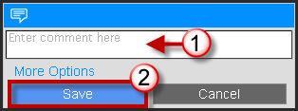
- A pop-up window will appear. Enter feedback to provide for your student. Then click Save.
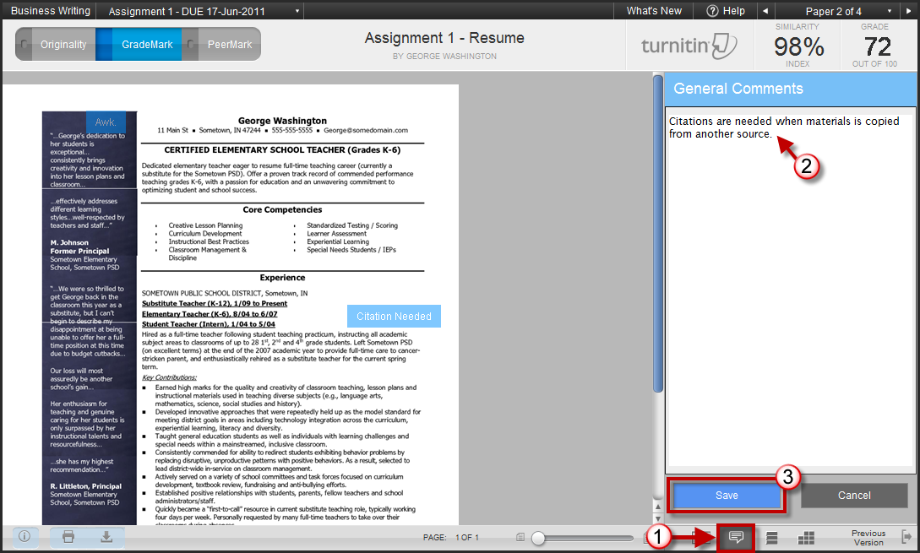
- Alternatively, you can click the Comments button in the bottom right corner of the screen. A panel will appear on the right side of the screen where you can add feedback for the overall document.
- Click Save.
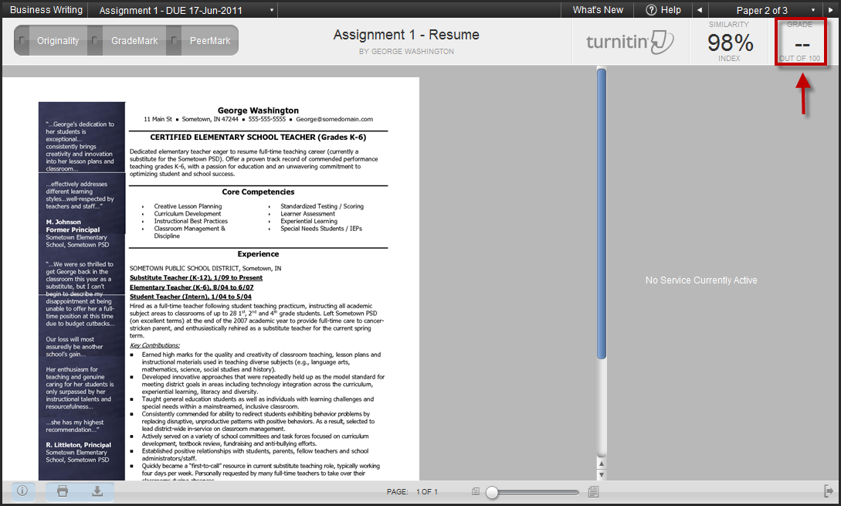
- Enter the grade for the assignment in the top right corner of the window. Then close the Turnitin pop-up window to return to the Grade Center.
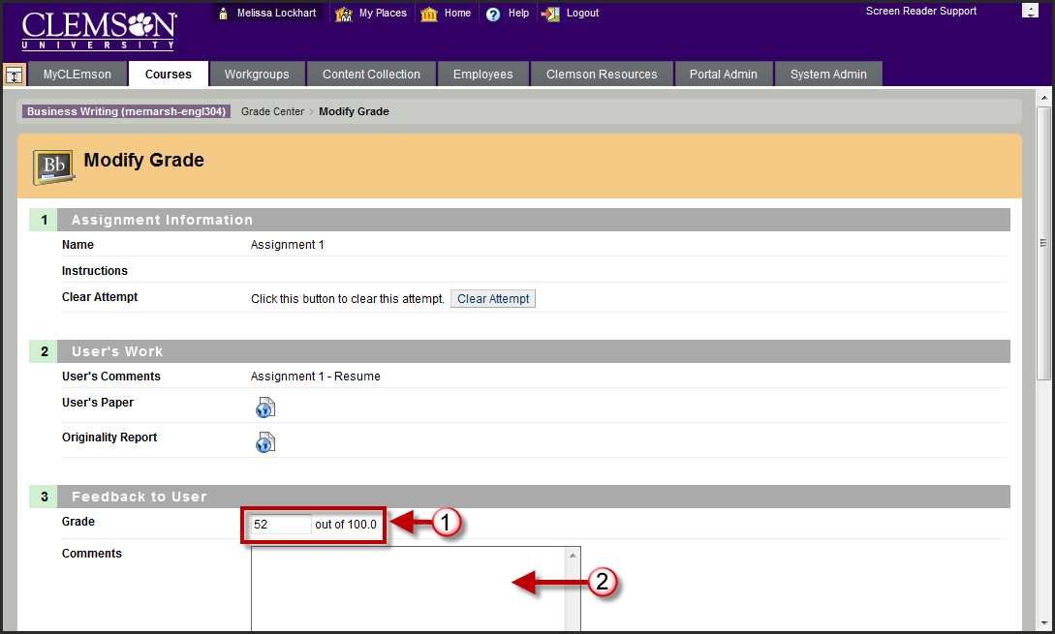
NOTE: Sometime you have to click Cancel for the assignment page, before the grade will transfer over. This refreshes the screen allowing the grade to populate.
- The Grade assigned from Turnitin should be populated in section 3, Feedback to User.
- Then enter any Comments to provide as feedback for the student.
- In section 4, Instructor Notes, enter notes that only the instructor will be able to view.
- Then click Submit.

Viewing the Originality Report through the Turnitin® Tool
- Login to Blackboard.
- Click the Courses tab.
- Click the course link. The system navigates you to the course home page.
- Click the action link to expand the Course Tools section of the Control Panel.
- Then click the Turnitin Assignments link.
- Click the View link under the Assignment for which you want to view submissions.
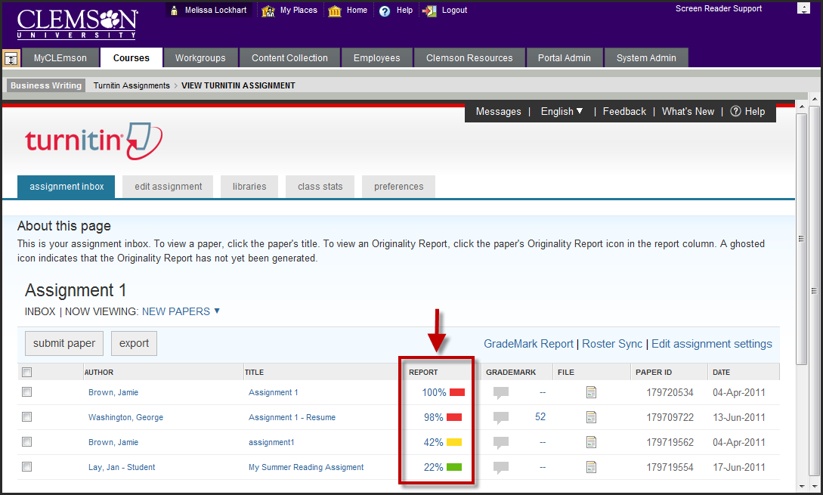
- The Turnitin Assignment Inbox is displayed.
- In the Report column click the percentage for specific assignment submissions to view their originality report.
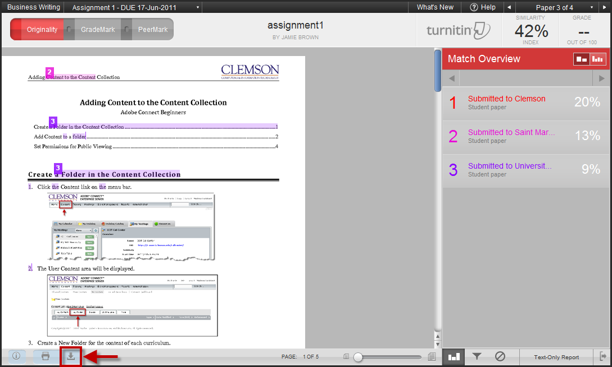
- The system displays the Originality Report.
- Click the Download button to save the Originality Report.
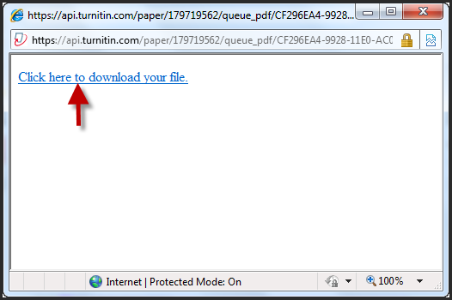
- A pop-up window will appear with a link. Click the link to download the Originality Report.

