Connect to Software (R) drive on a Mac

If you have a Mac and wish to connect to the Software Drive (R Drive) to download and install Clemson software, you must be on campus. It is also recommended that you use a wired ethernet connection.

This method will allow you to install any of the following programs: Audacity, AutoCad, SketchBookPro, Blender, Fetch, GIMP, Kurzweil 3000, LyX, Maple, MATLAB, McAfee VirusScan, Microsoft Office (Word, Excel, PowerPoint, Entourage), OpenOffice, POV-Ray, QuickTime, R, Scribus, Tn3270, VLC Player, VPN.

Go to the Finder and click on Go > Connect to server. In the server address, type in
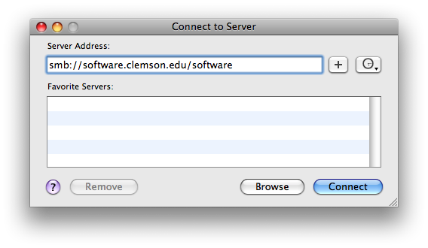
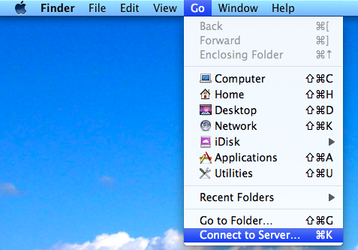
` smb://software.clemson.edu/software

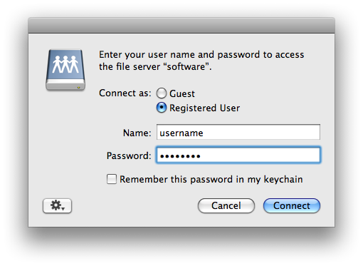
Click on the Connect button. You will see a window that reads “connecting to server” for a short time. Then you will need to fill in your Clemson user name and password and click Connect:

A folder will open called Software. There may be many folders that you are not able to access. For some of the programs there is a readme.txt that contains special installation instructions.

