Clemson Imaged Laptop Out of Box 2013

The first time you turn your new laptop on, you will see this. Please put your Clemson user name here:
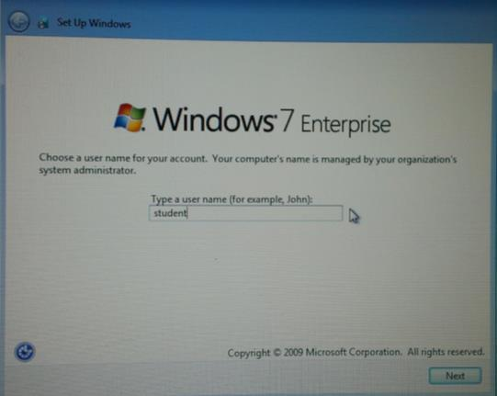
Next you will be asked to enter a password twice. You will use this every time you start your laptop. If you have a Clemson password you may use it – or anything you like. Just make sure you can remember it!
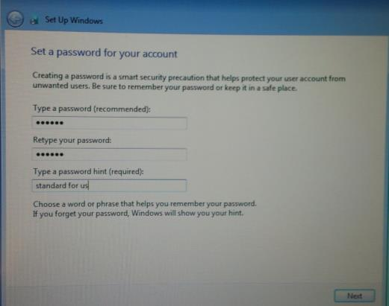
Then you will see this if you are on campus (eduroam will be the wireless network at Clemson). If you are at home it might find your home network. It is recommended that you select “Skip” for now and connect your computer to an Ethernet cable for fast connection. If you don’t have an Ethernet port, then connect to your home wireless. Remember that it will be a bit slower than Ethernet.
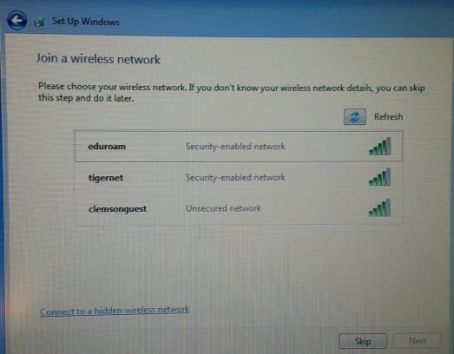
There may be a restart required, but when you get to your desktop, there will be an icon like this. Click on it:
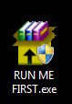

If you are off campus, it will detect and attempt to make a VPN connection. It is required for the process to continue. If you are prompted about it, go ahead and Connect. It will ask for your Clemson user name and password.
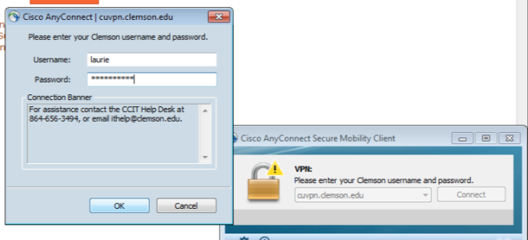
Once it connects, the installation of CCIT Software Center will begin. You may see several progress bars like this one as you continue:
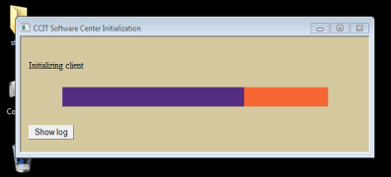

You may also see a question about Onboarding. Answer Yes to continue.
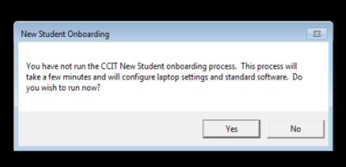
You will see the CCIT Configuration Manager. Enter your Clemson user name and password to log in:
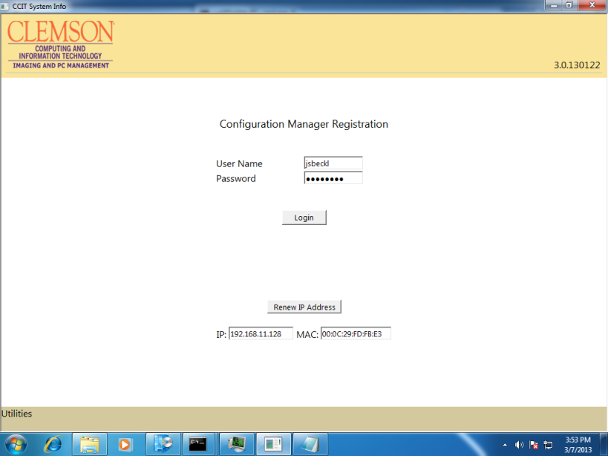

Welcome Screen. Read this screen and click the two boxes. Click Next.
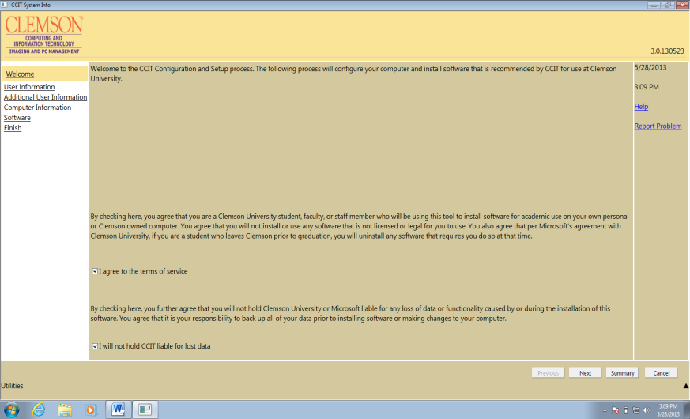
User Information. Put your Clemson user name in the first box. Left the checkmark under it!!! Invent a password for your computer in the last two boxes. This will replace what you did in the earlier step! (This is here for folks who accidentally do not use their Clemson user name the first time.)
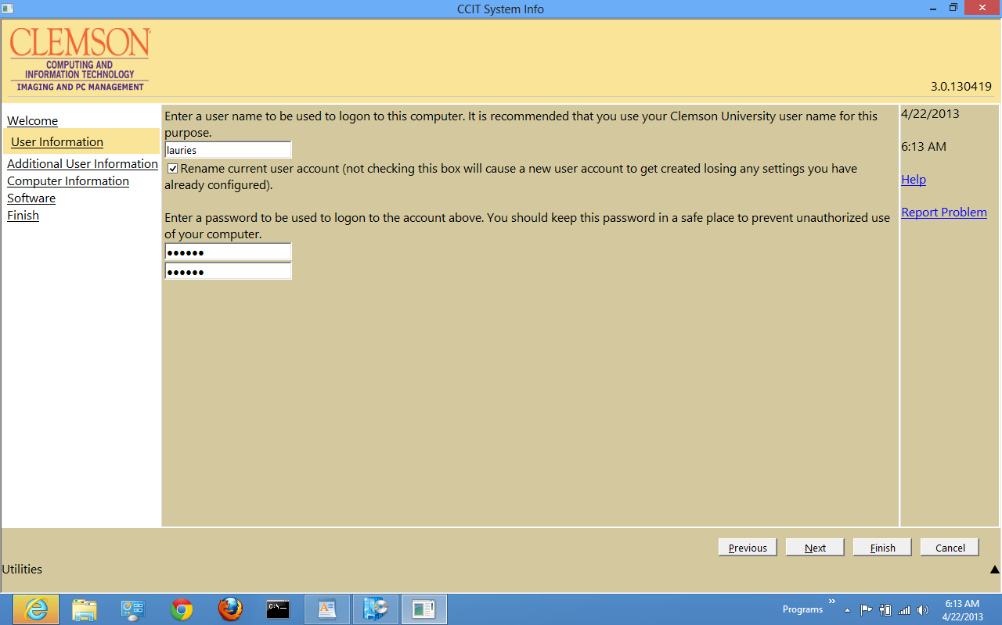
Computer Name. Put your Clemson user name here. Click Next
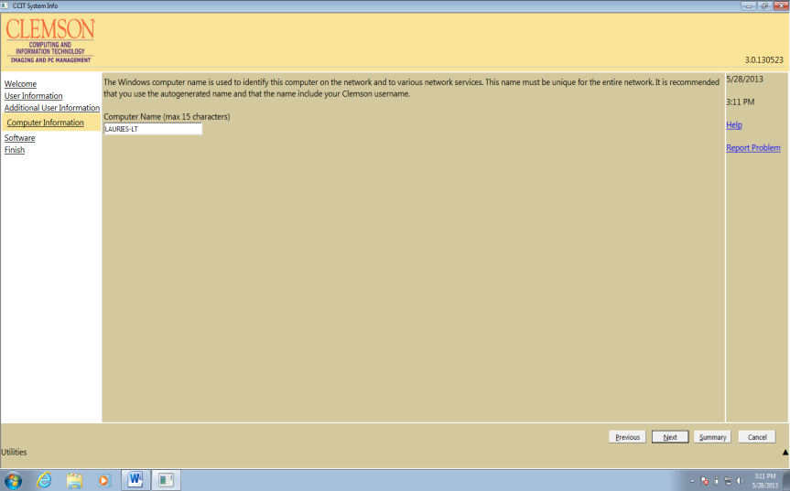
Software. Uncheck Microsoft Office since your computer already has that. Leave the other three checked and click Next.
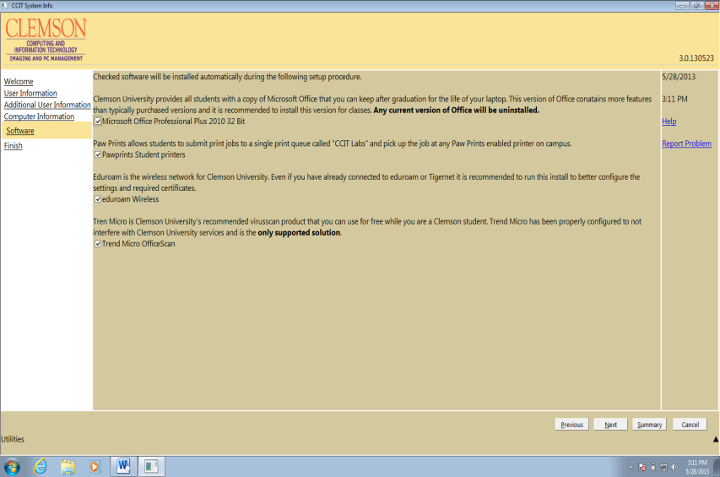
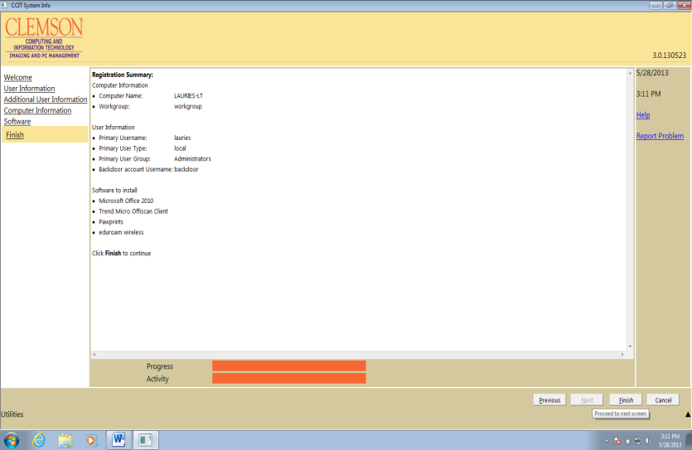
If you need to revisit this, click on:
Start, Programs, Microsoft System Center, Configuration Manager, CCIT Software Center
Start, Programs, Microsoft System Center, Configuration Manager, CCIT Software Center

