Browser Access and Navigation

- Login to Server at https://tableau.clemson.edu/

- Enter your Clemson University credentials. If you do not have your credentials, please contact Doug Henry via email douglah@clemson.edu or by phone (864) 656-4173. Then select “Resource Management Dashboards” if applicable

- Click the “Resource Management Dashboard” box and then click “Financials” to open the various dashboards and data stories
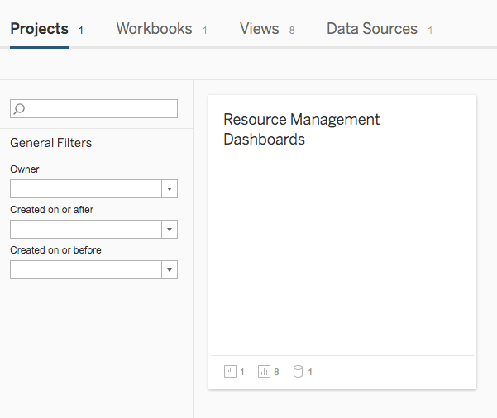

- Here you will find the Resources. “Income Statement” is the highest-level view. You have the ability to access each subcategory at this Main Menu OR navigate throughout by starting at the “Income Statement”

Subcategories include Unrestricted Expense Account, Unrestricted Expenses All Departments by Account, Unrestricted Expense All Accounts by Department, Fund Balance Expense by Account – Trend, Restricted Expense by Account, and Revenue by Account. For more information about each of these views, see Appendix A

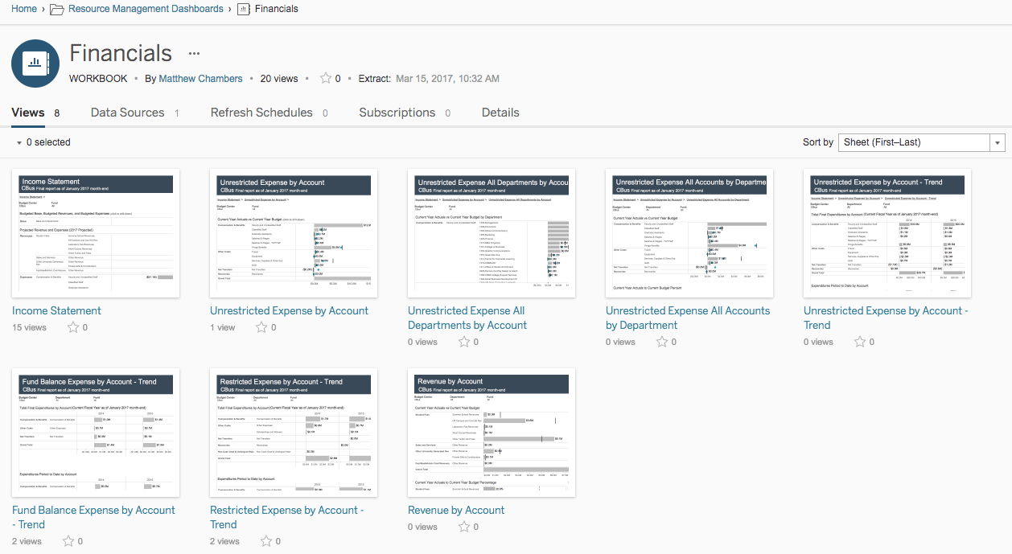

- Navigating views starting at the Income Statement:

Click the “Income Statement” Box. From here, you can see the selected Budget Center’s Budgeted Base, Budgeted Revenues, & Budgeted Expenses. You can select your area by clicking the dropdown menu under “Budget Center”
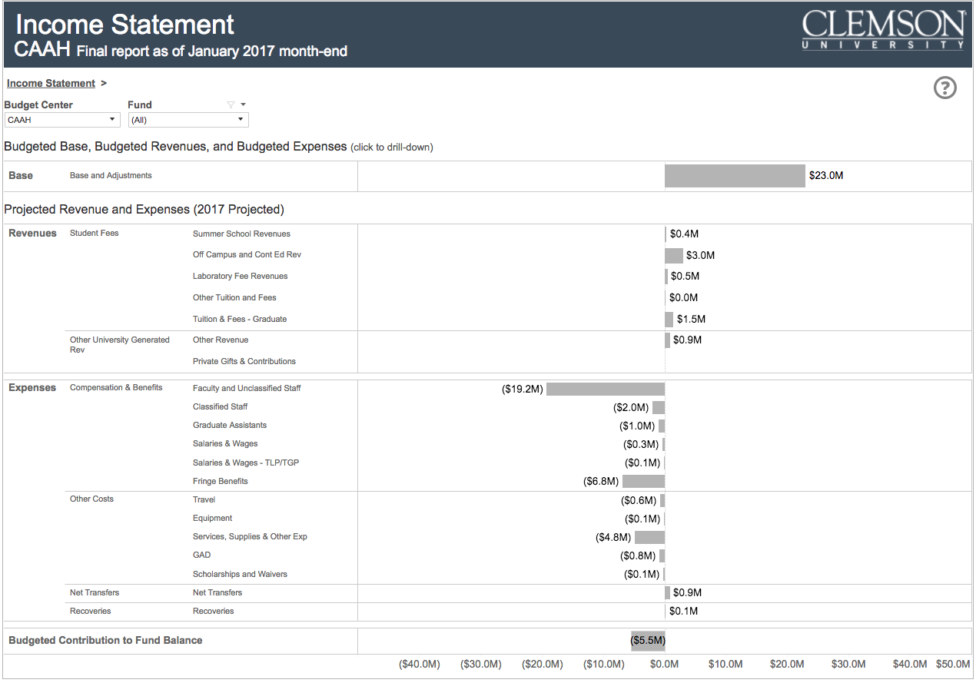

You can also filter and see data by Fund. Click the “Fund” dropdown menu for options. Select the fund, and click Apply
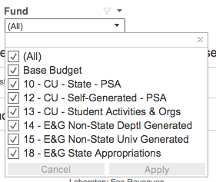

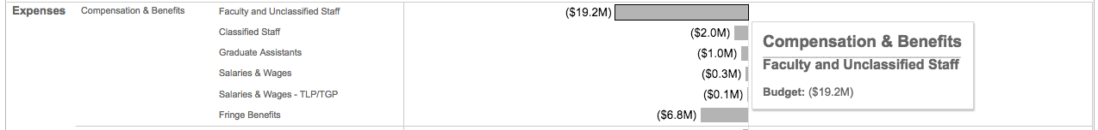
You can hover over any base, revenue, or expense grey bar to see more information

If you click on the grey bar, sometimes a hot link will appear. Use this link to navigate to breakdown views and more detailed information of the data.
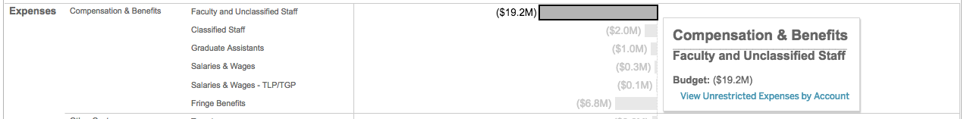

*Again, you can also go directly to the “Unrestricted Expense by Account” view starting from the Main Menu

- You can navigate back to the Income Statement (or any other previous view) by using the links at the top of the view. Or you can dig deeper into the information by clicking on another hotlink in the various grey bars. You can navigate back at any view level
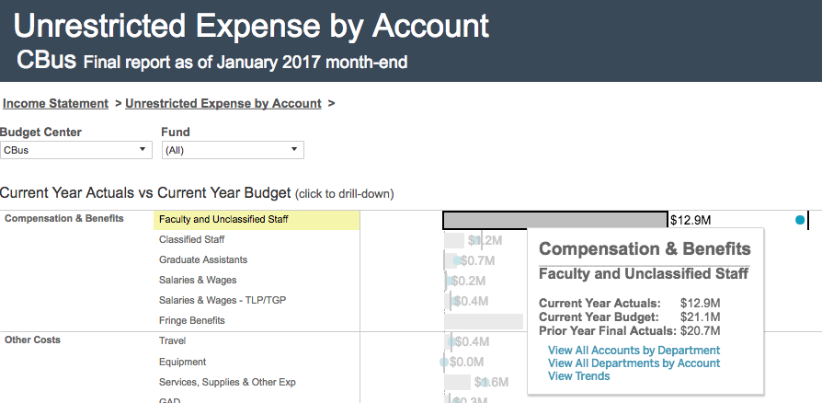

Navigate Back

See Further Views

- To get back to the Main Menu, use the navigation panel at the very top of the screen, click “Financials”

Tips and Tricks

- Search: You can search at the Main Menu or any level of the dashboards for keywords and information you want to see. Search bar is located at the top of the screen
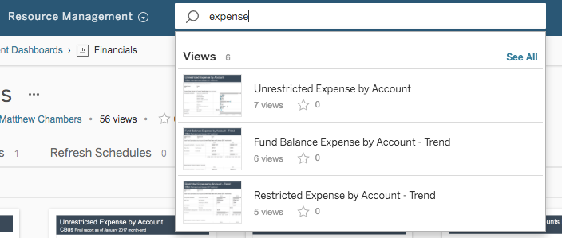

- Favorites: By clicking the little star next to each of the boxes on the Main Menu, you can Favorite certain views. You can quickly view your favorites at any time by clicking on the white star at the top of the screen
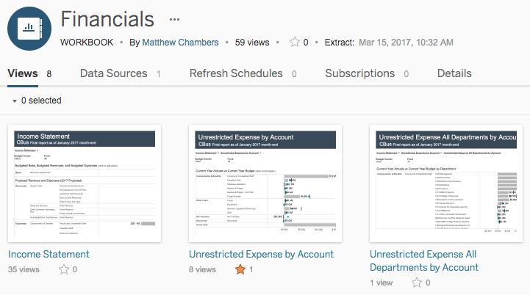
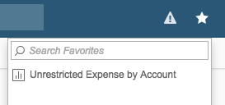

Appendix A

Income Statement: This high-level view shows the Budget Center’s overall Budgeted Base, Budgeted Revenues, and Budgeted Expenses. The Revenues and Expenses are Projected for the current year.

Unrestricted Expense by Account: This view shows Current Year Actuals vs Current Year Budget. It also shows what percentage of each expense line has been used compared to its budget, along with each expense line’s Current Actual to Current Budget Variance.
*The grey bars represent Current Year Actuals, the blue dot represents Prior Year Actuals, and the black vertical line represents the Current Year Budget. You can click or hover over each of these for more information.

Unrestricted Expense All Departments by Account: This view allows you to see Current Year Actuals vs Current Year Budget of each area’s various Department numbers. You can filter down by Fund or Account using the dropdown menu.
*The layout and capabilities are similar to the “Unrestricted Expense by Account.”

Unrestricted Expense All Accounts by Department: This view allows you to see Current Year Actuals vs Current Year Budget of the various accounts, while being able to filter down by Department using the dropdown menu.
*The layout and capabilities are similar to the “Unrestricted Expense by Account.”

Unrestricted Expense by Account – Trend, Fund Balance Expense by Account – Trend, and Restricted Expense by Account – Trend: In these views, you see a 3-year history and current year’s trends of Expenditures by Account. The first table shows Total Final Expenditures by Account (Current Fiscal Year as of January month-end). The second table shows Expenditures Period to Date by Account; here you can compare the current expenses to the expenses at the exact same day in previous years. You can filter by Department and/or Fund using the dropdown menus. This is the “bottom barrel view”; you can’t navigate any deeper into the data.

Revenue by Account: This view shows Current Year Actuals vs Current Year Budget. It also shows what percentage of each revenue line has been used compared to its budget, along with each revenue line’s Current Actual to Current Budget Variance.
*The grey bars represent Current Year Actuals and the black vertical line represents the Current Year Budget. You can click or hover over each of these for more information.

