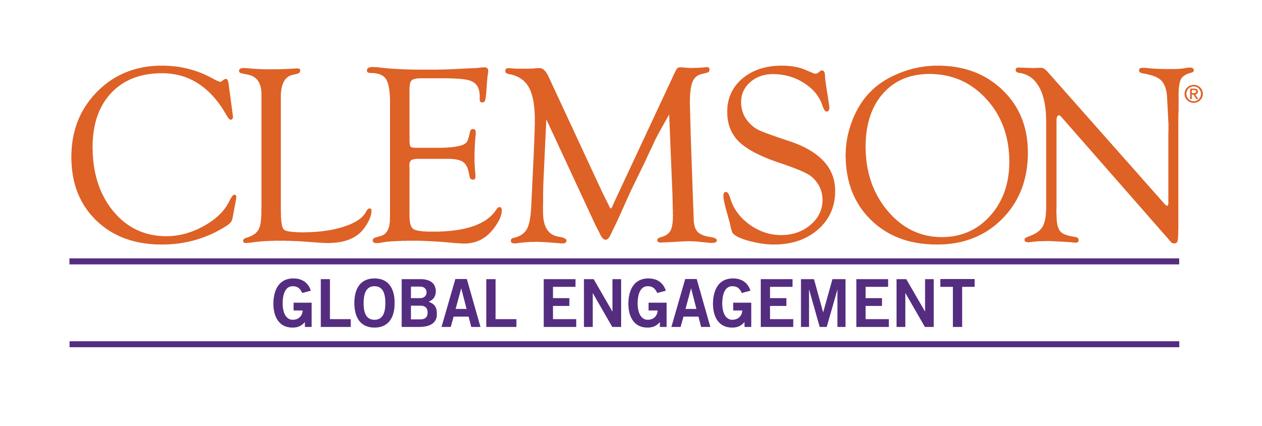

INTERNATIONAL PARTNERSHIP AGREEMENT
APPROVAL SHEET

Agreement Type | MOU  NEW RENEWAL | ACTIVITY  NEW RENEWAL
Institution/Location
Description of the Plan

CU Hosting Department
CU Faculty Contact(s) and Emails

Signature Approvals:
Department Chair |  |  | Date
Dean |  |  | Date
Office of Global Engagement |  |  | Date

Notes:

Reviews/Consultations:

Agreement Signed
Review for Renewal Requested
Renewed Agreement Signed
Renewed CU Signatories

