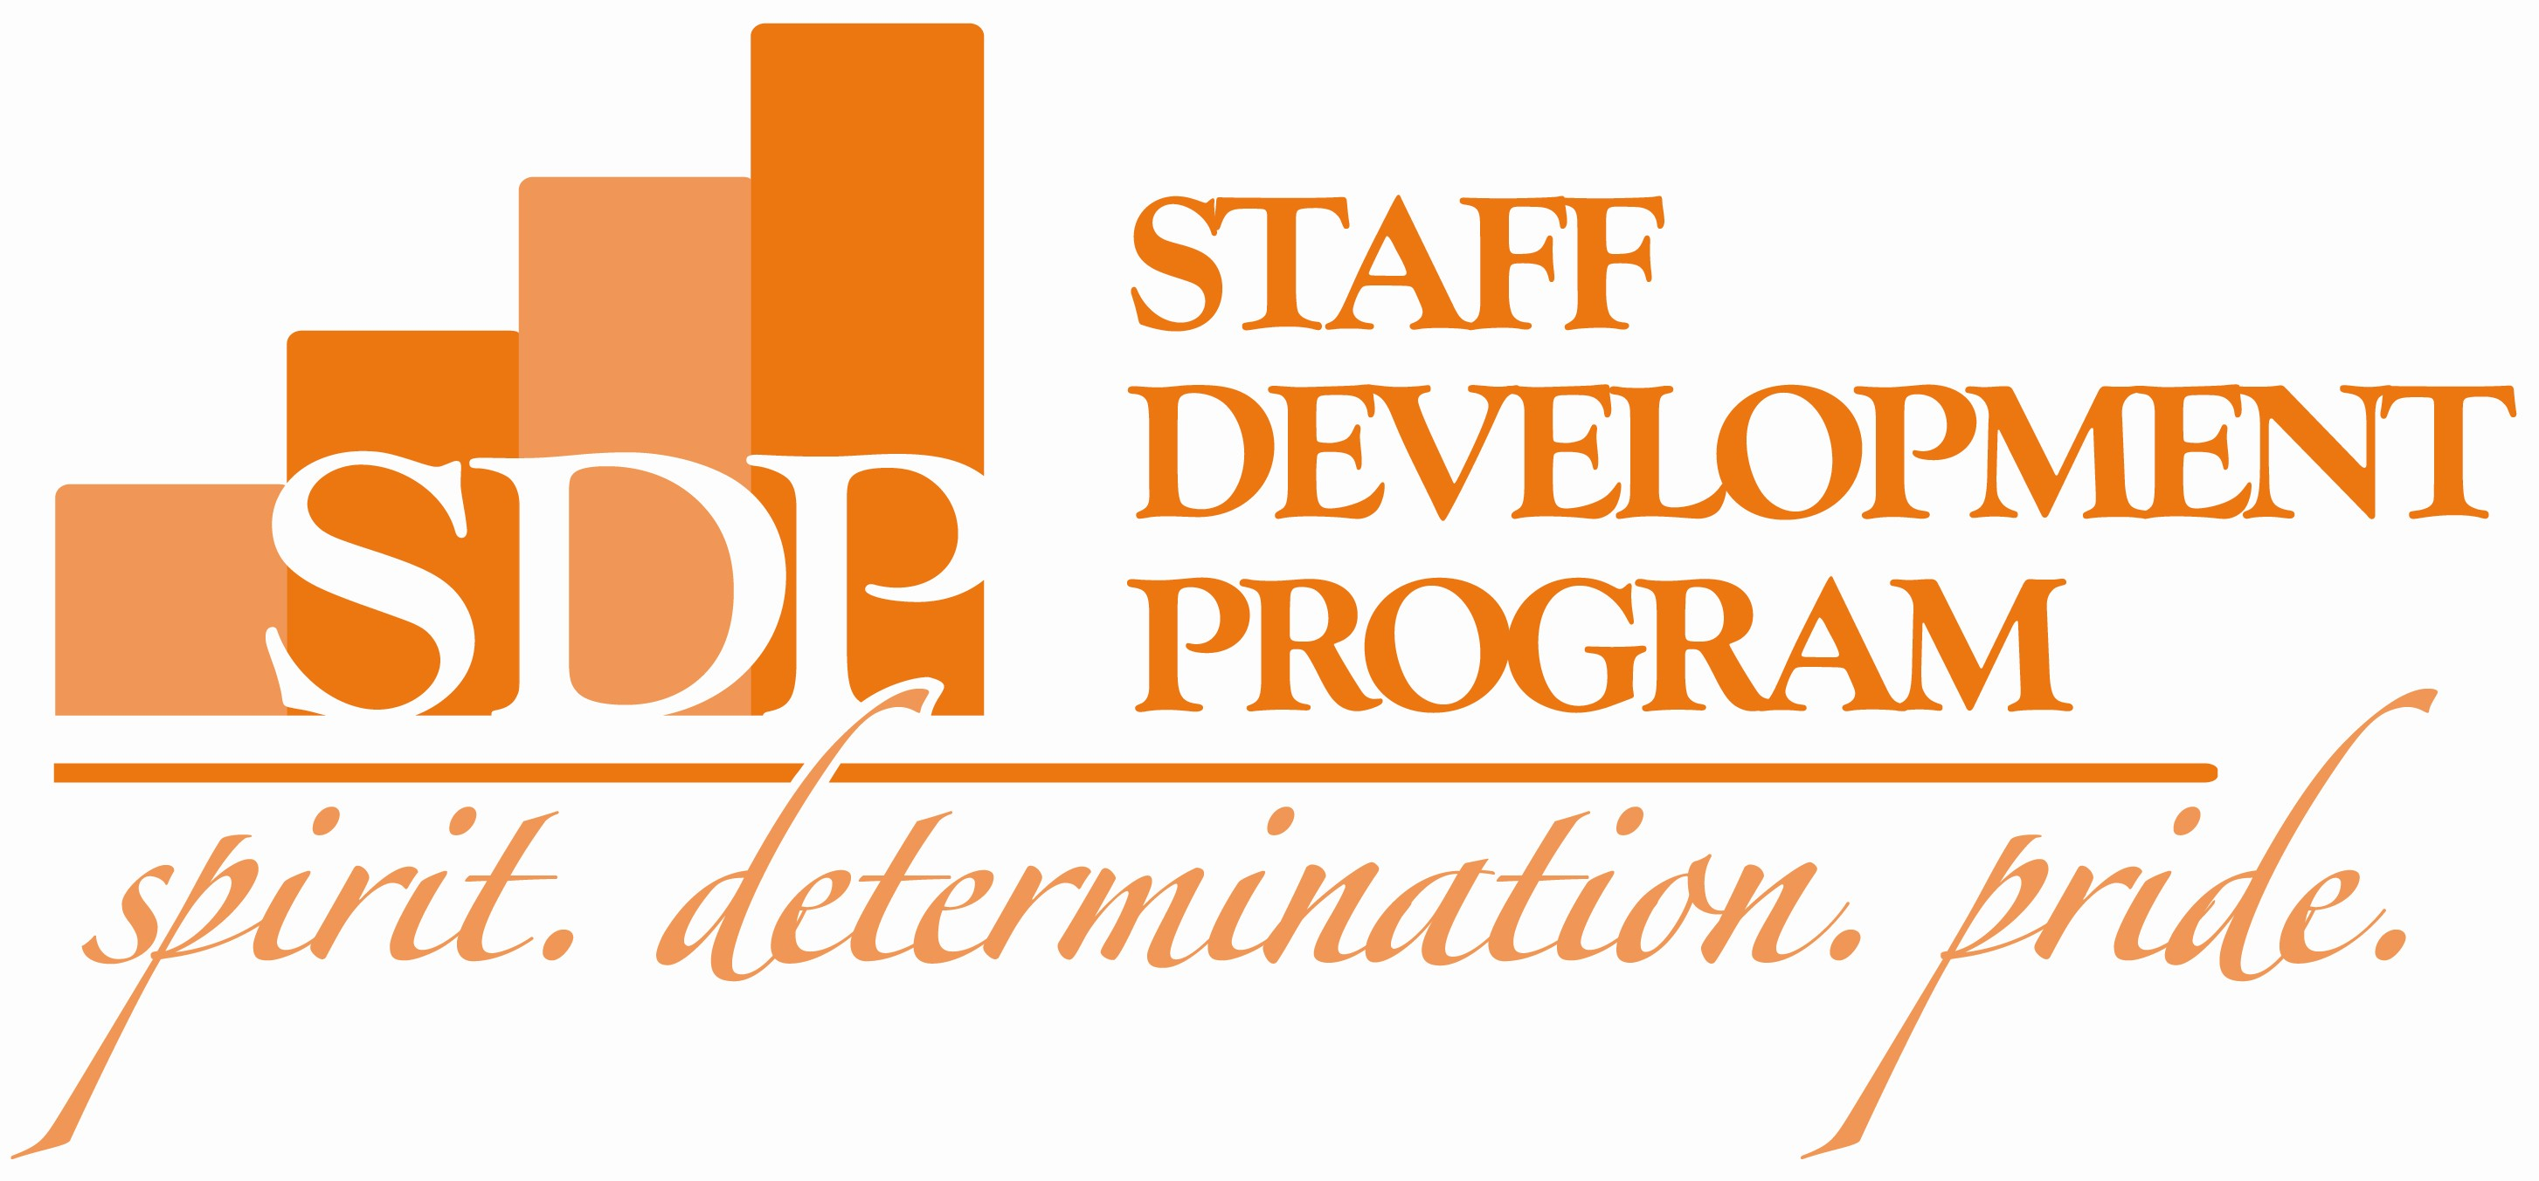

Staff Development Program (SDP) Application (2017-18)
Employee Information: Please fill in sections with the corresponding information. Use mouse or down arrow to navigate between fields.
Full Name: Click here to enter text. | State Classification: Click here to enter text.
Department Name: Click here to enter text. | Job Code: Click here to enter text.
Department Number: Click here to enter text. | Clemson Title if Different: Click here to enter text.
Email Address: Click here to enter text. | Supervisor Name: Click here to enter text.
Employee ID Number: Click here to enter text. | Supervisor Email: Click here to enter text.

Employee and Supervisor Agreement of Understanding:
I, Click here to enter text., and my supervisor, Click here to enter text., understand that I must meet the SDP criteria before my application will be reviewed and considered for acceptance into the program. Any supervisor who does not authorize the staff member completing this application to participate in the SDP at this time must complete the ‘supervisor objection’ portion of this form and return the form to the SDP office at 801 University Union, Clemson, SC 29634 by April 4, 2017.
The SDP website eligibility and program requirements: http://www.clemson.edu/sdp
Supervisor’s initial: Approval: _________________ Objection: _________________
Supervisor’s signature and date: _______________________________________________________
Employee’s signature and date: ________________________________________________________
Supervisor objection (if applicable)
All Clemson staff meeting the conditions and requirements set forth on the SDP Eligibility Form are qualified to be considered for participation in the program. However, the Steering Committee recognizes and appreciates that certain extenuating circumstances may warrant that specific individuals not be considered at this time. If, as a supervisor, you believe such circumstances exist for the employee identified on this application and that the employee should not be considered for SDP participation at this time, please describe those circumstances below and sign/date where indicated. (100 words or less)
Click here to enter text.

Staff Development Program (SDP) 2017-18 Participant Agreement:

I understand that I must complete all of the following requirements of the Staff Development Program in or to obtain and retain my salary increase:
- I understand I must complete a minimum of 150 total hours of development:
- Professional Development (a minimum of 74 documented contact hours)
- Personal Development (a minimum of 26 documented contact hours)
- University/Community-related Service (a minimum of 40 documented contact hours)
- Core Curriculum (a minimum of 10 documented contact hours)

- I understand I must fulfill the program requirements as indicated by the SDP 2017-18 guidelines.

- I understand I must continue to fulfill my regular job duties to the satisfaction of my supervisor during the period of my involvement in the SDP.

- I understand while supervisors may grant some leeway to permit SDP activity during ‘work’ hours, they are under no obligation to do so. Participants are to work with their supervisors to determine what will be allowed.

- I understand I must create and maintain detailed documentation of how I have completed the requirements of the program.

- I understand this is a two-year program and that I must complete and document at least 15 hours of SDP Steering Committee approved volunteer service to the SDP from July 1, 2018 through June 30, 2019 to fulfill the program requirements of the second year.

- I understand that 50 percent of the salary increase received from the completion of the first year of the two-year program will be forfeited if the volunteer service component is not completed to the satisfaction of the SDP Steering Committee.

- I understand that because there will only be a maximum of 25 participants in the SDP during this program year, the final selection of participants will be based on the quality and competitiveness of my application.

- I understand that if I am not accepted as a participant in the SDP, I am not eligible to appeal or grieve the decision under the Clemson University Grievance Policy.

- I understand my application must be received by the SDP Office no later than 4:30 p.m. on April 4, 2017. Applications may be mailed to 801 University Union, Clemson, SC 29634.

I, Click here to enter text., have reviewed, understand and agree to comply with the Staff Development Program (SDP) 2017-18 Participant Agreement.

Employee’s signature: _____________________________________ Date: ___________________
Applicant’s Proposed Program Information: Enter a goal. Beside it, enter the first activity for that goal. If you have more than one activity for a goal, keep entering them in subsequent lines, leaving the goal beside them blank. Continue adding goals and activities in this format until you’ve listed them all for each SDP section (Professional, Service and Personal). Next enter the provider/location information for each activity and the estimated hours you will spend completing those activities. Answer “yes” or “no” in the online column.
Professional Development Goals (74 hours) | Class/Seminar/Activities to Reach Goal | Provider/Location | Est. Contact Hours | Online?  (Yes or No)
 |  |  | 0
 |  |  | 0
 |  |  | 0
 |  |  | 0
 |  |  | 0
 |  |  | 0
 |  |  | 0
 |  |  | 0
 |  |  | 0
Professional Total: (Right Click on “0” and click “Update Field” to get total.) |  |  | 0.0

If the space above was inadequate, use this space to further describe professional goals and/or activities. (150 words or less)

Describe how you and the University will benefit by achieving these professional goals. (150 words or less)
Click here to enter text.

Staff Development Program (SDP) Application, cont.
University/Community-related Service Goals (40 hours) | Class/Seminar/Activities to Reach Goal | Provider/Location | Est. Contact Hours | Online?  (Yes or No)
 |  |  | 0
 |  |  | 0
 |  |  | 0
 |  |  | 0
 |  |  | 0
 |  |  | 0
 |  |  | 0
 |  |  | 0
Service Total: (Right Click on “0” and click “Update Field” to get total.) |  |  | 0.0

If the space above was inadequate, use this space to further describe service goals and/or activities. (150 words or less)

Describe how you and the University will benefit by achieving these service goals. (150 words or less)
Click here to enter text.

Personal Development Goals (26 hours) | Class/Seminar/Activities to Reach Goal | Provider/Location | Est. Contact Hours | Online?  (Yes or No)
 |  |  | 0
 |  |  | 0
 |  |  | 0
 |  |  | 0
 |  |  | 0
 |  |  | 0
 |  |  | 0
Personal Total: (Right Click on “0” and click “Update Field” to get total.) |  |  | 0.0

If the space above was inadequate, use this space to further describe personal development goals and/or activities. (150 words or less)

Describe how you and the University will benefit by achieving these personal goals. (150 words or less)
Click here to enter text.

