ABBY ACCOUNTING
AbbyAccounting@clemson.edu 864-000-0000
LinkedIn URL

EDUCATION
Clemson University - Wilbur O. and Ann Powers College of Business December 20xx
Bachelor of Science in Accounting Clemson, SC
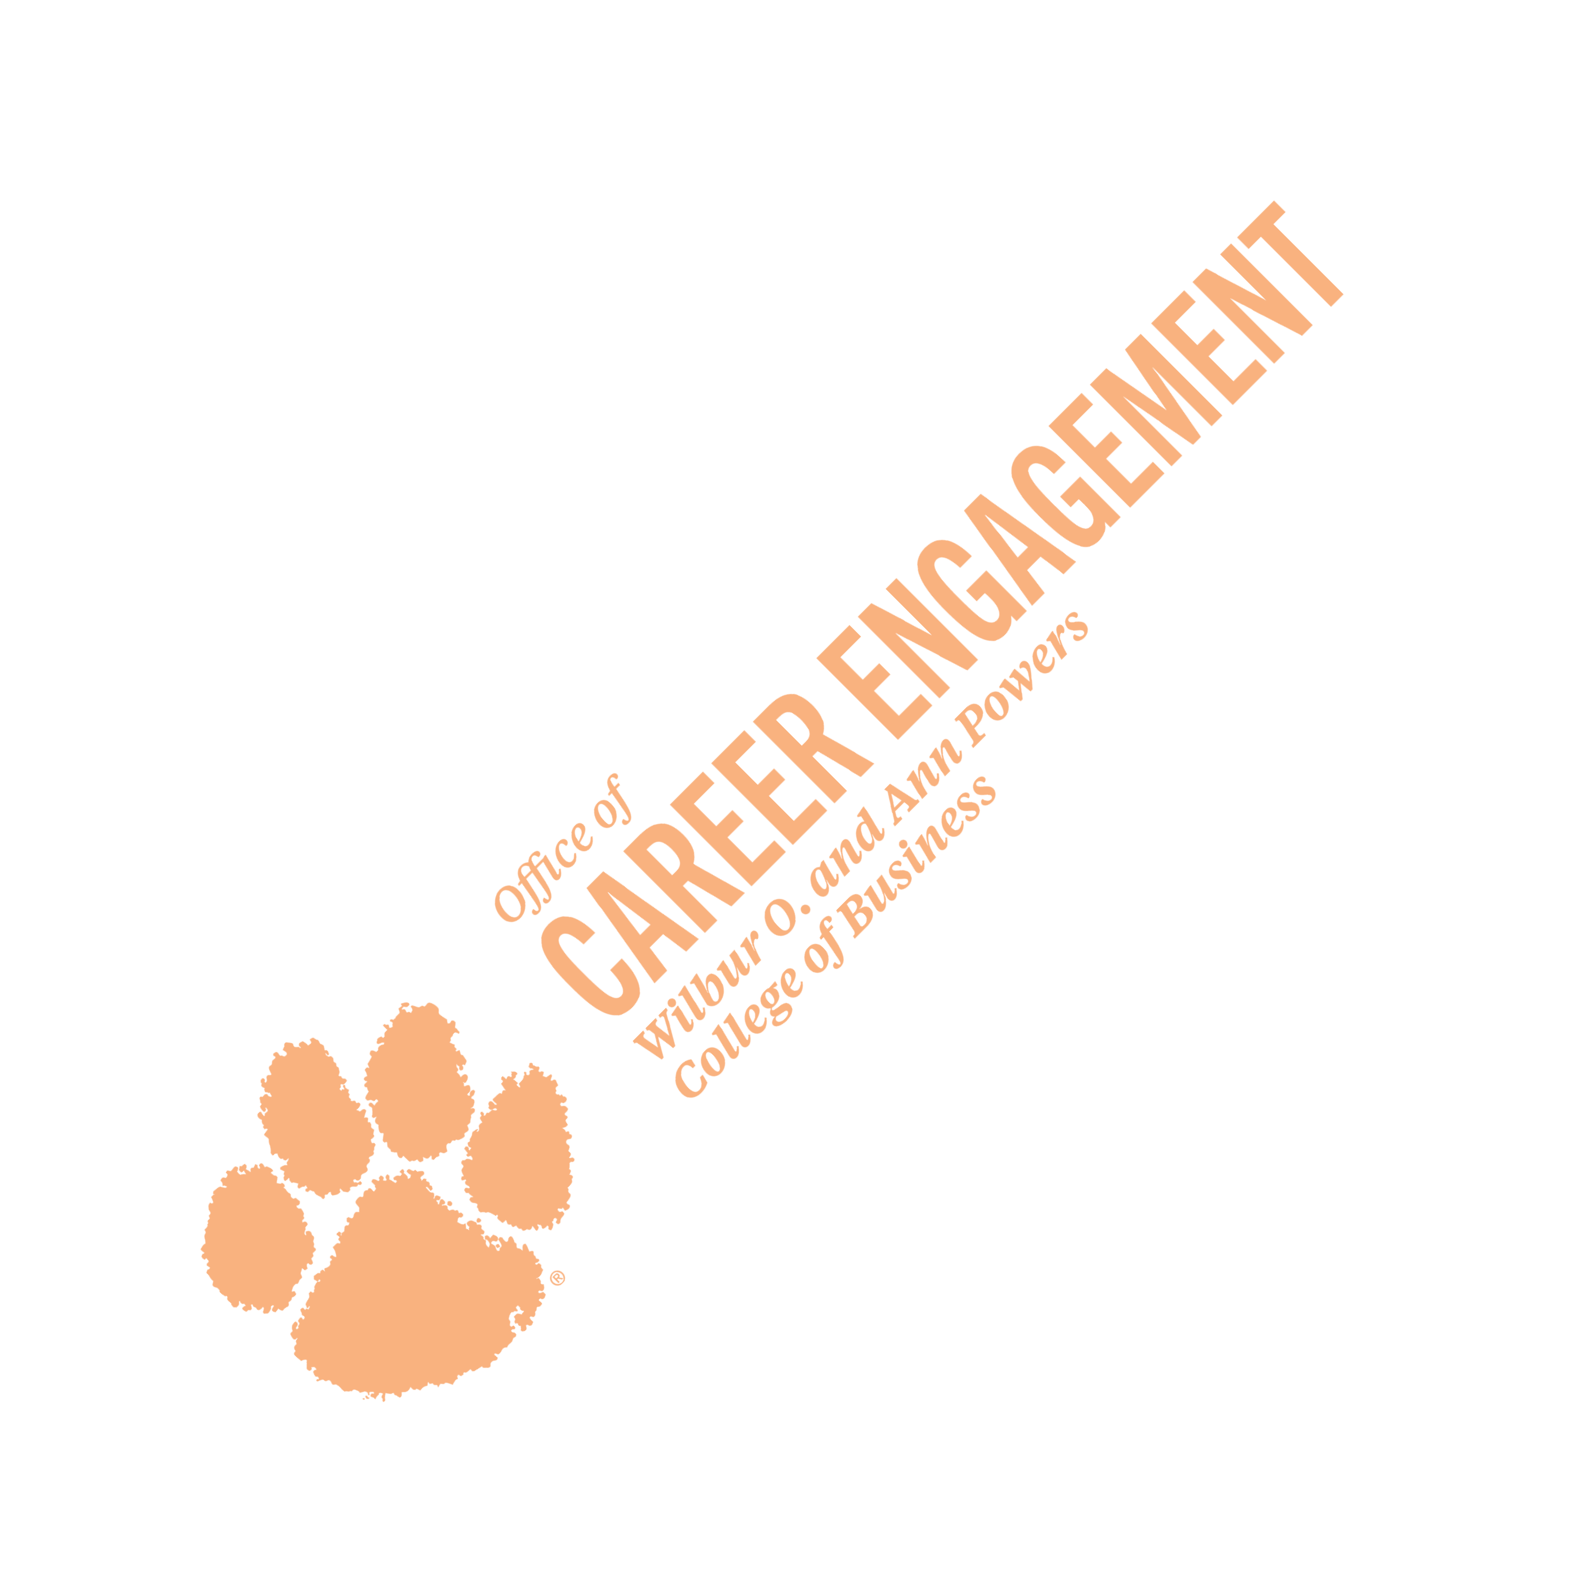
Minor: Finance GPA: 3.34/4.00

ACCOUNTING EXPERIENCE
Powers Associates August 20xx - December 20xx
Accounting Intern Clemson, SC
- Analyzed monthly financial reports with accounting managers, identifying key trends and discrepancies that led to strategic updates, enhancing financial accuracy and client reporting
- Prepared and reviewed debit and credit documents for 100+ clients, ensuring compliance with accounting standards and reducing financial record-keeping errors by 7%
Griffin Partnership May 20xx - August 20xx
Accounting Records Intern Atlanta, GA
- Conducted weekly audits of 20+ accounts, ensuring up-to date and accurate financial records and reducing financial discrepancies by 10%
- Trained and mentored 12 new interns on accounting processes, best practices, and company protocols, accelerating their onboarding and professional growth

OTHER EXPERIENCE
Sunflower Ridge Neighborhood May 20xx - August 20xx
Lifeguard Manager Atlanta, GA
- Supervised an 800-square-foot pool, enforcing safety regulations and ensuring a secure environment for guests
- Managed training sessions, assisting team members in obtaining Water Safety Certifications

LEADERSHIP & CAMPUS INVOLVEMENT
Delta Sigma Pi - Professional Business Fraternity January 20xx - Present
Vice President Clemson, SC
- Led interview and assessment processes for executive board candidates, providing structured feedback and recommendations for a balanced leadership team
- Directed a three-student committee dedicated to mental health awareness, organizing campus events and guest speaker sessions

Wilbur O. and Ann Powers College of Business Student Advisory Board for Accounting
Member January 20xx - May 20xx
- Partnered with faculty and administrators to address student concerns, delivering actionable recommendations that improved curriculum and student services
- Guided 12 new students exploring the Department of Accountancy, providing insights on coursework and career paths

TECHNICAL SKILLS
Fluent in Spanish | Excel (Pivot Tables, VLOOKUP - Proficient) | QuickBooks (Proficient)

