How to Search for Jobs on Business JobLink

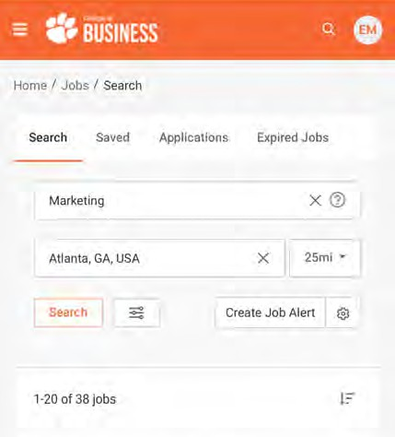


- Go to the Office of Career Engagement website and scroll down to “Access Business JobLink.”
- Go to “Jobs” in the upper left-hand corner and search using keywords and location.

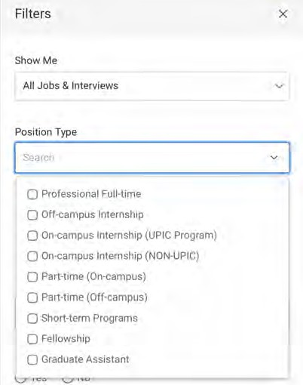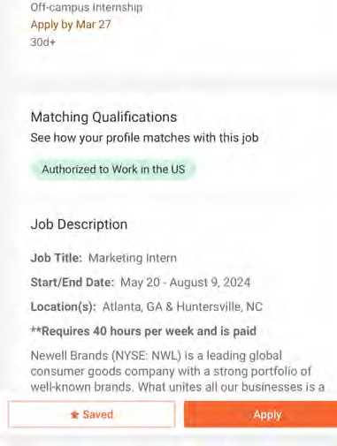

- Add filters to narrow down your search. You can specify whether you are looking for an internship or a full-time position.
- Click on the position to look at the job description and qualifications. You can apply here or add this to your “saved” jobs to refer back to later.



