Gabriela Graphic Communications
gabigraphiccomm@clemson.edu | 864-000-0000 LinkedIn URL | Digital Portfolio Link

EDUCATION
Clemson University - Wilbur O. and Ann Powers College of Business Clemson, SC
Bachelor of Science in Graphic Communications May 20xx
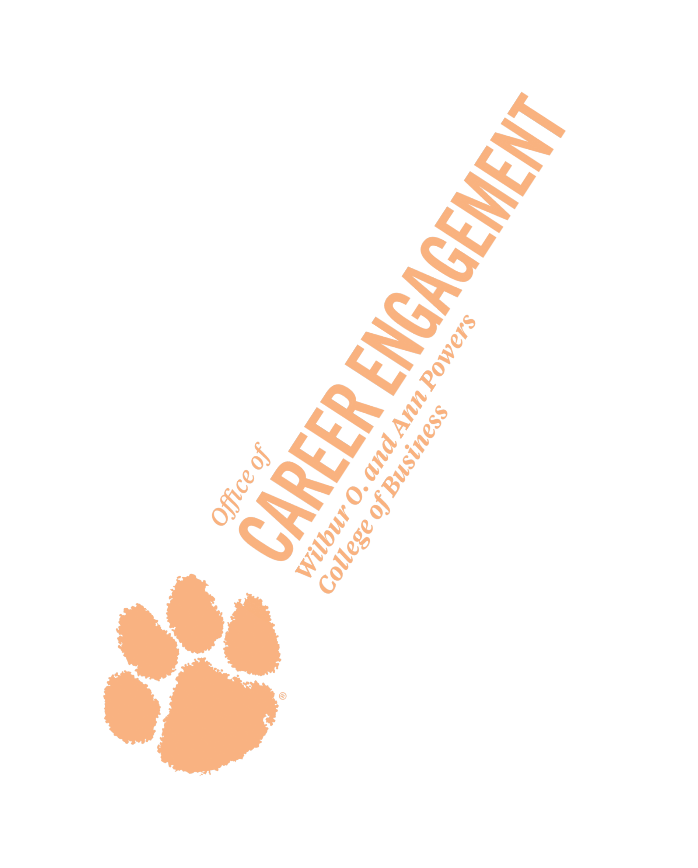
Minor: (if applicable) GPA: 3.7/ 4.0

PROFESSIONAL EXPERIENCE
Design Intern August 20xx-December 20xx
Clemson University Creative Services Clemson, SC
- Developed creative strategies to strengthen the University’s brand identity, ensuring alignment with institutional goals and visual standards
- Collaborated with colleagues to develop and execute three marketing campaigns for Homecoming Weekend, creating promotional materials that boosted student, alumni, and community engagement
- Recognized as Intern of the Month for producing high-quality designs that enhanced the University’s outreach and engagement

Graphic Design Intern May 20xx-August 20xx
City of Naperville Parks and Recreation
Naperville, IL
- Designed the city’s monthly newsletter, reaching 3,000+ area residents, increasing community engagement through visually compelling layouts and structured content
- Created trend and mood boards for the “Return to Nature Campaign,” shaping the visual branding for a citywide environmental initiative

OTHER EXPERIENCE
Front Desk Receptionist May-August 20xx-20xx
Sky Salon Naperville, IL
- Prepared and executed a social media campaign to support the salon’s rebranding
- Increased the salon’s Instagram engagement by 20% through targeted content strategies

LEADERSHIP & CAMPUS INVOLVEMENT
Vice President January 20xx- Present
Gamma Epsilon Tau - Graphic Honor Society
- Led a nominating committee to select the incoming Executive Board
- Managed a three-person committee to promote graphic communication initiatives on campus

Member August 20xx- May 20xx
Clemson University Student Government Association
- Served on the Campus Voting Committee, increasing student participation in elections through outreach initiatives
- Member of Student Finance Committee that allocated funding for student clubs and organizations

TECHNICAL SKILLS & INTERESTS
Adobe Creative Suite (Proficient), Illustrator (Proficient), Asana (Proficient)

