Interview Questions by Department

Marketing
- How do you measure the quality of your work?
- What marketing channels do you have experience with?
- How would you manage a new product launch?
- Could you talk about an insight or trend that you see happening in our industry?
Finance
- How do you explain complex financial topics to colleagues from other departments?
- What are the biggest challenges that finance professionals face today?
- How do you calculate WACC?
- What, in your opinion, makes a good financial model?

Accounting
- What accounting licenses and certifications do you have?
- What do you do when you have an upcoming deadline and several projects to finish?
- How do you keep up with ethical and legal regulations in the industry?
- How do you maintain accounting accuracy?
Management
- Describe a time when you and a peer experienced conflict in a professional setting. How did you overcome it?
- How do you motivate team members?
- How do you like to be managed?
- What projects or assignments best prepared you for this position?

Economics
- Which global trends will shape the world economy in the next five years? Ten years?
- Can you explain the difference between causation and correlation?
- How would you ensure that you effectively communicate economic data to your audience?
- How would you go about solving a problem?
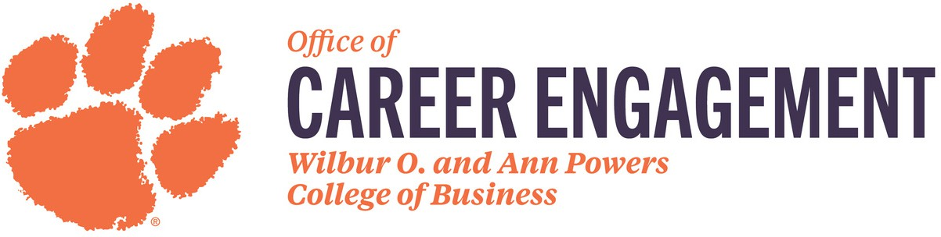

Graphic Communications
- How do you work with collaborators like copywriters, developers, and project managers?
- How do you incorporate feedback into your designs?
- Walk me through your portfolio. Which pieces are you most proud of, and why?
- Someone tells you to design something without any context. What do you do?

