Track Your Job Applications

As you apply to internships and jobs, it’s important to keep track of your applications, position descriptions, and where you stand in the hiring process. Create an Excel document to track your progress.

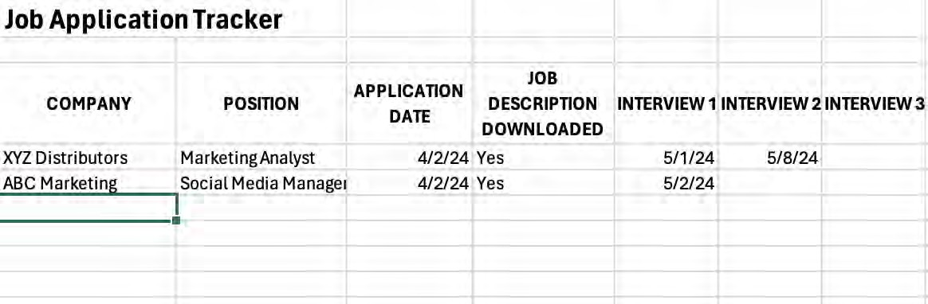

You’ll need to remember the exact company name and the position you applied for there.
Make sure you download the job description as soon as you apply so that you will have it as you prepare for the interview! Often, by the time you are interviewing for a position, the position description has been removed from the company’s postings.


