YOUR TITLE uses heading 1 style
IF IT IS SEVERAL LINES LONG,
BE SURE THAT LINE BREAKS LOOK ATTRACTIVE AND DON’T
LEAVE JUST ONE WORD ALONE ON THE LAST LINE
A [Thesis/Dissertation]
Presented to
The Graduate School of
Clemson University
In partial Fulfillment
Of the Requirements for the Degree
[Master of Science, Doctor of Philosophy, etc]
[Your Program Name here]
By
[Your Full Name]
[May, August or December 20##]
Accepted by:
[Advisor’s Name], Committee Chair
[Committee Member or Co-chair Name]
[Committee Member Name]
[Committee Member Name]
[Committee Member Name]

PLAIN LANGUAGE ABSTRACT – uses Heading 2
Uses Normal Style - A plain language abstract is a short, simple explanation of your research. It should not use jargon or technical terms. It should be understandable by an average member of the public. It should simply explain why the research was done, how it was done, and the key findings. The purpose is to make your research more accessible to more people. This manuscript page is required. Generally, it should be no longer than 500 words.

ABSTRACT – New page title Uses heading 2
All text uses Normal Style by default - The abstract is a succinct statement of the significant contents of the manuscript and the value and relevance of the study. This manuscript page is required. Generally, it should be no longer than 750 words.
When you need to emphasize content or draw attention to it – use “Quote” style. This is formatted to put a thin box around the text with space on all sides, so the text doesn’t run up against the outline
Another paragraph with “Normal” type styling will begin here before more sample styling for pull quote or emphasis text formatting.
When you need to emphasize content or draw attention to it without an outline, use “Intense Quote” style. This is formatted to bold with a paragraph indent.

DEDICATION
The text of the dedication will begin at this point. This manuscript page is optional — remove it if you don’t include a dedication. It should be no longer than one page.

ACKNOWLEDGMENTS
The text of the acknowledgments will begin at this point. This manuscript page is optional — remove it if you don’t include acknowledgments. It should be no longer than one page except in unusual cases.

TABLE OF CONTENTS
PLAIN LANGUAGE ABSTRACT II
ABSTRACT III
DEDICATION IV
ACKNOWLEDGMENTS V
TABLE OF CONTENTS VI
List of tables VIII
List of Figures IX
Chapter One: This is my chapter title 1
This is my first section of chapter 1 1
This is my first subsection for chapter 1 1
This is my second subsection for chapter 1 2
Heading 2
Chapter Two: Research Design and Methods 3
Research Design and Methods 3
Heading 3
Heading 4
Chapter Three: This is my fancy title to chapter three – what if it is extra long, what happens in the TOC then? 5
This is my fancy title to chapter three – what if it is extra long, what happens in the TOC then? 5
Heading 6
Heading 7
Appendices 9
Appendix A 10
Title of Appendix A Goes Here 10
Appendix B 12
Title of Appendix B Goes Here 12
Works Cited 13

List of tables
Reference Tables in Word to assign programmatic headings to tables for accessibility. The table of tables is generated with automated TOC from the Reference tab. Table titles/captions using the style “List of Tables” will be fed into this list.
Table 1.1: Fictitious Data for Popular South Carolina Tourist Cities. Uses “List of Tables” style. 1

List of Figures
Reference Images in Word, images concept or complex images to assign accurate alternative text to all images for accessibility. The list of figures is generated with automated TOC from the Reference tab. Image titles using the style “Caption” will be fed into this list.
Figure 3.1: The caption for figure 3.1 uses “Caption” style 4
Figure A.1: The title for the figure in the Appendix uses “Caption” style 7
Figure B.1: The title for figure A.1 uses “Caption” style 8

Chapter One: This uses heading 2

This is my first section of chapter 1 – this uses heading 3
This is where the text of chapter one will go. All the other chapters will be formatted just like this chapter. Indent the first line of each paragraph about one-fourth of an inch (no matter what indent you choose, use it on all paragraphs throughout the manuscript).
This will be the second paragraph. It’s formatted just like the first paragraph and is shown here just to give you an idea of how the breaks and spacing look.

This is my first subsection for chapter 1 – this uses Heading 4
This is where the text for this heading will be written. There is a sample table next.
Destination | Number of Visitors (in thousands)
Aiken | 250
Beaufort | 400
Charleston | 1200
Columbia | 600
Greenville | 700
Hilton Head Island | 900
Myrtle Beach | 1500
Spartanburg | 350
Table 1.1: Fictitious Data for Popular South Carolina Tourist Cities. Uses “List of Tables” style.

This is my second subsection for chapter 1– this uses Heading 4
This is where the text for this heading will be written.

This is a subheading under the second subsection in chapter 1 – this uses Heading 5
This is where the text for this subheading will be written. Lorem ipsum dolor sit amet, consectetur adipiscing elit. Nam semper dui vel commodo vehicula. Integer ligula nulla, faucibus nec eleifend ac, porta ut justo. Cras commodo eros at semper dapibus. Donec dictum ligula est, ut accumsan dui varius vitae. Curabitur at sem in lorem maximus pulvinar. Nulla dui augue, tristique vel nisl at, imperdiet dignissim arcu. Etiam rhoncus odio vulputate suscipit varius. Aliquam in rhoncus sapien. Etiam vehicula accumsan est a fringilla. Sed metus risus, porta eget lorem sed, dignissim semper nulla. Nam elementum a mi pharetra pretium.

Heading– this uses Heading 4
This is where the text for this heading will be written. Lorem ipsum dolor sit amet, consectetur adipiscing elit. Nam semper dui vel commodo vehicula. Integer ligula nulla, faucibus nec eleifend ac, porta ut justo. Cras commodo eros at semper dapibus. Donec dictum ligula est, ut accumsan dui varius vitae. Curabitur at sem in lorem maximus pulvinar. Nulla dui augue, tristique vel nisl at, imperdiet dignissim arcu. Etiam rhoncus odio vulputate suscipit varius. Aliquam in rhoncus sapien. Etiam vehicula accumsan est a fringilla. Sed metus risus, porta eget lorem sed, dignissim semper nulla. Nam elementum a mi pharetra pretium.

Chapter Two: Research Design and Methods – this uses heading 2

Research Design and Methods – this uses heading 3
This is where the text of chapter two will go. All the other chapters will be formatted just like this chapter. Indent the first line of each paragraph about one-fourth of an inch (no matter what indent you choose, use it on all paragraphs throughout the manuscript).
This will be the second paragraph. It’s formatted just like the first paragraph and is shown here just to give you an idea of how the breaks and spacing look.

Heading – this uses Heading 4
This is where the text for this heading will be written. Lorem ipsum dolor sit amet, consectetur adipiscing elit. Nam semper dui vel commodo vehicula. Integer ligula nulla, faucibus nec eleifend ac, porta ut justo. Cras commodo eros at semper dapibus. Donec dictum ligula est, ut accumsan dui varius vitae. Curabitur at sem in lorem maximus pulvinar. Nulla dui augue, tristique vel nisl at, imperdiet dignissim arcu. Etiam rhoncus odio vulputate suscipit varius. Aliquam in rhoncus sapien. Etiam vehicula accumsan est a fringilla. Sed metus risus, porta eget lorem sed, dignissim semper nulla. Nam elementum a mi pharetra pretium.

Subheading – this uses Heading 5
This is where the text for this subheading will be written. Lorem ipsum dolor sit amet, consectetur adipiscing elit. Nam semper dui vel commodo vehicula. Integer ligula nulla, faucibus nec eleifend ac, porta ut justo. Cras commodo eros at semper dapibus. Donec dictum ligula est, ut accumsan dui varius vitae. Curabitur at sem in lorem maximus pulvinar. Nulla dui augue, tristique vel nisl at, imperdiet dignissim arcu. Etiam rhoncus odio vulputate suscipit varius. Aliquam in rhoncus sapien. Etiam vehicula accumsan est a fringilla. Sed metus risus, porta eget lorem sed, dignissim semper nulla. Nam elementum a mi pharetra pretium.

Heading – this uses Heading 4
This is where the text for this heading will be written. Lorem ipsum dolor sit amet, consectetur adipiscing elit. Nam semper dui vel commodo vehicula. Integer ligula nulla, faucibus nec eleifend ac, porta ut justo. Cras commodo eros at semper dapibus. Donec dictum ligula est, ut accumsan dui varius vitae. Curabitur at sem in lorem maximus pulvinar. Nulla dui augue, tristique vel nisl at, imperdiet dignissim arcu. Etiam rhoncus odio vulputate suscipit varius. Aliquam in rhoncus sapien. Etiam vehicula accumsan est a fringilla. Sed metus risus, porta eget lorem sed, dignissim semper nulla. Nam elementum a mi pharetra pretium.

Chapter Three: This is my fancy title to chapter three

Subheading 3
This is where the text of chapter two will go. All the other chapters will be formatted just like this chapter. Indent the first line of each paragraph about one-fourth of an inch (no matter what indent you choose, use it on all paragraphs throughout the manuscript).
This will be the second paragraph. It’s formatted just like the first paragraph and is shown here just to give you an idea of how the breaks and spacing look.
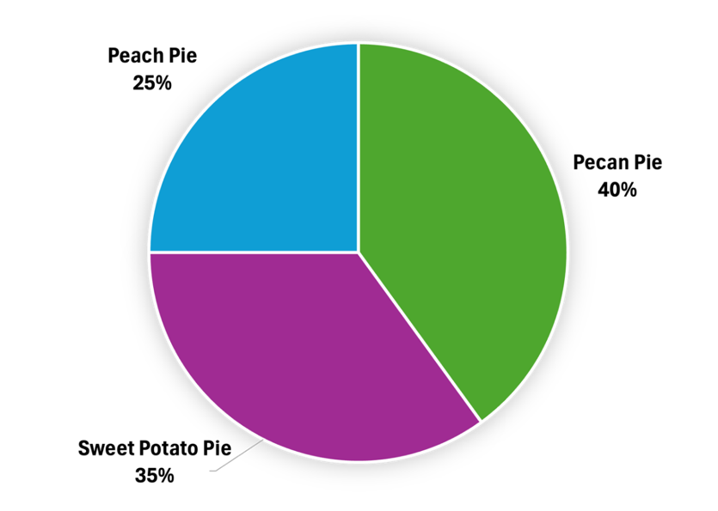
Figure 3.1: The caption for figure 3.1 uses “Caption” style
This text follows an image or table caption. Lorem ipsum dolor sit amet, consectetur adipiscing elit. Nam semper dui vel commodo vehicula. Integer ligula nulla, faucibus nec eleifend ac, porta ut justo. Cras commodo eros at semper dapibus. Donec dictum ligula est, ut accumsan dui varius vitae. Curabitur at sem in lorem maximus pulvinar. Nulla dui augue, tristique vel nisl at, imperdiet dignissim arcu. Etiam rhoncus odio vulputate suscipit varius. Aliquam in rhoncus sapien. Etiam vehicula accumsan est a fringilla. Sed metus risus, porta eget lorem sed, dignissim semper nulla. Nam elementum a mi pharetra pretium.

Heading – uses Heading 4
This is where the text of heading content will go. Lorem ipsum dolor sit amet, consectetur adipiscing elit. Nam semper dui vel commodo vehicula. Integer ligula nulla, faucibus nec eleifend ac, porta ut justo. Cras commodo eros at semper dapibus. Donec dictum ligula est, ut accumsan dui varius vitae. Curabitur at sem in lorem maximus pulvinar. Nulla dui augue, tristique vel nisl at, imperdiet dignissim arcu. Etiam rhoncus odio vulputate suscipit varius. Aliquam in rhoncus sapien. Etiam vehicula accumsan est a fringilla. Sed metus risus, porta eget lorem sed, dignissim semper nulla. Nam elementum a mi pharetra pretium.

Subheading – uses Heading 5
This is where the text of heading content will go. There is a pie chart follwing this sentence with alt text and a figure caprion. Lorem ipsum dolor sit amet, consectetur adipiscing elit. Nam semper dui vel commodo vehicula. Integer ligula nulla, faucibus nec eleifend ac, porta ut justo. Cras commodo eros at semper dapibus. Donec dictum ligula est, ut accumsan dui varius vitae. Curabitur at sem in lorem maximus pulvinar. Nulla dui augue, tristique vel nisl at, imperdiet dignissim arcu. Etiam rhoncus odio vulputate suscipit varius. Aliquam in rhoncus sapien. Etiam vehicula accumsan est a fringilla. Sed metus risus, porta eget lorem sed, dignissim semper nulla. Nam elementum a mi pharetra pretium.
- List
- here

Heading – uses Heading 4
This is where the text for this heading will be written. Lorem ipsum dolor sit amet, consectetur adipiscing elit. Nam semper dui vel commodo vehicula. Integer ligula nulla, faucibus nec eleifend ac, porta ut justo. Cras commodo eros at semper dapibus. Donec dictum ligula est, ut accumsan dui varius vitae. Curabitur at sem in lorem maximus pulvinar. Nulla dui augue, tristique vel nisl at, imperdiet dignissim arcu. Etiam rhoncus odio vulputate suscipit varius. Aliquam in rhoncus sapien. Etiam vehicula accumsan est a fringilla. Sed metus risus, porta eget lorem sed, dignissim semper nulla. Nam elementum a mi pharetra pretium.

Heading – uses Heading 5
This is where the text for this heading will be written. Lorem ipsum dolor sit amet, consectetur adipiscing elit. Nam semper dui vel commodo vehicula. Integer ligula nulla, faucibus nec eleifend ac, porta ut justo. Cras commodo eros at semper dapibus. Donec dictum ligula est, ut accumsan dui varius vitae. Curabitur at sem in lorem maximus pulvinar. Nulla dui augue, tristique vel nisl at, imperdiet dignissim arcu. Etiam rhoncus odio vulputate suscipit varius. Aliquam in rhoncus sapien. Etiam vehicula accumsan est a fringilla. Sed metus risus, porta eget lorem sed, dignissim semper nulla. Nam elementum a mi pharetra pretium.

Appendices

Appendix A – this uses Appendix H2

Title of Appendix A Goes Here – this uses Appendix H3
- Insert text, image or chart.
- Apply any needed accessibility elements – alternative text for images, programmatic and repeating headers, alterative text for data visualizations.
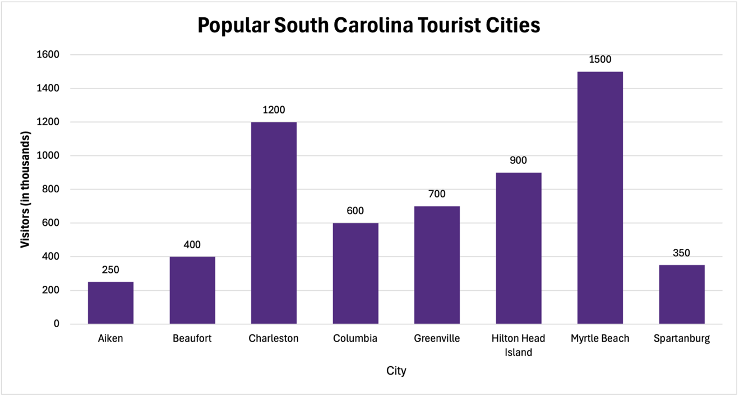
Figure A.1: The title for the figure in the Appendix uses “Caption” style
This text follows an image or table caption. Lorem ipsum dolor sit amet, consectetur adipiscing elit. Nam semper dui vel commodo vehicula. Integer ligula nulla, faucibus nec eleifend ac, porta ut justo. Cras commodo eros at semper dapibus. Donec dictum ligula est, ut accumsan dui varius vitae. Curabitur at sem in lorem maximus pulvinar. Nulla dui augue, tristique vel nisl at, imperdiet dignissim arcu. Etiam rhoncus odio vulputate suscipit varius. Aliquam in rhoncus sapien. Etiam vehicula accumsan est a fringilla. Sed metus risus, porta eget lorem sed, dignissim semper nulla. Nam elementum a mi pharetra pretium.

Appendix B – this uses Appendix H2

Title of Appendix B Goes Here – this uses Appendix H3
Figure B.1: The title for figure A.1 uses “Caption” style
This text follows an image or table caption. Lorem ipsum dolor sit amet, consectetur adipiscing elit. Nam semper dui vel commodo vehicula. Integer ligula nulla, faucibus nec eleifend ac, porta ut justo. Cras commodo eros at semper dapibus. Donec dictum ligula est, ut accumsan dui varius vitae. Curabitur at sem in lorem maximus pulvinar. Nulla dui augue, tristique vel nisl at, imperdiet dignissim arcu. Etiam rhoncus odio vulputate suscipit varius. Aliquam in rhoncus sapien. Etiam vehicula accumsan est a fringilla. Sed metus risus, porta eget lorem sed, dignissim semper nulla. Nam elementum a mi pharetra pretium.

Works Cited – this uses heading 2
- This list uses Bibliography Style
- Ackerman, Shirley, and William W. Turechek. “The Risks and Rewards of Online Editing.” IEEE Transactions on Professional Communication 31 (1988): 122-12.
- Albers, Michael J. “The Technical Editor and Document Databases: What the Future May Hold.” Technical Communication Quarterly 9.2 (2000): 191-206.
- Bernhardt, Stephen. “Seeing the Text.” College Composition and Communication 37.1 (1986): 66-78.
- Merriam-Webster OnLine. 2005. Merriam-Webster Incorporated. 5 July 2006. http://www.m-w.com/cgi-bin/dictionary.
- Ackerman, Shirley, and William W. Turechek. “The Risks and Rewards of Online Editing.” IEEE Transactions on Professional Communication 31 (1988): 122-12.
- Albers, Michael J. “The Technical Editor and Document Databases: What the Future May Hold.” Technical Communication Quarterly 9.2 (2000): 191-206.
- Bernhardt, Stephen. “Seeing the Text.” College Composition and Communication 37.1 (1986): 66-78.
- Merriam-Webster OnLine. 2005. Merriam-Webster Incorporated. 5 July 2006. http://www.m-w.com/cgi-bin/dictionary.
- Ackerman, Shirley, and William W. Turechek. “The Risks and Rewards of Online Editing.” IEEE Transactions on Professional Communication 31 (1988): 122-12.
- Albers, Michael J. “The Technical Editor and Document Databases: What the Future May Hold.” Technical Communication Quarterly 9.2 (2000): 191-206.
- Bernhardt, Stephen. “Seeing the Text.” College Composition and Communication 37.1 (1986): 66-78.
- Merriam-Webster OnLine. 2005. Merriam-Webster Incorporated. 5 July 2006. http://www.m-w.com/cgi-bin/dictionary.
- Ackerman, Shirley, and William W. Turechek. “The Risks and Rewards of Online Editing.” IEEE Transactions on Professional Communication 31 (1988): 122-12.
- Albers, Michael J. “The Technical Editor and Document Databases: What the Future May Hold.” Technical Communication Quarterly 9.2 (2000): 191-206.
- Bernhardt, Stephen. “Seeing the Text.” College Composition and Communication 37.1 (1986): 66-78.
- Merriam-Webster OnLine. 2005. Merriam-Webster Incorporated. 5 July 2006. http://www.m-w.com/cgi-bin/dictionary.
- Ackerman, Shirley, and William W. Turechek. “The Risks and Rewards of Online Editing.” IEEE Transactions on Professional Communication 31 (1988): 122-12.
- Albers, Michael J. “The Technical Editor and Document Databases: What the Future May Hold.” Technical Communication Quarterly 9.2 (2000): 191-206.
- Bernhardt, Stephen. “Seeing the Text.” College Composition and Communication 37.1 (1986): 66-78.
- Merriam-Webster OnLine. 2005. Merriam-Webster Incorporated. 5 July 2006. http://www.m-w.com/cgi-bin/dictionary.

