Department:

Date SOP was written:

Principal Investigator:

Building:

Laboratory:

Primary Emergency Contact (Name and Number):

Secondary Emergency Contact (Name and Number):

1-Methyl-2-Pyrrolidinone

Synonyms: N-Methyl-2-Pyrrolidinone; NMP; N-Methylpyrrolidinone, M-PYROL

Clemson University

Standard Operating Procedure

1. **Working Principle:**

Enter what general purpose this chemical will be having in this laboratory. Examples include DNA purification procedures, preservation of biological material, and as a solvent in organic synthesis.

1. **Physical and Chemical Properties**

**CAS #:** 872-50-4

**Molecular Formula:** C5H9NO

**Physical State (Form):** Liquid

**Potential Hazards:** Flammable Liquid, Skin Irritation, Eye Irritation, Reproductive Toxicity

**Incompatibilities:** Strong acids, Strong bases, Strong oxidizing agents, Strong reducing agents

1. **Health Effects**

**Globally Harmonized System (GHS) Pictograms:**

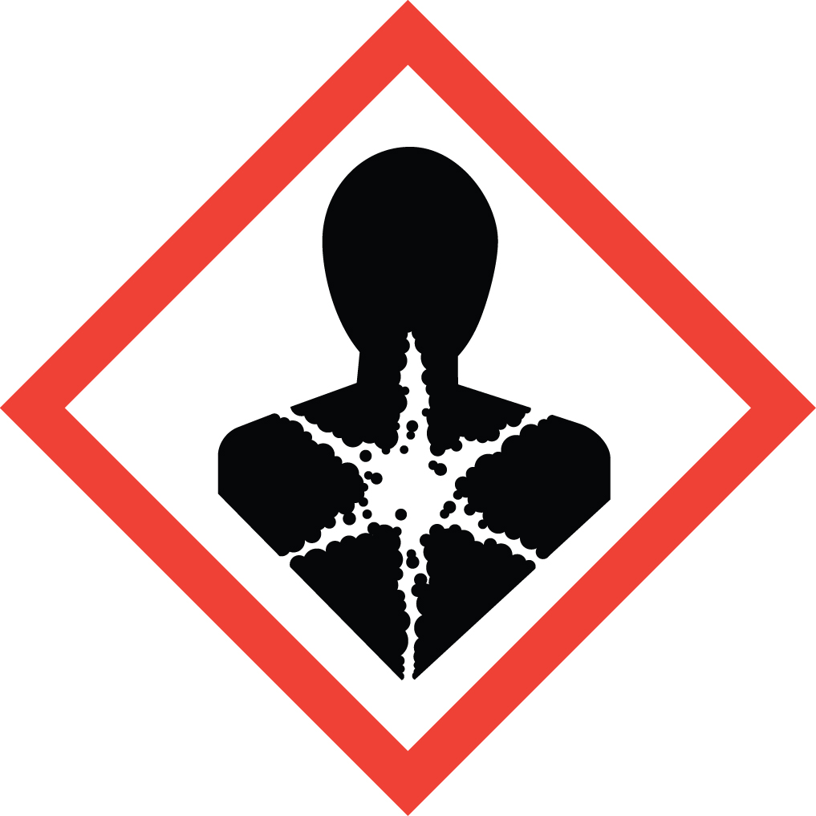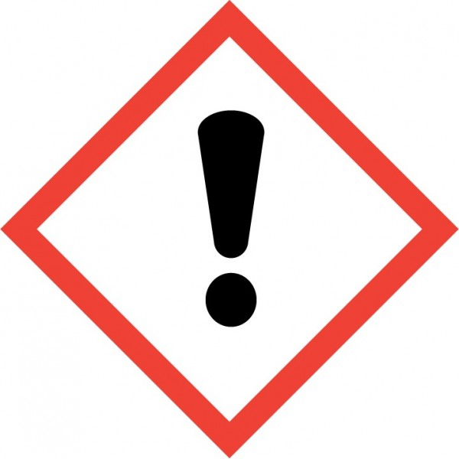

**Signal word:**

Danger

**Inhalation:**

May cause respiratory irritation

**Skin exposure:**

Causes skin irritation

**Eye exposure:**

Causes serious eye irritation

**Other Information:**

May damage fertility or the unborn child

May cause damage to organs through prolonged or repeated exposure

1. **Regulatory Review:**

OSHA Permissible Exposure Limit (PEL)

* + OSHA does not have a Permissible Exposure Limit (PEL) for 1-Methyl-2-Pyrrolidinone but it must be handled safely.

ACGIH Threshold Limit Value (TLV)

* + ACGIH does not have a Threshold Limit Value (TLV) for 1-Methyl-2-Pyrrolidinone but it must be handled safely.

NIOSH Recommended Exposure Limits (REL)

* NIOSH does not have Recommended Exposure Limits (REL) for 1-Methyl-2-Pyrrolidinone but it must be handled safely.

Note: The American Industrial Hygiene Associations has determined Workplace Environmental Exposure Levels (WEELs) for 1-Methyl-2-Pyrrolidinone

* 10.00 ppm 8-hour time weighted average (TWA)

**See Safety Data Sheet (SDS) for Biological Occupational Exposure Limits.**

1. **Controlling Exposure:**

***All procedures involving*** 1-Methyl-2-Pyrrolidinone ***must be performed in a properly functioning chemical fume hood.*** The fume hood is labeled-

Designated Area

Danger

1-Methyl-2-Pyrrolidinone

Flammable Liquid, Skin Irritation, Eye Irritation, Reproductive Toxicity

AUTHORIZED PERSONNEL ONLY

**Storage: Store away from incompatible materials. Label the container “**1-Methyl-2-Pyrrolidinone**,** Flammable Liquid, Skin Irritation, Eye Irritation, Reproductive Toxicity**.” Keep containers tightly closed in a dry, cool, well-ventilated area.**

1. **Personal Protective Equipment (PPE)**

**Respiratory Protection:**

Respiratory protection should not be necessary for lab personnel if the appropriate safe work practices and use proper ventilation are followed. Lab personnel intending to use/wear a respirator MUST be medically cleared, then trained and fit-tested by Occupational and Environmental Safety (OES) prior to use of any form of respiratory protection (including dust masks). Refer to [Respiratory Protection (clemson.edu)](https://www.clemson.edu/finance/oes/occsafetyhealth/industhygiene/programs/respiratoryprot.html) more information.

**Respirators should be used only under any of the following circumstances:**

* As a last line of defense (i.e., after engineering and administrative controls have been exhausted).
* When the PEL, TLV or other established limit has been exceeded or when there is a possibility that the PEL will be exceeded.
* Regulations require the use of a respirator for a particular chemical.
* Clemson University requires the use of a respirator.
* There is potential for harmful exposure due to an atmospheric contaminant (in the absence of PEL).

**Hand Protection:**

Disposable chloroprene gloves are recommended for splash contact. Gloves should be changed frequently and when contaminated.

Butyl-rubber gloves are recommended full contact. Gloves must be inspected prior to use. Dispose of contaminated gloves after use in accordance with applicable laws and good laboratory practices.

Always check with your glove manufacturer to make sure that the gloves are compatible with the hazardous material in the laboratory. Check these websites by glove manufacturers to ensure that the glove material will offer adequate protection.

Chemical Resistant Glove Directory - <http://www.chemrest.com/>

Ansell - <http://www.ansellpro.com/download/Ansell_8thEditionChemicalResistanceGuide.pdf>

**Eye Protection:**

ANSI approved safety glasses or chemical splash goggles.

**Skin and Body Protection:**

Lab coats should be worn and buttoned. Sleeves should be sufficient to prevent skin exposure while wearing gloves. Lab personnel should also wear full length pants (or equivalent) and close-toed shoes.

1. **Spill Control:**

A **minor chemical spill** is one where the lab personnel responsible for the spill feel that they are capable of handling the spill safely without the use of respiratory protection or the assistance of specially trained emergency response personnel. All other chemical spills are considered **major spills**. Details on spill control can be found in the OES Lab Safety Manual at [Lab_Safety_Manual.pdf (clemson.edu)](https://media.clemson.edu/research/oes/labsafety/Lab_Safety_Manual.pdf).

**Minor Chemical Spills**

In the event of a minor spill of hazardous material, lab personnel should do the following:

* Alert people in immediate area of spill.
* Wear protective equipment as needed, including safety goggles or face shield, gloves and lab coat. Consult the SDS for proper personal protective equipment requirements.
* Avoid breathing vapors from the spill. Increase area ventilation by turning on hoods and opening windows.
* Confine spill to small area with absorbent materials
* Use an appropriate spill kit to neutralize and absorb inorganic acids and bases. For other chemicals, use appropriate kit or absorb spill with vermiculite, dry sand, and diatomaceous earth or paper towels.
* Collect residue and related clean up debris in container, properly mark container to identify contents, attach ORS waste container label and submit on-line Chemical Waste Pick Up form
* Clean spill area with soap and water.

**Major Chemical Spills**

In the event of a major spill of hazardous material:

* Evacuate and immediately call CUFD at 911 or 656-2222. Personnel should be prepared to provide the following information:
  + Your name and phone number
  + Identity of material
  + Location of spill: building, room, location in room
  + Time of spill
  + Amount of spilled material
  + Did material enter sink or drain
* If life threatening emergency, call CUFD at 911 or 656-2222.
* Attend to injured or contaminated persons and remove them from exposure. In case of personal contamination, remove affected clothing and flush contaminated skin with water for at least 15 minutes.
* Be prepared to provide SDS to emergency personnel, if available.
* Alert people in the surrounding area to evacuate.  If there is no health or safety risk, turn off ignition and heat sources, maintain fume hood ventilation and open windows to increase ventilation.
* Close doors (do not lock them) to affected are a once the area is evacuated.
* Have someone knowledgeable of the incident and the laboratory available to assist emergency personnel when they arrive.

1. **Waste Disposal:**

Label containers of 1-Methyl-2-Pyrrolidinone waste with the words “Hazardous Waste, 1-Methyl-2-Pyrrolidinone.” Always keep lids on the waste container unless they are in use. When the waste is ready for disposal complete a Chemical Waste Pickup Form on the Clemson OES website [Hazardous Waste Management (clemson.edu)](https://www.clemson.edu/finance/oes/hazmaterials/hazardouswaste/index.html). For questions regarding hazardous waste disposal contact the Hazardous Materials Manager, 633-6357.

1. **Emergency Procedures:**

**Inhalation:**

If inhaled, remove to fresh air. If breathing becomes difficult, seek medical attention. Contact CUFD at 911 or 656-2222.

**Skin/Clothing Contact:**

Remove contaminated clothing and rinse body thoroughly in emergency shower for at least 15 minutes. Then seek medical attention. CUFD at 911 or 656-2222.

**Eye Contact:**

Rinse eyeball and inner surface of eyelid in the emergency eyewash station for at least 15 minutes. Then seek medical attention. CUFD at 911 or 656-2222.

**Ingested:**

Do NOT induce vomiting. If swallowed, wash out mouth with water. Then seek medical attention immediately. Contact CUFD at 911 or 656-2222.

1. **Lab-Specific Procedures:**

Enter the specific instructions the laboratory personnel will have to use when working with the hazardous chemical. This may include solvent preparation and usage, etc.

1. **Documentation of Training** (signature of all users is required)

* Prior to conducting any work with 1-Methyl-2-Pyrrolidinone, designated personnel must provide training to his/her laboratory personnel specific to the hazards involved in working with this substance, work area decontamination, and emergency procedures.
* The Principal Investigator must ensure that his/her laboratory personnel completed all required safety training.

I have read and understand the content of this SOP:

|  |  |  |
| --- | --- | --- |
| **Name** | **Signature** | **Date** |
|  |  |  |
|  |  |  |
|  |  |  |
|  |  |  |
|  |  |  |
|  |  |  |
|  |  |  |
|  |  |  |
|  |  |  |
|  |  |  |
|  |  |  |
|  |  |  |
|  |  |  |
|  |  |  |
|  |  |  |