Department:
Date SOP was written:
Principal Investigator:
Building:
Laboratory:
Primary Emergency Contact (Name and Number):
Secondary Emergency Contact (Name and Number):

Phenyl Isocyanate
Synonyms: Isocyanic Acid, Phenyl Ester; Phenylcarbimide, Isocyanatobenzene

Clemson University
Standard Operating Procedure

- Working Principle:
Enter what general purpose this chemical will be having in this laboratory. Examples include DNA purification procedures, preservation of biological material, and as a solvent in organic synthesis.

- Physical and Chemical Properties

CAS #: 103-71-9
Molecular Formula: C₇H₅NO
Physical State (Form): Liquid
Potential Hazards: Flammable Liquid, Acute Toxicity, Skin Corrosion, Serious Eye Damage, Respiratory Sensitization, Aquatic Toxicity (Acute & Chronic)
Incompatibilities: Acids, Bases, Strong oxidizing agents, Alcohols, Amines, Water
Note: Closed containers contaminated with water can rupture spontaneously.

- Health Effects

Globally Harmonized System (GHS) Pictograms:
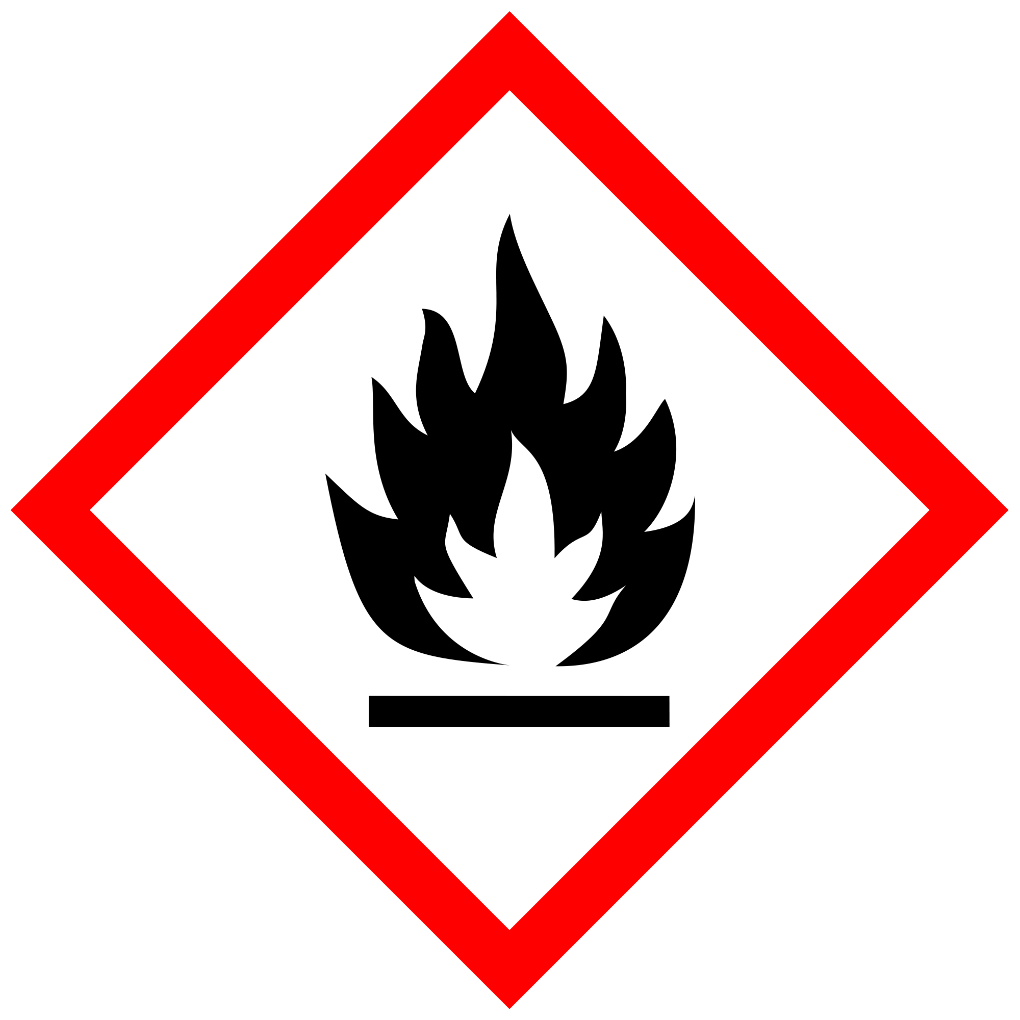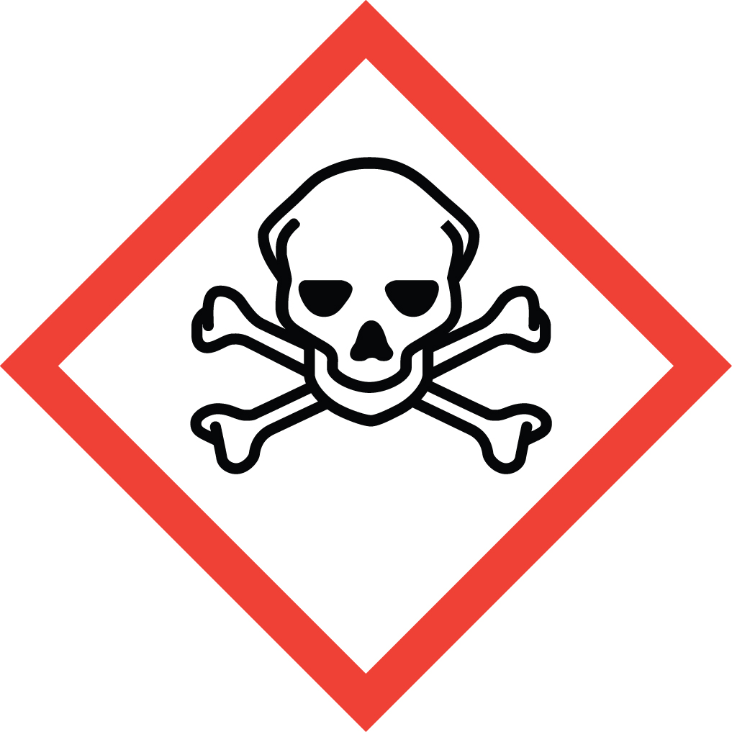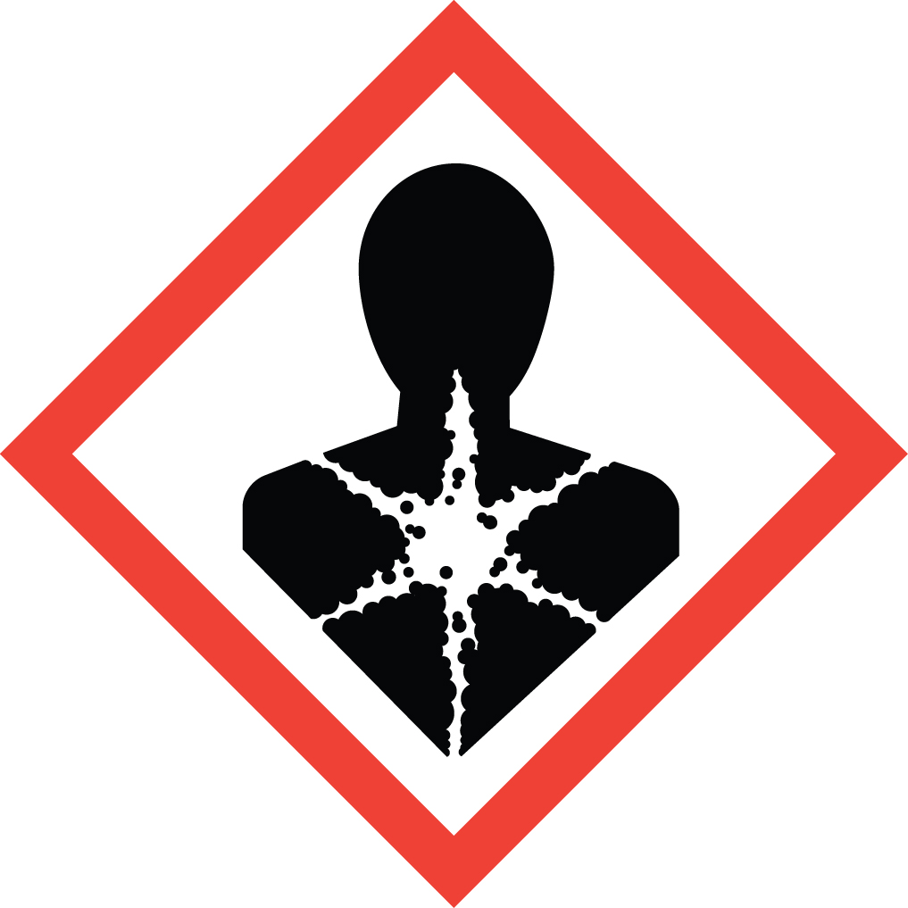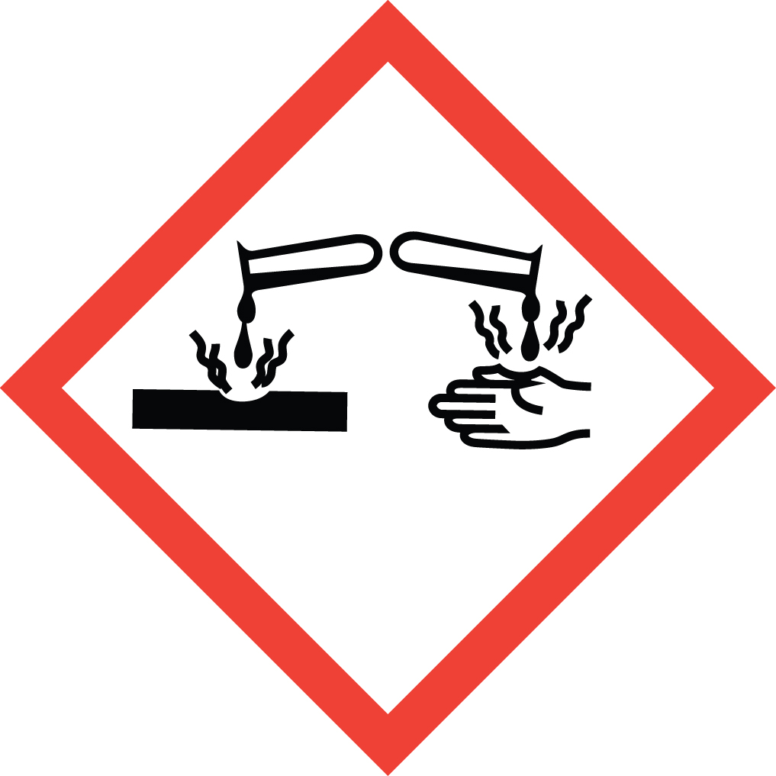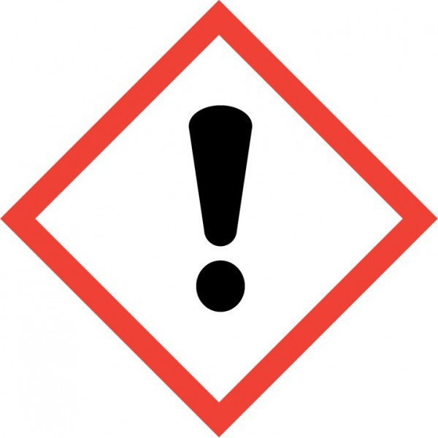

Signal word:
Danger

Inhalation:
Fatal if inhaled

Oral exposure:
Harmful if swallowed

Skin exposure:
Causes severe skin burns

Eye exposure:
Causes severe eye damage

Other information:
Flammable liquid and vapor
May cause allergy or asthma symptoms or breathing difficulties if inhaled
Harmful to aquatic life with long lasting effects

- Regulatory Review:

OSHA Permissible Exposure Limit (PEL)
  - OSHA does not have a Permissible Exposure Limit (PEL) for Phenyl Isocyanate but it must be handled safely.

ACGIH Threshold Limit Value (TLV)
  - 0.005 ppm 8-hour time weighted average (TWA)
  - 0.015 ppm 15-minute short term exposure limit (STEL) that should not be exceeded at any time during the work day

NIOSH Recommended Exposure Limits (REL)
  - NIOSH does not have a Recommended Exposure Limits (REL) for Phenyl Isocyanate but it must be handled safely.

- Controlling Exposure:

All procedures involving Phenyl Isocyanate must be performed in a properly functioning chemical fume hood. The fume hood is labeled-

Designated Area
Danger

Flammable Liquid, Acute Toxicity, Skin Corrosion, Serious Eye Damage, Respiratory Sensitization, Aquatic Toxicity
AUTHORIZED PERSONNEL ONLY

Storage: Store away from incompatible materials. Label the container “Phenyl Isocyanate, Flammable Liquid, Acute Toxicity, Skin Corrosion, Serious Eye Damage, Respiratory Sensitization, Aquatic Toxicity.” Keep containers tightly closed in a dry, cool, well-ventilated area.

- Personal Protective Equipment (PPE)

Respiratory Protection:
Respiratory protection should not be necessary for lab personnel if the appropriate safe work practices and use proper ventilation are followed. Lab personnel intending to use/wear a respirator MUST be medically cleared, then trained and fit-tested by Occupational and Environmental Safety (OES) prior to use of any form of respiratory protection (including dust masks). Refer to Respiratory Protection (clemson.edu) more information.

Respirators should be used only under any of the following circumstances:

- As a last line of defense (i.e., after engineering and administrative controls have been exhausted).
- When the PEL, TLV or other established limit has been exceeded or when there is a possibility that the PEL will be exceeded.
- Regulations require the use of a respirator for a particular chemical.
- Clemson University requires the use of a respirator.
- There is potential for harmful exposure due to an atmospheric contaminant (in the absence of PEL).

Hand Protection:
Fluorinated rubber gloves are recommended. Gloves must be inspected prior to use. Dispose of contaminated gloves after use in accordance with applicable laws and good laboratory practices.

Always check with your glove manufacturer to make sure that the gloves are compatible with the hazardous material in the laboratory. Check these websites by glove manufacturers to ensure that the glove material will offer adequate protection.

Chemical Resistant Glove Directory - http://www.chemrest.com/

Ansell - http://www.ansellpro.com/download/Ansell_8thEditionChemicalResistanceGuide.pdf

Eye Protection:
ANSI approved safety glasses or chemical splash goggles.

Skin and Body Protection:
Lab coats should be worn and buttoned. Sleeves should be sufficient to prevent skin exposure while wearing gloves. Lab personnel should also wear full length pants (or equivalent) and close-toed shoes.

- Spill Control:

A minor chemical spill is one where the lab personnel responsible for the spill feel that they are capable of handling the spill safely without the use of respiratory protection or the assistance of specially trained emergency response personnel. All other chemical spills are considered major spills. Details on spill control can be found in the OES Lab Safety Manual at Lab_Safety_Manual.pdf (clemson.edu).

Minor Chemical Spills

In the event of a minor spill of hazardous material, lab personnel should do the following:
- Alert people in immediate area of spill.
- Wear protective equipment as needed, including safety goggles or face shield, gloves and lab coat. Consult the SDS for proper personal protective equipment requirements.
- Avoid breathing vapors from the spill. Increase area ventilation by turning on hoods and opening windows.
- Confine spill to small area with absorbent materials
- Use an appropriate spill kit to neutralize and absorb inorganic acids and bases. For other chemicals, use appropriate kit or absorb spill with vermiculite, dry sand, and diatomaceous earth or paper towels.
- Collect residue and related clean up debris in container, properly mark container to identify contents, attach OES waste container label and submit on-line Chemical Waste Pick Up form
- Clean spill area with soap and water.

Major Chemical Spills

In the event of a major spill of hazardous material:
- Evacuate and immediately call CUFD at 911 or 656-2222. Personnel should be prepared to provide the following information:
  - Your name and phone number
  - Identity of material
  - Location of spill: building, room, location in room
  - Time of spill
  - Amount of spilled material
  - Did material enter sink or drain

- If life threatening emergency, call CUFD at 911 or 656-2222.
- Attend to injured or contaminated persons and remove them from exposure. In case of personal contamination, remove affected clothing and flush contaminated skin with water for at least 15 minutes.
- Be prepared to provide SDS to emergency personnel, if available.
- Alert people in the surrounding area to evacuate. If there is no health or safety risk, turn off ignition and heat sources, maintain fume hood ventilation and open windows to increase ventilation.
- Close doors (do not lock them) to affected are a once the area is evacuated.
- Have someone knowledgeable of the incident and the laboratory available to assist emergency personnel when they arrive.

- Waste Disposal:

Label containers of Phenyl Isocyanate waste with the words “Hazardous Waste, Phenyl Isocyanate.” Always keep lids on the waste container unless they are in use. When the waste is ready for disposal complete a Chemical Waste Pickup Form on the Clemson OES website (Hazardous Waste Management (clemson.edu)). For questions regarding hazardous waste disposal contact the Hazardous Materials Manager, 633-6357.

- Emergency Procedures:

Inhalation:
If inhaled, remove to fresh air. If breathing becomes difficult, seek medical attention. Contact CUFD at 911 or 656-2222.

Skin/Clothing Contact:
Remove contaminated clothing and rinse body thoroughly in emergency shower for at least 15 minutes. Then seek medical attention. CUFD at 911 or 656-2222.

Eye Contact:
Rinse eyeball and inner surface of eyelid in the emergency eyewash station for at least 15 minutes. Then seek medical attention. CUFD at 911 or 656-2222.

Ingested:
Do NOT induce vomiting. If swallowed, wash out mouth with water. Then seek medical attention immediately. Contact CUFD at 911 or 656-2222.

- Lab-Specific Procedures:
Enter the specific instructions the laboratory personnel will have to use when working with the hazardous chemical. This may include solvent preparation and usage, etc.

- Documentation of Training (signature of all users is required)
- Prior to conducting any work with Phenyl Isocyanate, designated personnel must provide training to his/her laboratory personnel specific to the hazards involved in working with this substance, work area decontamination, and emergency procedures.

- The Principal Investigator must ensure that his/her laboratory personnel completed all required safety training.

I have read and understand the content of this SOP:
Name | Signature | Date

