**General protocol – Alligator Sampling**

**Clemson University**

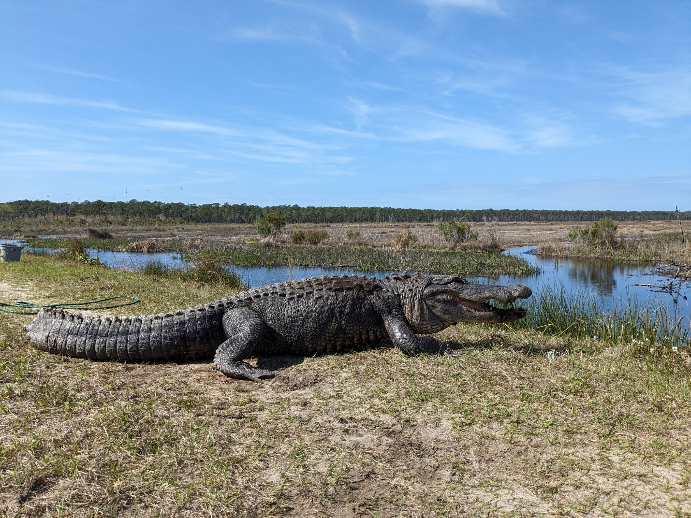

# Table of Contents

Table of Contents 2

I. Purpose 3

II. Safety Considerations 3

III. Alligator Capture 5

A. First Contact 5

B. Restrain with noose 6

C. Physical Restraint 6

D. Data Collection 7

IV. Tagging and Biological Sampling 8

A. Marking and Tagging 8

B. Blood Sampling 9

C. Muscle Biopsy Sampling 10

V. References 11

# Purpose

The purpose of this SOP is to describe the general methodology and activities pertaining to the sampling of live alligators for Clemson University research projects. Methodologies and activities included here are performed under approval from the Clemson University Institutional Animal Care and Use Committee and with appropriate state or federal permits. Additionally, methodologies described here are vetted and used by crocodilian experts under the International Union for the Conservation of Nature Species (IUCN) Survival Commission (SSC) Crocodile Specialist Group.

# Safety Considerations

Prior to beginning fieldwork, the field team and project lead(s) conduct a tail-gate safety talk to identify, discuss, and agree on appropriate mitigation actions for field-level safety hazards. All team members have the right to refuse work and call a safety stop to sampling activities if they feel uncomfortable, unsafe, or have questions regarding the tasks being performed. A field team consists of at least two people, but normally 3-4, during alligator sampling activities. During field outings, a safety check-in is established, usually Leah Gegory at Clemson University Baruch Institute for Coastal Ecology and Forest Science. In case of emergencies, the team will dial 9-1-1 and follow operator instructions. In non-emergency situations, the team is equipped with a first-aid kit and will use the kit and first-aid training as required.

The following are field-level hazards with accompanying safety considerations and mitigation measures:

|  |  |  |
| --- | --- | --- |
| Activity | Hazard | Mitigation |
| Equipment | | |
| Vehicles | Fatigue | Ensure driver(s) are well-rested and can switch or take a break if needed. |
|  | Road hazards: weather, wildlife, construction, other drivers | Drive appropriately based on conditions including inclement weather, low visibility, sun glare, and low light (nights). Ensure all lights and brakes are in working order. Obery traffic signs and warnings for construction. Remain vigilant at all times but be aware of increased risk of wildlife on the road during dawn, dusk, and night times. |
|  | Distracted driving | No use of hand-held cell phones by the driver. Use hands-free tools if available, pull over if needed, or have passengers perform necessary tasks. |
|  | Off-road driving – uneven terrain, mud, ledges, tire punctures | Ensure all vehicles have sufficient tread and are equipped with 4-wheel drive. Have a truck kit with first aid kit, jack, tire iron, recovery tow strap, flashlight, and emergency blanket when in the field. Drive slowly and be aware of off-road hazards while in the field. If it is not safe to proceed. Turn around, find an alternative route, or walk into the site |
| Environment | Heat and cold | Ensure team members are appropriately clothed for temperatures. In hot weather take breaks in the shade or vehicles at regular intervals to cool down. Bring extra water, cold packs, or a cooler to ensure all team members stay hydrated and have access to something for cooling down. Know the signs of heat exhaustion/stroke and take appropriate care to prevent or treat in the field. Stop work if temperatures are too high or cold. |
|  | Insects | Be aware of any potential allergies to biting and stinging insects. Have team members carry appropriate medical supplies (i.e., EpiPen) if required. Wear protective clothing and use repellent as necessary. |
|  | Wildlife | Wear appropriate footwear and protective equipment to mitigate risk from venomous snakes. Work as a team and remain vigilant of associated risks with wildlife while at work. Do not enter the water in areas where alligators are present. |
|  | Inclement Weather | If lightning is in the area (<15 sec between strike and thunder) seek shelter in vehicles or leave the field site. Wait at least 15 minutes until the lighting has passed before resuming work. Be prepared for rainfall. Do not work if there is risk for adverse weather and stop work if severe weather is present. |
|  | Uneven terrain | Be aware of risk for slips and trips. Wear appropriate footwear when in the field. Communicate hazards to other team members when navigating uneven terrain. |
| Research | Snatch hooks | Weighted treble hooks have risk of hooking users and bystanders. Make sure all personnel are clear of the area when using snatch hooks. Make visual confirmation of hook position/location when landing alligators to prevent stepping or kneeling on hooks. Communicate and manage risk of entanglement in fishing line and paracord attached to snatch hooks. Remove barbs from all hooks to facilitate removal of hooks from alligators and people. |
|  | Ropes and restraints | Ensure all ropes and restraints are in good condition. Manage ropes and restraints to prevent entanglement and tripping hazards to field team. |
|  | Biological sample collection | Be aware of poking and cutting risk of blood needles, knife/scalpel blades, and biopsy punches. Cap and dispose of these in a sharps container. Use gloves when performing sample collection and dispose of gloves after each use. |
|  | Alligator restraint | Ensure all team members have assigned roles. Keep all personnel except those involved in the capture outside a 3m radius around the alligator during capture. Ensure all team members make eye contact and receive confirmation from capture lead(s) before performing an action. Prior to restraining the alligator apply an opaque eye covering (i.e. towel) to reduce stress, and close jaws with a animal control pole before securing the jaws manually. Use a release rope to mitigate potential bite risk during release. |
|  | Alligator welfare | Reduce stress by keeping alligators cool with wet towels and shaded when working during the day. Keep alligator jaws closed with tape and eyes covered to prevent injury and stress. Release alligators at the site of capture. |
|  | Human welfare | Take breaks as needed. Ensure all team members have appropriate rest, food, and hydration. Do not force or demand performance of tasks beyond the experience and comfort level of participating field team members. Respect the right to stop work if team members feel unsafe, uncomfortable, or unsure about the tasks being performed. |

# Alligator Capture

## First Contact

In the field, alligators are most often swimming or loafing in the water away from the shoreline. First contact is made using a weighted treble hook (snatch hook) (Figure 1) to snag the alligator in the tough skin on its lateral and dorsal surface. All hooks are thrown away from the head to prevent hooking of the mouth, eyes, and nose. The barbs from hooks are removed (ground off prior to hook use) so if the line is broken the hooks can drop away. Snatch hooks can be thrown using a fishing rod or from spooled paracord in a bucket (hand-line). When using a hand-line the rope is wetted to prevent abrasions. Gloves may be used as well to protect the hands. Once hooked, the alligator is worked slowly into shore towards the capture team.

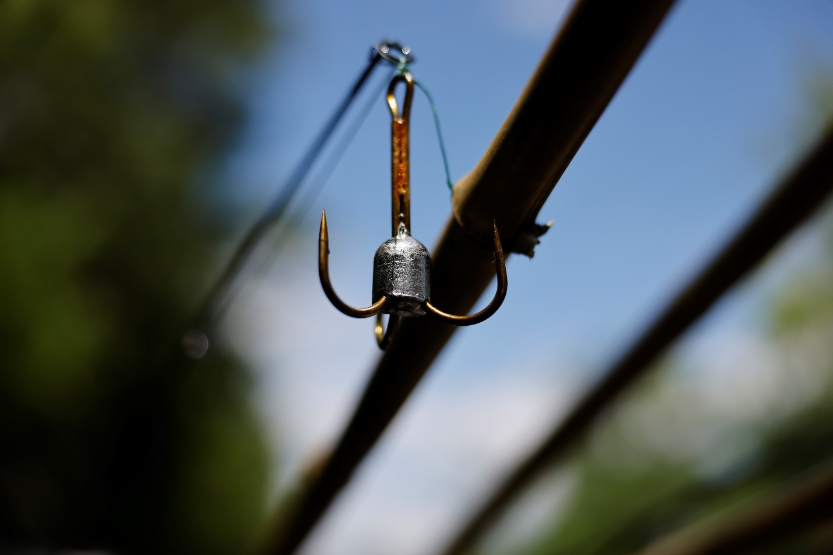

Figure 1. Standard 12/0 weighted treble hook used for alligator capture. The barbs of the hook are ground off to facilitate easy removal and to prevent lost hooks from staying embedded in the alligators’ skin.

## Restrain with noose

As the alligator is pulled to shore, the project team will use a wire noose (self-locking cable snare) as a primary restraint to secure the alligator and land it on shore. The noose is comprised of a strong rope attached to a wire noose fabricated with aircraft cable. There is a mechanism that allows the noose to tighten closed and maintain tension (“self-locking”). Thompson Snares model 2xx-72 are typically used (<https://thompsonsnares.com/collections/frontpage/products/2xx-72ds>). The snare is attached to a length of bamboo (2-3m long) with loop of the noose attached at two points to the end of the bamboo using one wrap of standard electrical tape. This configuration allows the nose to easily disconnect from the pole after placement on the alligator, to prevent the pole from becoming a risk to the field team if the alligator thrashes or spins once noosed/snared. The loop of the noose is slid over the head, back behind the posterior margin of the skull but in front of the shoulders, and tightened around the neck. Once in place, the bamboo pole breaks away from the noose and is moved away from the field team, which then decides on an appropriate location for pulling the alligator from the water onto land.

## Physical Restraint

Once the alligator is pulled up onto a clear and flat spot at the capture site, the capture team then moves to apply physical restraints to the alligator (Figure 2). If a snatch hook is still attached to the alligator, the team identifies its position on the alligator. One or two team members continue to apply tension to the neck noose to hold the alligator (particularly the head) in place. Another team member places the open loop of an animal restraint pole over the open jaws of the alligator and cinches the alligator’s mouth closed, while also pushing the animal’s head firmly against the ground. A towel may be placed over the eyes of the alligator either before the use of the control pole or after. The person holding the noose rope maintains pressure to keep control of the head and ensure the animal remains in place. Once the location of the hook is identified, the alligator’s eyes are covered, and its jaws are closed, one senior team member approaches the animal from the tail end, straddles the animal, walks carefully up toward the head, and in one motion falls to a kneeling position onto the animal’s neck while simultaneously placing the majority of her/his body weight on the animal’s closed snout with both hands.. A secondary team member straddles the tail of the alligator and lifts the hind legs to limit the movement of the animal. The team member on the head visually confirms that the jaws of the alligator are closed. This team member will then, while maintaining manual pressure and with the control pole still in place, work her/his fingers under the lower jaw (mandible) of the alligator (with thumbs still on top of the jaws) to hold the mouth shut manually. While squeezing her/his knees on either side of the neck, the team member on the head will slowly lift the head and closed jaws of the alligator up and back, reducing the leverage the alligator has to open its jaws and move its head. Another team member will then approach the alligator’s head from the front and apply multiple (>4 wraps) of electrical tape around the snout of the alligator, posterior to the nostrils, to securely close the jaws. Once the jaws are secured, the team will loosen the neck noose and may use a length of rope to secure the hind legs off of the ground to reduce/prevent movement of the alligator.

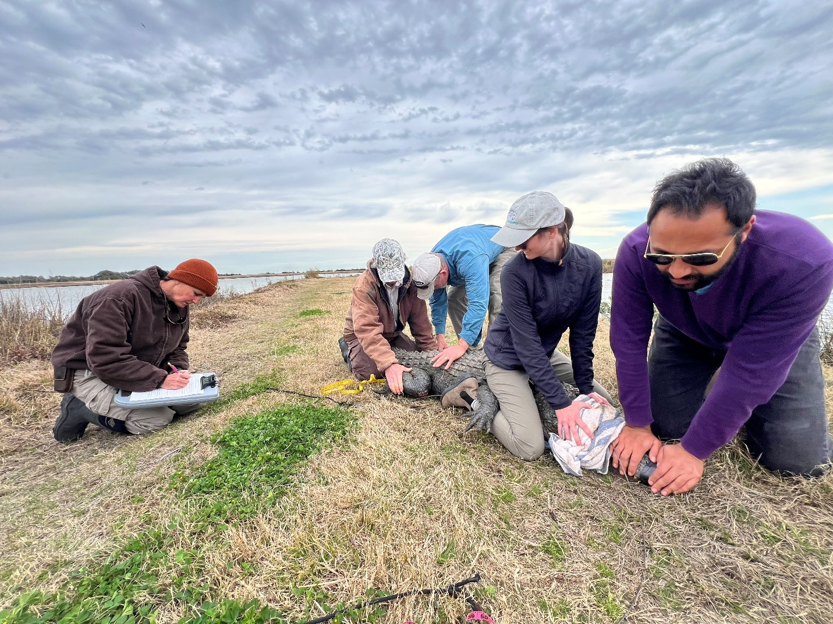

Figure 2. Field-team members physically restraining an adult American alligator. Throughout handling the jaws are taped shut and an eye covering is in place. At all times, there is a field team member physically restraining the alligator to prevent injury to the field team or the alligator.

## Data Collection

After restraining the alligator, the field team will then collect the following morphological information from each alligator (Zweig et al., 2004).

* Total length – measured from the tip of the top jaw to the tip of the tail.
* Snout to vent length – measured from the tip of the top jaw to the third scale row behind the hind legs.
* Tail girth –circumference of the tail measured at the third scale row behind the hind legs.
* Right hind foot length – measured from the heel bone to the tip of the longest toe, excluding the nail.
* Sex – a gloved hand is used to gently inset a digit into the cloaca and palpate for a phallus.

All measurements and sexing are conducted with one or multiple team members maintaining restraint of the alligator. Measurements are collected with a flexible measuring tape along the dorsal surface of the alligator and recorded on a standard data sheet in centimeters.

# Tagging and Biological Sampling

Once an alligator is retrained, measured, and sexed, the following steps are taken to individually mark animals and collect biological samples. Sites of capture are diverse and some or all of the following will be performed at a given sampling site. The extent of marking and sampling an individual alligator will be at the discretion of the field team, and considerations may include sample site, alligator size, and health of the alligator. In instances where alligators may be too small or sickly, tagging and sampling may not be performed. Throughout sample collection, we will monitor alligators for signs of stress, such as increased breathing rates, discharge from the nares, visible and audible indications of water inhalation, vocalizations, and fresh injuries. If we observe signs of alligator distress during sample collection, we will immediately stop the process, and the alligator will be released at the water’s edge to allow recovery and observation. We will release all captured alligators at the capture site.

## Marking and Tagging

There are three marking techniques that may be used for alligators captured during Clemson University alligator research. Currently, the only site where all three are performed is the Tom Yawkey Wildlife Center in Georgetown, SC. Most other state and institutional research efforts use scute clipping as the only marking technique.

* Passive Integrated Transponders (PIT) tags (Eversole et al., 2014) – PIT tags are commercially available transponders that are deployed subcutaneously. A hand-held reader is used to scan tagged animals and recover the individual identification code on the transponder. We use Biomark APT pre-loaded sterile PIT tags that are pre-loaded into a sterile needle. The needle is fitted to a hand-held implanter/applicator. The needle is inserted at a 45-degree angle beneath the skin and right jaw (masseter) muscle, parallel to the body. The tag is manually pushed from the needle into the skin and remains in the body subcutaneously. The tag is scanned to determine it is functional and the individual identification number confirmed. The needle is then capped and disposed of in the sharps container. The implanter/applicator is reuseable and is cleaned if necessary.
* Toe tags (Jennings et al., 1991) – Self-piercing metal toe tags (National Band Tag Company) are applied to the webbing of the right hind foot between the second and third digits. These stainless-steel tags have an individual identification number engraved in them which is recorded for each alligator. The tag is loaded onto specialized application pliers. The tag is pressed firmly into place leaving 1/4 to 1/3 of its length clear of the webbing to allow for potential growth.
* Scute clipping (Wilkinson, 1983)- The upright vertical scales along the tail are called tail scutes. The positioning of these scutes can be used to apply an alphabetic, numeric, or alpha-numeric code by notching/clipping a unique series of scutes on an individual. The scutes are composed of skin and keratinized tissue with little blood flow. Once a scute is notched, the portion removed will not regrow; therefore, the mark is permanent. This is the most widely used marking technique for crocodilians worldwide. A sharp knife is sterilized with alcohol prior to use. The team member performing marking will wear nitrile gloves. A second team member may stabilize the tail during the procedure. The marker makes shallow cuts down the webbing on each end of the scute. Following these shallow cuts, the knife is turned sideways to make a singular horizontal cut removing the top portion of the scute. The now flattened scute is disinfected with iodine antiseptic. The clipped portion of the scute is placed in a sterile plastic bag, stored on ice in the field, and later frozen at -20°C.

## Blood Sampling

A sterile needle is fitted to a sterile luer-lock syringe. The team member on the head of the alligator puts on gloves and is given the capped syringe. One other team member secures and restrains the hind legs and tail of the animal, and a third team member applies pressure to the snout of the alligator so that it remains securely against the ground. The team member drawing blood inserts the needle at a 90-degree angle into the skin in the center of the neck about 0.5 to 2 centimeters (depending on alligator size) behind the head of the alligator (i.e., post-occipital sinus) (Figure 3; Huchzermeyer, 2003; Myburgh et al., 2014; Wilhite and Nevarez, 2022). Once the skin is penetrated, the team member pulls the plunger of the syringe applying a gentle vacuum. The needle is slowly lowered until a flash of blood is observed in the syringe. The needle is then held in place, and blood is gently drawn by slowly lifting the plunger upward. Blood drawn does not exceed 30 mL for alligators, and less blood is drawn for smaller individuals. After blood is drawn, the needle is capped and blood is transferred to 1 – 4 10 ml lithium-heparin vacutainer blood tubes. Each tube is labeled and stored on ice in a non-food cooler. The needle is twisted off of the syringe and disposed of in a biological sharps container. The used syringes are disposed of in a garbage bag.

Figure 3. 3D CT reconstruction of the head and neck of a large (~2,000 mm) adult female alligator showing a transparent view with visible bones and osteoderms (a) and a surface model showing the point of needle insertion for blood collection (b). 1, pro-atlas; 2, portion of occipital sinus accessible for venipuncture (Wilhite and Nevarez (2022).

## Muscle Biopsy Sampling

Tail muscle is sampled using a minor surgical procedure with a biopsy punch (Kojima et al., 2023). We collect the sample from the lateral side of the tail following the methodology of Kojima et al. (2023). We wear gloves and sterilize the biopsy site with ethanol before the procedure and, using a 3-cc syringe, administer 1.5–3.0 cc of lidocaine, depending on the size of the alligator (Figure 4). The needle is inserted perpendicular to the spine, and half the lidocaine dose is distributed between the vertebrae and the biopsy site by slowly retracting the needle as lidocaine is released. We then insert the needle a second time anteriorly and parallel to the vertebrae and administer another dose of lidocaine by slowly retracting the needle (Kojima et al., 2023). Following local anesthesia, we use an appropriately sized biopsy punch to remove a piece of tail muscle: 12 mm biopsy punch for adults, 12 mm for subadults, and 10 mm for juveniles. We then insert the punch perpendicular to the body at the biopsy site and, while inserted, angle the bottom of the punch to separate the sample from the surrounding tissue. Placing a thumb over the end of the biopsy punch handle, we create a slight vacuum to remove the tissue from the punch. The muscle samples are stored in 2 mL cryovials and kept on ice in a non-food cooler until frozen for storage. The biopsy punch is disposed of in a sharps container. The biopsy site is liberally rinsed with iodine disinfectant solution.

Figure 4. (A) application of lidocaine to the lateral tail side of the alligator at the site of the biopsy punch. The lidocaine is allowed at least 5 minutes to incubate before proceeeding with the biopsy punch. (B) Post-punch photo of a biopsy punch performed on an alligator. The site of the biopsy is rinsed with 95% ethanol prior to biopsy to sterilize the site and is rinsed liberally with antiseptic iodine solution post-biopsy.

# References

Eversole, C. B., Henke, S. E., Ballard, B. M., and R. L. Powell. 2014. Duration of marking tags on American Alligators (*Alligator mississippiensis*). Herpetological Review, 45, 223–226.

Huchzermeyer, F. W. 2003. Crocodiles: biology, husbandry and diseases. CABI.

Jennings, M.L., David, D. N., and K. M. Portier. 1991. Effect of marking techniques on growth and survivorship of hatchling alligators. Wildlife Society Bulletin, 19, 204–207.

Kojima, L.V., Tuberville, T.D. and B. B. Parrott. 2023. Integrating Mercury Concentrations in American Alligators (*Alligator mississippiensis*) with Hunter Consumption Surveys to Estimate Exposure Risk. Environmental Toxicology and Chemistry.  <https://doi.org/10.1002/etc.5524>.

Myburgh, J. G., Kirberger, R. M., Steyl, J. C., Soley, J. T., Booyse, D. G., Huchzermeyer, F. W., and Lowers, R. H., et al. 2014. The post-occipital spinal venous sinus of the Nile crocodile (*Crocodylus niloticus*): Its anatomy and use for blood sample collection and intravenous infusions. Journal of the South African Veterinary Association, 85, 1–10.

Wilhite, R. and Nevarez, J., 2022. A review of venipuncture sites in Alligator mississippiensis with anatomical description of a novel venipuncture site. The Anatomical Record, 305, 3031–3036.

Wilkinson P. M. 1983. Nesting ecology of the American alligator in coastal South Carolina. Study Completion Report. Columbia, SC, USA.

Zweig, C. L., Mazzotti, F. J., Rice, K. G., Brandt, L. A. and C. L. Abercrombie. 2004. Evaluation of field measurements of the American alligator for use in morphometric studies. Herpetological Review, 35, 43.